**Anatomy** is the science of the structure and function of the body

Basic anatomy is the study of the minimal amount of anatomy consistent with the understanding of the overall tructure and function of the body

Clinical anatomy is the study of the macroscopic structure

and function of the body as it relates to the practice of

medicine and other health sciences

* s. **Median Sagittal Plane** This is a vertical plane passing through the center of the body, dividing it into equal right and left halves

Planes situated to one or the other side of the median plane and parallel to it are termed **paramedian**. A structure situated nearer to the median plane of the body than another is said to be **medial** to the other. Similarly, a structure that lies farther away from the median plane than another is said to be **lateral** to the other

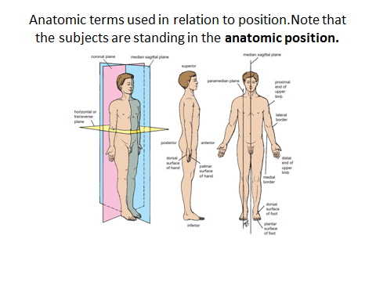**Coronal Planes** These planes are imaginary vertical planes at right angles to the median plane (see Fig. 1.1). it is parallel to the forehead . **Horizontal, or Transverse, Planes** These planes are at right angles to both the median and the coronal planes (see Fig. 1.1). The **terms anterior and posterior** are used to indicate the front and back of the body, respectively (see Fig. 1.1). To describe the relationship of two structures, one is said to be anterior or posterior to the other insofar as it is closer to the anterior or posterior body surface. In describing the hand, the terms **palmar and dorsal surfaces** are used in place of anterior and posterior, and in describing the foot, the terms **plantar and dorsal surfaces** are used instead of lower and upper surfaces (see Fig. 1.1). The terms **proximal and distal** describe the relative distances from the roots of the limbs; for example, the arm is proximal to the forearm and the hand is distal to the forearm. The terms **superficial and deep** denote the relative distances of structures from the surface of the body, and the terms **superior and inferior** denote levels relatively high or low with reference to the upper and lower ends of the body

The terms **internal and external** are used to describe the relative distance of a structure from the center of an organ or cavity; for example, the internal carotid artery is found inside the cranial cavity and the external carotid artery is found outside the cranial cavity. The term **ipsilateral** refers to the same side of the body; for example, the left hand and the left foot are ipsilateral. **Contralateral** refers to opposite sides of the body; for example, the left biceps brachii muscle and the right rectus femoris muscle are contralateral. **The supine** position of the body is lying on the back. **The prone** position is lying face downward. Terms Related to Movement A site where two or more bones come together is known as **a joint**. Some joints have no movement (sutures of the skull), some have only slight movement (superior tibiofibular joint), and some are freely movable (shoulder joint). **Flexion** is a movement that takes place in a sagittal plane. For example, flexion of the elbow joint approximates the anterior surface of the forearm to the anterior surface of the arm. It is usually an anterior movement, but it is occasionally posterior, as in the

case of the knee joint (see Fig. 1.2)..

Terms Related to Movement A site where two or more bones come together is known as a joint. Some joints have no movement (sutures of the skull), some have only slight movement (superior tibiofibular joint), and some are freely movable (shoulder joint). **Flexion** is a movement that takes place in a sagittal plane. For example, flexion of the elbow joint approximates the anterior surface of the forearm to the anterior surface of the arm. It is usually an anterior movement, but it is occasionally posterior, as in the case of the knee joint (see Fig. 1.2). Extension means straightening the joint and usually takes place in a posterior direction (see Fig. 1.2). Lateral flexion is a movement of the trunk in the coronal plane (Fig. 1.3**).**

**Abduction is** a movement of a limb away from the midline of the body in the coronal plane (see Fig. 1.2). **Adduction is a** movement of a limb toward the body in the coronal plane (see Fig. 1.2). In the fingers and toes, abduction is applied to the spreading of these structures and adduction is applied to the drawing together of these structures (see Fig. 1.3)..

**Rotation** is the term applied to the movement of a part of the body around its long axis. **Medial rotation** is the movement that results in the anterior surface of the part facing medially. **Lateral rotation** is the movement that results in the anterior surface of the part facing laterally. **Pronation of the forearm** is a medial rotation of the forearm in such a manner that the palm of the hand faces posteriorly (see Fig. 1.3). Supination of the forearm is a lateral rotation of the forearm from the pronated position so that the palm of the hand comes to face anteriorly (see Fig. 1.3). **Circumduction** is the combination in sequence of the movements of flexion, extension, abduction, and adduction (see Fig. 1.2). **Protraction** is to move forward; retraction is to move backward (used to describe the forward and backward movement of the jaw at the temporomandibular joints**). Inversion** is the movement of the foot so that the sole faces in a medial direction (see Fig. 1.3). **Eversion** is the opposite movement of the foot so that the sole faces in a lateral direction (see Fig. 1.3the words used in Anatomy are based in ancient Latin and Greek languages. These words follow simple rules. Each word is made up of basic prefixes, suffixes, and roots that can be combined to form words. Commonly used terms in prefixes, suffixes, and roots.

Prefix Meaning Anatomical Example Ante - In front of Antebrachial (In front of + Arm + Pertaining to) Endo- Inside, within Endometrium (Inside + Womb Epi- Above, on, over Epidermis (Above + Skin) Exo - Out, outside Exocrine gland (Outside + sift) gland Extra- Beyond, outside Extracellular (Outside + Cell+ Pertaining to Hypo- Under Hypothalamus (Under + Thalamus) Infra- Beneath, Below Infraspinatus muscle (Below + Spine) muscle

Inter- Between Interneuron (Between + Neuron

Prefix Meaning Anatomical Example Intra- Inside, within Intravenous (Inside + Vein + Pertaining to) Intramural ---------------- ------ (Within + Wall) Juxta- Beside Juxtaglomerular cell (Beside + Ball of thread*) cell * = glomerulus (kidneys)

Para- Beside, beyond Parathyroid gland (Beside + Thyroid) gland Peri- Around Pericardium (Around + Heart + Pertaining to) Retro- Behind Retroperitoneal (Behind + Stretched around) Sub- Beneath , under Subscapularis muscle (Under + Spine) muscle Supra- Above, upon Supraorbital (Above + Eye + Pertaining to

Trans- Across, through Transverse plane (Across + Turn) plane)

Prefix Meaning Anatomical Example Hemi- Half Hemi-diaphragm (Half + Diaphragm) Semi- Half Semitendinosus muscle (Half + Tendon) muscle Mono - One, single Monocyte (One + Cell) ) Uni - One Unicellular (One + Cell + Pertaining to Bi- Two , double Bilateral (Two + Side) Di- Two, double Digastric muscle (Two + Belly + Pertaining to) - Three Triceps muscle (Three + Head) muscle Quad- Four Quadriceps muscle (Four + Head) muscle Quadrilateral

Basic structures

**Skin** The skin is divided into two parts: the superficial part, the epidermis; and the deep part, the dermis (Fig. 1.4). The epidermis is a stratified epithelium whose cells become flattened as they mature and rise to the surface. On the palms of the hands and the soles of the feet, the epidermis is extremely thick, to withstand the wear and tear that occurs in these regions. In other areas of the body, for example, on the anterior surface of the arm and forearm, it is thin. The dermis is composed of dense connective tissue containing many blood vessels, lymphatic vessels, and nerves. It shows considerable variation in thickness in different parts of the body, tending to be thinner on the anterior than on the posterior surface. It is thinner in women than in men. The dermis of the skin is connected to the underlying deep fascia or bones by the superficial fascia, otherwise known as subcutaneous tissue

**The appendages of the skin** are the nails, hair follicles, sebaceous glands, and sweat glands. **The nails** are keratinized plates on the dorsal surfaces of the tips of the fingers and toes. The proximal edge of the plate is the root of the nail (see Fig. 1.5). With the exception of the distal edge of the plate, the nail is surrounded and overlapped by folds of skin known as nail folds. The surface of skin covered by the nail is the nail bed (see Fig. 1.5). **Hairs** grow out of follicles, which are invaginations of the epidermis into the dermis

**Sebaceous glands** pour their secretion, the sebum, onto the shafts of the hairs as they pass up through the necks of the follicles. They are situated on the sloping undersurface of the follicles and lie within the dermis). Sebum is an oily material that helps preserve the flexibility of the emerging hair. It also oils the surface epidermis around the mouth of the follicle. **Sweat glands** are long, spiral, tubular glands distributed over the surface of the body, except on the red margins of the lips, the nail beds, and the glans penis and clitoris (see Fig. 1.4). These glands extend through the full thickness of the dermis,

* 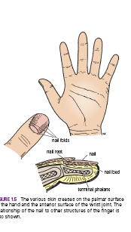

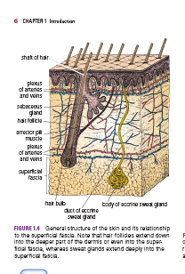

* **The fasciae of the body** can be divided into two types—**superficial** and **deep**—and lie between the skin and the underlying muscles and bones.
* The **superficial fascia,** or subcutaneous tissue, is a mixture of loose areolar and adipose tissue that unites the dermis of the skin to the underlying deep fascia (Fig. 1.6).
* In the scalp, the back of the neck, the palms of the hands, and the soles of the feet, it contains numerous bundles of collagen fibers that hold the skin firmly to the deeper structures.
* In the eyelids, auricle of the ear, penis and scrotum, and clitoris, it is devoid of adipose tissue.
* The **deep fascia** is a membranous layer of connective tissue that invests the muscles and other deep structures (see Fig.
* 1.6). In the neck, it forms well-defined layers that may play an important role in determining the path taken by pathogenic organisms during the spread of infection. In the thorax and abdomen, it is merely a thin film of areolar tissue covering the muscles and aponeuroses. In the limbs, it forms a definite sheath around the muscles and other structures, holding them in place. Fibrous septa extend from the deep surface of the membrane, between the groups of muscles, and in many places divide the interior of the limbs into compartments (see
* Fig. 1.6). In the region of joints, the deep fascia may be considerably thickened to form restraining bands called **retinacula ,**Their function is to hold underlying tendons in position or to serve as pulleys around which the tendons may move.
* Muscle
* The three types of muscle are skeletal, smooth, and cardiac.
* **Skeletal Muscle**
* Skeletal muscles produce the movements of the skeleton; they are sometimes called **voluntary muscles** and are made up of striped muscle fibers. A skeletal muscle has two more attachments. The attachment that moves the least is referred to as the **origin,** and the one that moves the most, the **insertion** (Fig. 1.8). Under varying circumstances, the
* degree of mobility of the attachments may be reversed; therefore, the terms origin and insertion are interchangeable.
* The fleshy part of the muscle is referred to as its **belly** (see Fig. 1.8). The ends of a muscle are attached to bones, cartilage, or ligaments by cords of fibrous tissue called
* **tendons** (Fig. 1.9). Occasionally, flattened muscles are attached by a thin but strong sheet of fibrous tissue called an **aponeurosis** (see Fig. 1.9). A **raphe** is an interdigitation of the tendinous ends of fibers of flat muscles (see Fig. 1.9).
* Internal Structure of Skeletal Muscle
* The muscle fibers are bound together with delicate areolar tissue, which is condensed on the surface to form a fibrous envelope, the **epimysium.** The individual fibers of a muscle
* are arranged either parallel or oblique to the long axis of the muscle (Fig. 1.10). Because a muscle shortens by one third to one half its resting length when it contracts, it follows
* that muscles whose fibers run parallel to the line of pull will bring about a greater degree of movement compared with those whose fibers run obliquely. Examples of muscles
* with parallel fiber arrangements (see Fig. 1.10) are the sternocleidomastoid,
* the rectus abdominis, and the sartorius. Muscles whose fibers run obliquely to the line of pull are referred to as **pennate muscles** (they resemble a feather) (see Fig. 1.10). A **unipennate muscle** is one in which the tendon lies along one side of the muscle and the muscle fibers pass obliquely to it (e.g., extensor digitorum longus).
* A **bipennate muscle** is one in which the tendon lies in the center of the muscle and the muscle fibers pass to it from two sides (e.g., rectus femoris). A **multipennate muscle**
* may be arranged as a series of bipennate muscles lying alongside one another (e.g., acromial fibers of the deltoid) or may have the tendon lying within its center and the muscle fibers passing to it from all sides, converging as they go (e.g., tibialis anterior).
* For a given volume of muscle substance, pennate muscles have many more fibers compared to muscles with parallel fiber arrangements and are therefore more powerful;
* in other words, range of movement has been sacrificed for strength.
* Skeletal Muscle Action
* All movements are the result of the coordinated action of many muscles. However, to understand a muscle’s action, it is necessary to study it individually.
* A muscle may work in the following four ways: **Prime mover:** A muscle is a prime mover when it is the chief muscle or member of a chief group of muscles
* responsible for a particular movement. For example, the quadriceps femoris is a prime mover in the movement of extending the knee joint (Fig. 1.11).
* **Antagonist:** Any muscle that opposes the action of the prime mover is an antagonist. For example, the biceps femoris opposes the action of the quadriceps femoris
* when the knee joint is extended (see Fig. 1.11). Before prime mover can contract, the antagonist muscle must be equally relaxed; this is brought about by nervous reflex inhibition.
* **Fixator:** A fixator contracts isometrically (i.e., contraction increases the tone but does not in itself produce movement) to stabilize the origin of the prime mover so that it can act efficiently. For example, the muscles attaching the shoulder girdle to the trunk contract as fixators to allow the deltoid to act on the shoulder joint (see Fig. 1.11).
* **Synergist:** In many locations in the body, the prime mover muscle crosses several joints before it reaches the joint at which its main action takes place. To prevent unwanted
* movements in an intermediate joint, groups of muscles called **synergists** contract and stabilize the intermediate joints. For example, the flexor and extensor muscles of
* the carpus contract to fix the wrist joint, and this allows the long flexor and the extensor muscles of the fingers to work efficiently (see Fig. 1.11).
* These terms are applied to the action of a particular muscle during a particular movement; many muscles can act as a prime mover, an antagonist, a fixator, or a synergist,
* depending on the movement to be accomplished Muscles can even contract paradoxically for example, when the biceps brachii, a flexor of the elbow joint, contracts
* and controls the rate of extension of the elbow when the triceps brachii contracts.
* Nerve Supply of Skeletal Muscle
* The nerve trunk to a muscle is a mixed nerve, about 60% is motor and 40% is sensory, and it also contains some sympathetic autonomic fibers. The nerve enters the muscle at about the midpoint on its deep surface, often near the margin; the place of entrance is known as the **motor point.** This arrangement allows the muscle
* to move with minimum interference with the nerve trunk.
* Naming of Skeletal Muscles
* Individual muscles are named according to their shape, size, number of heads or bellies, position, depth, attachments, or actions. Some examples of muscle names are
* shown in Table

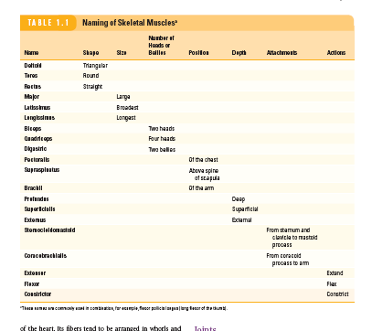

**Muscle Tone**

Determination of the **tone** of a muscle is an important clinical examination. If a muscle is **flaccid,** then either the afferent, the efferent, or both neurons involved in the reflex arc necessary for

the production of muscle tone have been interrupted. For example,

if the nerve trunk to a muscle is severed, both neurons will have

been interrupted. If poliomyelitis has involved the motor anterior

horn cells at a level in the spinal cord that innervates the muscle,

the efferent motor neurons will not function. If, conversely, the

muscle is found to be hypertonic, the possibility exists of a lesion

involving higher motor neurons in the spinal cord or brain.

**Muscle Attachments**

The importance of knowing the main attachments of all the major

muscles of the body need not be emphasized. Only with such

knowledge is it possible to understand the normal and abnormal

actions of individual muscles or muscle groups. How can one

even attempt to analyze, for example, the abnormal gait of a

patient without this information?

**Muscle Shape and Form**

The general shape and form of muscles should also be noted,

since a paralyzed muscle or one that is not used (such as

occurs when a limb is immobilized in a cast) quickly atrophies

and changes shape. In the case of the limbs, it is always worth

remembering that a muscle on the opposite side of the body can

be used for comparison.

**Smooth Muscle**

Smooth muscle consists of long, spindle-shaped cells closely arranged in bundles or sheets. In the tubes of the body, it provides the motive power for propelling the contents through the lumen. In the digestive system, it also causes the ingested food to be thoroughly mixed with the digestive juices. A wave of contraction of the circularly arranged fibers passes along the tube, milking the contents onward. By their contraction, the longitudinal fibers pull the wall of the tube proximally over the contents. This method of propulsion is referred to as **peristalsis.**

**In storage organs such as the urinary bladder and the uterus**, the fibers are irregularly arranged and interlaced with one another. Their contraction is slow and sustained and brings about expulsion of the contents of the organs.

**In the walls of the blood vessels**, the smooth muscle fibers are arranged circularly and serve to modify the caliber of the lumen.

Depending on the organ, **smooth muscle fibers may be made to contract** by local stretching of the fibers, by nerve impulses from autonomic nerves, or by hormonal stimulation.

**Cardiac Muscle**

Cardiac muscle consists of striated muscle fibers that branch and unite with each other. It forms the myocardium of the heart. Its fibers tend to be arranged in whorls and spirals, and they have the property of spontaneous and rhythmic contraction. Specialized cardiac muscle fibers form the **conducting system of the heart.**

Cardiac muscle is supplied by autonomic nerve fibers that terminate in the nodes of the conducting system and

in the myocardium.

**Necrosis of Cardiac Muscle**

The cardiac muscle receives its blood supply from the coronary

arteries. A sudden block of one of the large branches of a

coronary artery will inevitably lead to necrosis of the cardiac

muscle and often to the death of the patient.

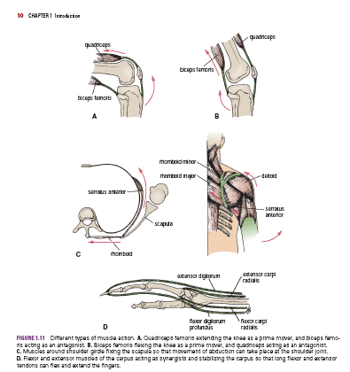

Joints

A site where two or more bones come together, whether

or not movement occurs between them, is called a **joint.**

Joints are classified according to the tissues that lie between

the bones: fibrous joints, cartilaginous joints, and synovial

joints.

**Fibrous Joints**

The articulating surfaces of the bones are joined by fibrous

tissue (Fig. 1.12), and thus very little movement is possible.

The sutures of the vault of the skull and the inferior tibiofibular

joints are examples of fibrous joints.

**Cartilaginous Joints**

Cartilaginous joints can be divided into two types: primary

and secondary. A **primary cartilaginous joint** is one in which the bones are united by a plate or a bar of hyaline cartilage. Thus, the union between the **epiphysis** and the **diaphysis** of a growing bone and that between the 1st rib and the manubrium sterni are examples of such a joint. No movement is possible. A **secondary cartilaginous joint** is one in which the bones are united by a plate of fibrocartilage and the articular surfaces of the bones are covered by a thin layer of hyaline cartilage. Examples are the joints between the vertebral bodies (see Fig. 1.12) and the **symphysis pubis.** A small amount of movement is possible.

**Synovial Joints**

The articular surfaces of the bones are covered by a thin layer

of hyaline cartilage separated by a joint cavity (see Fig. 1.12).

This arrangement permits a great degree of freedom of movement. The cavity of the joint is lined by **synovial** **membrane,** which extends from the margins of one articular surface to those of the other. The synovial membrane is protected on the outside by a tough fibrous membrane referred to as the **capsule** of the joint. The articular surfaces are lubricated by a viscous fluid called **synovial fluid,** which is produced by the synovial membrane. In certain synovial

joints, for example, in the knee joint, discs or wedges of fibrocartilage are interposed between the articular surfaces of the bones. These are referred to as **articular discs.**

**Fatty pads** are found in some synovial joints lying between the synovial membrane and the fibrous capsule or bone. Examples are found in the hip (see Fig. 1.12) and knee joints.The degree of movement in a synovial joint is limited by the shape of the bones participating in the joint, the coming together of adjacent anatomic structures (e.g., the thigh against the anterior abdominal wall on flexing the hip joint), and the presence of fibrous **ligaments** uniting the bones. Most ligaments lie outside the joint capsule, but in the knee some important ligaments, the **cruciate ligaments,** lie within the capsule (Fig. 1.13).

Synovial joints can be classified according to the arrangement

of the articular surfaces and the types of movement that are possible.

■■ **Plane joints:** In plane joints, the apposed articular surfaces are flat or almost flat, and this permits the bones to slide on one another. Examples of these joints are the sternoclavicular and acromioclavicular joints (Fig. 1.14).

■■ **Hinge joints:** Hinge joints resemble the hinge on a door, so that flexion and extension movements are possible.

Examples of these joints are the elbow, knee, and ankle

joints (see Fig. 1.14).

■■ **Pivot joints:** In pivot joints, a central bony pivot is surrounded

by a bony–ligamentous ring (see Fig. 1.14), and

rotation is the only movement possible. The atlantoaxial

and superior radioulnar joints are good examples.

■■ **Condyloid joints:** Condyloid joints have two distinct

convex surfaces that articulate with two concave surfaces.

The movements of flexion, extension, abduction,

and adduction are possible together with a small

amount of rotation. The metacarpophalangeal joints or

knuckle joints are good examples (see Fig. 1.14).

■■ **Ellipsoid joints:** In ellipsoid joints, an elliptical convex

articular surface fits into an elliptical concave

articular

surface. The movements of flexion, extension, abduction,

and adduction can take place, but rotation is impossible.

The wrist joint is a good example

(see Fig. 1.14).

■■ **Saddle joints:** In saddle joints, the articular surfaces are

reciprocally concavoconvex and resemble a saddle on

a horse’s back. These joints permit flexion, extension,

abduction, adduction, and rotation. The best example

of this type of joint is the carpometacarpal joint of the

thumb (see Fig. 1.14).

■■ **Ball-and-socket joints:** In ball-and-socket joints, a ballshaped

head of one bone fits into a socketlike concavity

of another. This arrangement permits free movements,

including flexion, extension, abduction, adduction,

medial rotation, lateral rotation, and circumduction.

The shoulder and hip joints are good examples of this

type of joint (see Fig. 1.14).

**Stability of Joints**

The stability of a joint depends on three main factors: the

shape, size, and arrangement of the articular surfaces; the

ligaments; and the tone of the muscles around the joint.

Articular Surfaces

The ball-and-socket arrangement of the hip joint (see

Fig. 1.13) and the mortise arrangement of the ankle joint

are good examples of how bone shape plays an important

role in joint stability. Other examples of joints, however,

in which the shape of the bones contributes little or nothing

to the stability include the acromioclavicular joint, the

calcaneocuboid joint, and the knee joint.

Ligaments

**Fibrous ligaments** prevent excessive movement in a joint (see Fig. 1.13), but if the stress is continued for an excessively long period, then fibrous ligaments stretch. For example, the ligaments of the joints between the bones forming the arches of the feet will not by themselves support the weight of the body. Should the tone of the muscles that normally support

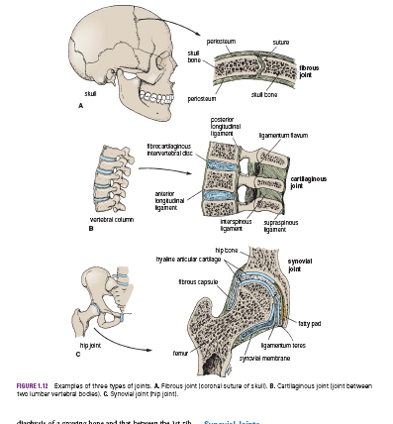

be required to dislocate this joint. The knee joint is very unstable without the tonic activity of the

quadriceps femoris muscle. The joints between the small bones forming the arches of the feet are largely supported by the tone of the muscles of the leg, whose tendons are inserted into the

bones of the feet (see Fig. 1.13).

**Nerve Supply of Joints**

The capsule and ligaments receive an abundant sensory nerve supply. A sensory nerve supplying a joint also supplies the muscles moving the joint and the skin overlying the insertions of these muscles, a fact that has been codified as **Hilton’s law.**

