|  |  |  |
| --- | --- | --- |
| **وزارة التعليم العالي والبحث العلمي**  **كلية المستقبل الجامعة**  **قسم/هندسة تقنيات الحاسوب**  **مختبر/أسس الاتصالات** | | **رمز السجل :**  **تاريخ الإصدار:**  **رقم الإصدار:** |
| **المرحلة : الثانية** |
| **سجل التجارب للعام الدراسي 2023 - 2024** | | |

## Experiment 4:

### Band Stop Filters

## Object :

The students vary the input frequency while observing both the input and output on the oscilloscope. They should identify one circuit arrangement as a Band Stop filter .

**الأجهزة والمعدات:-**

**Computer by using multisim program**

1- function generator

2-resistor

3-capacitor

4-Indactor

5-2 channel oscilloscope

## THEORY :-

The following circuit is an example of a band stop filter:

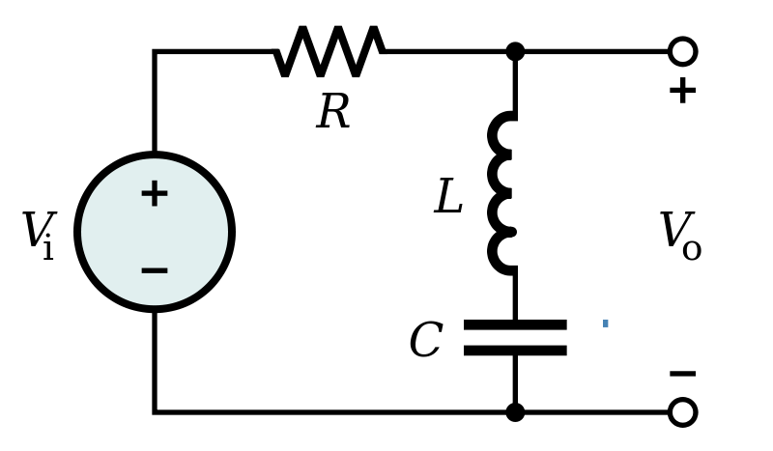

**Band Stop Filter**, (BSF) is another type of frequency selective circuit that functions in exactly the opposite way to the Band Pass Filter we looked at before. The band stop filter, also known as a *band reject filter*, passes all frequencies with the exception of those within a specified stop band which are greatly attenuated.

If this stop band is very narrow and highly attenuated over a few hertz, then the band stop filter is more commonly referred to as a *notch filter*, as its frequency response shows that of a deep notch with high selectivity (a steep-side curve) rather than a flattened wider band.

Also, just like the band pass filter, the band stop (band reject or notch) filter is a second-order (two-pole) filter having two cut-off frequencies, commonly known as the -3dB or half-power points producing a wide stop band bandwidth between these two -3dB points.

Then the function of a band stop filter is too pass all those frequencies from zero (DC) up to its first (lower) cut-off frequency point ƒL, and pass all those frequencies above its second (upper) cut-off frequency ƒH, but block or reject all those frequencies in-between. Then the filters bandwidth, BW is defined as: (ƒH – ƒL).

So for a wide-band band stop filter, the filters actual stop band lies between its lower and upper -3dB points as it attenuates, or rejects any frequency between these two cut-off frequencies. The frequency response curve of an ideal band stop filter is therefore given as :

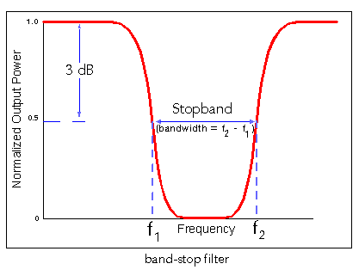

#### Band Stop Filter Calculator :

This is a second-order filter because of 2 cut-off frequencies (lower and higher) with a bandwidth of -3dB that points between upper and lower points. So, the bandwidth can be

(fL – fH). The bandwidth can be calculated by taking the difference between lower cut-off frequency fL and upper

cut -off frequency fH

Bandwidth = fL – fH

The center frequency is the square root of the difference between the cut-off frequency of low pass filter and the cut-off frequency of high pass filter

**fc = √( fL x fH)**

Where fc = center frequency

fL = cut-off frequency of low pass filter

fH = cut-off frequency of high pass filter

Consider the RC band stop filter to calculate the cut-off frequency.

The cut-off frequency of the low pass filter is given as

**fL = 1/2πR1C1**

The cut-off frequency of the high pass filter is given as

**fH = 1/2πR2C2**

The quality factor Q of the circuit can be calculated as

Q = fc/bandwidth

The band stop filter circuit using R, L, and C is discussed below.

This filter allows a particular range of frequencies, which are above and below the cut-off frequencies of high pass and low pass filter circuits. It blocks the frequency components between the low and high-frequency ranges. The circuit using R, L, and C is shown below.

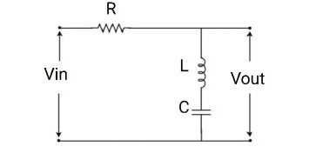

**RLC Circuit**

The passive elements R, L, and C are connected in series. The input voltage is applied across the resistor and the output voltage is obtained across the inductor and the capacitor. This filter allows all the high and low-frequency components with respect to the cut-off frequency. At low-frequency range, the capacitor becomes an open circuit and the inductor becomes a short circuit. At the high-frequency range, the capacitor becomes a short circuit and the inductor becomes an open circuit.

This circuit behaves as an open circuit at high and low-frequency ranges due to the capacitor and inductor are connected in series. Hence, at the mid-frequency range, the filter behaves as a short circuit and is blocked by the filter. The components used in the circuit determines the lower and higher cut-off frequency. The transfer function of the circuit is,

**H(jω) = j(ωL – 1/ωC) / (R+(jωL – (1/ωC)))**

Where ω = 2πf = angular frequency

#### Frequency Response:

The **frequency response of the band stop filter** is shown in the below figure. The frequency response is drawn between frequency vs gain.

In practice, the switching mechanism of the capacitor changes the output characteristics of high pass and low pass filters and are not similar to the ideal filter. The passband gain of this filter should be equal to the gain of the low pass and high pass filter.

**Frequency Response**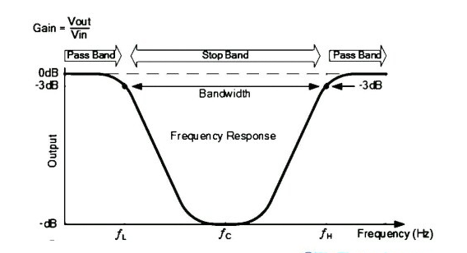

In an ideal band stop filter, the pass band gain should be Amax and the stop band gain should be zero. But it is not possible in practice due to the transition region between the high and low pass filter sections. The pass band ripples and the stop band ripples can be measured by using,

Stop band ripple = – 20 log10(δs) dB

Pass band ripple = -20 log10(1-δp) dB

Where δp = pass band filter magnitude response

δs = stop band filter magnitude response

For example, if the lower cut-off frequency ([low pass filter](https://www.watelectronics.com/what-is-a-low-pass-filter-circuit-its-working/)) is 500Hz and the upper cut-off frequency (high pass filter) is 1000Hz, then the band stop filter works by allowing the low frequencies below and up to 500Hz and high frequencies above 1000Hz. The frequencies between 500Hz and 1000Hz are attenuated. The band stop filter gives a wide frequency response when compared to the[band pass filter](https://www.watelectronics.com/what-is-band-pass-filter-circuit-its-working/)

Band stop filters are used in many fronts. They’re currently used to filter noise or distortions, especially with DSL internet service. They’re also used in a lot of household appliances, particularly to considerably reduce the 60 hertz (Hz) interference coming from the walls of houses

