Al-Mustaqbal University College

مادة اللغة الانكليزية

Understanding the Past Continuous Tense

BY

Zainab Kareem ALJanabi

Lecture: Understanding the Past Continuous Tense

The past continuous tense (also called the past progressive tense) is used to describe actions that were happening at a specific time in the past. It focuses on the duration of the action, rather than its completion. In this lecture, we will explore its structure, uses, and common mistakes students make when using it.

1. Structure of the Past Continuous Tense:

The past continuous tense is formed using:

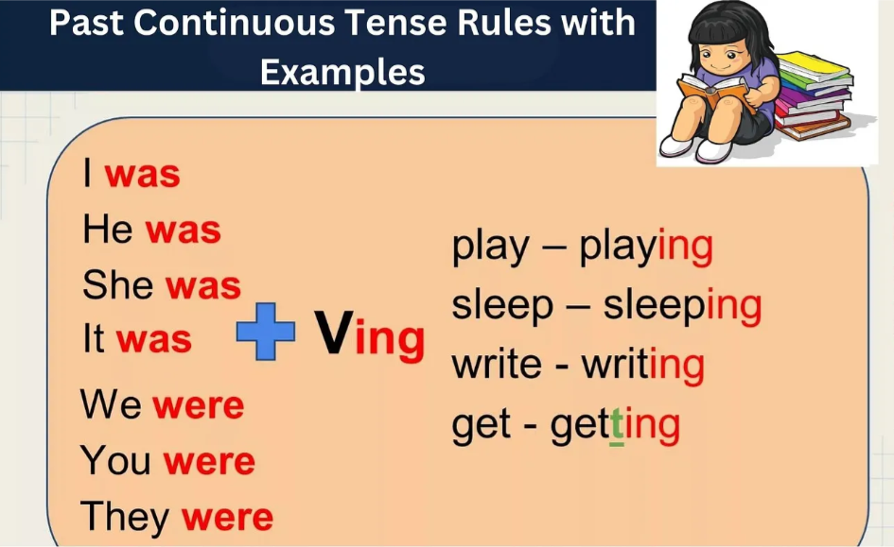

* Subject: I / They
* Was/Were: I (was) / They (were) – depending on the subject
* Verb + ing: reading / playing

Affirmative sentences:

* He was watching TV when I called.
* They were studying for the exam last night.
* I was reading a book when the phone rang.
* They were playing football at 4 PM yesterday

Negative sentences:

To make negative sentences, add "not" after was/were:

* I was not (wasn't) sleeping when you knocked.
* They were not (weren't) listening to the teacher.

Questions:

In questions, reverse the subject and the auxiliary verb (was/were):

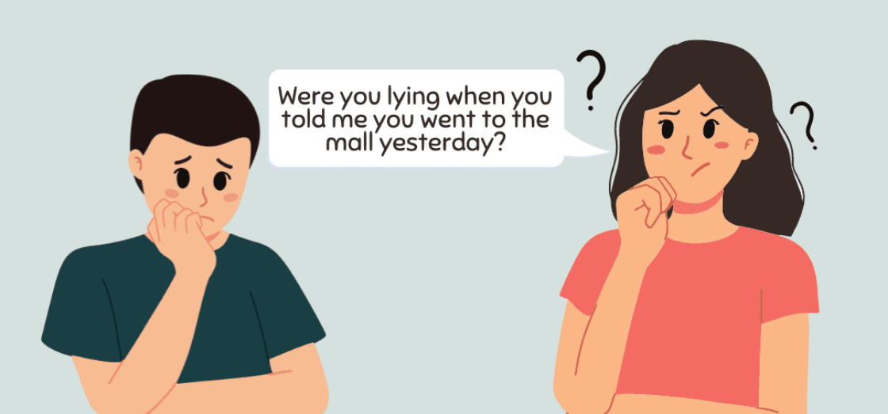

* Was she reading a book when you entered?
* Were they playing football at the park?

Uses of the Past Continuous Tense:

It is commonly used to describe a longer action that was interrupted by a shorter action in the past (often expressed with the past simple).

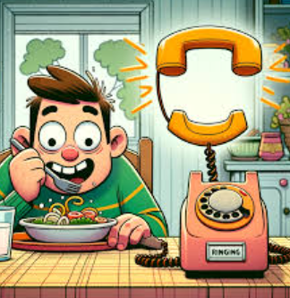

* She was reading when the doorbell rang.
  + The longer action (was reading) is interrupted by the shorter action (doorbell rang).
* We were watching a movie when the lights went out.

It can describe two or more actions happening simultaneously in the past.

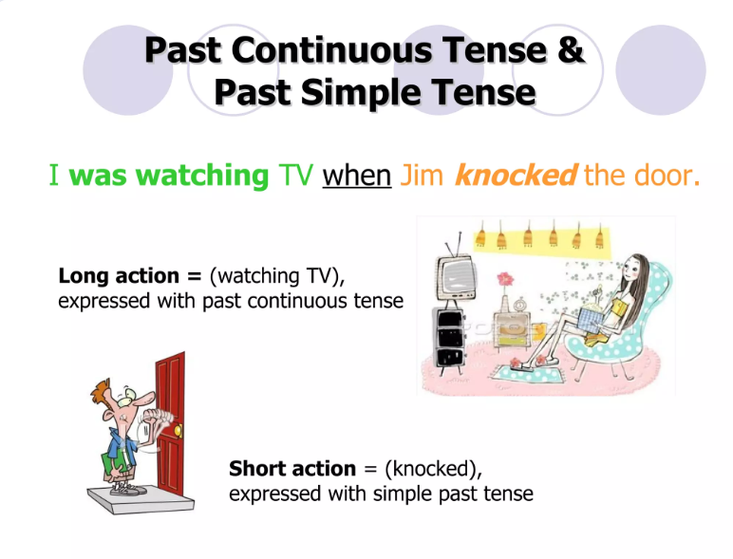

* I was watching TV when he knocked the door.

Writers often use the past continuous to set the scene in a story, providing a backdrop for a series of events.

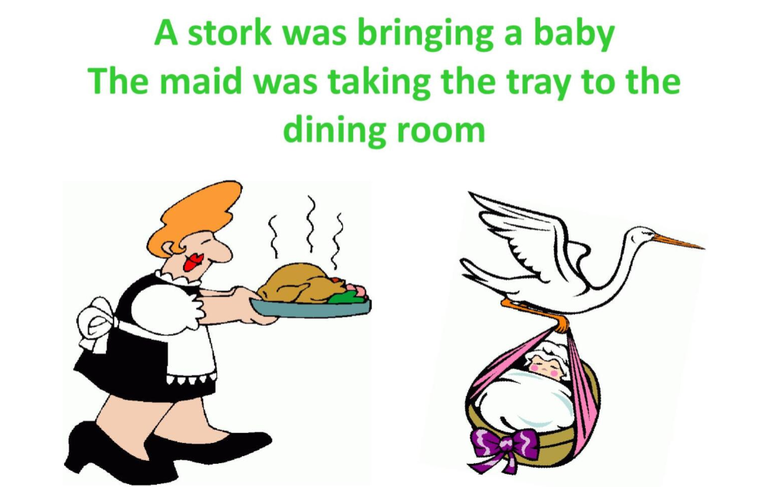

Time Expressions Used with the Past Continuous:

Certain time expressions often accompany the past continuous tense to provide context:

* At 3 PM yesterday, I was working on my project.
* While I was studying, my phone rang.
* When the teacher arrived, we were talking.
* All evening, they were playing video games.

Tip: Use "was" with singular subjects (I, he, she, it) and "were" with plural subjects (you, we, they).

She was reading a book.

Tip: Always add -ing to the main verb in the past continuous tense.

She was reading a book.

Tip: Use the past continuous for the longer action (walking) and the past simple for the shorter, interrupting action (saw).

I was walking to the store when I saw him.