**Al-mustaqbal University**

**College of Engineering and Engineering Technologies**

**Department of Computer Engineering Technologies**

***Communications Fundamentals***

***Second Stage***

***Tutorial Sheet (2)***

**Example 1 : Find the Fourier series of the function**

**f(x) = x2, –𝜋 < x < 𝜋.**

**Solution:**

Let us find the values of the real numbers a0, an, and bn. The period of the given function is 2𝜋, then,

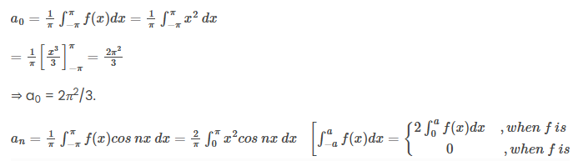

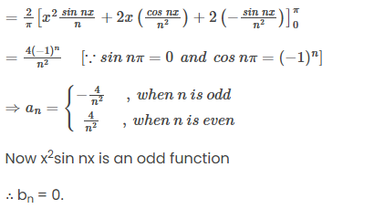

The Fourier series of x2 is

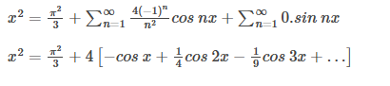

**(1)**

**Example 2 : Find the Fourier series of the periodic function f(x), such that**

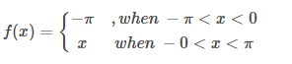

**Solution:**

Clearly, the period of the function of 2𝜋, then,

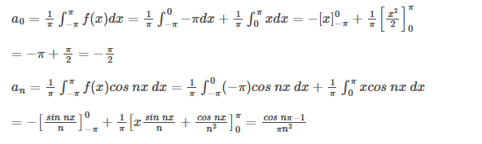

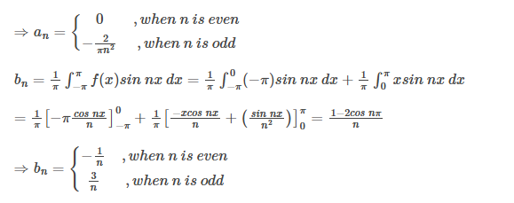

Putting the values of a’s and b’s we get the required Fourier series:

f(x) = – 𝜋/4 – 2/𝜋[cos x + 1/32 cos 3x + 1/52 cos 5x + …] + [3 sin x – ½ sin 2x + 3/3 sin 3x – …]

**(2)**

**Example 3 :** Find the Fourier series of |x| where –𝜋 < x < 𝜋.

**Solution:**

Let f(x) = |x| and period of f is 2𝜋.

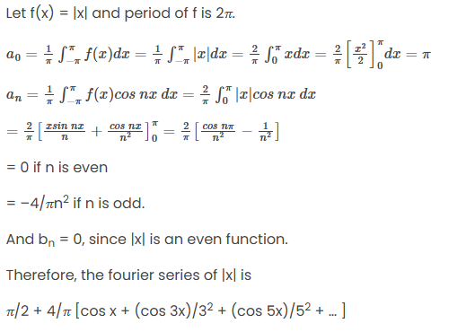

**)3)**

**Example 4 :**Find the value of the real number a0 of the Fourier series if

f(x) = x2 for 0 ≤ x ≤ 2𝜋.

**Solution:**

Given f(x) = x2, for this also the period of the function is 2𝜋

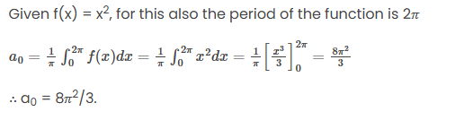

**(4)**

**Example 5 :**Obtain a Fourier expression for

f (x) = ${ x}^{3}$ for –π < x < π

**Solution.** f (x) = x 3 is an odd function.

∴ a0 = 0 and an = 0

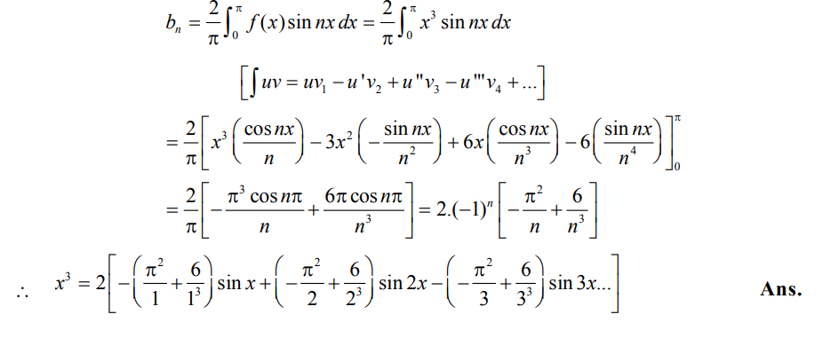

**(5)**

**Example 6 :** Represent the following function by a Fourier sine series

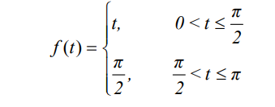 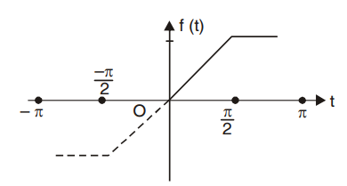

**Solution:**

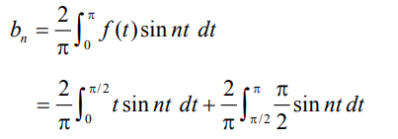

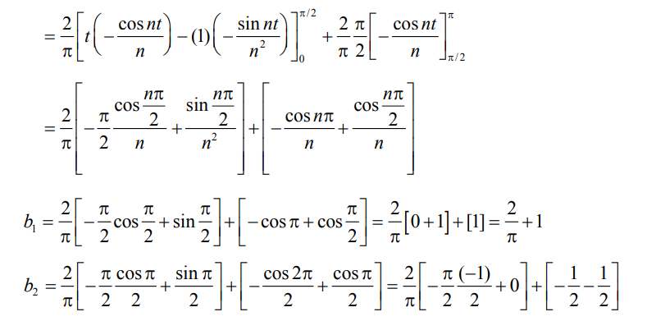

**(6)**

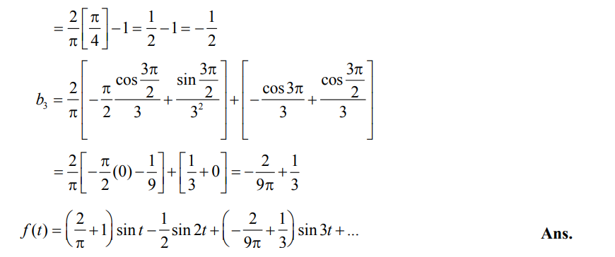

**(7)**

**Example 7 :** A periodic function of period 4 is defined as

f(x) = |x| –2 < x < 2. 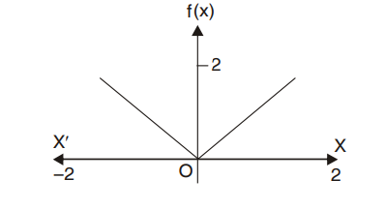

Find its Fourier series expansion.

**Solution.** f (x) = |x| –2 < x < 2.

f (x) = x 0 < x < 2

f (x) = –x –2 < x < 0

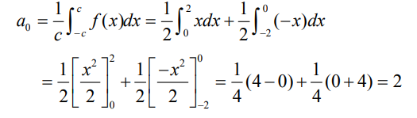

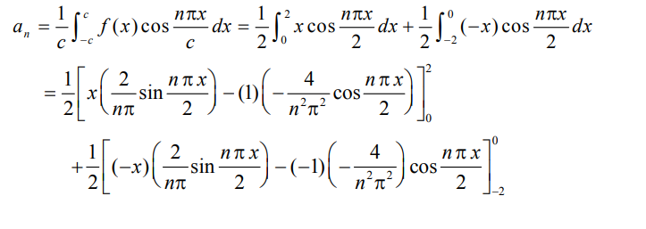

**(8)**

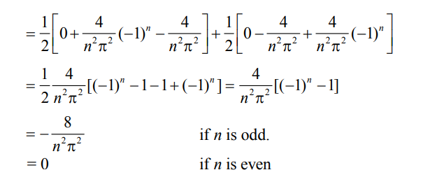

bn = 0 as f(x) is even function. Fourier series is

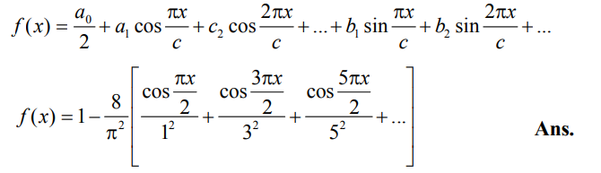

**(9)**

**Example 8 :** Find the Fourier series corresponding to the function f (x) defined in ( –2, 2) as follows

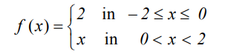 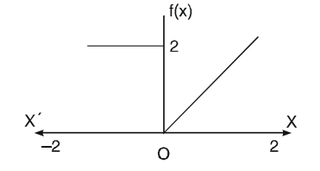

**Solution.** Here the interval is ( –2, 2) and c = 2

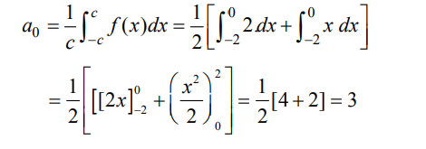

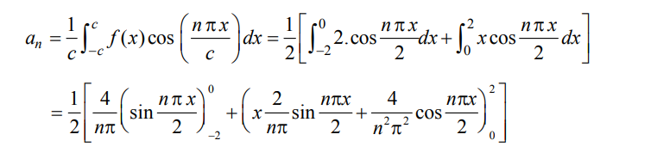

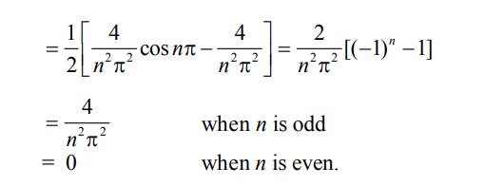

**(10)**

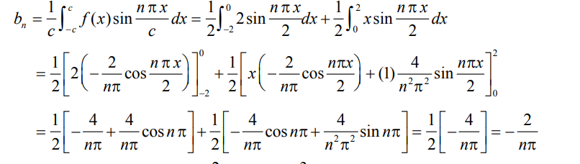

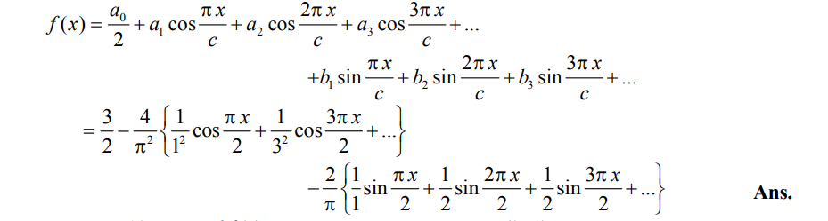

**(11)**