General anatomy

Lec. 5

The face

**The Face** Skin of the Face The skin of the face possesses numerous sweat and sebaceous glands. It is connected to the underlying bones by loose connective tissue, in which are embedded the muscles of facial expression. No deep fascia is present in the face. Wrinkle lines of the face result from the repeated folding of the skin perpendicular to the long axis of the underlying contracting muscles, coupled with the loss of youthful skin elasticity. Surgical scars of the face are less conspicuous if they follow the wrinklelines

Sensory Nerves of the Face The skin of the face is supplied by branches of the three divisions of the **trigeminal nerve**, except for the small area over the angle of the mandible and the parotid gland (Fig. 11.41), which is supplied by the great auricular nerve (C2 and 3). The overlap of the three divisions of the trigeminal nerve is slight compared with the considerable overlap of dermatomes of the trunk and limbs. The ophthalmic nerve supplies the region developed from the frontonasal process; the maxillary nerve serves the region developed from the maxillary process of the first pharyngeal arch; and the mandibular nerve serves the region developed from the mandibular process of the first pharyngeal arch. These nerves not only supply the skin of the face, but also supply proprioceptive fibers to the underlying muscles of facial expression. They are, in addition, the sensory nerve supply to the mouth, teeth, nasal cavities, and paranasal air sinuses.

**Ophthalmic Nerve** The ophthalmic nerve supplies the skin of the forehead, the upper eyelid, the conjunctiva, and the side of the nose down to and including the tip. Five branches of the nerve pass to the skin.

-1The lacrimal nerve supplies the skin and conjunctiva of the lateral part of the upper eyelid (Fig. 11.41). -2The supraorbital nerve winds around the upper margin of the orbit at the supraorbital notch (Fig. 11.41). It divides into branches that supply the skin and conjunctiva on the central part of the upper eyelid; it also supplies the skin of the forehead.

-3The supratrochlear nerve winds around the upper margin of the orbit medial to the supraorbital nerve (Fig. 11.41). It divides into branches that supply the skin and conjunctiva on the medial part of the upper eyelid and the skin over the lower part of the forehead, close to the median plane.

-4The infratrochlear nerve leaves the orbit below the pulley of the superior oblique muscle. It supplies the skin and conjunctiva on the medial part of the upper eyelid and the adjoining part of the side of the nose (Fig. 11.41).

-5 The external nasal nerve leaves the nose by emerging between the nasal bone and the upper nasal cartilage. It supplies the skin on the side of the nose down as far as the tip

**Maxillary Nerve** The maxillary nerve supplies the skin on the posterior part of the side of the nose, the lower eyelid, the cheek, the upper lip, and the lateral side of the orbital opening. Three branches of the nerve pass to the skin.

-1The infraorbital nerve is a direct continuation of the maxillary nerve. It enters the orbit and appears on the face through the infraorbital foramen. It immediately divides into numerous small branches, which radiate out from the foramen and supply the skin of the lower eyelid and cheek, the side of the nose, and the upper lip (Fig. 11.41).

-2The zygomaticofacial nerve passes onto the face through a small foramen on the lateral side of the zygomatic bone. It supplies the skin over the prominence of the cheek (Fig. 11.41).

-3The zygomaticotemporal nerve emerges in the temporal fossa through a small foramen on the posterior surface of the zygomatic bone. It supplies the skin over the temple

**Mandibular Nerve** The mandibular nerve supplies the skin of the lower lip, the lower part of the face, the temporal region, and part of the auricle. It then passes upward to the side of the scalp. Three branches of the nerve pass to the skin.

-1The mental nerve emerges from the mental foramen of the mandible and supplies the skin of the lower lip and chin (Fig. 11.41).

-2The buccal nerve emerges from beneath the anterior border of the masseter muscle and supplies the skin over a small area of the cheek (Fig. 11.41).

-3 The auriculotemporal nerve ascends from the upper border of the parotid gland between the superficial temporal vessels and the auricle. It supplies the skin of the auricle, the external auditory meatus, the outer surface of the tympanic membrane, and the skin of the scalp above the auricle.

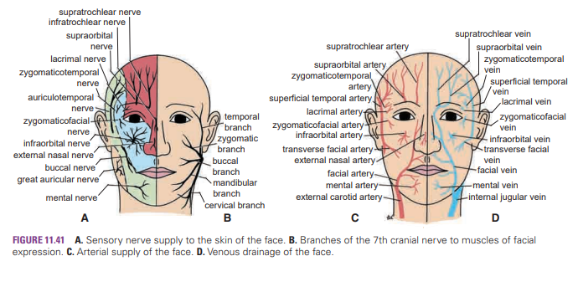

Clinical note:

Sensory Innervation and Trigeminal Neuralgia The facial skin receives its sensory nerve supply from the three divisions of the trigeminal nerve. Remember that a small area of skin over the angle of the jaw is supplied by the great auricular nerve (C2 and 3). Trigeminal neuralgia is a relatively common condition in which the patient experiences excruciating pain in the distribution of the mandibular or maxillary division, with the ophthalmic division usually escaping. A physician should be able to map out accurately on a patient’s face the distribution of each of the divisions of the trigeminal nerve.

Arterial Supply of the Face The face receives a rich blood supply from two main vessels: the facial and superficial temporal arteries, which are supplemented by several small arteries that accompany the sensory nerves of the face. The facial artery arises from the external carotid artery (Figs. 11.55 and 11.59). Having arched upward and over the submandibular salivary gland, it curves around the inferior margin of the body of the mandible at the anterior border of the masseter muscle. It is here that the pulse can be easily felt (Fig. 11.132). It runs upward in a tortuous course toward the angle of the mouth and is covered by the platysma and the risorius muscles. It then ascends deep to the zygomaticus muscles and the levator labii superioris muscle and runs along the side of the nose to the medial angle of the eye, where it anastomoses with the terminal branches of the ophthalmic artery (Fig. 11.41). **Branches**

■ The submental artery arises from the facial artery at the lower border of the body of the mandible. It supplies the skin of the chin and lower lip.

■ The inferior labial artery arises near the angle of the mouth. It runs medially in the lower lip and anastomoses with its fellow of the opposite side.

■ The superior labial artery arises near the angle of the mouth. It runs medially in the upper lip and gives branches to the septum and ala of the nose.

■ The lateral nasal artery arises from the facial artery alongside the nose. It supplies the skin on the side and dorsum of the nose.

■ The superficial temporal artery (Fig. 11.41), the smaller terminal branch of the external carotid artery, commences in the parotid gland. It ascends in front of the auricle to supply the scalp (see page 578).

■ The transverse facial artery, a branch of the superficial temporal artery, arises within the parotid gland. It runs forward across the cheek just above the parotid duct (Fig. 11.41).

■ The supraorbital and supratrochlear arteries, branches of the ophthalmic artery, supply the skin of the forehead (Fig. 11.41).

**Venous Drainage of the Face** The facial vein is formed at the medial angle of the eye by the union of the supraorbital and supratrochlear veins (Fig. 11.41). It is connected to the superior ophthalmic vein directly through the supraorbital vein. By means of the superior ophthalmic vein, the facial vein is connected to the cavernous sinus (Fig. 11.9); this connection is of great clinical importance because it provides a pathway for the spread of infection from the face to the cavernous sinus. The facial vein descends behind the facial artery to the lower margin of the body of the mandible. It crosses superficial to the submandibular gland and is joined by the anterior division of the retromandibular vein. The facial vein ends by draining into the internal jugular vein. Tributaries The facial vein receives tributaries that correspond to the branches of the facial artery. It is joined to the pterygoid venous plexus by the deep facial vein and to the cavernous sinus by the superior ophthalmic vein. The transverse facial vein joins the superficial temporal vein within the parotid gland.

**Lymph Drainage** of the Face Lymph from the forehead and the anterior part of the face drains into the submandibular lymph nodes (Fig. 11.42). A few buccal lymph nodes may be present along the course of these lymph vessels. The lateral part of the face, including the lateral parts of the eyelids, is drained by lymph vessels that end in the parotid lymph nodes. The central part of the lower lip and the skin of the chin are drained into the submental lymph nodes.

**Muscles of the Face** (Muscles of Facial Expression) The muscles of the face are embedded in the superficial fascia, and most arise from the bones of the skull and are inserted into the skin (Fig. 11.38). The orifices of the face, namely, the orbit, nose, and mouth, are guarded by the eyelids, nostrils, and lips, respectively. It is the function of the facial muscles to serve as sphincters or dilators of these structures. A secondary function of the facial muscles is to modify the expression of the face. **All the muscles of the face are developed from the second pharyngeal arch and are supplied by the facial nerve.**

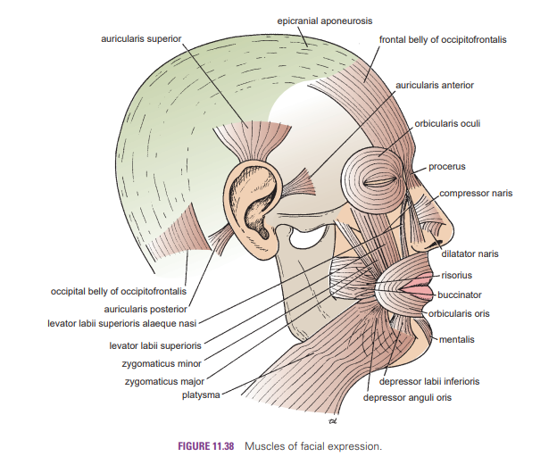

Facial Nerve As the facial nerve runs forward within the substance of the parotid salivary gland (see page 630), it divides into its five terminal branches (Fig. 11.41).

■ The temporal branch emerges from the upper border of the gland and supplies the anterior and superior auricular muscles, the frontal belly of the occipitofrontalis, the orbicularis oculi, and the corrugator supercilii.

■ The zygomatic branch emerges from the anterior border of the gland and supplies the orbicularis oculi.

■ The buccal branch emerges from the anterior border of the gland below the parotid duct and supplies the buccinator muscle and the muscles of the upper lip and nostril.

■ The mandibular branch emerges from the anterior border of the gland and supplies the muscles of the lower lip.

■ The cervical branch emerges from the lower border of the gland and passes forward in the neck below the mandible to supply the platysma muscle; it may cross the lower margin of the body of the mandible to supply the depressor anguli oris muscle. The facial nerve is the nerve of the second pharyngeal arch and supplies all the muscles of facial expression. It does not supply the skin, but its branches communicate with branches of the trigeminal nerve. It is believed that the proprioceptive nerve fibers of the facial muscles leave the facial nerve in these communicating branches and pass to the central nervous system via the trigeminal nerve. A summary of the origin and distribution of the facial nerve is shown in Figure 11.67.

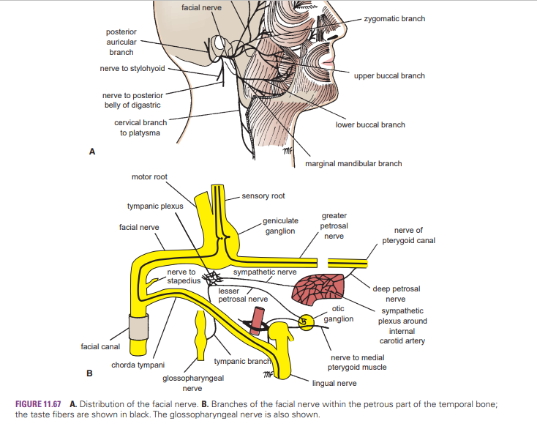

Clinical note

Facial Infections and Cavernous Sinus Thrombosis The area of facial skin bounded by the nose, the eye, and the upper lip is a potentially dangerous zone to have an infection. For example, a boil in this region can cause thrombosis of the facial vein, with spread of organisms through the inferior ophthalmic veins to the cavernous sinus. The resulting cavernous sinus thrombosis may be fatal unless adequately treated with antibiotics.

Blood Supply of the Facial Skin The blood supply to the skin of the face is profuse so that it is rare in plastic surgery for skin flaps to necrose in this region. Facial Arteries and Taking the Patient’s Pulse The superficial temporal artery, as it crosses the zygomatic arch in front of the ear, and the facial artery, as it winds around the lower margin of the mandible level with the anterior border of the masseter, are commonly used by the anesthetist to take the patient’s pulse.

Facial Muscle Paralysis The facial muscles are innervated by the facial nerve. Damage to the facial nerve in the internal acoustic meatus (by a tumor), in the middle ear (by infection or operation), in the facial nerve canal (perineuritis, Bell’s palsy), or in the parotid gland (by a tumor) or caused by lacerations of the face will cause distortion of the face, with drooping of the lower eyelid, and the angle of the mouth will sag on the affected side. This is essentially a lower motor neuron lesion. An upper motor neuron lesion (involvement of the pyramidal tracts) will leave the upper part of the face normal because the neurons supplying this part of the face receive corticobulbar fibers from both cerebral cortices.