**Human Anatomy**

**م.د علي سلمان**

**Lec. 8**

**Parotid region**

**Regions of Head**

To allow clear communications regarding the location of structures, injuries, or pathologies, the head is divided into regions (Fig. 1).

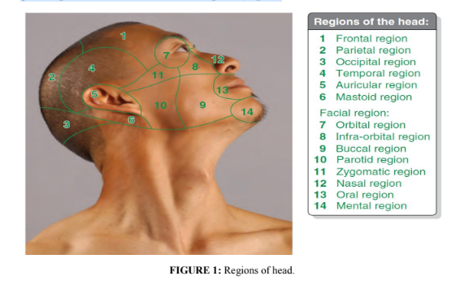

**Parotid Region**

The parotid region is the posterolateral part of the facial region (Fig. 2), bounded by the:

• Zygomatic arch superiorly.

• Angle and inferior border of the mandible inferiorly.

• Ramus of the mandible medially.

• Anterior border of the masseter muscle anteriorly.

• External ear and anterior border of the sternocleidomastoid muscle posteriorly.

**The parotid region** includes the parotid gland and duct, the parotid plexus of the facial

nerve (CN VII), the retromandibular vein, the external carotid artery, and the masseter

muscle. On the parotid sheath and within the gland are parotid lymph nodes. **The five**

**terminal branches of the facial nerve leave through the anterior border of the gland in**

**a radiating manner that resembles the foot of a goose. Hence, this pattern is known as “pes anserinus”.**

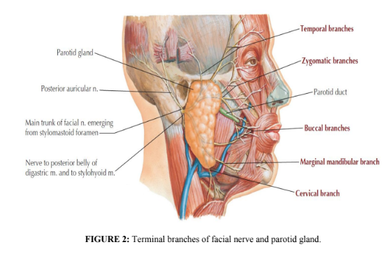

**Parotid Gland**

The parotid gland is the largest of three paired salivary glands and is composed mostly

of serous acini. It is enclosed within the parotid sheath, a tough unyielding capsule

derived from the deep cervical fascia. (Fig. 3). It lies in a deep hollow below the

external auditory meatus, behind the ramus of the mandible (Fig. 4), and in front of the

sternocleidomastoid muscle.

The parotid gland has an irregular shape; the apex is posterior to the angle of the

mandible, and its base is related to the zygomatic arch. The subcutaneous lateral

surface of the parotid gland is almost flat (Fig. 4).The facial nerve divides the gland

into superficial and deep lobes. Fatty tissue between the lobes confers the flexibility

the gland must have to accommodate the motion of the mandible.

**Parotid Duct**

The parotid (Stensen’s) duct passes horizontally from the anterior edge of the gland

(Figs. 2 & 4) and passes forward over the lateral surface of the masseter muscle about

one fingerbreadth below the zygomatic arch. It then turns medially, dives deeply into

the buccal fat-pad, **piercing the buccinator muscle and enters the vestibule of oral cavity**

**through a small orifice (papilla) opposite the second maxillary molar tooth (Fig**. 4).

The oblique passage of the duct in the buccinator muscle acts as a valve-like

mechanism & prevents inflation of the duct during blowing. The duct is about 2 in. (5

cm) long. It is represented by the middle 1/3rd of a line extending from the tragus of

the auricle to a point midway between the ala of nose & upper lip.

**Innervation of Parotid Gland and Related Structures**

Although the parotid plexus of the facial nerve (CN VII) is embedded within the parotid

gland, CN VII does not provide innervation to the gland. **The auriculotemporal and**

**great auricular nerves** provide sensory fibers to the gland and innervate the parotid

sheath (Fig. 3) as well as the overlying skin. The parasympathetic component of the

glossopharyngeal nerve (CN IX) supplies presynpatic secretory fibers to the otic

ganglion (Fig. 5). The postsynaptic parasympathetic fibers are conveyed from the

ganglion to the gland by the auriculotemporal nerve. Stimulation of the

parasympathetic fibers produces a thin, watery saliva. Sympathetic fibers are derived

from the cervical ganglia through the external carotid nerve plexus on the external

carotid artery (Fig. 3).

**Arterial Supply:**

External carotid artery & its terminal branches.

**Venous Drainage**

Into the retro-mandibular vein.

**Lymph Drainage**

Into the parotid & then into the deep cervical lymph nodes.

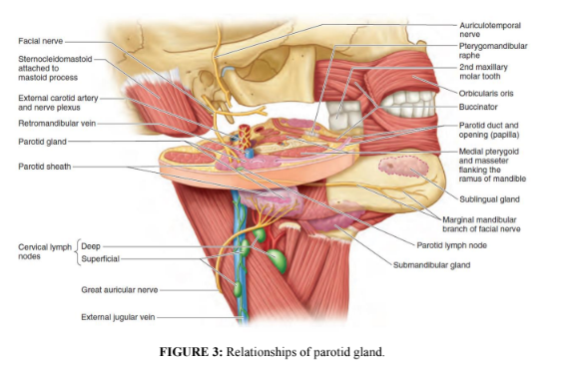

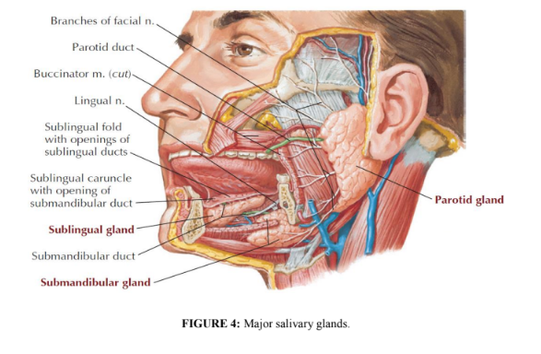

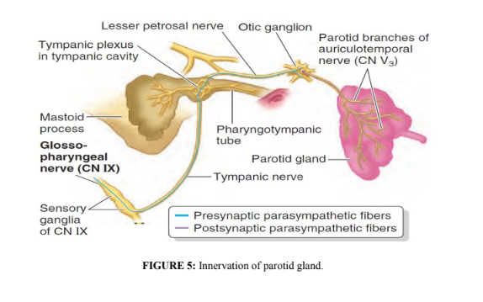

**The Buccal Pad of Fat**

Superficial to the buccinators (on either side of the face) are encapsulated collections

of fat; these buccal fat-pads are much larger in infants, to reinforce the cheeks and

keep them from collapsing during sucking. The blood supply to the buccal fat-pad

originates from the buccal and deep temporal branches of the maxillary artery, the

transverse facial branch of the superficial temporal artery, and branches of the facial

artery. This rich vascularity allows a reliable long axial flap and explains the rapid

surface re-epithelialization. The cheeks are innervated by buccal branches of the

mandibular nerve.

The buccal fat-pad’s primary function is thought to be related to chewing and suckling,

especially in infants. Another proposed function is as gliding pads that facilitate the

action of the muscles of mastication. The buccal fat pad may also function as a cushion

to protect sensitive facial muscles from injury due to muscle action or exterior force.

**Clinical Notes**

➢ Parotid Duct Injury

The parotid duct may be damaged in injuries to the face or may be inadvertently

cut during surgical operations on the face.

➢ Parotid Salivary Gland and Lesions of the Facial Nerve

The parotid salivary gland consists essentially of superficial and deep parts, and the

important facial nerve lies in the interval between these parts. A benign parotid

neoplasm rarely, if ever, causes facial palsy. A malignant tumor of the parotid is

usually highly invasive and quickly involves the facial nerve, causing unilateral

facial paralysis.

➢ Parotid Gland Infections

The parotid gland may become acutely inflamed as a result of retrograde bacterial

infection from the mouth via the parotid duct. The gland may also become infected

via the bloodstream, as in mumps. In both cases, the gland is swollen; it is painful

because the fascial capsule derived from the investing layer of deep cervical fascia

is strong and limits the swelling of the gland.

**➢ Frey’s Syndrome**

Frey’s syndrome is an interesting complication that sometimes develops after

penetrating wounds of the parotid gland. When the patient eats, beads of

perspiration appear on the skin covering the parotid. This condition is caused by

damage to the auriculotemporal and great auricular nerves. During the process

of healing, the parasympathetic secretomotor fibers in the auriculotemporal nerve

grow out and join the distal end of the great auricular nerve. Eventually, these fibers

reach the cutaneous sympathetic nerves that supply the sweat glands in the facial

skin. By this means, a stimulus intended for saliva production produces sweat

secretion instead.

References

1. Snell RS. Clinical Anatomy by Regions. 9th edition. Philadelphia, PA:

Lippincott Williams & Wilkins, 2012.

2. Keith LM: Clinically Oriented Anatomy, 7th edition. Wolters Kluwer, 2014.

1- one of the following statement is false the parotid region is bounded by the:

a. Zygomatic arch superiorly.

b. Ramus of the mandible medially.

c. Anterior border of the masseter muscle anteriorly.

d. orbit posteriorly.

2- The parotid region includes the following except:

a. the parotid gland

b. the parotid gland and duct.

c. the retromandibular vein.

d. optic nerve.

3.One of the following nerve has five terminal branches that leave that leave the parotid gland in radiating manner that resembles the foot of a goose:

a. trigeminal nerve.

b. optic nerve.

C . abducent nerve

d. fascial nerve.

4- Frey’s Syndrome :

a. develops after penetrating wounds of the parotid gland.

b. When the patient eats, beads of perspiration appear on the skin covering the parotid.

c. This condition is caused by damage to the auriculotemporal and great auricular nerves.

d.all of the above.

5- The Parotid Duct enters the vestibule of oral cavity through a small orifice (papilla) and opens opposite:

a. the second upper maxillary molar tooth.

b. first upper maxillary molar tooth.

c. the second lower molar tooth.

d.None of the above.