**Compression Index**

The **compression index (Cc)** is a soil parameter that quantifies the compressibility of a soil during primary consolidation under a load. It is determined from the slope of the void ratio (e) versus the logarithm of effective stress $(logσ)$ plot, commonly obtained from oedometer tests.

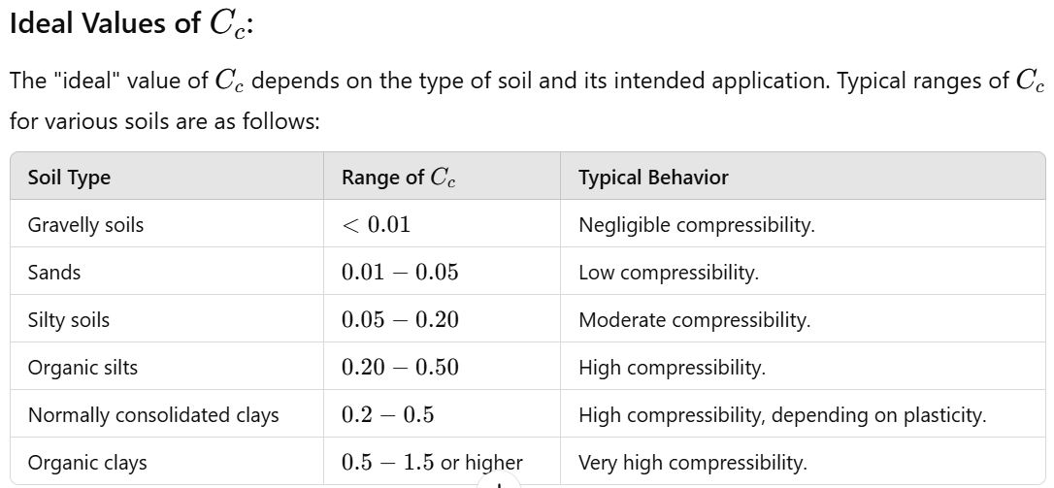

**Key Factors Affecting Cc​:**

1. **Soil Composition**:
   * **Clays and silts** have higher Cc​ due to higher compressibility.
   * **Sands and gravels** have lower Cc​ because of their dense particle packing.
2. **Soil Structure**: Loose, highly structured, or organic soils tend to have higher Cc​.
3. **Stress History**: Overconsolidated soils usually have lower Cc​ compared to normally consolidated soils.

**"Ideal" Cc​ for Design:**

The ideal value for a particular project depends on balancing compressibility with the required performance of the structure. For example:

* For **foundations**, low Cc​ soils (e.g., sands) are preferred to minimize settlement.
* For **landfills or embankments**, higher Cc​ values may be acceptable if settlements are anticipated and accounted for in the design.

In design, realistic and accurate values based on laboratory or field tests are critical, as overestimating or underestimating Cc can lead to costly issues such as excessive settlement or overly conservative designs.