**head & neck anatomy 2nd y**

**Pterygopalatine fossa**:

The pterygopalatine fossa is a cone-shaped depression , It is located between

the **maxilla, sphenoid and palatine bones,** and communicates with other regions of

the skull and facial skeleton via several canals and foramina.

**Boundaries :**

**Anterior**: Posterior wall of the maxilla.

**Posterior**: Pterygoid process of the sphenoid bone.

**Inferior**: Palatine bone. At the bottom of the fossa, the **pyramidal process of the palatine bone** articulates with the **lateral pterygoid plate** and **maxilla** and forming the narrow floor of the pterygopalatine fossa.

**Superior**: body of the sphenoid and the Inferior orbital fissure.

**Medial**: Perpendicular plate of the palatine bone

**Lateral**: Pterygomaxillary fissure Pterygopalatine fossa contain , **3rd part of maxillary artery, maxillary nerve and its branches and pterygopalatine ganglion.**

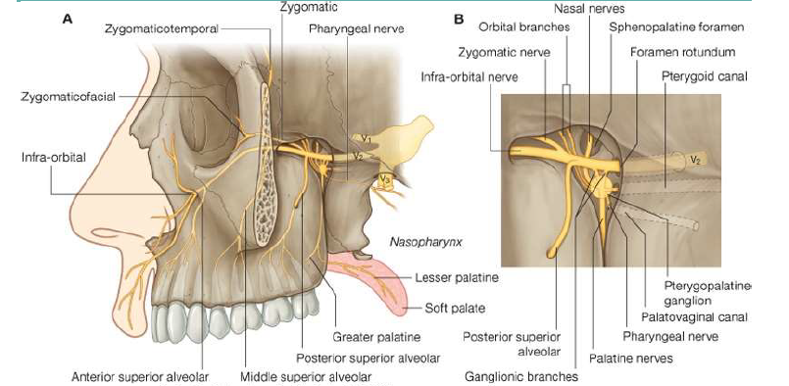

**Maxillary vessels**

The 3rd part of **maxillary artery** passes through the **pterygomaxillary fissure**,

enters the **pterygopalatine fossa** in front of the ganglion and gives off its branches.

Veins accompany the arteries and, passing through the fossa, emerge at the

pterygomaxillary fissure to drain into the **pterygoid plexus**.

**Maxillary nerve**

The maxillary nerve arises from the trigeminal ganglion in the middle cranial

fossa. It passes forward in the lateral wall of the cavernous sinus and leaves the skull

through the foramen rotundum and crosses the pterygopalatine fossa to enter the

orbit through the inferior orbital fissure. It then continues as the infraorbital nerve in

the infraorbital groove, and it emerges on the face through the infraorbital foramen.

**Direct branches of maxillary nerve**

1. **meningeal branch** [dural branch or middle meningeal nerve] to the middle

cranial fossa.

2. **Ganglionic branches**, which are two short nerves that suspend the

pterygopalatine ganglion in the pterygopalatine fossa.

3. **zygomatic nerve** arises from the maxillary nerve in the **fossa** and runs through

the **inferior orbital fissure** to enter the orbit, which divides into the

**zygomaticotemporal and the zygomaticofacial** nerves that supply the skin of

the face. The **zygomaticotemporal** branch gives parasympathetic secretomotor

fibers [communicating brach] to the **lacrimal gland** via the **lacrimal nerve**.

4. The **posterior superior alveolar nerve** is also given off in the fossa. It passes

through the pterygomaxillary fissure on to the posterior wall of the maxilla.

which supplies the maxillary sinus as well as the upper molar teeth and

adjoining parts of the gum and the cheek'

5. **infraorbital nerve** passing through inferior orbital fissure to become in the

floor of the orbit running in the infraorbital groove and give here the middle

superior alveolar nerve, and anterior superior alveolar in the infraorbital canal.

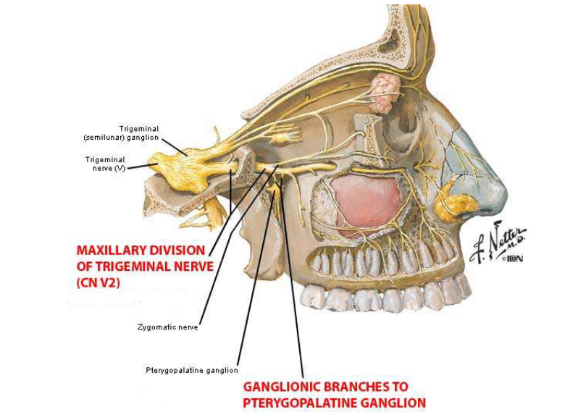

**Pterygopalatine Ganglion**

The ganglion lies immediately in front of the opening of the pterygoid canal and

the nerve of that canal runs straight into the back of the ganglion. The ganglion sits

deep within the pterygopalatine fossa near the sphenopalatine foramen. It is the **largest**

**parasympathetic ganglion** related to branches of the maxillary nerve (via

pterygopalatine branches). The autonomic root is the **nerve of the pterygoid canal**

(Vidian nerve). This nerve is formed in the foramen **lacerum** by union of the ***greaterpetrosal nerve***, containing mainly **parasympathetic secretomotor fibers**, with the

***deep petrosal*** *nerve*, containing **postganglionic sympathetic fibers from the superior**

**cervical ganglion**. The former is a branch of the **facial nerve** and the latter is a branch

from the **internal carotid sympathetic plexus**. The combined nerve passes forward in

the **pterygoid canal** and joins the **ganglion**.

Postganglionic parasympathetic fibers leave the ganglion and distribute with

branches of the maxillary nerve. These fibers are **secretomotor** in function, and

provide **parasympathetic innervation** to the **1/lacrimal gland, and muscosal glands of**

**the 2/palate, 3/nose 4 / paranasal sinuses and 5/nasopharynx.** It is the ganglion of hay

fever (‘running nose and eyes’).

The postganglionic secretomotor fibers to the lacrimal gland leave the ganglion

and join the maxillary nerve, pass in its zygomatic branch into the orbit, join the

lacrimal branch of the ophthalmic nerve and so reach the lacrimal gland.

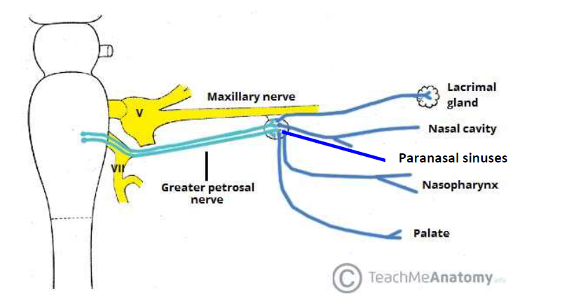

The rest of the fibers in the connections between the maxillary nerve and the

ganglion are sensory and, like the sympathetic fibers in the deep petrosal nerve, they

pass through the ganglion without relay.

The only cell bodies in the ganglion are parasympathetic (secretomotor). The

branches of the pterygopalatine ganglion are distributed to the nose, palate and

nasopharynx. Every branch carries a mixture of all **three kinds of fibers: sensory,**

**secretomotor and sympathetic.**

**Indirect branches of maxillary nerve :** which are distributed through the

branches of pterygopalatine ganglion.

**1/ Medial posterior superior nasal nerves** pass through the **sphenopalatine**

**foramen**, cross the **roof of the nose**, and are distributed to the **septum**. The largest

of these is termed the **nasopalatine nerve [long sphenopalatine]**, as it continues

beyond the septum through the **incisive canal** to supply the anterior part of the hard

palate.

**2/The lateral posterior superior nasal nerves [short sphenopalatine]** pass

through the **sphenopalatine foramen** and turn forward to supply the

posterosuperior part of the lateral wall of the nose.

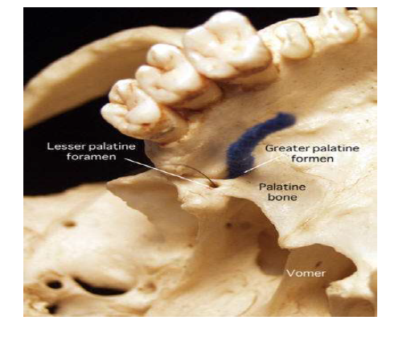

**3/The greater palatine nerve** passes down through the greater palatine canal,

between the perpendicular plate of the palatine bone and the maxilla. At the greater

palatine foramen it turns forward to supply the mucous membrane of the hard

palate. As it descends it also supplies **the posteroinferior** part of the lateral wall of

the nose and the medial wall of the maxillary sinus.

**4/The lesser palatine nerves**, two in number, pass down behind the greater

palatine nerve and emerge through the **lesser palatine foramen**. They pass back to

the **soft palate** and the **mucous membrane of the palatine tonsil**. They carry the only

special sensory fibers transmitted in the **greater petrosal nerve**; these are **sensory**

**(taste) fibers** that have their cell bodies in the **genicular ganglion** of the **facial nerve**.

**5/The pharyngeal nerve** passes back through the **palatovaginal** canal (a little

canal between the **vaginal process of the medial pterygoid plate** and the **sphenoidal**

**process of the palatine bone**) and supplies the mucous membrane of the

**nasopharynx.**

**6/**A few fine **orbital branches** enter the orbit via the **inferior orbital fissure** and

supply **periosteum of the orbital floor and the mucous membrane of the sphenoidal**

**and ethmoidal sinuses.**

**Openings**

There are seven openings that connect the pterygopalatine fossa with the orbit, nasal

and oral cavities, middle cranial fossa and infratemporal fossa. The openings

transmit blood vessels and nerves between these regions.

**1/Pterygomaxillary Fissure**

The pterygomaxillary fissure connects the **infratemporal fossa** with the **pterygopalatine**

**fossa** . It transmits two neurovascular structures:

• **Posterior superior alveolar nerve** – a branch of the maxillary nerve. It exits through

the fissure into the infratemporal fossa, where it goes on to supply the maxillary

molars.

• **3rd part of the maxillary artery** – enters the pterygopalatine fossa via the fissure.

**2/Foramen Rotundum**

The foramen rotundum connects the pterygopalatine fossa to the **middle cranial fossa**.

It conducts a single structure, the **maxillary nerve.**

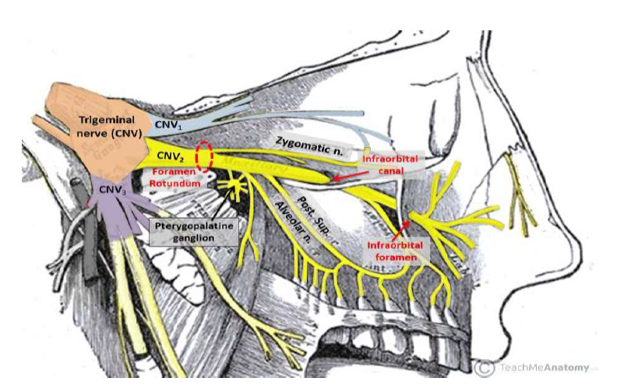

**3/Pterygoid canal:** runs from the **middle cranial fossa** [anterior wall of foramen

lacerum] and through the medial pterygoid plate. It carries the **nerve, artery and**

**vein of the pterygoid canal.**

**4/Pharyngeal Canals [palatovaginal canal]:** communicates with the

**nasopharynx**. It carries the **pharyngeal branches of the maxillary nerve , artery and**

**vein.**

**These two canals**, with the **foramen rotundum**, are the three openings **in the posterior wall of the pterygopalatine fossa**

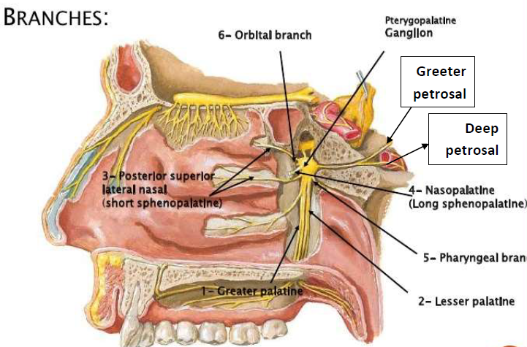

**5/Inferior Orbital Fissure**

The inferior orbital fissure forms the **superior boundary of the pterygopalatine**

fossa and communicates with the **orbit**. It is a space between the **sphenoid and maxilla**

**bones.**

*The **zygomatic branch** of the maxillary nerve

*The **infraorbital nerve, artery and vein** pass through the inferior orbital fissure

*The **inferior ophthalmic vein** communicate with **pterygoid venus pluxes** through this fissure.

*The **orbital branches** from pterygoid ganglion .

**6/Greater Palatine Canal**

The perpendicular plate of palatine bone articulates anteriorly with the maxilla

and between the two lies the **greater palatine canal** which opens below at a foramen

on the hard palate.The greater palatine canal lies in the floor **of the pterygopalatine**

**fossa**, and communicates with the **oral cavity**. Branching from the greater palatine canal

are the **lesser palatine canals**. The greater palatine canal transmits the **descending**

**palatine artery and vein**, the **greater palatine nerve** and the **lesser palatine nerve**.

**7/Sphenopalatine Foramen**

This foramen is the only opening in the medial boundary. It connects the

pterygopalatine fossa to the **nasal cavity**. It is formed by the **sphenopalatine notch** at

the superior aspect of the **perpendicular plate of the palatine bone [orbital process**

**anteriorly and sphenoidal process posteriorly]and the body of the sphenoid**.

The sphenopalatine foramen transmits the **sphenopalatine artery and vein**, as well as

the **nasopalatine nerve** (a large branch of the pterygopalatine ganglion), with other

branches mentioned above.