GENERL ANTOMY LEC. 7

**م.د علي سلمان جاسم**

**Temporal region)the temple)**

-**1Temporal fossa**

The temporal fossa is the region on the side of the head above the external ear canal, which is covered by the temporalis muscle. The side of the head anterior and superior to the ear is commonly called the temple. The skin, fascia, and portions of the extrinsic muscles of the ear in this region overlie the deeper fan-shaped temporalis muscle that attached to the bones of the temporal fossa. Superiorly, this fossa is bounded by the superior temporal line, whereas its inferior boundary is the zygomatic arch, even though the temporalis muscle extends inferiorly below this arch into the infratemporal fossa.

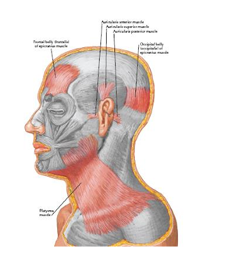

**The floor of the temporal fossa is formed by the bones of the side of the head that is portions of the frontal, sphenoid, temporal, and parietal bones.** The inferior and superior temporal lines begin at the Zygomatic process of the frontal bone and arch posteriorly over the parietal bone before descending to the temporal bone and blending into the zygomatic process of temporal bone. The tough fascia covers the temporalis muscle is called temporalis fascia attaching superiorly to the superior temporal line. Inferiorly, the fascia splits into two layers, which attach to the lateral and medial surfaces of the zygomatic arch. The temporal fascia also tethers the zygomatic arch superiorly.

When the powerful masseter muscle, which is attached to the inferior border of the arch, contracts and exerts a strong downward pull on the zygomatic arch, the temporal fascia provides resistance.

**Boundaries:** a. Posterosuperiorly: superior temporal line b. Inferiorly: infratemporal crest c. Anteriorly: frontal process of zygomatic bone d. Laterally: zygomatic arch e. **Floor: formed by 4 bones: frontal, parietal, temporal, and sphenoid forming (pterion)** which is thinnest part of the lateral wall of the skull where the anteroinferior corner of the parietal bone articulates with the greater wing of the sphenoid. **Clinically, the pterion is an important area because it overlies the anterior division of the middle meningeal artery and vein.**

**Contents:** temporalis muscle, deep temporal nerves and vessels, auriculotemporal nerve, superficial temporal vessels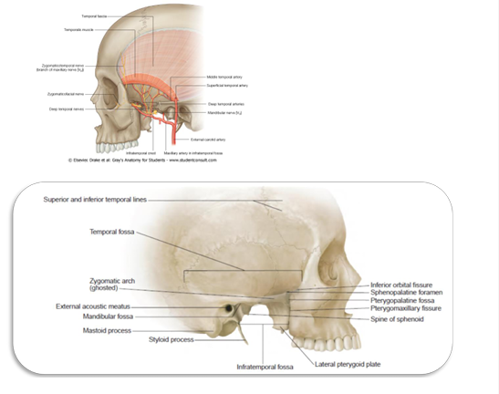

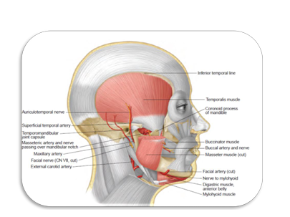

-2INFRATEMPORAL FOSSA

Learning objectives:

• At the end of the lecture the student should be able to know:

• Infratemporal fossa

• Boundaries of infratemporal fossa.

• Contents of infratemporal fossa.

Infratemporal fossa

An irregularly shaped cavity behind the maxilla, situated below and medial to the zygomatic arch. Infratemporal fossa lies below the infratemporal crest on the greater wing of the sphenoid.

**Boundaries:**

▪ Medially: lateral pterygoid plate of sphenoid bone.

▪ Laterally: The ramus of the mandible.

▪ Anteriorly: The posterior surface of the maxilla.

▪ Posteriorly: The styloid process of the temporal bone .

▪ Superior: Greater wing of the sphenoid below the infratemporal crest, and by the under surface of the temporal squama.

▪ Floor is formed by the Medial pterygoid muscle.

Communications:

• At the anterior end of the medial wall “in front of the pterygoid process” the pterygomaxillary fissure communicates it with the pterygo-palatine fossa.

• At the upper end of the anterior wall “above the maxilla” the inferior orbital fissure communicates it with the orbit.

• At the lateral end of the anterior wall the space between the maxilla medially and the ramus of the mandible laterally communicates with the buccal space above and the sublingual space below.

• At the lateral end of the roof ‘the space between the infratemporal crest medially and the zygomatic arch laterally” communicates it with the temporal fossa.

• At the roof the foramen ovale and foramen spinosum communicate it with the middle cranial fossa.

• The posterior boundary is continuous with the post-styloid compartment of the parapharyngeal space containing the styloid apparatus and the carotid sheath.

**Contents:**

a- **Muscles:**

1. Lower part of temporalis.

2. Lateral and medial pterygoid.

b- **Vessel:** Maxillary artery originating from the external carotid artery and its branches.

c- Veins: Pterygoid venous plexus.

d- **Nerves:**

1. Mandibular nerve.

2. – Inferior alveolar nerve

3. – Lingual nerve

4. – Buccal nerve

5. Chorda tympani nerve.

6. – Otic ganglion.

General arrangement of the structures in the fossa:

From superficial “lateral” to deep “medial’:

1. Ramus of the mandible.

2. Lateral pterygoid muscle above with the buccal branch of the mandibular nerve and maxillary artery emerging between its two heads, the lingual and inferior alveolar branches of the mandibular nerve lower down on the surface of the medial pterygoid muscle.

3. Deep to the lateral pterygoid muscle the mandibular nerve gives the two roots of the auriculotemporal nerve which pass backwards then unite together to form the nerve that winds medial then posterior to the neck of the mandible to reach the superior pole of the parotid gland.

4. Otic ganglion between the mandibular nerve and the tensor palate muscle.

5. Pterygoid plexus of veins are on either side and inside the lateral pterygoid muscle.

6. Maxillary artery enters the fossa between the necks of the mandible laterally and the sphenomandibular ligament medially with the auriculotemporal nerve above, then the artery passes forwards at the lower edge of the lateral pterygoid muscle then dips between its two heads to enter the pterygo-maxillary fissure. The artery has a variable relation to the lower head of the muscle; either deep or superficial.

The end