 

**Electromagnetic waves**

**Lecture 9**

**Coordinate System and Application**

**Ammar karem**

**Tow stage**

**Department of medical physics**

**Al-Mustaqbal University-College**

## Vector Analysis and Vector Algebra

* 1. **Vector** is a quantity having both magnitude and direction such as displacement, velocity, force and acceleration.

Example1

Write the vector for each of the following: a. of the vector (1, −3, −5) to( 2, −7,0).

b . of the vector (2, −7,0) to) 1, −3, −5). c .The location vector to (4,90.(− .) solution

a〈−1,4, −5〉 b〈1, −4,5〉

The two vectors in a and b are different in sign only, and this shows that they have the same magnitude, but they are opposite

direction.

c〈−90,4〉

## Vector Algebra

Laws of vector algebra. If A, B and C are vectors and m and n are scalars, then

1. A+ B = B + A Commutative Law for Addition
2. A+ (B+C) = (A+B) + C Associative Law for Addition
3. mA = Am Commutative Law for Multiplication
4. m (nA) = (mn) A Associative Law for Multiplication
5. (m+ n) A = mA + nA Distributive Law
6. m (A+ B) = mA + mB Distributive Law

## Example:

Let us take A = 10 and B = 5 10 + 5 = 5 + 10

15 = 15

## Example:

Prove:- (3+7) = (-3)+(-7)

## Proof:

-(10) = -3-7

-10 = -10

L.H.S = R.H.S

## Example:

Let us take A = 2, B = 4 and C = 6 L.H.S =A+(B+C) = 2 + (4 + 6)

= 12

R.H.S = (A+B)+C = (2 + 4) + 6

=12

L.H.S = R.H.S 12 = 12

## Example:

Let us take A = 2, B = 3 and C = 5 L.H.S =A × (B + C)= 2 × (3+5)

= 2 × 8

= 16

R.H.S = A × B + A × C = 2 × 3 + 2 × 5

=6+ 10

=16

L.H.S = R.H.S 16 = 16 Example A=4,m=5

mA = Am 5x4=4x5

20=20

## Example

A=5

m=3 n=2

m (nA) = (mn) A

3(2x5)=(3x2)5

3x10=6x5

30=30

# Scalar product

The process of multiplying a vector quantity by another vector quantity, the product of which is a non-vector scalar quantity, which has only an amount..



## The following laws are valid:

1. A . B = B . A Commutative Law for Dot Products
2. A . (B + C) = A . B + A . C Distributive Law
3. m(A . B) = (mA) . B = A . (mB) = (A . B)m, where m is a scalar.

4. i . i = j . j = k . k = 1, i . j = j . k = k . i = 0

1. If A = Al i + A2 j + A3 k and B = Bl i + B2 j + B3 k, then

A . B = A1B1+A2 B2+A3 B3

A . A = A2 = A1 2 + A2 2 + A3 2 B . B = B 2 = B1 2 + B2 2 + B3 2

1. If A . B = 0 and A and B are not null vectors, then A and B are perpendicular.

**Example:** Find the scalar product of the vectors a = 2i + 3j - 6k and b = i + 9k.

**Solution:** To find the scalar product of the given vectors a and b, we will multiply their corresponding components.

a.b = (2i + 3j - 6k).(i + 0j + 9k)

= 2.1 + 3.0 + (-6).9

= 2 + 3 - 54

= -49

**Example:** Calculate the scalar product of vectors a and b when the modulus of a is 9, modulus of b is 7 and the angle between the two vectors is 60°.

**Solution:** To determine the scalar product of vectors a and b, we will use the scalar product formula.

a.b = |a| |b| cosθ

= 9 × 7 cos 60°

= 63 × 1/2

= 31.5

**Example 1:** Find the angle between the two vectors 2i + 3j + k, and 5i -2j + 3k.

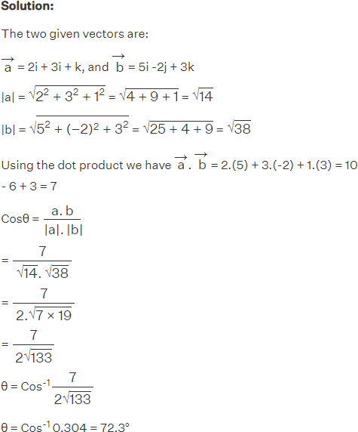

# Vector products

The process of multiplying a vector quantity by another vector quantity, the product of which is a vector quantity with magnitude and direction.



## Cross or vector product

**1-4-1 The following laws are valid:**

1. A × B = - B × A Commutative Law for Cross Products Fails
2. A × (B + C) = A × B + A × C Distributive Law
3. m(A × B) = (mA) × B = A × (mB) = (A × B)m , where m is a scalar.

4. i × i = j × j = k × k = 0, i × j = −j × i = k,

j × k = −k × j = i, k × i = −i × k = j.

1. If A = Al i + A2 j + A3 k and B = Bl i + B2 j + B3 k, then
2. The magnitude of A × B is the same as the area of a parallelogram with sides A and B.
3. If A × B = 0 and A and B are not null vectors, then A and B are parallel.

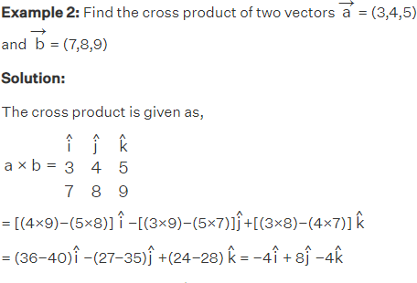

**Example:** Two vectors have their scalar magnitude as

∣a∣=2√3 and ∣b∣ = 4, while the angle between the two vectors is 60∘.

Calculate the cross product of two vectors.

