**Medical physics Department**

**Radiation physics lab.**

**first stage**

**By**

**Dr. Duaa Jafer Dheaa**

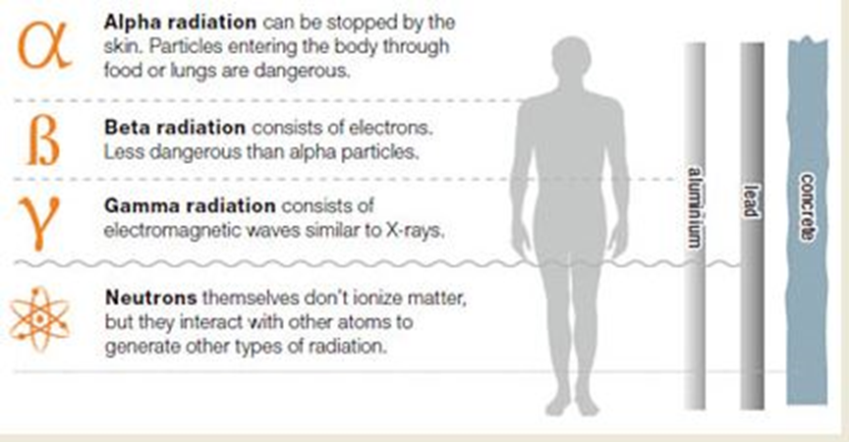

**Experiment (1)**

**X-Ray Production**

**Basic requirement of X-ray production**

a) X-rays are produced when energetic electrons interact with target and convert their kinetic energy into electromagnetic radiation (x-rays).

b) This task can be accomplished in a device called x-ray tube where an electron source (cathode), a target (anode).

c) A source of energy is required to accelerate the electrons.

**1. X-ray tube**

* X–ray tube is composed of a cathode and an anode located within an X- ray tube.
* The glass of the tube prevents (the generated X – ray) from leaving in all directions.
* The window allows that X – ray emit out.
* Electrons to be released from the filament through thermionic emission.
* The electrons are attracted towards the positively charged anode and hit the tungsten target with a maximum energy.
* In an X- ray tube the heated material is known as the filament, which is similar to the filament in a light bulb.
* In a light bulb the filament is heated by passing electrical current through it.

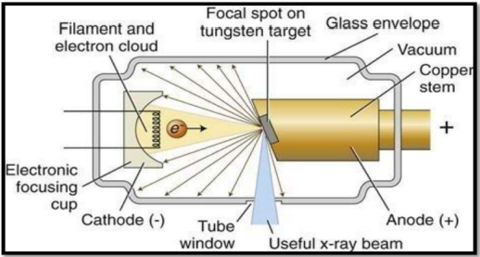

Figure (1): Schematics of an X-ray tube: the electrons are emitted from the cathode and collected at the anode releasing X-ray radiation

* **Anode**

A positive electrode (anode) which incorporates a target, usually of tungsten. The anode is the component in which the x-radiation is produced. It is a relatively large piece of metal that connects to the positive side of the electrical circuit.

Anode has two primary functions:

1. Convert electronic energy into x-radiation

2. Dissipate the heat created in the process

The fraction of the total electronic energy that is converted into x-radiation

(Efficiency) depends on two factors: the atomic number (Z) of the anode material and the energy of the electrons. Most x-ray tubes use tungsten, which has an atomic number of 74, as the anode material. In addition to a high atomic number, tungsten has several other characteristics that make it suited for this purpose. Tungsten is characterized by its ability to maintain its strength at high temperatures, and it has a high melting point and a relatively low rate of evaporation.

Most x-ray tubes used for mammography have molybdenum-surface anodes. This material has an intermediate atomic number (Z = 42), which produces characteristic x-ray photons with energies well suited to this particular application. Some mammography tubes also have a second anode made of rhodium, which has an atomic number of 45. This produces a higher energy and more penetrating radiation, which can be used to image dense breast.

* Cathode

A negative electrode (cathode) which incorporates a filament. The basic function of the cathode is to expel the electrons from the electrical circuit and focus them into a well-defined beam aimed at the anode. The typical cathode consists of small coil of wire (a filament) recessed within a cup-shaped region, as shown below.

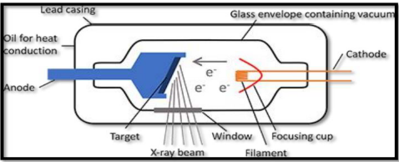

Figure (2): Shows the typical cathode consists of a small coil of wire (filament) recessed within a cup-shaped region

In a process known as thermionic emission, thermal energy (or heat) is used to expel the electrons from the cathode. The filament of the cathode is heated in the same way as a light bulb filament by passing a current through it. This heating current is not the same as the current flowing through the x-ray tube (the MA) that produces the x-radiation. During tube operation, the cathode is heated to a glowing temperature, and the heat energy expels some of the electrons from the cathode.

The high-voltage source is typically of the order of 10 3 to 10 6 volts. The filament

(Cathode) is heated and emits electrons by the process of thermionic emission. At such high temperatures (2200°C) the atomic and electronic motion in a metal is sufficiently to enable a fraction of the free electrons to leave the surface. These electrons are then repelled by the negative cathode and attracted by the positive anode. The electrons are accelerated by the high voltage source toward the target (anode). Because of the vacuum, they are not hindered in any way, and bombard the target with a velocity around half the speed of light.

**2. X-ray production at the anode**

The electrons hit the anode with a maximum kinetic energy and interact with the

Anode by losing energy via:

1- Elastic interaction: only happens if the kinetic energy of electron < 10 eV. Electrons interact but conserve all their energy.

2- Inelastic interaction: causes excitation/ionization in atoms and releases energy via electromagnetic (EM) radiation and thermal energy.

At the anode, electrons can interact with the atoms of the anode in several ways to produce x-ray photons.

Inner shell interaction: produces characteristic radiation.

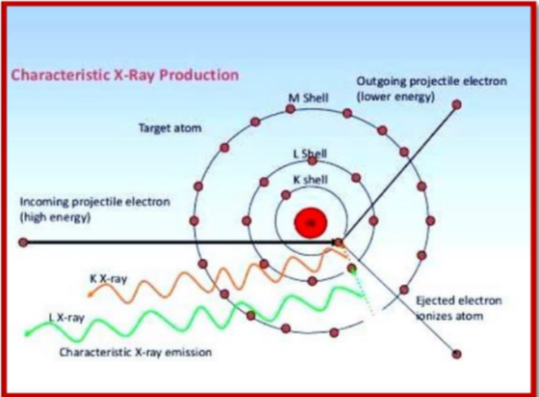

Figure (3): characteristic x-ray emission