Alcohols

structure of alcohols, nomenclature, classification

**Structure and classification of alcohols**

Similar to water, an alcohol can be pictured as having an *sp*3 hybridized tetrahedral oxygen atom with nonbonding pairs of [electrons](https://www.britannica.com/science/electron) occupying two of the four *sp*3 hybrid orbitals. (*See* chemical bonding for a discussion of hybrid orbitals.) Alkyl groups are generally bulkier than [hydrogen](https://www.britannica.com/science/hydrogen) atoms, however, so the R―O―H [bond angle](https://www.britannica.com/science/bond-angle) in alcohols is generally larger than the 104.5° H―O―H bond angle in water. For example, the 108.9° bond angle in methanol shows the effect of the [methyl group](https://www.britannica.com/science/methyl-group), which is larger than the hydrogen atom of water.

One way of classifying alcohols is based on which [carbon](https://www.britannica.com/science/carbon-chemical-element) atom is bonded to the [hydroxyl group](https://www.britannica.com/science/hydroxyl-group). If this carbon is primary (1°, bonded to only one other carbon atom), the [compound](https://www.merriam-webster.com/dictionary/compound) is a [primary alcohol](https://www.britannica.com/science/primary-alcohol). A [secondary alcohol](https://www.britannica.com/science/secondary-alcohol) has the hydroxyl group on a secondary (2°) carbon atom, which is bonded to two other carbon atoms. Similarly, a tertiary alcohol has the hydroxyl group on a tertiary (3°) carbon atom, which is bonded to three other carbons. Alcohols are referred to as allylic or benzylic if the hydroxyl group is bonded to an allylic carbon atom (adjacent to a C=C double bond) or a benzylic carbon atom (next to a [benzene](https://www.britannica.com/science/benzene) ring), respectively.

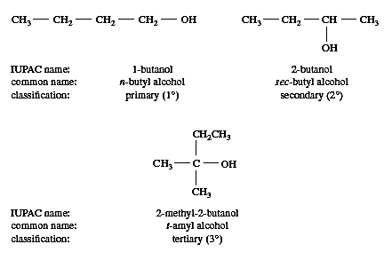

[**Nomenclature**](https://www.britannica.com/science/nomenclature)

As with other types of organic [compounds](https://www.merriam-webster.com/dictionary/compounds), alcohols are named by both formal and common systems. The most generally applicable system is that adopted at a meeting of the [International Union of Pure and Applied Chemistry](https://www.britannica.com/topic/International-Union-of-Pure-and-Applied-Chemistry) (IUPAC) in Paris in 1957. Using the IUPAC system, the name for an alcohol uses the -ol suffix with the name of the parent [alkane](https://www.britannica.com/science/paraffin-hydrocarbon), together with a number to give the location of the hydroxyl group. The rules are summarized in a three-step procedure:

1. Name the longest carbon chain that contains the carbon atom bearing the ―OH group. Drop the final -e from the alkane name, and add the suffix -ol.
2. Number the longest carbon chain starting at the end nearest the ―OH group, and use the [appropriate](https://www.britannica.com/dictionary/appropriate) number, if necessary, to indicate the position of the ―OH group.
3. Name the substituents, and give their numbers as for an alkane or [alkene](https://www.britannica.com/science/olefin).

The first example below has a longest chain of six carbon atoms, so the root name is hexanol. The ―OH group is on the third carbon atom, which is indicated by the name 3-hexanol. There is a methyl group on carbon 3 and a chlorine atom on carbon 2. The complete IUPAC name is 2-chloro-3-methyl-3-hexanol. The prefix cyclo- is used for alcohols with cyclic alkyl groups. The hydroxyl group is assumed to be on carbon 1, and the ring is numbered in the direction to give the lowest possible numbers to the other substituents, as in, for example, 2,2-dimethylcyclopentanol.