Dienes: preparation, reactions

**Preparation of dienes:-**

1. Retro-diels Alder reaction (pyrolysis of cycloalkene) : when cyclohexene vapours is passed over heated nichrome alloy then 1,3-Butadiene is produced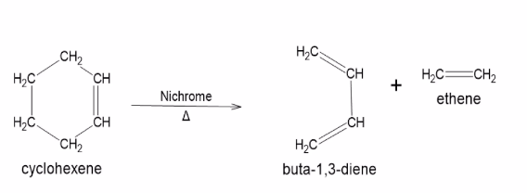

2. Catalytic hydrogenation : 1,3-Butadiene is prepared by catalytic hydrogenation of n-butane, 1-butene or 2-butene

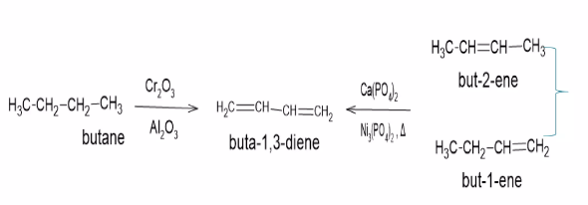

-3 Dehydrogenation of butane-1,3-diol :

acid catalysed dehydration of butane-1,3-diol gives 1,3-butadiene.

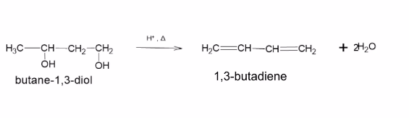

4. Dehydrohalogenation of 1,3-dichlorobutanes : when 1,3-dichloro-3-methylbutane is reacted with alcoholic KOH then isoprene (2-methylbuta-1,3-diene) is formed

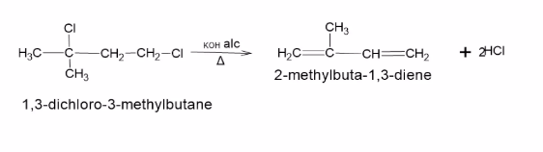

**Chemical reactions of dienes:-**

Some important chemical reactions of dienes are as follows:

1. Electrophilic addition to dienes:

a) Addition of Halogens:

When 1,3-Butadiene is treated with 1 mole of bromine it gives a mixture of 1,2 and 1,4- addition pr

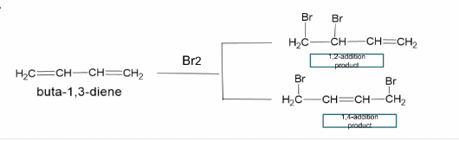

McS. ISSA. FARHAN