



**Ministry of Higher Education and Scientific Research**

**Al-Mustaqbal University**

**College Of Engineering & Technology**

**Computer Techniques Engineering Department**

**2023 -2024**

**Computer Networks Fundamentals**

**Lecture 4:**

**Transmission Modes**

**4.1- Transmission Modes**

The term transmission mode is used to define the direction of signal flow between two linked devices. There are *three* types of transmission modes:

* ***Simplex.***
* ***Half duplex.***
* ***Full duplex***

***Simplex***

In, simplex mode, the communication is unidirectional, as on a one-way street. Only one of the two stations on a link can transmit the other can only receive (see Figure below).



Server Link Workstation

Keyboards and traditional monitors are both examples of simplex devices. The keyboard can only introduce input; the monitor can only accept output.

***Half-Duplex***

In half-duplex mode, each station can both transmit and receive, but not at the same time When one device is sending, the other can only receive, and vice versa (see Figure below).



Server Link Workstation

The half-duplex mode is like a one-lane road with two-directional traffic. In a half-duplex transmission, the entire capacity of a channel is taken over by whichever of the two devices is transmitting at the time. Walkie-talkies are half-duplex systems.

***Full-Duplex***

In full-duplex mode (also called duplex), both stations can transmit and receive simultaneously (see Figure below).



Server Link Workstation

The full-duplex mode is like a two-way street with traffic flow in both directions at the same time. In full-duplex mode, signals going in either direction share the capacity of the link.

This sharing can occur in two ways: either the link must contain two physically separate transmission paths, one for sending or the other for receiving; or, the capacity of the channel is divided between signals traveling in opposite directions.

**4.2- Categories of Networks**

The category of a network can be determined

* According to its size.
* According to its physical architecture (center of control).
* According to transmission technology.
* According to its ownership.
* According to service providing.

1. ***According to the size:***

We are generally referring to three primary categories:

* ***Local area networks (LANs).***
* ***Metropolitan area networks (MANs).***
* ***Wide area networks (WANs).***
* **Local Area Network (LAN)**
* A local area network is usually privately owned and links the devices in a single office building, or campus. Depending on the needs of an organization and the type of technology used. A LAN can be as simple as two PCs and a printer in someone's home office or it can extend throughout a company and include voice, sound, and video peripherals. Currently, LAN size ***is limited to a few Kilometers.***
* LANs are designed to ***allow resources to be shared between personal computers or workstations***. The resources to be shared can include hardware (e.g., a printer), software (e.g., an application program), or data. A common example of a LAN, found in many business environments, links a work group of task-related computers, for example, engineering workstations or accounting PCs. One of the computers may be given a large-capacity disk drive and become a server to the other clients. Software can be stored on this central server and used as needed by the whole group In this example the size of the LAN may be determined by licensing restrictions on the number of users per copy of software, or by restrictions on the number of users licensed to access the operating system.
* In addition to size, LANs are distinguished from other types of networks by their ***transmission media and topology***. In general, a given LAN will use only one type of transmission medium. The most common LAN topologies are bus, ring, and star.
* Traditionally, LANs have data rates in the 4 to 16 Mbps range. Today, however, speeds are increasing and can reach 1Gbp***s*** or even ten's of Gigabits per seconds.
* **Metropolitan Area Network (MAN)**

A metropolitan area network is designed to ***extend over*** an entire city. It may be a single network such as a cable television network or it may be a means of connecting a number of LANs into a larger network so that resources may be shared LAN-to-LAN as well as device-to-device.

For example, a company can use a MAN to connect the LANs in all of its offices throughout a city (see Figure below).

A MAN may be wholly owned and operated by a private company, or it may be a service provided by a public company, such as a local telephone company. Many telephone companies provide a popular MAN service called Switched Multi-megabit Data Services (SMDS)

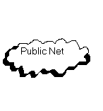

Terminator

Terminator

Tap

Tap

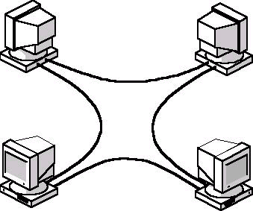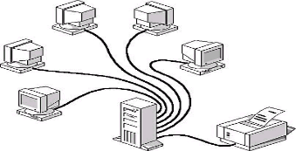

* **Wide Area Network (WAN)**

A wide area network provides ***long-distance*** transmission of data; voice, image, and video information over large geographical areas that may comprise a country, a continent, or even the whole world. In contrast to LANs (which depend on their own hardware for transmission), WANs may utilize public, leased, or private communication devices, usually in combinations, and can therefore span an unlimited number of miles. A WAN that is wholly owned and used by a single company is often referred to as an *enterprise network*.

1. ***According to the physical architecture (center of control)***

* **Centralized Networks**

A central computer "Mini computer or Mainframe" that manages all

communication and requests in the network.

* **Distributed Network**

A group of Personal Computers (PC's) works together and share the same

input / output devices.

* **Hybrid Network**

A combination of centralized and distributed networks

1. ***According to the ownership***

* **Public Network**

On a network that is owned, managed, and operated by a public company.

* **Private Network**

Owned and managed by a private organization

1. ***According to transmission technology***

* **Broadcasting Network**

It does not restrict or determine a specified destination. It has a single communication channel that is shared by all themachines on the network. Short messages, called packets sent by anymachine are received by all the others. Broadcast systems generallyalso allow the possibility of addressing a packet to all destinations byusing a special code in the address field.

* **Point to Point Network**

Data or packets are sent to a specify destination which is able to reflect an

each of the receiving.

1. ***According to service providing***

* **Peer to Peer Network**

Any PC connected to this network can provide services to any other PC and

request for services from any.

* **Client/Server Network**

The most popular network. The net depends on a PC acts as a service provider

called the SERVER. The server restricts the same policy to control the

determination of the client how will get the service and type of service.