**Aromatic Compounds**

Benzene has a high degree of unsaturation but is unreactive.It does not undergo the usual addition reactions of alkenes and alkynes. It does react under more vigorous conditions(heat or catalysts) to form products of substitution. This difference in chemical reactivity is due to the structure of benzene.

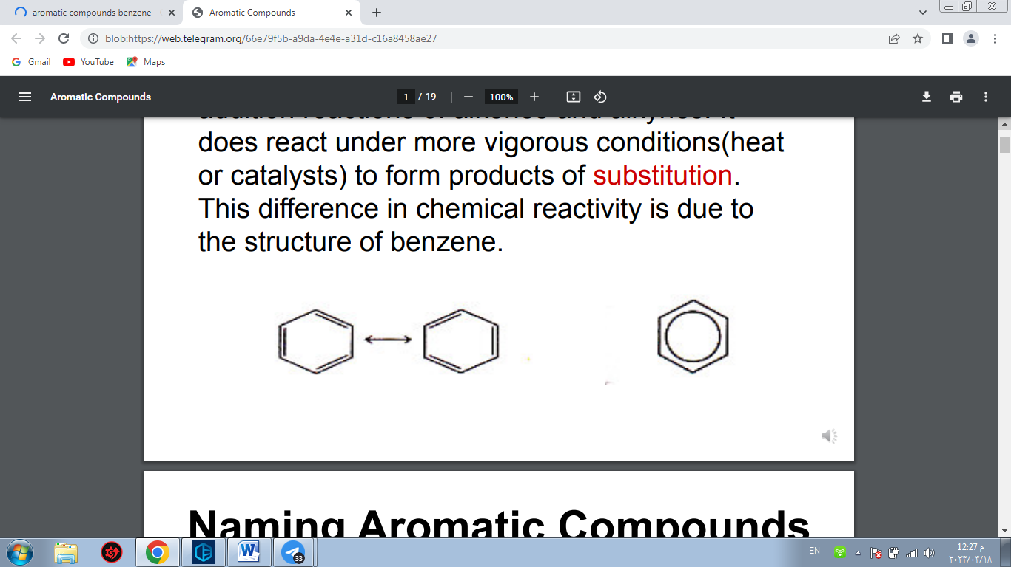

**Naming Aromatic Compounds**

When one group is attached to benzene, the compound is named by placing the name of the group as prefix to the benzene.

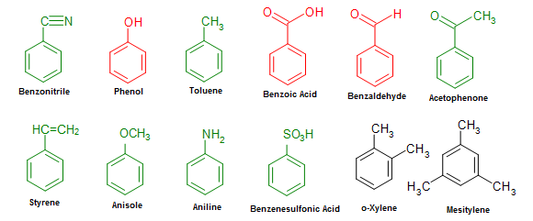

If two groups are attached to the benzene ring, the name must not only tell what groups are present, but also where they are located. We can differentiate the three possible isomers of a disubstituted benzene in two ways.

For example:

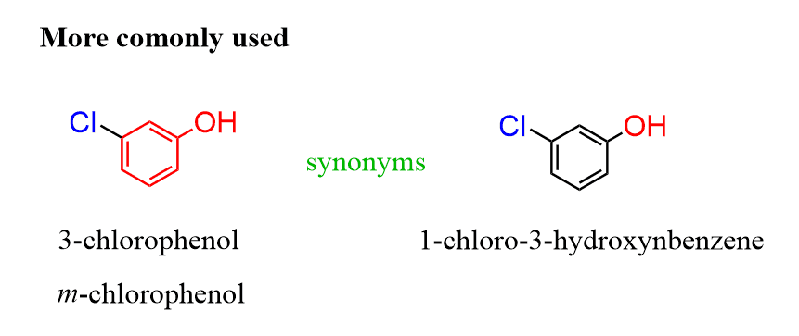

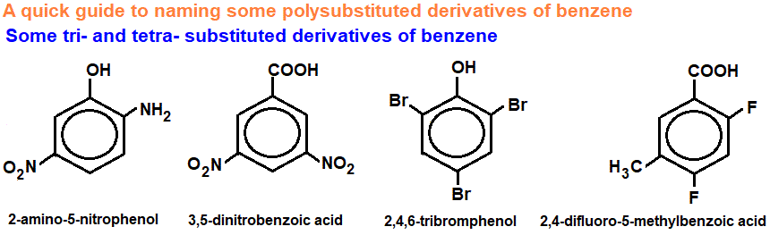

**Naming ortho , meta and para**

* [**ortho**](https://bluebox.creighton.edu/demo/modules/en-boundless-old/www.boundless.com/definition/ortho/index.html)

A prefix used to name an aromatic ring with two adjacent substituents.

* [**meta**](https://bluebox.creighton.edu/demo/modules/en-boundless-old/www.boundless.com/definition/meta/index.html)

A prefix used to name an aromatic ring with two substituents separated by one carbon on the ring.

* [**para**](https://bluebox.creighton.edu/demo/modules/en-boundless-old/www.boundless.com/definition/para/index.html)

A prefix used to name an aromatic ring with two substituents directly across from one another on the ring.

For example:

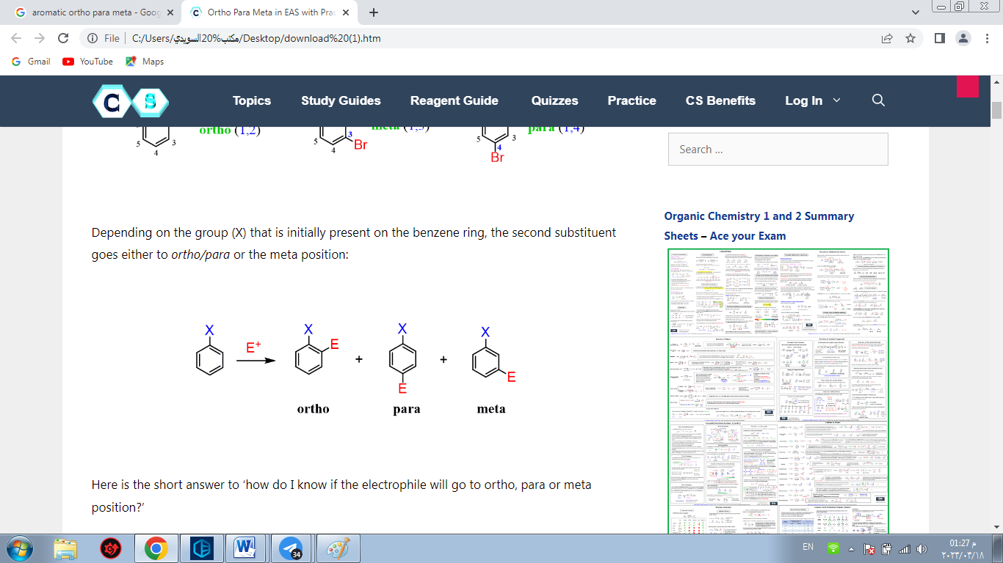

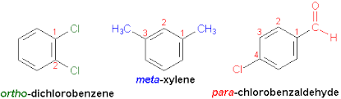

**Reactions of Benzene**

Even though benzene is highly unsaturated it does not undergo any of the regular reactions of alkenes such as addition or oxidation

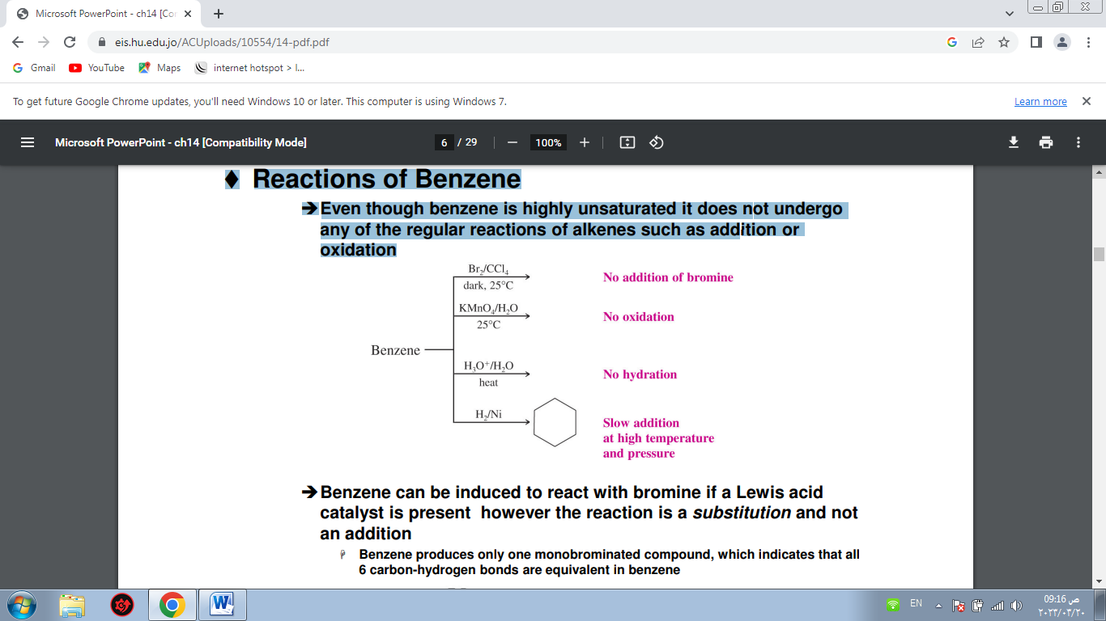

Benzene can be induced to react with bromine if a Lewis acid catalyst is present however the reaction is a substitution and not an addition

**Benzene produces only one monobrominated compound, which indicates that all 6 carbon-hydrogen bonds are equivalent in benzene**

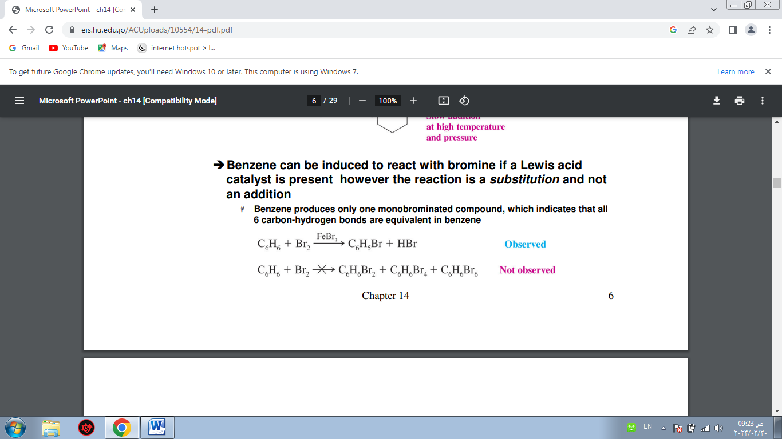

**The Stability of Benzene**

Benzene is much more stable than would be expected based on calculations for “cyclohexatriene” A reasonable prediction for the heat of hydrogenation of hypothetical cyclohexatriene is -360 kJ mol-1 (3 times that of cyclohexene, -120 kJ mol-1 ) The experimentally determined heat of hydrogenation for benzene is -280 mol-1, 152 kJ mol-1 more stable than hypothetical cyclohexatriene This difference is called the resonance energy

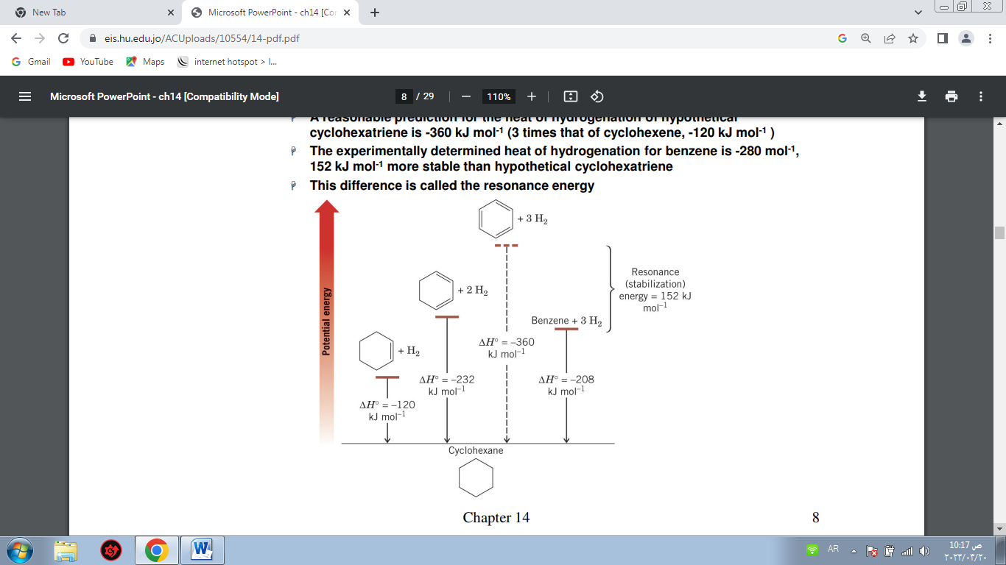

**Substitution Reactions Of Aromatic Compounds**

Substitution reactions on aromatic compounds are the most important methods for the preparation of aromatic compounds. Synthesizing them from nonaromatic precursors is considerably less important. Via substitution reactions, electrophiles and nucleophiles can be introduced into aromatics. A series of mechanisms is available for this

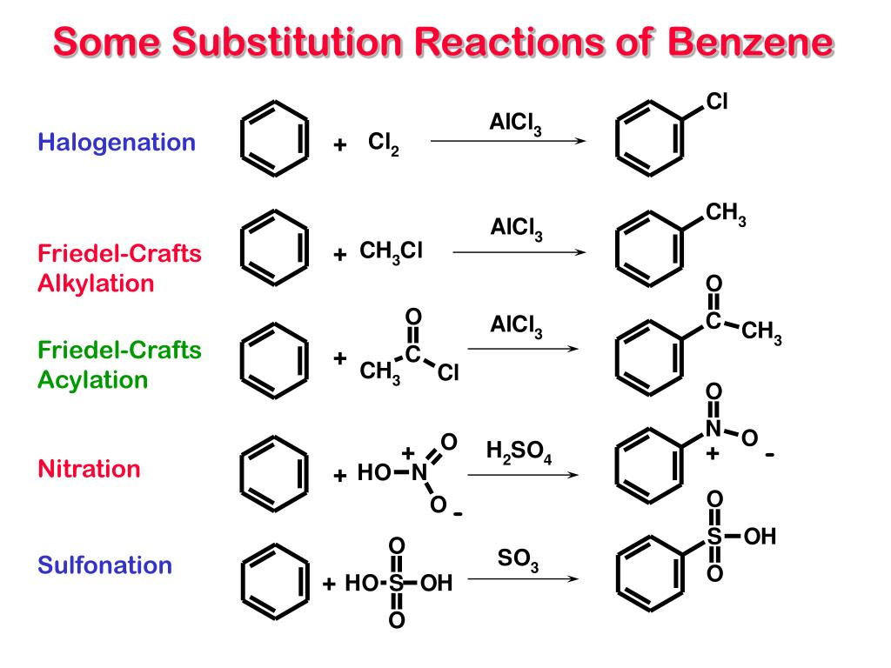

Toluene,nitrobenzene,chlorobenzene and many other aromatic compounds also undergo substitution reactions. These compounds differ from benzene in that they already have a substituent on the benzene ring. The remaining five hydrogens are not equivalent. When these hydrogens undergo substitution reactions, isomers can be formed depending on which hydrogen is replaced.

**Physical properties**

**1-Boiling points**

In benzene, the only attractions between the neighbouing molecules are the van der Waals dispersion forces. There is no permanent dipole on the molecule. Benzene boils at 80°C, which is higher than other hydrocarbons of similar molecular size (pentane and hexane, for example).

**2-Melting points**

You might have expected that methylbenzene's melting point would be higher than benzene's as well, but it isn't - it is much lower! Benzene melts at 5.5°C; methylbenzene at -95°C Molecules must pack efficiently in the solid if they are to optimize their intermolecular forces.

**3-Solubility in water**

The arenes are insoluble in water. Benzene is quite large compared with a water molecule. For benzene to dissolve, it would have to break a significant number of the existing hydrogen bonds between the water molecules

**4-Reactivity**

Benzene is resistant to addition reactions. Adding something new to the ring would require that some of the delocalized electrons form bonds with the substituent being added, resulting in a major loss of stability because the delocalization is broken.

**Huckel’s Rule:**

The 4n+2π Electron Rule Planar monocyclic rings with a continuous system of p orbitals and 4n + 2π electrons are aromatic (n = 0, 1, 2, 3 etc) Aromatic compounds have substantial resonance stabilization Benzene is aromatic: it is planar, cyclic, has a p orbital at every carbon, and 6 π electrons (n=1)

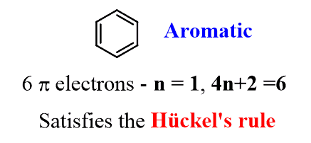

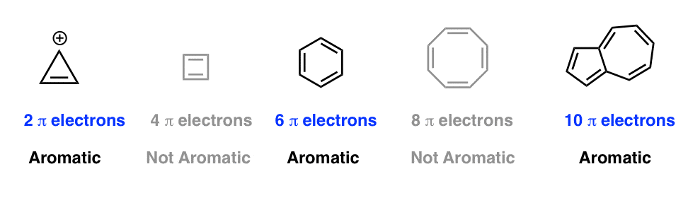

**Use huckel's rule to indicate weither compounds are aromatic or non aromatic?**

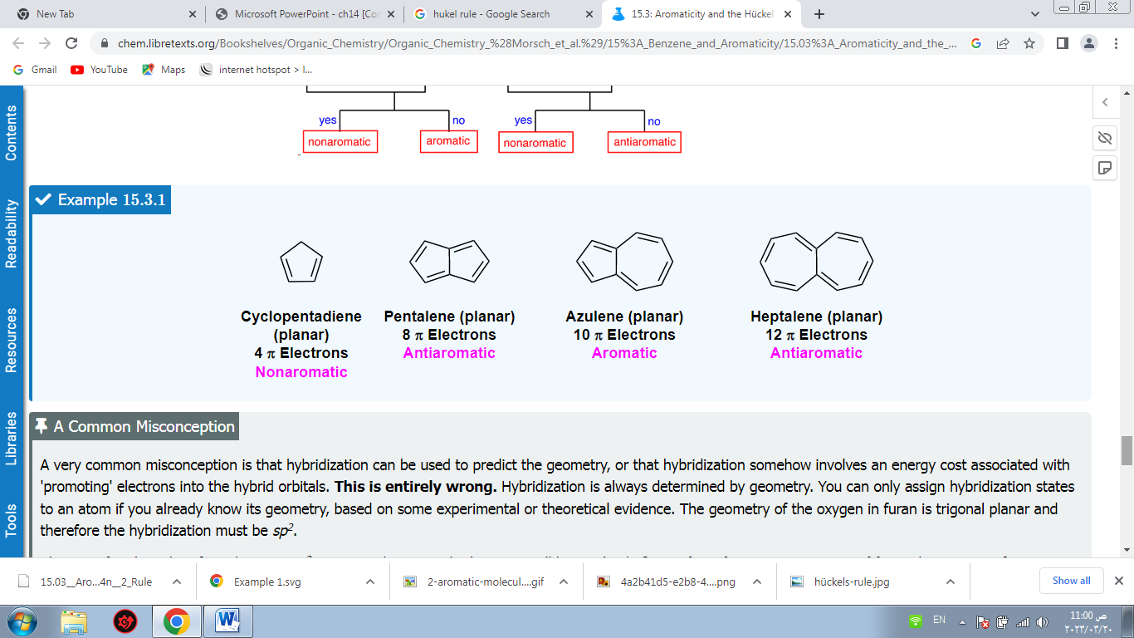

**Name by ortho and meta and para?**

