**Unit 5**

**(This and That , Expletive there , prepositions , vocabulary and Comprehension)**

**5.1. Sports , Food , and Drinks**

For the following , complete the words :

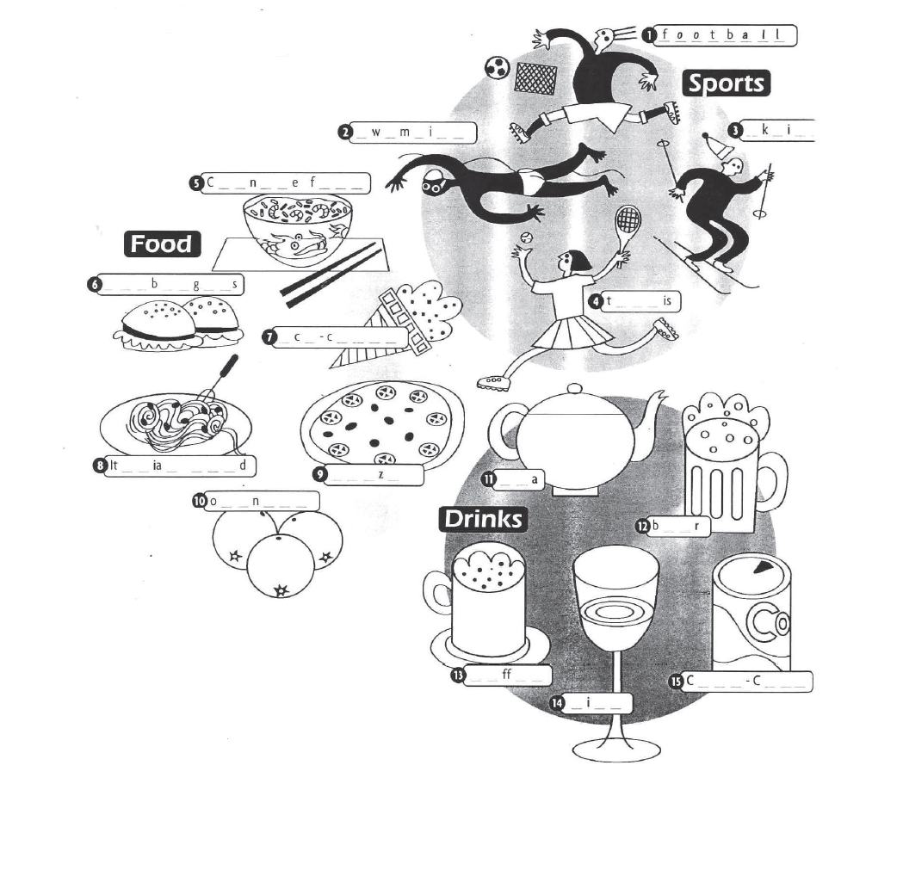

5.2. Grammar spot/ spots

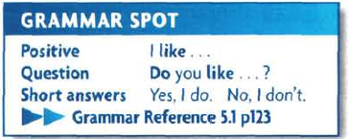 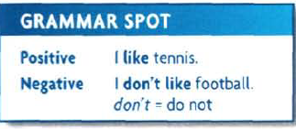 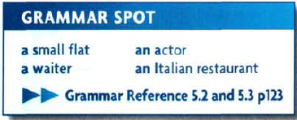

**5.3. Vocabulary**

**Nationality and Languages**

Match the countries and Nationality for the following



**5.4. Every day English**

Numbers and Prices

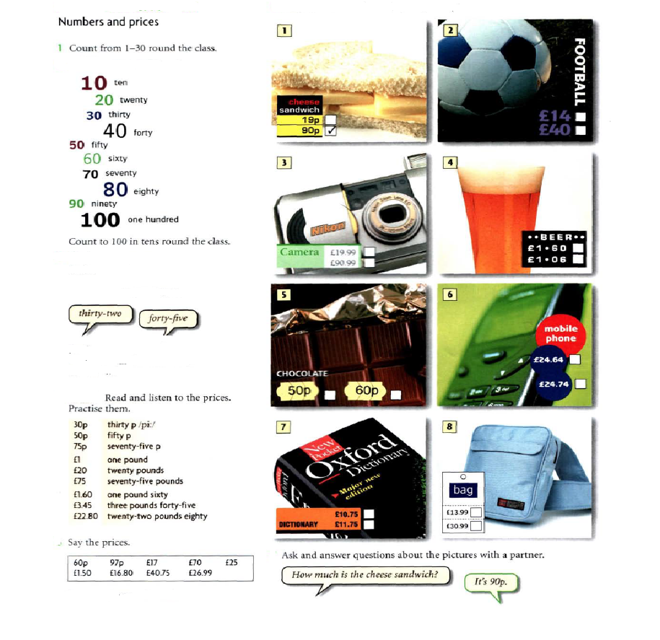

**5.5. This and that**

**5.5.1 *This*, *that*, *these*, *those* as pronouns**

a. Referring to things or ideas

We normally use *this, that, these* and *those* as pronouns to refer to things or ideas:

*Put the butter, chocolate and sugar in a saucepan. Heat****this****over a low flame until it melts.*

*We’re going to eat first and then go to the film. Are you happy with****that****?* (Are you happy with the idea of eating first, then going to the film?)

[talking about the TV]

*Can you turn****that****off if you’re not watching it?*

[talking about shoes]

*What colour are****those****? Black or dark blue. I can’t see.*

b. Referring to people

We can use *this* and *that* as pronouns to refer to people when we want to identify ourselves or others, or to ask the identity of other speakers:

*Linda,****this****is my mother, Anne.*

*Is****that****your brother over there?*

We often do this in telephone calls and in answer-phone messages:

*Hello, is****that****Ken Orm?****This****is Jane Bromham here.*

***5.5.2 This* and *these*, *that* and *those*: uses**

- Physical closeness and distance

We use *this* and *these* most commonly to point to things and people that are close to the speaker or writer, or things that are happening now:

*Shall I use****this****knife here?*

- [pointing to something]

*Is****this****what you mean?*

*I’ll post****these****letters on my way home.*

- [pointing to a pile of books]

*Do****these****belong to the Bradshaws?*

We use *that* and *those* most commonly to point to things and people which are not easy to identify in a situation. They are often more distant from the speaker, and sometimes closer to the listener:

*What’s in****that****bottle over there?*

*Could you blow out****those****candles near you?*

Sometimes they are not visible to either the speaker or listener:

*Budapest!****That****’s my favourite place!*

- Emotional distance

We sometimes use *this, these, that, those* to identify emotional distance. We use *this* and *these* to refer to things that we feel positive about, that we are happy to be associated with, or we approve of:

*I love****these****new woollen mobile phone covers that you can get.*

We use *that* and *those* to create distance:

*What are you going to say to****that****sister of yours?*

[talking about a restaurant]

*I didn’t like the decoration. It had****those****awful paintings.*

- Shared knowledge and new information

We sometimes use *that* instead of *the* to refer the listener to shared knowledge, often when we are telling a story or explaining something:

*You know****that****old shop on the corner? Well, they’re going to turn it into a restaurant.*

We sometimes use *this* instead of *a/an* to refer to something important or recent, or to introduce a new person or thing in a story:

***This****guy knocked on the door and asked if I wanted new windows.*

*Then suddenly she pulled out****this****big pile of papers from her briefcase and threw them on the table.*

**5.6. Here and there , prepositions**

a- ***Here* and *there*: meanings**

When we use *here*, it typically refers to the place where the speaker is, and we see the position of people and things from the speaker’s point of view:

*Do you want to stay****here****or go to another restaurant?*

*Could you come****here****and help me for a minute?*

When we use *there*, it typically refers to the place where the listener or another person is, and we see the position of people and things from the listener’s or another person’s point of view:

*Our son Jim’s living in Barcelona. He wants us to go****there****for a holiday.*

**A:**

*Where’s my cup of tea?*

**B:**

*It’s* ***there***, *next to you, on the little table!*

b- ***Here* and *there* with *this*, *that*, *these*, *those* (demonstratives)**

We often use *here* with nouns that have *this* or *these* before them, and *there* with nouns that have *that* or *those* before them:

*Are****these****shoes****here****yours?*

*You press****that****button****there****and the motor should start.*

*Here* and *there* with *bring* and *take*

We often use *here* with *bring* and *there* with *take*:

***Bring****your glass****here****and I’ll give you some juice.*

*This package has to go to the post room. Would you****take****it****there****for me, please?*

**See also:**

* [*Bring*, *take* and *fetch*](https://dictionary.cambridge.org/grammar/british-grammar/bring-take-and-fetch)
* [*Go and*, *come and*](https://dictionary.cambridge.org/grammar/british-grammar/and#and__11)

c- ***Here* and *there* after prepositions**

We can use *here* and *there* after prepositions:

*Is there a bank****around here****?*

*It’s cold****in here****. Shut that door!*

**A:**

*Where shall I put this box of books?*

**B:**

*Oh, put it* ***over there***, *please, by the bookshelf*.

d- ***Here* and *there* in front position**

We can use *here* and *there* in front position, with the subject and verb inverted. The most common expressions of this type are *here is x*, *here comes x*, *there is x, there goes x*:

**A:**

***Here’s the CD*** *I said I’d lend you, the Brazilian music*.

**B:**

*Oh, thanks*.

***Here comes your taxi****, so we’d better say bye bye now.*

[pointing to a shop across the street]

***There’s the shop****where I bought those black shoes you liked.*

*Oh look,****there goes****Freda on a bike. I didn’t know she had one!*

When the subject is a pronoun, we do not invert the subject and verb:

**A:**

*Where’s the tin opener?*

**B:**

***There it is***, *on the sink*.

Not: ~~There is it, on the sink~~.

d- ***Here you are*, *there you are***

We can use *here you are* and *there you are* (or, in informal situations, *here you go* and *there you go*) when giving something to someone. *Here* and *there* have the same meaning in this use:

**A:**

*Did you get my newspaper?*

**B:**

*Yes*. ***Here you are***. [gives it to A]

**A:**

*Can you pass me that dictionary?*

**B:**

***There you go***. [gives A the dictionary]

**A:**

*Thank you*.

e- ***Here it is!* *There he is!***

We often use *here* + subject pronoun *+ be* and *there* + subject pronoun + *be* at the moment of finding or meeting someone or something we have been looking for or waiting for:

**A:**

*Has anyone seen my pen?*

**B:**

***Here it is***, *right by the phone*.

*Simon!****There you are!****Everyone’s waiting for you!*

f- ***Here I am!***

People often say that they have arrived or that someone else has arrived using *here* + subject pronoun + *be*:

**A:**

*Hello!* ***Here we are****! I hope we haven’t missed lunch?*

**B:**

*Hello. No, you’re right on time*.

g- ***Here*: on the telephone**

People often use *here* to identify themselves on the telephone or in voicemail messages:

**A:**

*Hi, Rex*, ***Julia here***. *How are you?*

**B:**

*Julia, hi. Fine, thanks. And you?*

**See also:**

* [Telephoning](https://dictionary.cambridge.org/grammar/british-grammar/telephoning)

***Hello there!***

We often use *there* in informal situations after *hello* and *hi*:

**A:**

***Hello there***. *How’s things?*

**B:**

***Hi there***. *Fine. How are you?* (*How’s things?* is something that we say in informal contexts but we don’t write it. *How are things?* is less informal.

**5.7. Homework**

**5.7.1. write a Nationality**

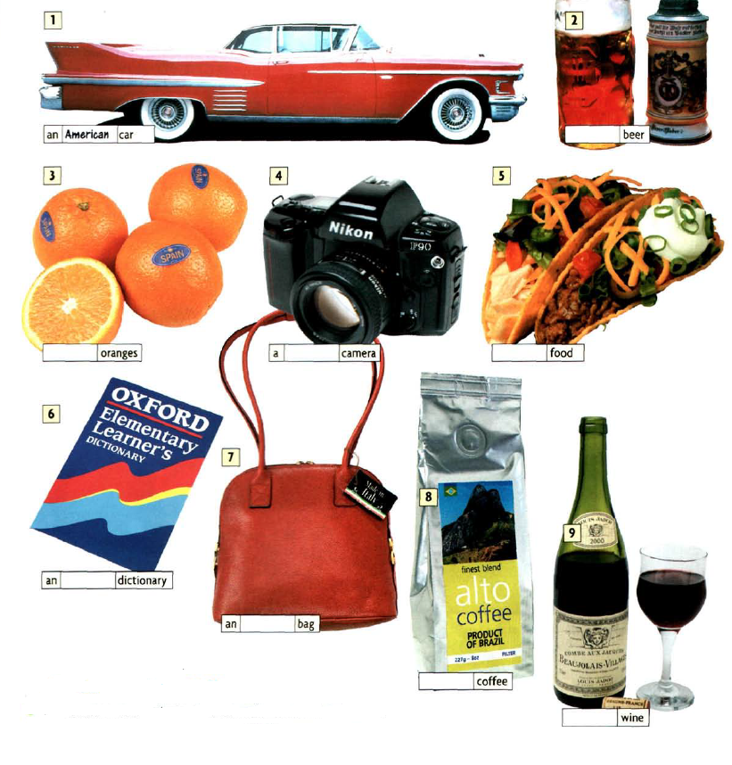**5.7.2. Fill with this, that , these , those**

**.7.2. Fill with this, that , these , those for the following:**

1.---------------- are the flowers I picked out for you.

2. I could not find --------------------- sweater yesterday.

3. Are you going to eat ----------------- cookies?

4. ------------------ pencils her need to be sharpened.

5. I stopped believing ---------------- months ago.

6. ---------------- noodles are really delicious .

7. -------------- colors did not look good on me.

8. Why did ------------------- children run away?

9. I want to talk about ------------- right now.

10. May I touch ---------------------- statue?

**5.8. References :**

**1.** **https://dictionary.cambridge.org/grammar/british-grammar/this-that-these-those**

**2.** [**https://dictionary.cambridge.org/grammar/british-grammar/here-and-there?q=Here+and+there+after+prepositions**](https://dictionary.cambridge.org/grammar/british-grammar/here-and-there?q=Here+and+there+after+prepositions)

**2. New head way – student book**

**4. New head way – Work book**