**Unit 6**

**Plural , Expression of quantity , vocabulary and comprehension**

**6.1 The time**

**6.1.1 - Write the time**

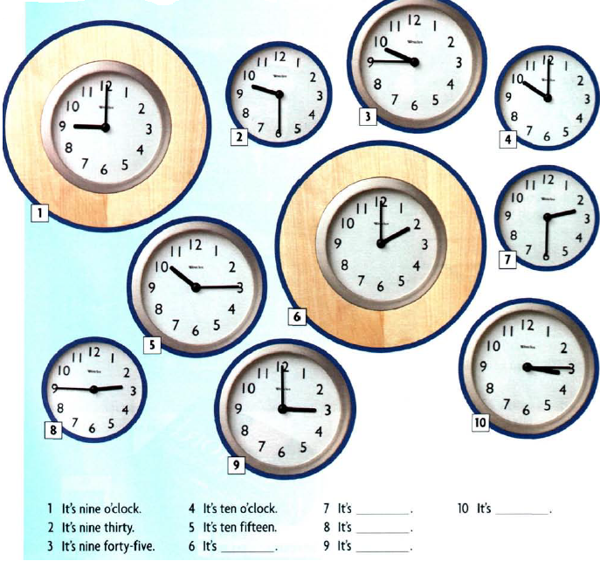

**6.1.2 Look at the pictures and write the time for the following**

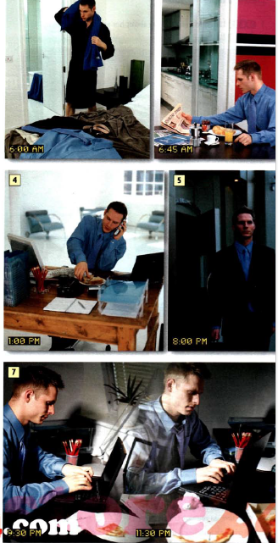

**6.2 Grammar spot/ spots**

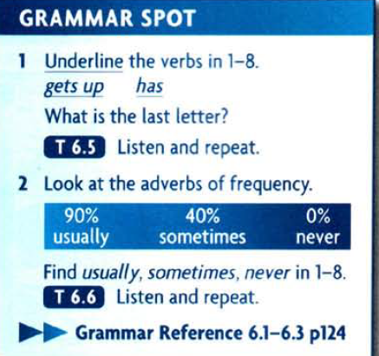

**6.3 . Practice - Katya day-**

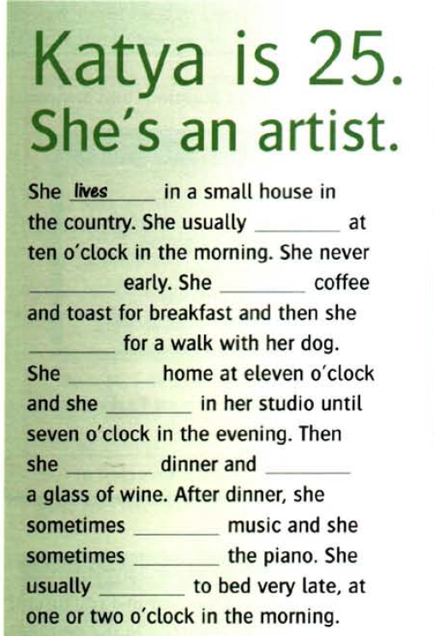 **Complete the text with the verb**

**6.4. Expression of quantity**

**6.4.1. Groups of expression**

There is a group of **expressions of quantity** that can be **singular** or **plural** depending on the prepositional phrase that follows.  These words are: **plenty**, **lots**, **a lot**, **all**, **some**, **most**,**a great deal**, **none**, (***fractions*)** and (***percentages***.)

**plenty**, **lots**, **a lot**, **all**, **some**, **most**,**a great deal**, **none**,:

 If the noun in the prepositional phrase is a **countable** word that is plural, then the **expression of quantity** is **plural** and the verb is also **plural**.  If the noun in the prepositional phrase is an **uncountable**word, which cannot be made plural, then the **expression of quantity** is **singular** and the verb is also **singular**.  Look at these examples:

**6.4.2. Groups’ items**

**6.4.2. a. Plenty of**

**Plenty of** **patience is** required for this job..  
(‘**patience**‘ is **uncountable**, which makes **plenty singular**, so the **verb** is **singular**.)

**Plenty of** **spare parts** **are** kept in the garage.  
(‘**spare parts**‘ is **countable**, which makes **plenty** **plural**, so the **verb** is **plural**.)

**Plenty of**the **food** I have eaten **was** unhealthy.  
(‘**food**’ is **uncountable**, which makes **plenty** **singular**, so the **verb** is **singular**.)

**Plenty of** my **friends** **know** it’s my birthday.  
(‘**friends**’ is **countable**, which makes **plenty** **plural**, so the **verb** is **plural**.)

(WRONG:  Plenty food …)

**6.4.2.b . Lots of / A lot of**

**Lots (A lot) of** **money** **changes** hands at a market.  (‘**money**’ is **uncountable**.)

**Lots (A lot) of people change** their minds.  (‘**people**’ is **countable**.)

**Lots (A lot) of** the **information** we received **was** too late.  (‘**information** is **uncountable**.)

**Lots (A lot) of** his **jokes** **were** not very funny.  (‘**jokes**’ is **countable**.)

(WRONG:  Lots food, A lot food …)

**6.4.2.c . All**

**All** **mammals** **produce** milk .  (‘**mammals**’ is **countable**.)

**All** of the **work** **needs** to be redone.  (‘**work**’ is **uncountable**.)

**All** of our **answers** **were** right.  (‘**answers**’ is **countable)**

(WRONG:  All of work …)

**Some**

**Some** **students** **have** exams next week.  (‘**students**’ is **countable**.)

**Some** of the **time** **passes** quickly.  (‘**time**’ is **uncountable**.)

(WRONG:  Some of vehicles …)

**6.4.2.d. Most**

**Most people** in Europe **speak** more than one language.  (‘**people**’ is **countable**.)

**Most** of his **advice** **is** very good.  (‘**advice**’ is **uncountable**.)

**Most** of the **students** I know **have** smart phones.  (‘**students**’ is **countable**.)

(WRONG:  Most of people …)

**6.4.2.e. A great deal of**

**A great deal of energy gets** lost in exercise.  (‘**energy**’ is **uncountable**.)

**A great deal of** **hikers** **get** lost in the mountains.  (‘**hikers**’ is **countable**.)

**A great deal of** our **time** **was** spent fishing.  (‘**time**’ is **uncountable**.)

**A great deal of** the **products** we use **come** from Asia.  (‘**products**’ is **countable**.)

**6.4.2.f. None of**

**None of** the **advice** **is** good.  (‘**advice**’ is **uncountable**.)

**None of** his **solutions** **seem** to work.  (‘**solutions**’ is **countable**.)

(NOTE: In British English, “none” is considered singular no matter what follows.)

(WRONG:  None advice …)  (but “No advice” is correct)

(WRONG:  None of advice …)

**6.4.3 Fractional and percentages**

**Fractions and percentages have the same grammar:**

**Two thirds of** the **test** **was** based on the textbook.  (‘**test**’ is **singular**.)

**Three quarters of** the **students** **were** prepared for the test.  (‘**students**’ is **plural**.)

**Sixty percent of** the **land** **is** desert.  (‘**land**’ is **singular**.)

**Eighty percent of** the **towns** **are** located along the coast.  (‘**towns**’ is **plural**.)

**A way to remember these words is to remember PLASMAN.  This is what the first letters of all these words spell.  P= plenty, L= lots/ a lot, A= all, S= some, M= most, A= a great deal, N= none**

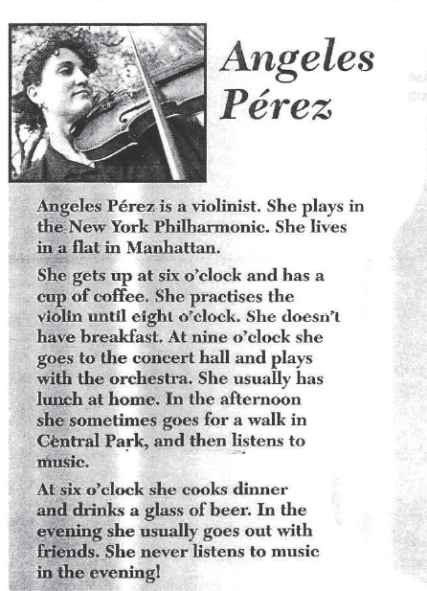**6.5. Reading and answer the questions**

**Put the words in the correct order**

**pPur**

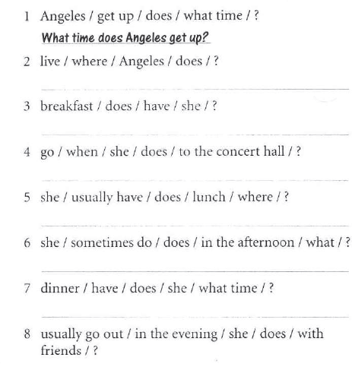

**6.6. Every day English**

**1. Days of the week**

**6.6.2 Write the correct preposition in the boxes**

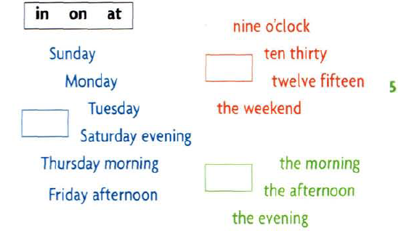

**6.7 . Homework**

**6.7.1 Complete with in , on , and at for the following :**

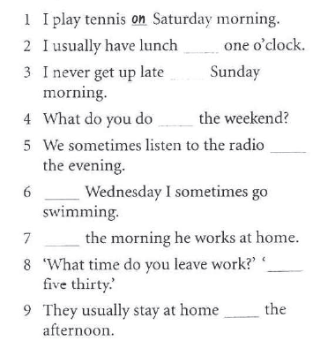

**6.7.2 . Choose the correct item for the following:**

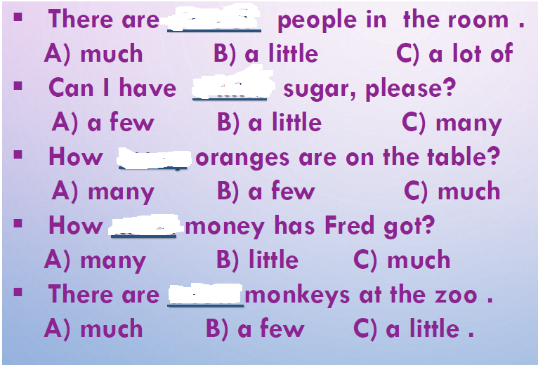

**6.8. References**

**1. New head way student book**

**2. new head way – work book**

**3. Love my esl.com , ( ESL ) English as a second language , Tag archive expression of quantity .**

**4. Expression of quantity . ppt**