**Unit 8**

**Question words , Asking Questions , Vocabulary and Comprehension**

**8.1. starter- Rooms and furniture-**

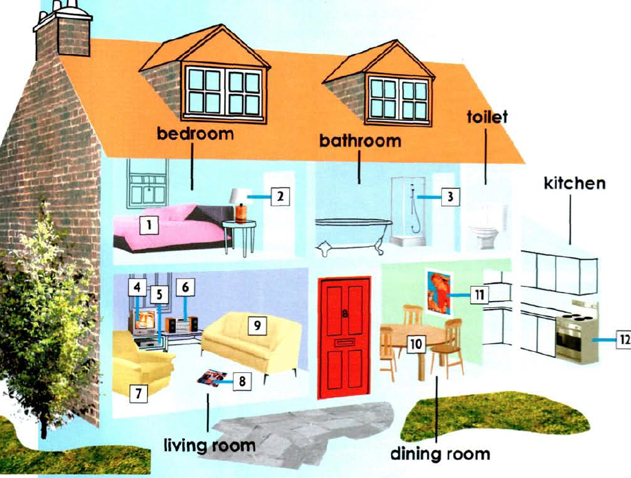

**Find the things in the house , write number**

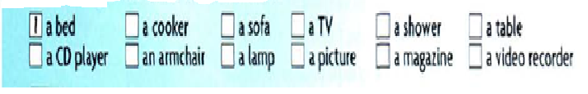

**8.2 Nicolas’ living room**

**Complete the sentences with the right words about Nicola’s living room**

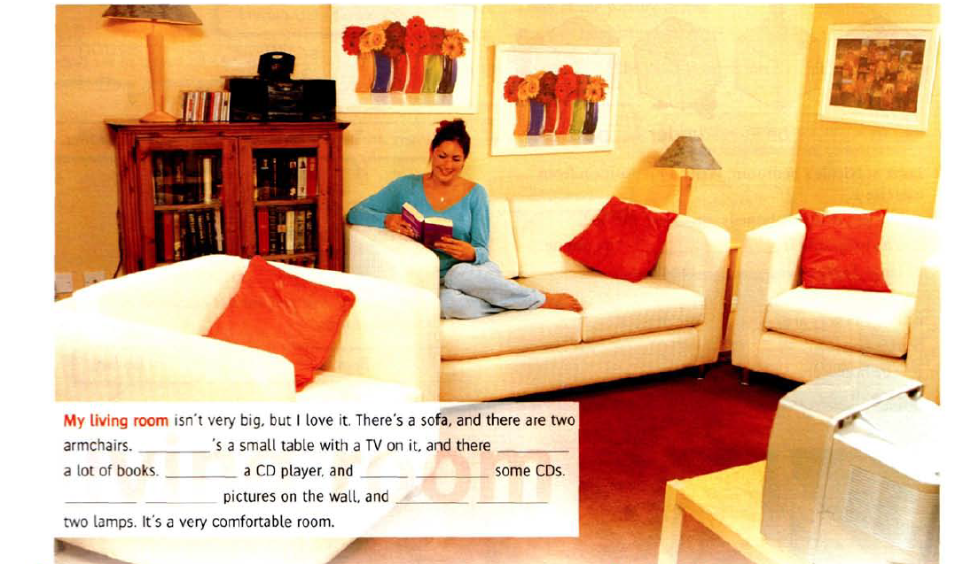

**8.3 Grammar spot/ spots**

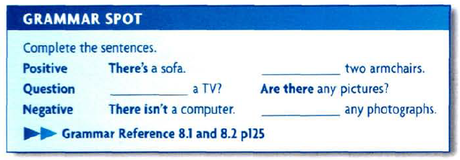

**8.4 Prepositions ( In , On ,Under and Next to ).**

**Look at the Nicole’s room and fill the blanks with in , on , under or next to**

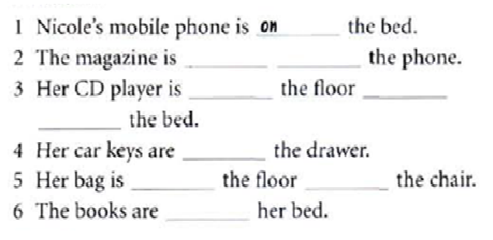

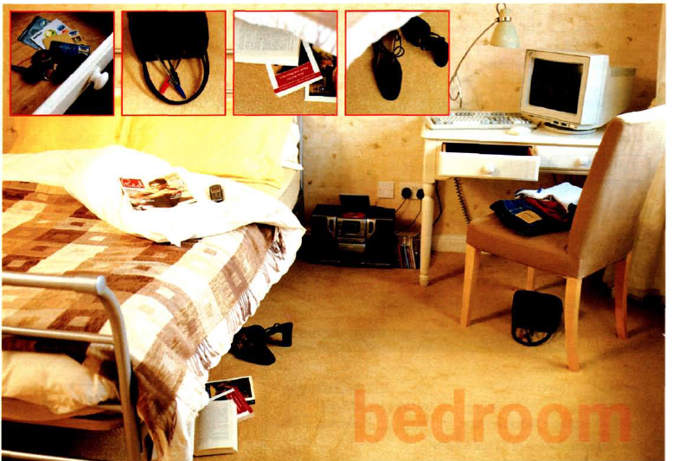

**8.5. Questions and answer**

**Put in the correct order**

1. House , Do , a. Live , Flat , in , a, or , you

----------------------------------------------?

2. How , there, bedrooms , are , many

-------------------------------------------------?

3. Telephone , there , the , is , a , in, kitchen.

---------------------------------------- ?

4. television , in , kitchen , the , there , is, a,

------------------------------------------ ?

5. Video recorder, the , is , a ,television there , under

--------------------------------------------- ?

6. Are , books , bedroom , in , a lot of , there , the

------------------------------------------------ ?

7. Pictures , there , on , Are , the , wall , any

--------------------------------------------------- ?

**8.6. From the following text , complete the chart with noun or adjective**



**8.7. Question words**

**8.7.1. Question Words and uses**

**How** is a very special question word. It's the only question word that doesn't start with W. **How** asks the manner (way of doing) of something>

**When**. Do you want to know what time something happened? Or what time something will happen? Then **when** is your word of choice (the one you should use).

**Whose**. **Whose** jacket is this? It's my mom's. **Whose** birthday is today? It's Jenny's. **Whose** pencil is on the floor? That's mine. **Whose** team is better?

**When** and **Where**. “When” and “**where**” are used to ask about time and place, respectively. For example, “When is your birthday?” or “**Where** did you go on vacation?”.

**Who** is used when you want to know about a person. This can be about asking whether (if) a person has done something, or if you cannot remember **who** someone ...

Who and **Whom**. “Who” and “**whom**” are used to ask about people. “Who” is used as the subject of a sentence, and “**whom**” is used as the object of a sentence. For ...

**Which** is a very specific (special, exact) question word. This is because it asks you to pick (choose, decide) between two different things. Think of **which** .

**What**. **What** is it? It's a table. **What** color is your dress? It's purple. **What** is your mom doing? She's cooking in the kitchen. **What** do you think about the weather?.

What and **Why**. “What” and “**why**” are two of the most common WH question words. We use “what” to ask about things, and we use “**why**” to ask about reasons

How was your exam? how + adj/adv, asking about extent or degree, see examples below. **how far**, distance, **How far** is Pattaya from Bangkok ..

**8.7.2 Question Words table**

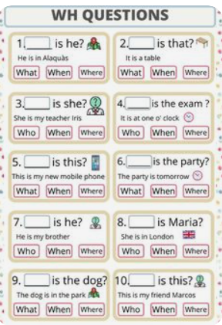

**8.8.1. Asking questions**

To understand what makes a question great, it helps to know the different types of questions:

* **Open-ended questions** leave room for more discussion and demand more explanation. These are questions that don’t allow the responder to give simple “Yes” or “No” answers or short responses. Here’s a workplace example:  
    
  *How do you feel about the new policy updates at work?*
* **Follow-up questions** let you pursue the topic and expand the conversation. For example, when talking to a friend about their family planning you might ask:  
    
  *How would you react if your partner told you they were pregnant?*
* **Leading questions**prompt a specific response and steer the conversation in a new direction. You might ask your partner the following about a rental property:    
    
  *Didn’t you love the house with the big pool?*

There isn’t a universal formula for asking great questions because it depends on the question asker and the context.

**8.8.2. What makes you a good question asker?**

It doesn’t matter what type of question you’re asking if it leads to the information you need. But to do that, you need to know what kind of information you’re looking for and who’s the best person to ask.

|  |  |
| --- | --- |
| **Questions using 'to be'** | **Questions using other verbs** |
| Where is your house? | Where do you live? |
| How is the food? | How do you like the food? |
| Who is that girl? | Who do you know? |
| When is your birthday? | When do you work? |

**8.9. Homework**

**8.9.1 Write Sentences in your language**

1.There’s a table in the dinning room

-------------------------------------------------

2. there are three arm chairs in the living room.

-------------------------------------------------

3. Is there a picture on the wall ? Yes, there is

----------------------------------------------------

4. Are there any magazines under the bed ? No, there aren’t.

------------------------------------------------------------------------------

**8.9.2 Complete sentences using words from the bank**

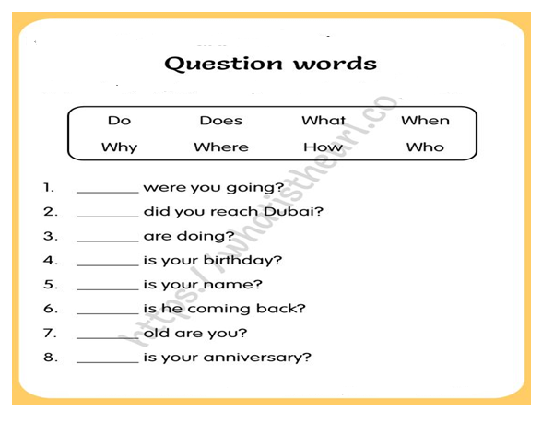

**8.10 . References :**

1. New head way - student book –

2. New head way – Work book

# 3. **WH- questions (Question Words), web page :**

<https://basicenglishspeaking.com/wh-questions/#google_vignette>

4. https://www.lingobest.com/free-online-english-course/asking-questions-in-english/