Unit 5
(This and That , Expletive there , prepositions , vocabulary and Comprehension)
5.1. Sports , Food , and Drinks
For the following , complete the words
5.25.
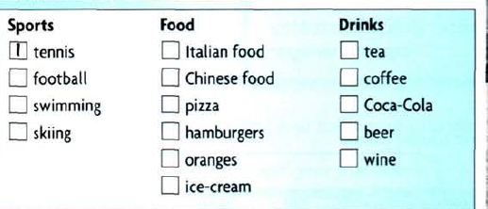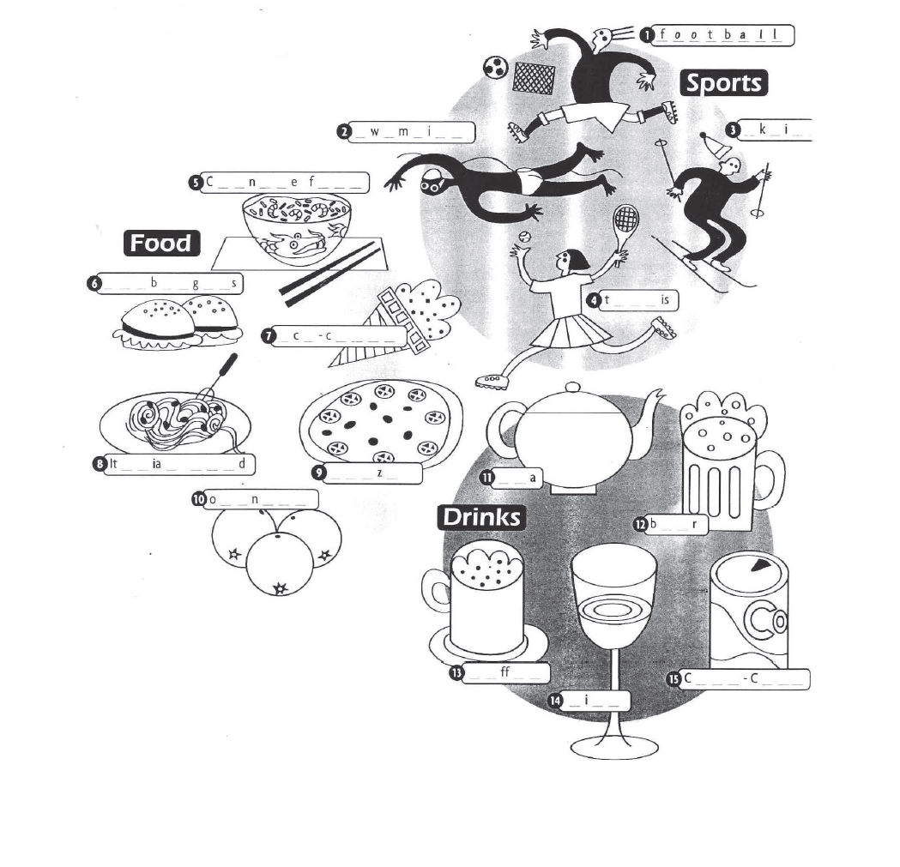
5.2. Grammar spot/ spots
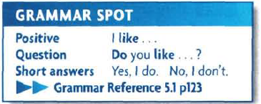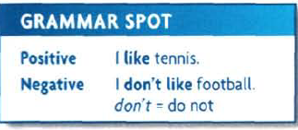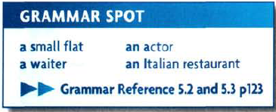

5.3. Vocabulary
Nationality and Languages
Match the countries and Nationality for the following
5.4. Every day English
Numbers and Prices
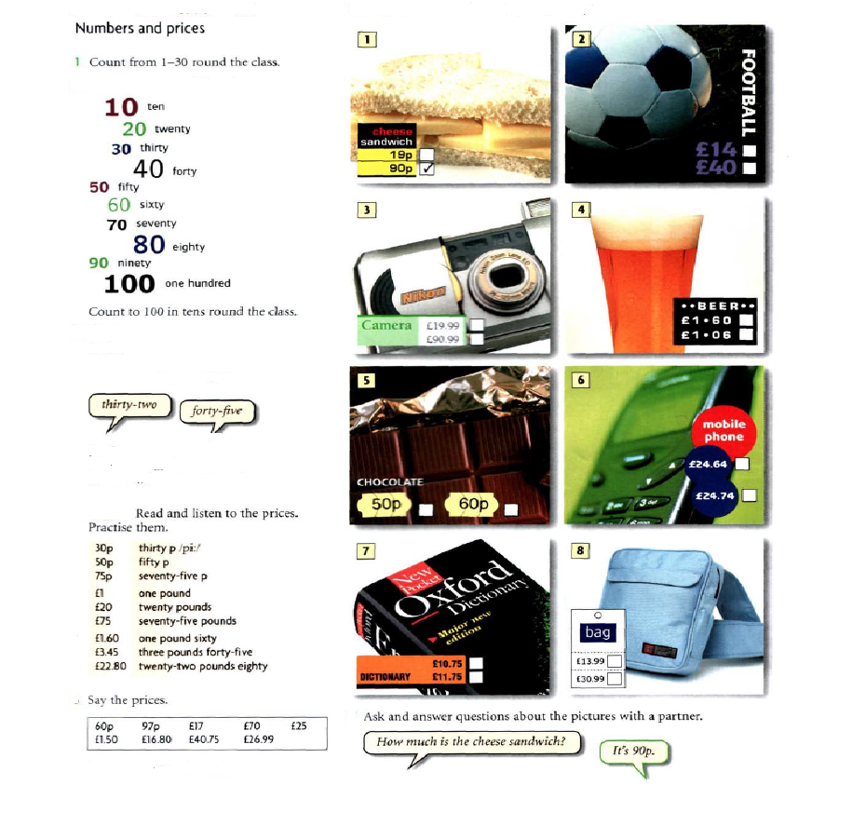
5.5. This and that

This, that, these, those as pronouns

Referring to things or ideas
We normally use this, that, these and those as pronouns to refer to things or ideas:
Put the butter, chocolate and sugar in a saucepan. Heat this over a low flame until it melts.
We’re going to eat first and then go to the film. Are you happy with that? (Are you happy with the idea of eating first, then going to the film?)
[talking about the TV]
Can you turn that off if you’re not watching it?
[talking about shoes]
What colour are those? Black or dark blue. I can’t see.

Referring to people
We can use this and that as pronouns to refer to people when we want to identify ourselves or others, or to ask the identity of other speakers:
Linda, this is my mother, Anne.
Is that your brother over there?
We often do this in telephone calls and in answer-phone messages:
Hello, is that Ken Orm? This is Jane Bromham here.

This and these, that and those: uses

Physical closeness and distance
We use this and these most commonly to point to things and people that are close to the speaker or writer, or things that are happening now:
Shall I use this knife here?
[pointing to something]
Is this what you mean?
I’ll post these letters on my way home.
[pointing to a pile of books]
Do these belong to the Bradshaws?
We use that and those most commonly to point to things and people which are not easy to identify in a situation. They are often more distant from the speaker, and sometimes closer to the listener:
What’s in that bottle over there?
Could you blow out those candles near you?
Sometimes they are not visible to either the speaker or listener:
Budapest! That’s my favourite place!

Emotional distance
We sometimes use this, these, that, those to identify emotional distance. We use this and these to refer to things that we feel positive about, that we are happy to be associated with, or we approve of:
I love these new woollen mobile phone covers that you can get.
We use that and those to create distance:
What are you going to say to that sister of yours?
[talking about a restaurant]
I didn’t like the decoration. It had those awful paintings.

Shared knowledge and new information
We sometimes use that instead of the to refer the listener to shared knowledge, often when we are telling a story or explaining something:
You know that old shop on the corner? Well, they’re going to turn it into a restaurant.
We sometimes use this instead of a/an to refer to something important or recent, or to introduce a new person or thing in a story:
This guy knocked on the door and asked if I wanted new windows.
Then suddenly she pulled out this big pile of papers from her briefcase and threw them on the table.

5.6. Here and there , prepositions

Here and there

Grammar > Using English > Spoken English > Here and there
from English Grammar Today
Here and there are adverbs.

Here and there: meanings
When we use here, it typically refers to the place where the speaker is, and we see the position of people and things from the speaker’s point of view:
Do you want to stay here or go to another restaurant?
Could you come here and help me for a minute?
When we use there, it typically refers to the place where the listener or another person is, and we see the position of people and things from the listener’s or another person’s point of view:
Our son Jim’s living in Barcelona. He wants us to go there for a holiday.
A:
Where’s my cup of tea?
B:
It’s there, next to you, on the little table!

Here and there with this, that, these, those (demonstratives)
We often use here with nouns that have this or these before them, and there with nouns that have that or those before them:
Are these shoes here yours?
You press that button there and the motor should start.

Here and there with bring and take
We often use here with bring and there with take:
Bring your glass here and I’ll give you some juice.
This package has to go to the post room. Would you take it there for me, please?
See also:
- Bring, take and fetch
- Go and, come and

Here and there after prepositions
We can use here and there after prepositions:
Is there a bank around here?
It’s cold in here. Shut that door!
A:
Where shall I put this box of books?
B:
Oh, put it over there, please, by the bookshelf.

Here and there in front position
We can use here and there in front position, with the subject and verb inverted. The most common expressions of this type are here is x, here comes x, there is x, there goes x:
A:

Here’s the CD I said I’d lend you, the Brazilian music.
B:
Oh, thanks.
Here comes your taxi, so we’d better say bye bye now.
[pointing to a shop across the street]
There’s the shop where I bought those black shoes you liked.
Oh look, there goes Freda on a bike. I didn’t know she had one!
When the subject is a pronoun, we do not invert the subject and verb:
A:
Where’s the tin opener?
B:
There it is, on the sink.
Not: There is it, on the sink.

Here you are, there you are
We can use here you are and there you are (or, in informal situations, here you go and there you go) when giving something to someone. Here and there have the same meaning in this use:
A:
Did you get my newspaper?
B:
Yes. Here you are. [gives it to A]
A:
Can you pass me that dictionary?
B:
There you go. [gives A the dictionary]
A:
Thank you.

Here it is! There he is!
We often use here + subject pronoun + be and there + subject pronoun + be at the moment of finding or meeting someone or something we have been looking for or waiting for:
A:
Has anyone seen my pen?
B:
Here it is, right by the phone.
Simon! There you are! Everyone’s waiting for you!

Here I am!
People often say that they have arrived or that someone else has arrived using here + subject pronoun + be:
A:
Hello! Here we are! I hope we haven’t missed lunch?
B:
Hello. No, you’re right on time.

Here: on the telephone
People often use here to identify themselves on the telephone or in voicemail messages:
A:
Hi, Rex, Julia here. How are you?
B:
Julia, hi. Fine, thanks. And you?
See also:
- Telephoning

Hello there!
We often use there in informal situations after hello and hi:
A:
Hello there. How’s things?
B:
Hi there. Fine. How are you? (How’s things? is something that we say in informal contexts but we don’t write it. How are things? is less informal.)

5.7. Homework
5.7.1. write a Nationality
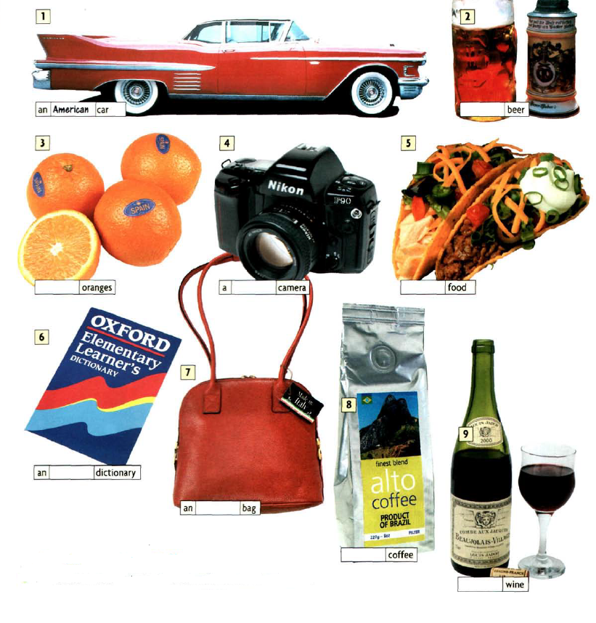
5.7.2. Fill with this, that , these , those 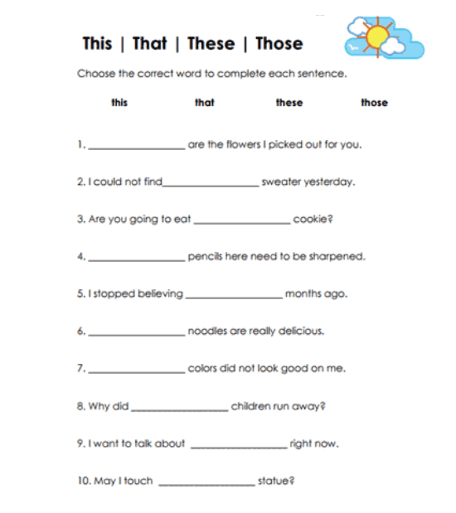

5.8. References :
1. https://dictionary.cambridge.org/grammar/british-grammar/this-that-these-those
2. https://dictionary.cambridge.org/grammar/british-grammar/here-and-there?q=Here+and+there+after+prepositions
2. New head way – student book
4. New head way – Work book

