**Lceture 6**

**Cell division**

Cell division is the process in which a cell duplicates itself by dividing its genetic material. For prokaryotes, this process follows simple binary fission in reproduction.

In a eukaryotic cell, division for sexual reproduction or vegetative growth occurs through a process involving the replication of DNA, followed by two rounds of division without an intervening round of DNA replication.

**What is Cell Division?**

Cell division can be defined as a process by which a cell distributes its genetic material and cytoplasm and gives rise to new daughter cells. It is a part of the larger [cell cycle](https://www.vedantu.com/biology/cell-cycle) and has a direct role in cell reproduction.

In well-developed organisms, there are two types of cell division observed, mitosis and meiosis. These are very complex processes that are carried out through different phases.

However, if simplified, mitosis can be defined as the exact duplication of a cell where the daughter cells will have the same genetic information as the parent cell.

In meiosis, the daughter cells will only have half of the genetic information of the original cell. The common end phase in both processes is cytokinesis and the division of the cytoplasm. .

**Cell Division- Mitosis and Meiosis**

The two well-documented types of cell division are:

1.Mitosis

2. Meiosis

3. Binary Fission

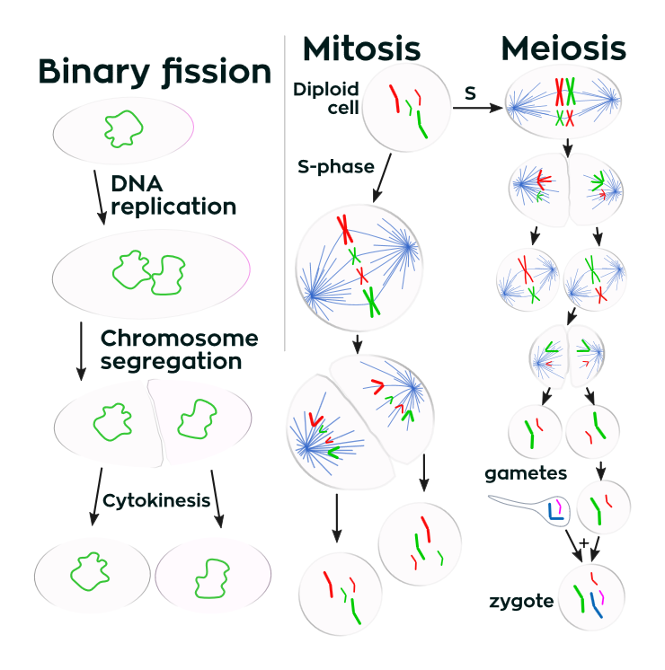

**Mitosis**

It is the type of cell division where one cell divides to produce two genetically identical daughter cells.

A great majority of cell divisions that take place in our body is mitosis. The process is integral to an organism's body growth and development, and it takes place throughout the organism's lifetime.

For some single-celled organisms such as yeast, mitotic cell division is the only way they can reproduce. In the following, we will learn about the mitotic process of cell division.

The cell division phases of mitosis are:

1. Early a nd late prophase
2. Metaphase
3. Anaphase
4. Telophase

Before mitosis begins, the cell is in a state called interphase and it copies its DNA and so the chromosomes in the nucleus consist of two copies which are called sister chromatids. In animals, the centrosome is also copied. Centrosomes control mitosis in animal cells. .

**Early and Late Prophase**

* In the early prophase, the cell initiates cell division by breaking down some cell components and building other components and then the chromosome division starts.
* In this stage, the chromosomes start to condense which helps them to separate easily in later stages
* Afterwards, the mitotic spindle starts to form, a structure made of microtubules. It organizes the chromosomes and moves them around during mitosis. The mitotic spindle grows between the centrosomes of the cell as they move towards different poles.
* The nucleolus then disappears which is a sign that the nucleus is getting ready to break down.
* In the late prophase which is also called prometaphase, the mitotic spindle starts to organize the chromosomes.
* Once the chromosomes finish condensing, they form a compact structure.
* Then the nuclear envelope breaks down and the chromosomes are released.
* At the end of the prophase, the mitotic spindle grows, and some microtubules start to capture and organize chromosomes.

**Metaphase**

* Metaphase starts when the mitotic spindle organizes all chromosomes and lines them up in the middle of the cell to divide.
* All chromosomes align at the metaphase plate.
* At this stage of metaphase, the two kinetochores of each chromosome should be attached to microtubules from opposite spindle poles. Before proceeding forward to anaphase, the cell will check if all kinetochores are properly attached to microtubules and it is called spindle checkpoint.
* The spindle checkpoint ensures that the sister chromatids are split equally into two daughter cells.

**Anaphase**

* In this stage, the sister chromatids separate from each other and move towards the opposite poles of the cell. The protein glue that holds them breaks and allows them to separate.
* Microtubules that are not attached to chromosomes elongate and push apart. In doing so they separate the poles and makes the cell longer. These processes are controlled by motor proteins and these proteins carry the chromosomes and microtubules as they move.

**Telophase**

* In this stage, the cell is almost divided and starts to re-establish its normal cellular structures as cytokinesis takes place.
* The mitotic spindle breaks down into its building blocks and two new nuclei are formed, one for each set of chromosomes.
* The nuclear membrane and the nucleoli then reappear and the chromosomes begin to de- condense to return to their normal form.

**Cytokinesis**

* In animal cells, cytokinesis is contractile. There's a pinch-like formation within the cell which divides it in two like a coin purse with a 'drawstring'. The "drawstring" is a band of actin protein filaments. The pinch crease is called the cleavage furrow.
* Plant cells can't be divided like this as they have a rigid cell wall and are too stiff. A cell plate forms down the middle of the cell which splits the daughter cells.

**Meiosis**

In meiosis, a single cell divides twice to produce four cells that contain half of the original amount of genetic material. It can be observed in sperm cells in males and egg cells in females.

