***AL- Mustaqbal University***

**Optometry Department**

**Lec.8**

Optical Instruments

assistant teacher

MCS

**Ali Hadi Al-Husseini**

*2023-2024*

***Auto-refractometer***



automated refractor is a computer‐controlled machine used during an eye examination to provide an objective measurement of a person's refractive error and prescription for glasses or contact lenses. This is achieved by measuring how light is changed as it enters a person's eye.

The majority of autorefractors calculate the vision correction a patient needs (refraction) by using sensors that detect the reflections from a cone of infrared light. These reflections are used to determine the size and shape of a ring in the retina which is located in the posterior part of the eye. By measuring this zone, the autorefractor can determine when a patient's eye properly focuses an image. The instrument changes its magnification until the image comes into focus. The process is repeated in at least three meridians of the eye and the autorefractor calculates the refraction of the eye, sphere, cylinder and axis.

The type of infrared light used in this device is near infrared radiation (NIR) is used due to more reflection from the fundus is happen compare to normal Radiation, and another reason NIR is invisible to the patient so patient does not feel photophobia, pupil constriction and Accommodation is unaffected. Main disadvantage of the NIR is: It is more scattered from the fundus compared to other Radiation.

Infrared radiation is used in the range of 780 nm and 950 nm as the primary radiation source.

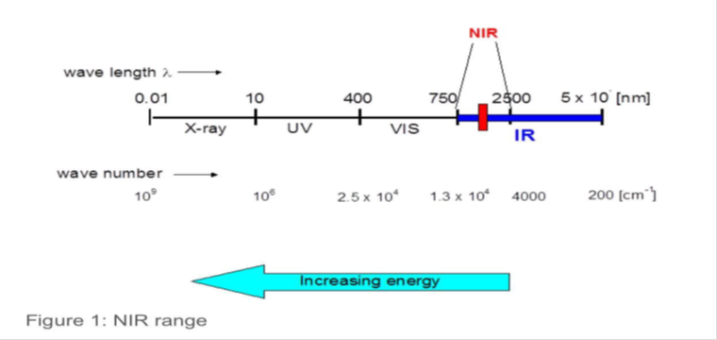

Since refraction is all about how the eyes bend (or refract) the light entering the eyes. The way they do this determines where light is focused onto the retina at the back of the eye, and therefore how clearly human can see. How well the eye refracts light is based on three things:

• Axial length, which is the shape of eye (how long or short it is)

• The curvature of cornea.

• The curvature of your lens (the clear lens in the eye that changes shape to help focus the light onto the retina).



***Principles of autorefractometers:***

• The Scheiner principle

• The optometric principle (retinoscopy principle)

• The best ‐focus principle

• The knife – edge principle

• The ray – deflection principle

• The image size principle

***The Scheiner’s Principle***

In 1619, Scheiner found that one can determine an eye’s refractive error from dual pinhole apertures before the pupil. His observations are as follows:

When a distant object’s parallel light rays enter the eye of an emmetropic patient, they point to the retina. However, the beams get restricted to two tiny bundles when a dual pinhole aperture is placed before the pupil.

One can observe two small light spots when the bundle of ray’s traverses before touching the retina. A Myopic eye results in such an observation.

Two small light spots also occur when the bundle of rays touches the retina before meeting. A Hypermetropic eye reveals such observations.



***The optometric principle (retinoscopy principle)***

Here, fundus reflex is being observed. Regarding Fundus Reflex, two characteristics are being seen.

• Direction of the motion of the Fundus Reflex compared to Incident beam.

• Speed of the motion of the Fundus Reflex compared to Incident beam.

***BEST FOCUS PRINCIPLE:***

To achieve the Neutralization, here actually highest contrast is being assessed during the target is focused on the Retina.

In case of Emmetropia, the images of a target are focused properly on the Retina and achieved highest contrast. But sometimes, images are focused on the Retina but Contrast level is diminished due to mild defocused on the Retina of the images of an object. By the changes of the vergence of the Incident rays may achieve best focus and highest contrast.

***AUTO REFLECTION BASED ON IMAGE SIZE OF THE FUNDUS REFLEX***

Here, fundus image size is measured at three or different meridians and calculates the Refractive error on the basis of ocular magnification and ocular minification compared to Emmetropia.

  


***Procedure:***

• For autorefractor testing, ask the patient to be seated on a chair in the diagnostic procedure room.

• The patient’s head will then be positioned so that their chin is resting on the chin rest and their forehead is resting on the forehead rest of the autorefractor.

• Then ask the patient to look on the target through right eye.

• Now you have to move the joystick to push the device left/right or up/down or front/back so that the image of the patient’s eye that you are viewing in the monitor is focused.

• Once the image is on focus, you must position the square on the center of the monitor at the pupil reflex.

• Once the square is positioned at the corneal reflex and the patient’s eye image is on focus you have to press the capture button on the joystick for three times

• When the capture button is pressed, the machine bounces off infra‐red rays from the retina (innermost light sensitive layer of the eye) back to device and takes a series of measurements to determine the patient’s refractive power. It will show three different reading of the patient’s refractive error and gives the average reading as the final reading for the refractive error.

• Finally, the device will print out the final prescription (average reading from the three readings) of the patient’s refractive error

• Repeat the above procedures for left eye.

Autorefractors are particularly beneficial for people who may have trouble concentrating during a longer exam, or have difficulty clearly describing their vision problems (such as small children, people with dementia, or a mental disability). It can give a quick, highly accurate measurement to determine whether any vision correction is needed, with minimal input.