***Lab5***

***Second stage***

***Medical Physical Department***

***Digital Electronics***

**Lab 5 :** **DeMorgan’s theory**

**By**

***Asst. Prof. Dr. Mehdi Ebady Manaa***

**DeMorgan’s theory**

**DeMorgan’s Theory – Background**

DeMorgan’s Theory is used to convert AND/NAND gates to OR/NOR ones, and presented OR/NOR gates by AND/NAND gates by these 2-laws:

$$A + B= (A'. B')'$$

$$A . B = ( A'+ B')'$$

**Basics of Boolean algebra**

Boolean Postulates

P1: X = 0 or X = 1 P2: 0 . 0 = 0

P3: 1 + 1 = 1

P4: 0 + 0 = 0

P5: 1 . 1 = 1

P6: 1 . 0 = 0 . 1 = 0

P7: 1 + 0 = 0 + 1 = 1

**Boolean Laws**

**Commutative Law**

A + B = B + A

A B = B A

**Associate Law**

(A + B) + C = A + (B + C)

(A B) C = A (B C)

**Distributive Law**

A (B + C) = A B + A C

A + (B C) = (A + B) (A + C)

**Identity Law**

A + A = A

A A = A

**Zero and one laws**

$$A + 1 = 1$$

$$A · 0 = 0$$

**De Morgan's Theorem**

http://www.ee.surrey.ac.uk/Projects/Labview/boolalgebra/graphics/tab2t11a.gif

http://www.ee.surrey.ac.uk/Projects/Labview/boolalgebra/graphics/tab2t11b.gif

### **Simplifying Boolean logic functions**

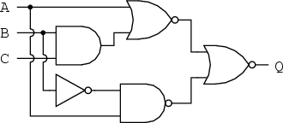Given the following circuit

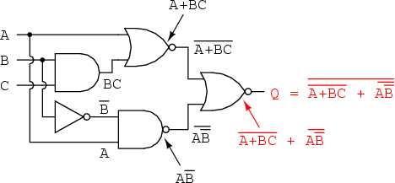The Boolean expression that represents the above circuit is as follows

We can simplify the above Boolean expression as follows

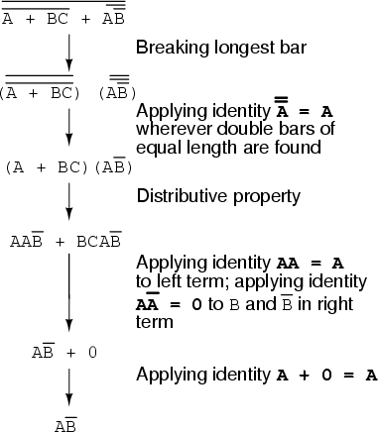

This means that the above circuit can be replaced by the following one

http://sub.allaboutcircuits.com/images/04306.png

## Lab Tasks

### Task 1: Circuit analysis

Find the Boolean expression that represents the outputs x and y shown in the following circuit.

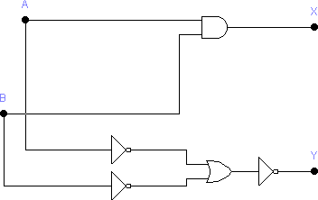

According to the circuit above find the equation of X and Y, then fill the truth table.

X =

Y =

|  |  |  |  |
| --- | --- | --- | --- |
| A | B | X | Y |
| 0 | 0 |  |  |
| 0 | 1 |  |  |
| 1 | 0 |  |  |
| 1 | 1 |  |  |

What do you notice?

**Task 2: Circuit analysis**

Find the Boolean expression that represents the outputs x and y shown in the following circuit.

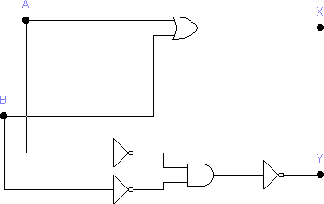

According to the circuit above find the equation for X and Y, then fill the truth table.

X =

Y =

|  |  |  |  |
| --- | --- | --- | --- |
| A | B | X | Y |
| 0 | 0 |  |  |
| 0 | 1 |  |  |
| 1 | 0 |  |  |
| 1 | 1 |  |  |

What do you notice?