***Lab 4***

***Second stage***

***Medical Physical Department***

***Digital Electronics***

**Lab 4 :** **Boolean expression**

**By**

***Asst. Prof. Dr. Mehdi Ebady Manaa***

**Boolean expression**

***Objectives***

* To learn how to directly convert a Boolean expression to circuit.
* To learn how to analyze a given digital logic circuit by finding the Boolean expression that represents the circuit
* To learn how to analyze a given digital logic circuit by finding the truth table that represents the circuit.

**Example:**

$$Z = A + B . C'$$

The above function is implemented in the following digital logic Circuit

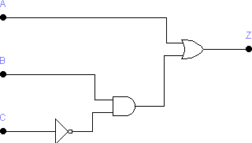

Now after drawing the circuit above using EWB we find that its truth table is as shown below ( notice that logic **1 means connect** the input to the Vcc line, and logic **0 means connecting** the input to the ground)

|  |  |  |  |
| --- | --- | --- | --- |
| A | B | C | Z |
| 0 | 0 | 0 | 0 |
| 0 | 0 | 1 | 0 |
| 0 | 1 | 0 | 1 |
| 0 | 1 | 1 | 0 |
| 1 | 0 | 0 | 1 |
| 1 | 0 | 1 | 1 |
| 1 | 1 | 0 | 1 |
| 1 | 1 | 1 | 1 |

***Lab Tasks***

**Task 1: Converting Boolean expressions into circuits**

Convert the following Boolean expression to a circuit, draw the circuit on EWB and simulate it to fill-in its truth table shown below.

$$X = Y + Z . Y'$$

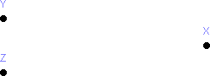Draw the circuit in the space below

Now, fill-in the truth table of the circuit you drawn

|  |  |  |
| --- | --- | --- |
| Y | Z | X |
| 0 | 0 |  |
| 0 | 1 |  |
| 1 | 0 |  |
| 1 | 1 |  |

**Task 2: Converting Boolean expressions into circuits**

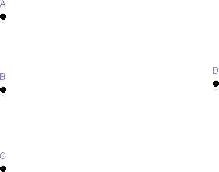Convert the following Boolean expression to a circuit, draw the circuit on EWB and simulate it to fill-in its truth table shown below.

|  |  |  |  |
| --- | --- | --- | --- |
| A | B | C | D |
| 0 | 0 | 0 |  |
| 0 | 0 | 1 |  |
| 0 | 1 | 0 |  |
| 0 | 1 | 1 |  |
| 1 | 0 | 0 |  |
| 1 | 0 | 1 |  |
| 1 | 1 | 0 |  |
| 1 | 1 | 1 |  |

**Task 3: Digital logic circuit analysis – Finding the Boolean expression of a given circuit**

Find the Boolean expression of the following circuit, draw the circuit on EWB and simulate it to fill-in its truth table shown below.

W =

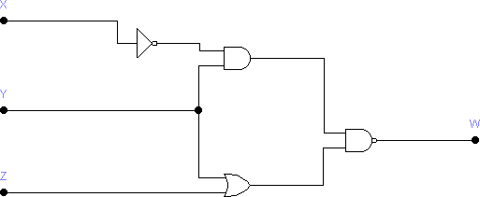

Note: the logic converter tool from EWB to fill-in the following table. For that, you need to connect the A, B and C inputs of the logic converter to X, Y and Z lines, respectively. Further, you need to connect the ‘out’ line of the logic converter to W. As shown in the following diagram

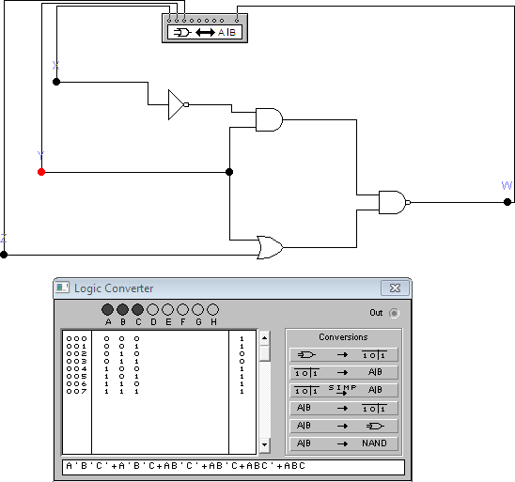

|  |  |  |  |
| --- | --- | --- | --- |
| X | Y | Z | W |
| 0 | 0 | 0 |  |
| 0 | 0 | 1 |  |
| 0 | 1 | 0 |  |
| 0 | 1 | 1 |  |
| 1 | 0 | 0 |  |
| 1 | 0 | 1 |  |
| 1 | 1 | 0 |  |
| 1 | 1 | 1 |  |