***Lab 3***

***Second stage***

***Medical Physical Department***

***Digital Electronics***

**Lab 3 : The NAND and NOR Gates**

**By**

***Asst. Prof. Dr. Mehdi Ebady Manaa***

**The NAND and NOR Gates**

1. **The NAND Gate**

The NAND gate function is the complement of the AND  
function, as indicated by a graphic symbol which consists of an AND  
graphic symbol followed by a small circle (bubble) which represents  
the NOT gate that is shown in Fig. (1) and the truth table shown in  
Table (1).

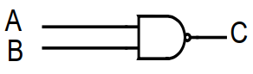

Fig. (1) Logic Symbol for NAND gate

**Table (1) Truth table for NAND gate**

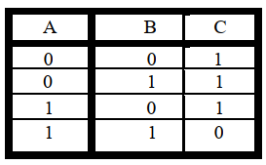

**The NOR Gat**

The NOR function is the complement of the OR function and  
uses an OR graphic symbol followed by small circle (bubble) which  
represents NOT gate. That is shown in Fig. (2) and the truth table shown in Table (2).

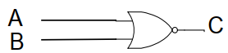

Fig (2) Logic Symbol for NOR gate.

**Table (2) Truth table for NOR gate**

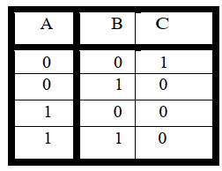

1. ***Background***

The NAND gate represents the complement of the AND operation. Its name is an abbreviation of NOT AND. The graphic symbol for the NAND gate consists of an AND symbol with a bubble on the output, denoting that a complement operation is performed on the output of the AND gate.

The NOR gate represents the complement of the OR operation. Its name is an abbreviation of NOT OR. The graphic symbol for the NOR gate consists of an OR symbol with a bubble on the output, denoting that a complement operation is performed on the output of the OR gate.  
A universal gate is a gate which can implement any Boolean function without need to use any other gate type. The NAND and NOR gates are universal gates. In practice, this is advantageous since NAND and NOR gates are economical and easier to fabricate and are the basic gates used in all IC digital logic families. In fact, an AND gate is typically implemented as a NAND gate followed by an inverter not the other way around!! Likewise, an OR gate is typically implemented as a NOR gate followed by an inverter not the other way around!!

1. **Implement any gate with NAND gates only**

To build an inverter (**NOT** gate) using a NAND gate: All NAND input pins connect to the input signal A gives an output A’. An **AND** gate can be replaced by NAND gates as shown in the figure (The AND is replaced by a NAND gate with its output complemented by a NAND gate inverter). An **OR** gate can be replaced by NAND gates as shown in the figure (The OR gate is replaced by a NAND gate with all its inputs complemented by NAND gate inverters).  
The following figure shows all cases presented above

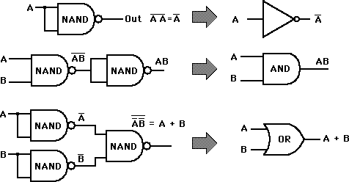

1. 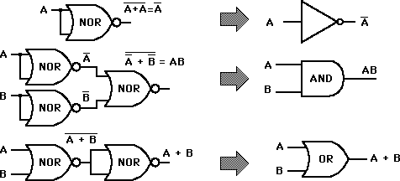**Implement any gate with NOR gates only**

To build an inverter (**NOT** gate) using a NOR gate: All NOR input pins connect to the input signal A gives an output **A'**.

An OR gate can be replaced by NOR gates as shown in the figure (The OR is replaced by a NOR gate with its output complemented by a NOR gate inverter). An AND gate can be replaced by NOR gates as shown in the figure (The AND gate is replaced by a NOR gate with all its inputs complemented by NOR gate inverters). The following figure shows all cases presented above

1. **Equivalent Gates**

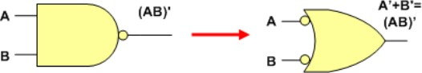A NAND gate is equivalent to an inverted-input OR gate.

An AND gate is equivalent to an inverted-input NOR gate.

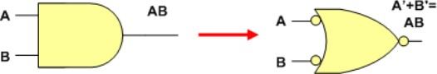

A NOR gate is equivalent to an inverted-input AND gate.

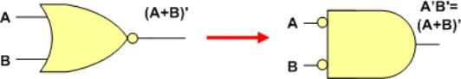An OR gate is equivalent to an inverted-input NAND gate.

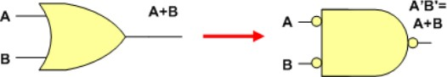

1. **Building Circuits using NAND and NOR gates only**

**Example**: Building Circuits using NAND gates only

Implement the following function using AND, OR gates

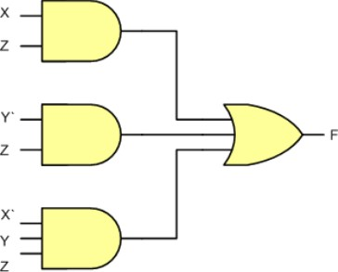

$$F = XZ + Y'Z + X'YZ$$

Re-implement the same function above using NAND gates only

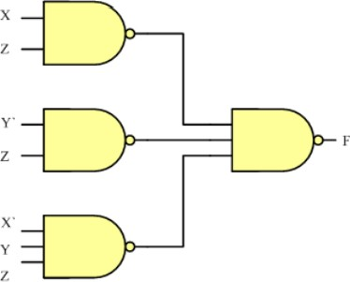

## Lab Tasks

### **Task 1: The Universal NAND gate**

Use EWB to show that the following gates are equivalent

### **Task 2: The Universal NOR gate**

Use EWB to show that the following gates are equivalent

**Task 3: Implementing circuits using NOR gates only**

Implement the following function using AND, OR gates

$$F=(A+B).C'+A'D$$

Re-implement the same function above using NOR gates only

Show, using EWB, that both circuits are equivalent

**Task 4: Implementing circuits using NAND gates only**

Implement the following function using NAND gates (Use the logic converter in EWB)

F= AB(A+C'D)+A'C'B

To do so, you need to write the Boolean algebra expression to implement and the press the  button in the logic converter as shown next

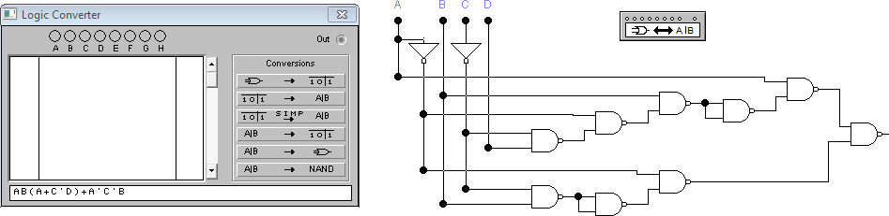

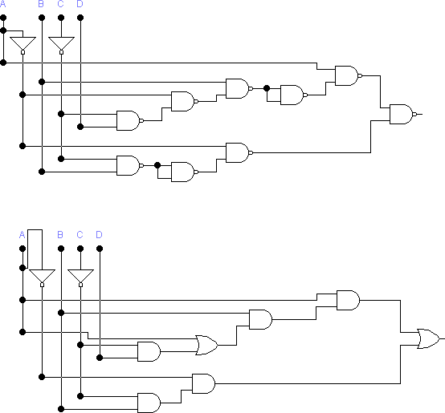The solution should look like as follows