General Physics
Experimental Lecture 1
Ohm’s Law

1st stage

by
Assistant lecturer
Ansam Fadil Ali Showard

2022-2023

Objective:
To find the relationship between voltage and current (investigate the Ohm's Law)

Apparatus:
• Power supply
• Connecting wires
• resistances
• Ammeter
• Voltmeter

Theory:
In this lab, you will construct a simple circuit using a single known resistance, R. Then you will use an ammeter to measure the current, I, through the resistance and a voltmeter to measure the potential difference, V, across the resistance. With this data, you can check the validity of Ohm's Law (V = IR) in the circuit.
Procedure:
1. Connect the circuit shown below using a fixed resistance R.
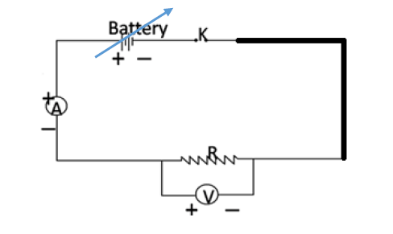

2. Set the value of electromotive force into certain voltage (electromotive force).
3. You can get different readings of the current I and voltage V by varying the battery source.
4. Record the value of the current through the resistance and the voltage across it.
5. Repeat step 3 to get at least 6 different readings.
6. Record the data in the Table.

Voltage (V) | Current (A)
0.10 | 0.01
0.23 | 0.03
0.36 | 0.05
0.42 | 0.07
0.52 | 0.09

7. Plot a graph of the voltage (V) and the current (I), with V on vertical axis and (I) on horizontal axis. Draw the best straight line fit of the data.
8. Determine the slope of the straight line which is the resistance R in this case.
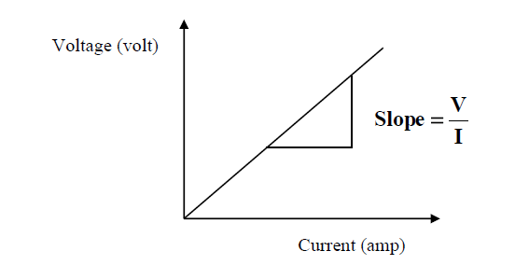

------------------------------------------------------------
Example 1: If the resistance of an electric iron is 50 Ω and a current of 3.2 A flows through the resistance. Find the voltage between two points.
Solution:
If we are asked to calculate the value of voltage with the value of current I and resistance R, we use the following formula to calculate the value of V:
R = V/ I
V = I × R
Substituting the values in the equation, we get
V = 3.2 A × 50 Ω
V = 160 V

Example 2: An EMF source of 8.0 V is connected to a purely resistive electrical appliance (a light bulb). An electric current of 2.0 A flows through it. Consider the conducting wires to be resistance-free. Calculate the resistance offered by the electrical appliance.
Solution:
When we are asked to determine the value of resistance when the values of voltage and current are given, we cover R in the triangle. This leaves us with only V and I, more precisely V ÷ I.
Substituting the values in the equation, we get
R = V ÷ I
R = 8 V ÷ 2 A
R = 4 Ω

