**The microscopes**

Microscope

A microscope is a high precision optical instrument that uses a lens or a combination of lenses to produce highly magnified images of small specimens or objects especially when they are too small to be seen by the naked (unaided) eye. A light source is used (either by mirrors or lamps) to make it easier to see the subject matter.

A microscope can be used for numerous things:

1- hobbyists have an interest in microscope worlds from learning and having fun to using a microscope for the study of stamps, coins, gems, insects, etc .

2- medical uses from analysis to advanced research in many and varied disciplines .

3- students have an interest in pursuing knowledge anywhere from middle school through the university level.

4- industrial uses as inspection and measurement tools.

5- imaging of whatever you are looking at.

**Parts of the microscope**

**1. Ocular Lens (Eyepiece**): where you look through to see the image of your specimen. Magnifies the specimen 10X actual size.  
**2. Body tube**: the long tube that supports the eyepiece and connects it to the objectives.

**3. Nosepiece:** the rotating part of the microscope at the bottom of the body tube, it holds the objectives.

**4. Objective Lenses:** (low, medium, high). Depending on the microscope, may have 2, 3 or more objectives attached to the nosepiece; they vary in length (the shortest is the lowest power or magnification; the longest is the highest power or magnification).

4 × (very low power objective)

10 × (low power objective)

40 × (High power objective)

100 × (Oil immersion objective)

It also contains a fixed ocular (eye piece) lens, usually of 10 × or 5×.

**5. Arm**: part of the microscope that you carry the microscope with,  
connects the head and base of the microscope.

**6. Coarse Adjustment Knob**: large, round knob on the side of the  
microscope used for "rough" focusing of the specimen; it may  
move either the stage or the upper part of the microscope. Location may vary depending on microscope; it may be on the bottom of the arm or on the top.

**7. Fine Adjustment Knob**: small, round knob on the side of the  
microscope used to fine-tune the focus of specimen after using the  
coarse adjustment knob. As with the Coarse Adjustment Knob,  
location may vary depending on the microscope.

**8. Stage**: large, flat area under the objectives; it has a hole in it (see  
aperture) that allows light through; the specimen/slide is placed on  
the stage for viewing.

**9. Mechanical stage knobs**: Consist of 2 knobs, used for movement of the stage on the (x,y) direction .

**10. Stage Clips**: clips on top of the stage which holds the slide in  
place.  
**11. Aperture:** the hole in the stage that concentrates light through the specimen for better viewing.

**12. Diaphragm**: controls the amount of light going through the  
aperture; may be adjusted.

**13.Light or Mirror**: source of light usually found near the base of the microscope; used to direct light upward through the microscope. The light source makes the specimen easier to see.

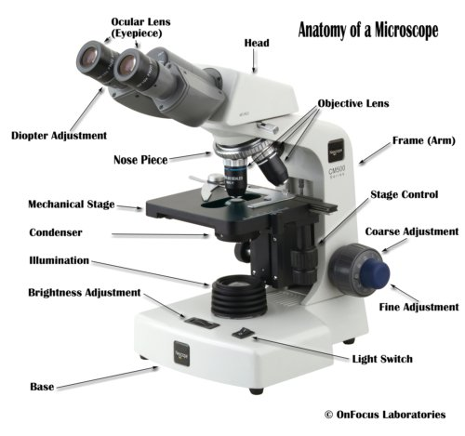

**Types of objective lenseses**

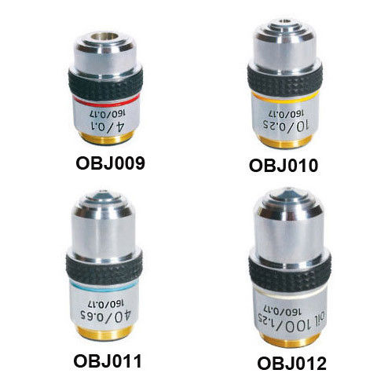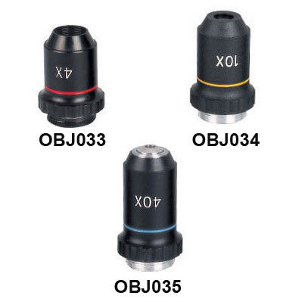

**Types of Eyepiece lens**

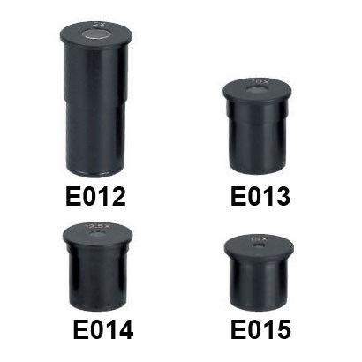

**Method of magnification**

A-Direct illumination: where the light bulb is located inside the base directly below the condenser, usually neutral filter or colored filter is put just on the light source.

B- Indirect illumination: where we have a mirror in place of the light bulb, light strikes the mirror and the light reflected through the condenser to the specimen.

Type of condenser:

1-Bright – field condenser

2- Dark – field condenser