***Lecture 1***

***Fourth stage***

***Medical Physical Department***

***Medical Image Analysis-II***

**Digital Image Acquisition**

**X-ray Imaging, Magnetic Resonance Imaging**

**By**

***Asst. Prof. Dr. Mehdi Ebady Manaa***

### **Medical Images**

Medical images are pictures of distributions of physical attributes captured by an image acquisition system. Most of today’s images are digital. They may be post-processed for analysis by a computer-assisted method. Medical images come in one of two varieties: Projection images project a physical parameter in the human body on a 2D image, while slice images produce a one-to-one mapping of the measured value. Medical images may show anatomy including the pathological variation of anatomy if the measured value is related to it or physiology when the distribution of substances is traced. X-ray imaging, CT, MRI, nuclear imaging, ultrasound imaging, photography, and microscopic images are types of medical images.

**Concepts, notions and definitions**

* Imaging techniques: x ray, fluoroscopy and angiography, DSA, x-ray CT, CT angiography, MR imaging, MR angiography, functional MRI, perfusion MRI, diffusion MRI, scintigraphy, SPECT, PET
* Reconstruction techniques: filtered backprojection, algebraic reconstruction, EM algorithms
* Image artefacts: noise, motion artefacts, partial volume effect, MR-specific artefacts, ultrasound-specific artefacts

A major difference between most digital medical images and pictures acquired from photography is that the depicted physical parameters in medical images are usually inaccessible for inspection (see Fig. 2.1). Features or quantities determined by computer-assisted analysis cannot easily be compared with true features or quantities. It would be, e.g., infeasible to open the human body to verify whether a tumor. volume measured in a sequence of CT images in some posttreatment confirmation scan corresponds to the true volume. Fortunately, the physical property depicted, its diagnostic value, and possible artefacts are usually well known. Furthermore, the imaging technique has been chosen on purpose because it is known to produce images that depict diagnostically relevant information. The development of efficient analysis techniques often uses this knowledge as part of the domain knowledge to make up for the inaccessibility of the measured property. A physical property measured by an imaging device and presented as a picture must meet three conditions to be useful. It has to penetrate the human body, it must not unduly interfere with it, and it must be meaningful for answering some medically relevant question.

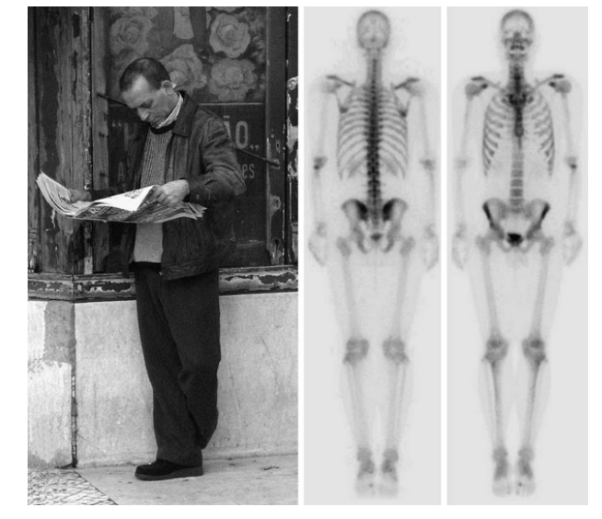

**Fig. 2.1 Information from a photography is quite different from that of a medical image (in this case a bone scintigraphy, published under Creative Commons license). While the human depicted in the photo looks familiar, interpretation of the image on the right requires expertise with respect to the meaning of the intensities. On the other hand, specific domain knowledge exists as to how to interpret image intensity in the scintigraphy and the image is acquired in a way that makes analysis as easy as possible, all of which cannot be said about the picture on the left. Obviously, the kind of task for computer-based image analysis is different for these two pictures**

With respect to digital imaging, four major and several minor imaging techniques meet these requirements. The major techniques are as follows.

* **X-ray imaging** measures the absorption of short wave electromagnetic waves, which is known to vary between different tissues.
* **Magnetic resonance imaging** measures the density and molecular binding of selected atoms (most notably hydrogen which is abundant in the human body), which varies with tissue type, molecular composition, and functional status.
* **Ultrasound imaging** captures reflections at the boundaries between and within tissues with different acoustic impedance.
* **Nuclear imaging measures** the distribution of radioactive tracer material administered to the subject through the blood flow. It measures function in the human body.

Other imaging techniques include **EEG and MEG imaging, microscopy, and photography**. All the techniques have in common that an approximate mapping is known between the diagnostic question, which was the reason for making the image and the measurement value that is depicted. This can be very helpful when selecting an analysis technique. If, for instance, bones need to be detected in an x-ray, CT slice, a good first guess would be to select a thresholding technique with a high threshold because it is known that x-ray attenuation in bone is higher than in soft tissues and fluids. Many of the imaging techniques come in two varieties: Projection images show a projection of the 3D human body onto a 2D plane and slice images show a distribution of the measurement value in a 2D slice through the human body. **Slice images may be stacked to form a volume.** Digitized images consist of a finite number of image elements. Elements of a 2D picture are called pixels (picture elements) and elements of stacked 2D slices are called voxels (volume elements). We will call pixels or voxels scene elements if the dimension of the scene is not known or not important.

2D and 3D images may have an additional time dimension if the variation along the time axis provides additional diagnostic information (e.g., if normally and abnormally beating hearts are compared). Slice images are usually reconstructed from some kind of projection. Reconstruction may cause additional artefacts.

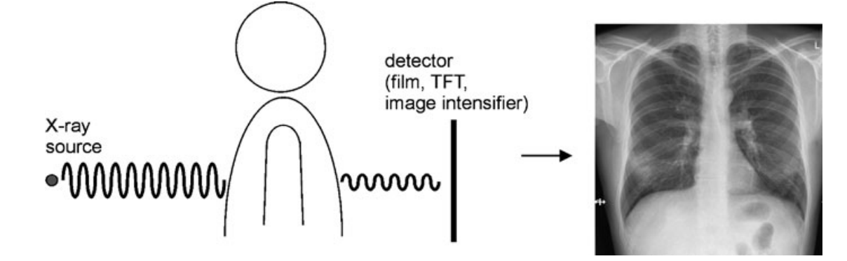

**Fig. 2.2 X-rays penetrate the human body and produce an image that shows the integral of tissue-specific absorption along a path from the X-ray source**

### **X-Ray Imaging**



X-ray imaging uses the dependency of photoelectric absorption on the atomic number for producing a diagnostically meaningful image (see Fig. 2.3 for examples). Being the oldest technique, a vast number of different imaging methods evolved from the original method presented by C.W. Röntgen (Wilhelm Conrad Röntgen ,  27 March 1845 – 10 February 1923) was a German [mechanical engineer](https://en.wikipedia.org/wiki/Mechanical_engineering) and [physicist](https://en.wikipedia.org/wiki/Physicist), who, on 8 November 1895, produced and detected [electromagnetic radiation](https://en.wikipedia.org/wiki/Electromagnetic_radiation) in a [wavelength](https://en.wikipedia.org/wiki/Wavelength) range known as [X-rays](https://en.wikipedia.org/wiki/X-ray) or Röntgen rays, an achievement that earned him the inaugural [Nobel Prize in Physics](https://en.wikipedia.org/wiki/Nobel_Prize_in_Physics) in 1901) .

In this section we will only touch on the subject to give an impression of how the images are created and what kind of different x-ray imaging techniques exist.

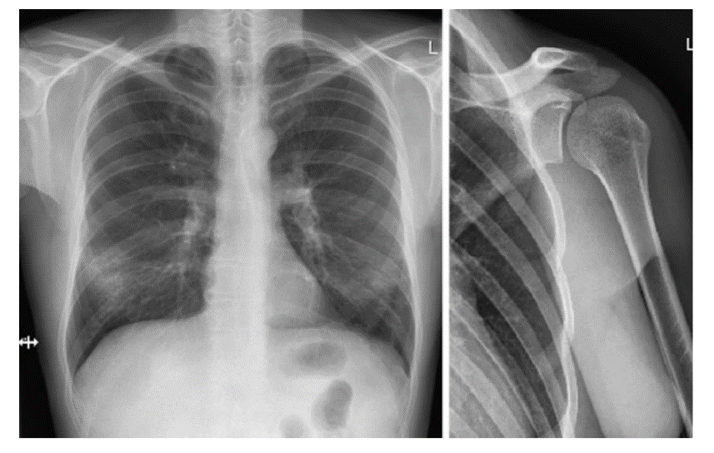

**Fig. 2.3 Two radiographs Bone structures in the two images are clearly visible. Differentiating between different soft tissues is more difficult as is the depth order of the projected structures**

*Diagnostic equipment for x-ray imaging consists at least of a cathode ray tube emitting x rays and a receptor with the patient placed between the emitter and receptor*. The receptor may be film, an image intensifier, or a flat panel detector with the latter two producing digital images. If the x-ray tube is assumed to be a point source for x rays and the receptor is planar, the image intensity at every location of the receptor will be proportional to the attenuation along a ray from the x-ray tube to the receptor. The measured intensity for a monochromatic beam at a location (x,y) on the receptor is then

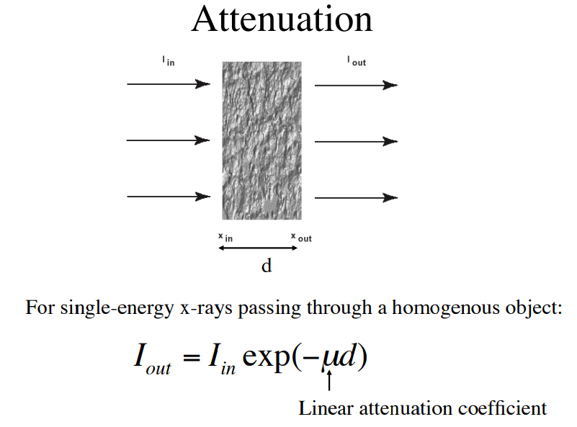

The imaging process described above is idealized in that it assumes that the xray source is a point source. In reality, the focal spot of an x-ray source covers a finite area leading to a loss of resolution due to penumbrae. Its extent depends on the distances between the source, object, and receptor, as well as on the diameter of the focal spot (see Fig. 2.4). Regular x-ray CRTs have a focal spot with a diameter of 1 mm, fine focus CRTs have one with a 0.5-mm diameter and microfocus CRT has a 0.2-mm diameter focal spot.

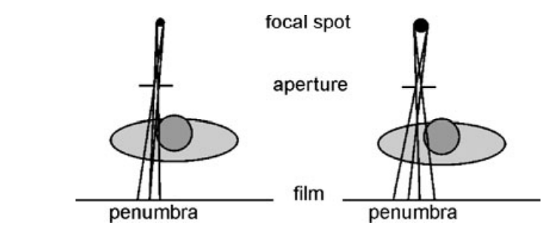

**Fig. 2.4 Different sizes of the focal spot cause different blurring even if the aperture is the same**

Images from an image intensifier suffer from a number of artefacts of which the following three are relevant for postprocessing (see Fig. 2.5).

* **Vignetting**التضليل is caused by the angle at which rays fall onto the input screen. The angle is perpendicular to the image screen in the center. In this case, the incident x-ray energy is distributed over the smallest possible area. The intensity (i.e., the energy per unit area) is maximal. The angle decreases with the distance to the center, causing the incident x-ray energy to be distributed over a larger area. Hence, the intensity decreases with the distance to the center.
* **Pincushion distortion** التشويهis caused by the curvedness of the input screen and results in magnification. Magnification increases with the deviation of the input surface from a tangent plane to the center of the screen.
* **The S-distortion** is caused by external electromagnetic fields that influence the course of the electron beam between the input and output phosphor.

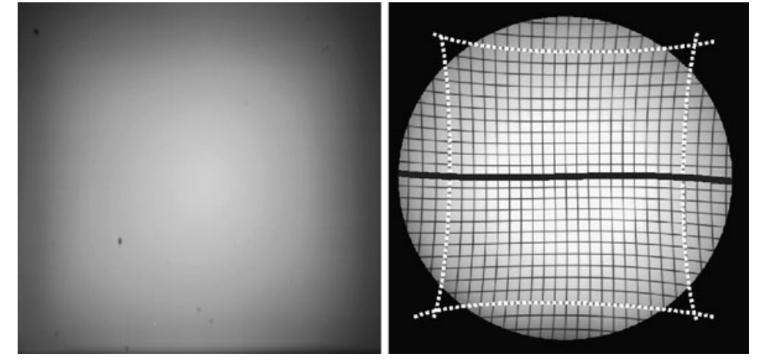

**Fig. 2.5 Vignetting causes shading in an image as it can be seen in the picture of homogeneous material on the left. The location dependent magnification by a pincushion distortion of an image intensifier is seen on the test pattern of equal-sized squares on the right (dashed lines). This image also shows the much less rominent deformation due to the earth magnetic field**

### **Magnetic Resonance Imaging**

Protons and neutrons of the nucleus of an atom possess an angular momentum that is called *spin*. These spins cancel if the number of subatomic particles in a nucleus is even. Nuclei with an odd number exhibit a resultant spin that can be observed outside of the atom. This is the basis of magnetic resonance imaging (MRI). In MRI, spins of nuclei are aligned in an external magnetic field. A high frequency electromagnetic field then causes spin *precession* السبق that depends on the density of magnetized material and on its molecular binding. The resonance of the signal continues for some time after this radio signal is switched off. The effect is measured and exploited to create an image of the distribution of the material. Magnetic resonance imaging almost exclusively uses the response of the hydrogen nucleus which is abundant in the human body. Variation of hydrogen density and specifically its molecular binding in different tissues produces a much better soft tissue contrast than CT. MRI has some further advantages if compared with x-ray CT.

* MRI does not use ionizing radiation. • Images can be generated with arbitrary slice orientation including coronal and sagittal viewsالمنظور الاهليلي والسهمي.
* Several different functional attributes can be imaged with MRI. In summary, MRI is a remarkably versatile imaging technique justifying an extended look at the technique.

