***Lecture 3***

***Fourth stage***

***Medical Physical Department***

***Medical Image Analysis***

**Image Storage and Transfer.**

**Information Systems in a Hospital, the DICOM File Format.**

**By**

***Asst. Prof. Dr. Mehdi Ebady Manaa***

1. **Image Storage and Transfer**

Medical images are created, stored, accessed, and processed in the restricted environment of a hospital. The semantic of a medical image is driven by the particular purpose for creating it. This results in specific solutions for the archiving of medical images. Transfer is different for medical images as well as it is driven by the technical specification of the various image acquisition systems and the particular requirements of the users of these images. The archiving and transfer of images is governed by two standards (HL7 and DICOM) that will be discussed in this lecture. The goal of the presentation is to enable the reader to understand the way images are stored and distributed in a hospital. It should further enable the reader to access images if some analysis method shall be applied to it and to decide how to implement such an analysis method in a clinical environment.

**Concepts, notions and definitions introduced in this lecture**

* Information systems: the role of HIS, RIS, and PACS
* Basic concepts of HL7
* Introduction to the DICOM standard: information objects and services, establishing DICOM connectivity, the DICOM file format
* Technical properties of medical images › Medical workstations

It is likely that the first problem encountered when processing a digital medical image is how to access the image within the framework of information systems in the hospital. It will be difficult to set up a useful software module for post-processing images without some basic understanding as to how they are archived and transferred. Although experienced users in the hospital may be able to help, an image processing expert is generally assumed to be sufficiently knowledgeable with respect to data bases and information systems.

Medical images differ from other images in several aspects. This has an impact as to how they can be accessed. The most obvious of these aspects is that medical images receive their semantics only within the context in which they were created. Context information includes, for instance, demographic information about the person who was imaged, technical details about the image acquisition system, or the reason for the examination. Context information about medical images is much more extensive than for other images, where information about the size and quantization may suffice. For reasons of data integrity and data security, context needs to be firmly associated to the image. A second important difference is that medical images are mappings of measurements of very different origins into a pictorial representation. Although photographs are used in diagnosis and treatment planning as well, medical imaging goes far beyond this, hence adding to the requirements for image meta-information. An unknown number of details about different image acquisition techniques have to be stored with the image. Storing meta-information describing the different parameters related to some image acquisition system efficiently leads to image formats that are different from conventional formats such as JPEG or PNG. A third aspect that differentiates medical images from other pictures is that the use of medical images is highly constrained and regulated. Medical images contain sensitive personal information of which misuse must be prevented. Images have often been acquired for justifying quite invasive actions (a decision in diagnosis or therapy with its consequences) that have to be executed with care and responsibility. A system where such images are created, stored, and accessed must be designed in a way that actively supports these goals. In consequence, images must not be accessed out of a framework that guarantees that the purpose of image access serves the intention for creating and keeping the image. If a user intends to apply computer-based analysis techniques on a medical image he or she should be aware of the points raised above. Hence, we will give an overview about storing and accessing medical images in a hospital. The class is not meant to be a comprehensive description about information systems in a hospital in general. We will mainly focus on topics that are directly related to images in the information system.

* 1. **Information Systems in a Hospital (HIS)**

Images may be generated from patients who are either admitted to the hospital or who are sent in for outpatient examination. In either case, information is acquired that is necessary for the management of the actions performed while the patient is in the hospital. Hence, this information has to be accessible at various places (see Fig. 3.1). This includes information

* which is necessary for administrating the patient’s stay such as patient demographics, billing information, and so on;
* which is necessary for performing the examination to which the images belong such as patient demographics, anamnesis, reports, and so on.
* which is necessary for interpreting the images such as patient demographics, reports, imaging device information, the images themselves, and so on.

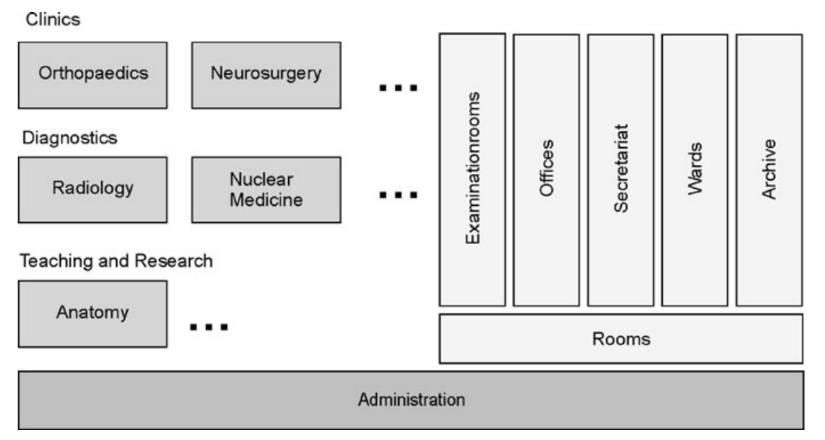

Fig. 3.1 Schematic view at functions and location in a hospital that deal with images or information related to images

The information is kept in different information systems in the departments of the hospital. Patient administration data are kept in the Hospital Information System (HIS). The HIS maps the internal structure of a hospital (its departments, clinics, its access points for getting administrative information) into a data base representation and governs access to this information. Ideally, a HIS would replace all paper files documenting a patient’s stay. Any authorized person at any location in a hospital would have immediate access to this information. It requires that a modern hospital is equipped with the necessary network infrastructure, storage devices, and access points (such as PCs on the network). Such an environment exists in many modern hospitals. Communication is often realized as a type of intranet solution to prevent unauthorized access. With increasing decentralization (outpatient care, outsourcing of administrative and technical support, teleradiologyالطب الاشعاعي , etc.), the secure and authorized access to this and other information systems from the outside world has become necessary and possible. Data about radiological examinations are kept in a different system, which is called a Radiology information system (RIS, see Fig. 3.2). The reason for this and other independent subsystems within the hospital is the complexity of the information structure and information flow. Modularization keeps the information where it is needed with well-defined interfaces governing the information exchange between systems. It also helps to prevent unauthorized access. Department policy may prohibit, for instance, that an image created in a Radiology Department may be accessed without having a report from the Radiology Department associated to it.

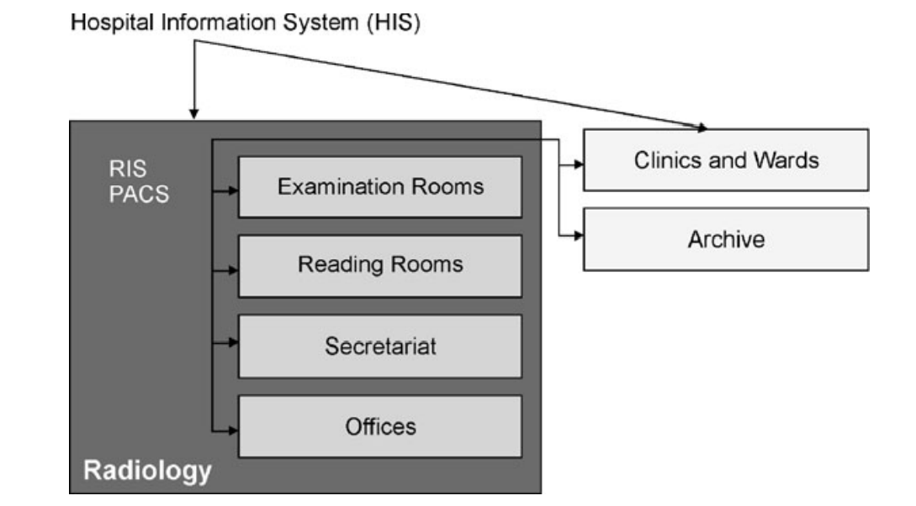

Fig. 3.2 The departmental Radiology Information System (RIS) and the Picture Archiving and Communication System (PACS) are responsible for organizing, transferring and archiving image data and image meta data

It gave rise to the introduction of another image information system, which is called a Picture Archiving and Communication System (PACS, see Fig. 3.3). First PACSs were introduced in the early 1980s. A PACS should archive and distribute pictures together with the related information within radiology and to the departments who ordered the images. Besides the images, this information includes patient demographics, information about reports, as well as technical information about the images such as the imaging device and its technical parameters.

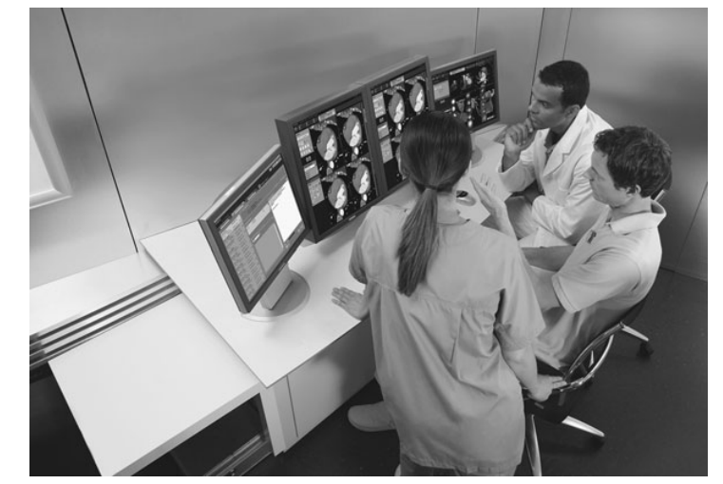

Fig. 3.3 In a PACS, the user has access to images from acquisition systems, workstations and the archive. It usually requires a specific monitor configuration to render images, meta-information, and the interface to administer data access in a suitable way

The task may also be part of the PACS. In this case, access requires only communication with the PACS. In fact, the separation between RIS and PACS is much less obvious than that between HIS and RIS. For the latter, a clear hierarchy between the hospital and departmental information systems is reason for different systems, while for the former one a synchronicity of the development and type of data (text vs. images) is the main reason. In the future, PACS and RIS will probably fuse into a single departmental information system. Two different communication standards evolved: the HL7 messaging standard and DICOM. HL7 (Health Level 7) was developed for standardizing communication between clinical information systems, whereas DICOM   
(Digital Imaging and Communications in Medicine) is specifically targeted at standardizing the communication of images. The former plays a role when connecting HIS, RIS, and PACS systems and it will be briefly reviewed here. The latter mainly standardizes image communications between the components of a PACS system. As such, it will be a likely interface encountered by somebody wishing to access images stored in some picture archiving system. It will be reviewed in more detail in the next section. HL7 is a standard developing organization that is accredited by the American National Standards Institute (ANSI). It is devoted to developing standards for communication in the health care business. The name HL7 stands for Health Level 7 and it refers to the application layer (the seventh layer) of the OSI (open systems interconnect)

The OSI model is a framework for layered protocols in network communication. The application layer provides application-specific protocols for communication including information about the authentication of communication partners, quality of service of the communication, and syntax of the messages exchanged. HL7 is not a complete specification of such a protocol (such as DICOM, see below), but describes the syntax and semantics of messages on this layer. For establishing communication a layer-7-protocol is still to be agreed upon by which these messages are exchanged (such as, e.g., FTP).

* 1. **The DICOM Standard**

When digital image acquisition systems such as x-ray computed tomography appeared in the clinics, the medium for data exchange and archival was film. Even though the data were created digitally, they were printed on film when sent away for reporting, for transferring them to the referring physician, or for archiving. Digital images were stored digitally as well, but mainly for internal reasons related to the local infrastructure around the image acquisition system. There, digital images could be displayed on a local workstation, simple image analysis tools could be applied, or images could be selected that should be printed on film. Initially, digital communication with other systems was not considered. Consequently, most vendors developed their own formats to store information deemed necessary for the purposes mentioned above. The decision about what information to store was dictated by the need to preserve the semantically relevant information produced. This includes the following.

* Patient information: Name and demographic information, identification in other information systems in the hospital, and so on.
* Examination information: Referring clinic and/or physician, examination type, and so on.
* Technical information: Many image acquisition systems require careful parameter selection controlling the acquisition process. A description of an x-ray CT, for instance, would include the wavelength and amplitude of radiation, number and spacing of slices, spatial resolution within slices, reconstruction method and reconstruction kernel, and so on.
* (Auxiliary) reporting information: Measurements and annotations being created during reporting, and so on.
* The image or image sequence. If sequences of images are generated, this information is often tagged to every single image of the sequence. DICOM stands for digital image communication in medicine and is a full-fledged specification of the application layer of the OSI model. For the communication of medical images it replaces other file communication protocols such as, e.g., FTP.

On the other hand, DICOM-conform machinery greatly simplifies the connectivity between the imaging components and the hospital information system. Today, it will be difficult to sell a major imaging device that does not conform to the standard. DICOM is an interface standard similar to HL7. Internal communication is still vendor-specific. DICOM is designed to standardize communication between components such as imaging systems, printers, archives, and workstations. Formerly, these were often stand-alone system clusters communicating through specialized interfaces. This meant, for instance, that a CT image acquisition device of manufacturer X and an MRI device of manufacturer Y both required their own printer, archive, and workstation. Not only does this inhibit combined access to images from both devices, it also results in an inefficient use of hardware resources.

**1.3 The DICOM File Format**

User-implemented image analysis methods usually are not directly integrated into software on a medical workstation communicating via DICOM with an archive or the image acquisition system. In most cases, the images to be analyzed are accessed as files stored on some offline medium. Chapter 10 of the DICOM standard describes a file format standard for communication using offline media. Since the file format has to support the storage of many different types of information objects, it has to be highly variable. On the other hand, the necessary effort for reading a file should be minimal. The two goals have been achieved by choosing a tagged format. Each tag relates to some data element (e.g., the patient name) of an information object. Its description can be found in a data dictionary. The name of the DICOM file is its UID. Its content consists of a header of a fixed length followed by a sequence of tagged data elements. The header contains the following.

* A 128-byte preamble, which is meant to support specific DICOM implementations. It does not have to follow the tagged structure of the DICOM file. If it is not used, it should be filled with zeroes.
* A four byte identification by the ASCII codes of the letters “D,” “I,” “C,” and “M.” Again, this information is not tagged.
* A mandatory set of data elements containing meta-information about the file. Each of the data elements has to follow the tagged file format described below. A data element consists of three parts: the tag, the length of the data element specified by the tag, and the information itself. The tag consists of a 4-byte group number and a 4-byte element number. The length of the tag is a 4-byte element following the tag and indicates the number of bytes reserved for the following information. Medical images may come with two, three, or four dimensions. 2D images may be slices of the human body such as an ultrasound image or a single CT slice. They may also be projections of a 3D scene such as an x-ray image or a scintigram. 3D images are volumes of the human body such as a 3D sequence from computed tomography, or time sequences of 2D images. 4D images are 3D volumes``` acquired over time. The DICOM file format in which images are stored often treats 2D images as an information unit even if they are part of a 3D or 4D sequence. A 3D data set is then treated as a sequence and a 4D data set is treated as a study of several sequences.