*** Lecture 9***

***Fourth stage***

***Medical Physical Department***

***Medical Image Analysis***

**Point, Line, and Edge Detection,**

**Line Detection Using the Hough Transform, Thresholding Image Segmentation**

**By**

***Asst. Prof. Dr. Mehdi Ebady Manaa***

### **Image Segmentation**

Segmentation is to subdivide an image into its component regions or objects. Segmentation should stop when the objects of interest in an application have been isolated. Most of the segmentation algorithms in this lecture are based on one of two basic properties of image intensity values: ***discontinuity and similarity.*** In the first category, *the approach is to partition an image into regions based on abrupt changes in intensity*, such as edges. *Approaches in the second category are based on partitioning an image into regions that are similar according to a set of predefined criteria.* . Thresholding, region growing, and region splitting and merging are examples of methods in this category. We show that improvements in segmentation performance can be achieved by combining methods from distinct categories, such as techniques in which edge detection is combined with thresholding.

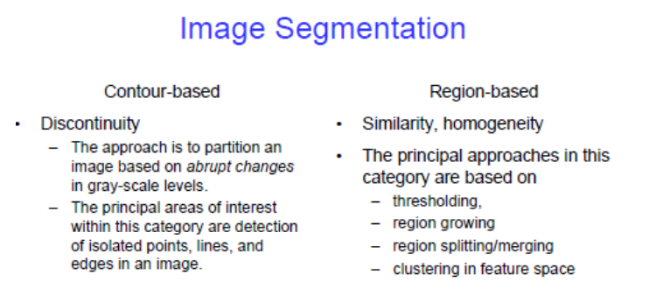

**Examples**

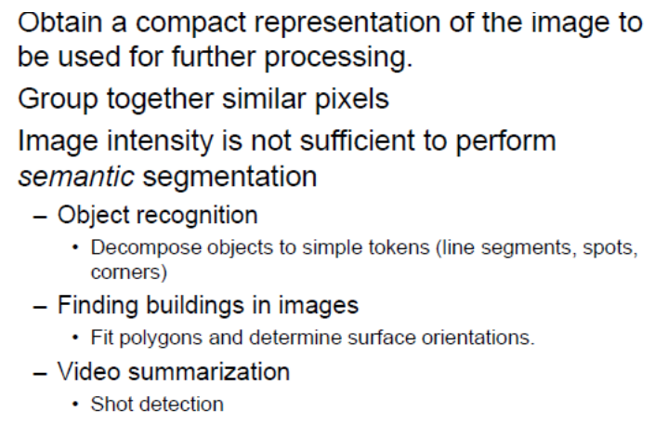

### **Point, Line, and Edge Detection**

The focus of this section *is on segmentation methods that are based on detecting sharp, local changes in intensity.* The three types of image characteristics in which we are interested are *isolated points, lines, and edges*. Edge pixels are pixels at which the intensity of an image changes abruptly, and edges (or edge segments) are sets of connected edge pixels. Edge detectors are local image processing tools designed to detect edge pixels. A line may be viewed as a (typically) thin edge segment in which the intensity of the background on either side of the line is either much higher or much lower than the intensity of the line pixels. In fact, as we will discuss later, lines give rise to so-called “roof edges.” Finally, an *isolated point* may be viewed as a foreground (background) pixel surrounded by background (foreground) pixels.

**There are many types of image segmentation strategies**

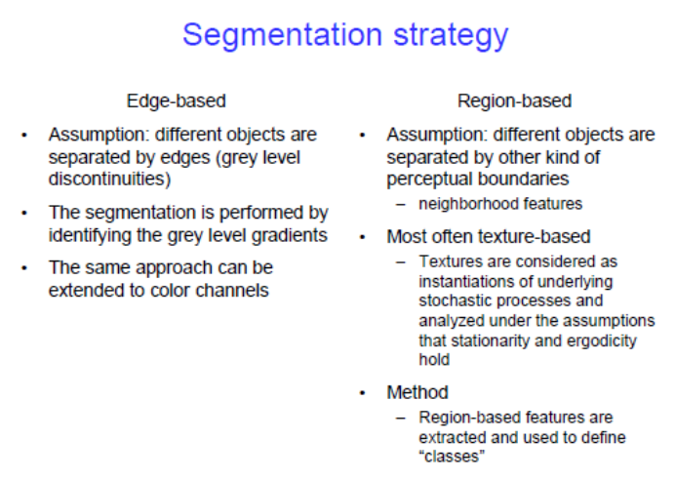

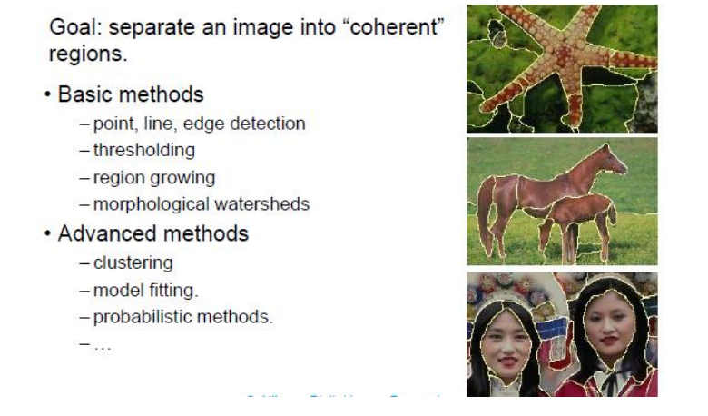

Segmentation algorithms generally are based on one of 2 basis properties of intensity values: ***discontinuity*** : to partition an image based on sharp changes in intensity. ***similarity*** : to partition an image into regions that are similar according to a set of predefined criteria.

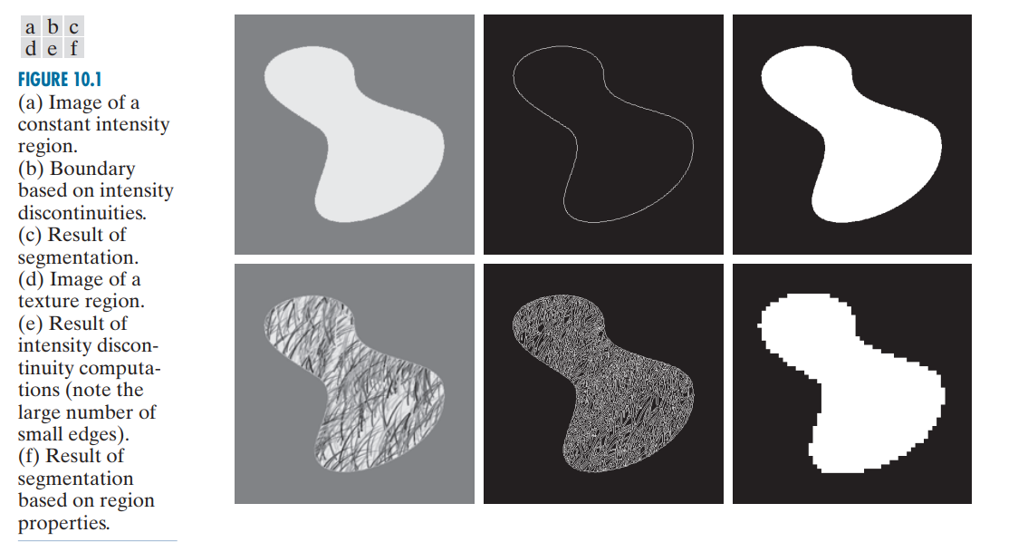

### **Derivative**

It is necessary to use derivative (first and second) in order to discover discontinuities. If we observe a line within an image we can consider it as a one-dimensional function f(x). we will now define the first derivative simply as the difference between two adjacent pixels.

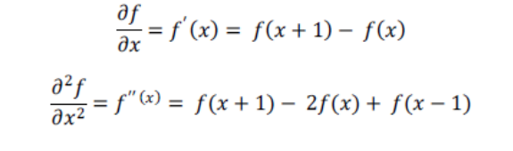

First derivative generally produce **thicker edge** in an image. Second derivative has a **very strong response to find details and noise. Second derivative sign can be used to determine the transition direction.**

### **. Detection of isolated point**

Based on the fact that *a second order derivative* is very sensitive to sudden changes we will use it to detect an isolated point. We will use a Laplacian which is the second order derivative over a two dimensional function.

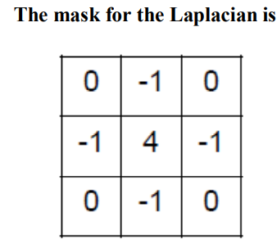

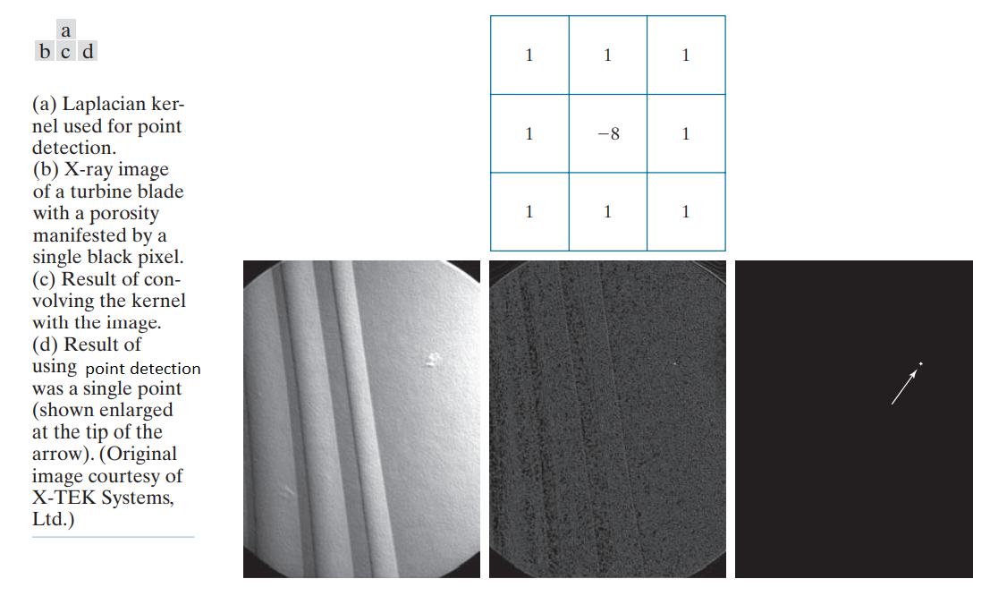

**3.2. Line Detection**

We can use the *Laplacian also for detection of line*, since it is sensitive to sudden changes and thin lines. We must note that since the second derivative changes its sign on a line it creates a “double line effect” and it must be handled. Second derivative can have negative results and we need to scale the results**.** Because the Laplacian image contains negative values, scaling is necessary for display. As the magnified section shows, mid gray represents zero, darker shades of gray represent negative values, and lighter shades are positive. The double-line effect is clearly visible in the magnified region.

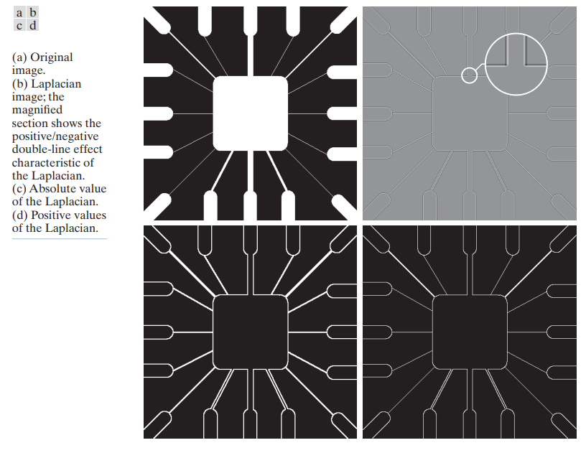

**The Laplacian is isotropic متماثل, i.e. independent of direction. If we would like to detect lines on a certain direction only we might want to use masks that would emphasize a certain direction and be less sensitive to other directions.**

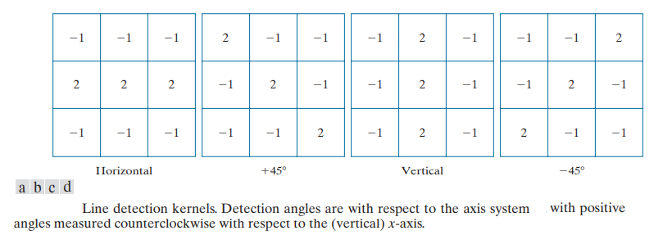

**3.3. Edge models**

Ideally, edges should be 1 pixel thin. In practice, they are blurred and noisy.

***3 different edge types are observed***:

* ***Step edge*** حافة الخطوة–Transition of intensity level over 1 pixel only in ideal, or few pixels on a more practical use
* ***Ramp edge*** حافة المنحدر–A slow and graduate transition
* 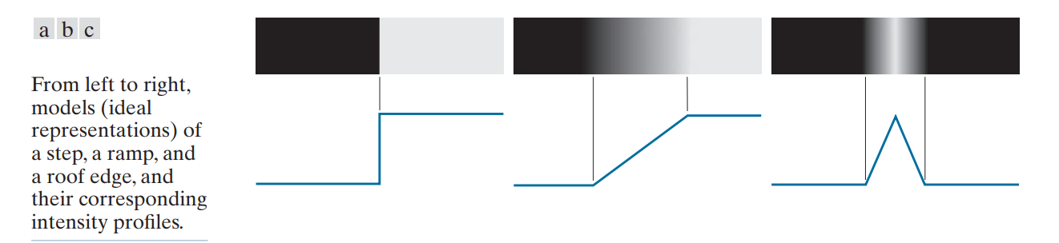***Roof edge***حافة السقف –A transition to a different intensity and back. Some kind of spread line

**With gradient operators, we can use as an example two operators**

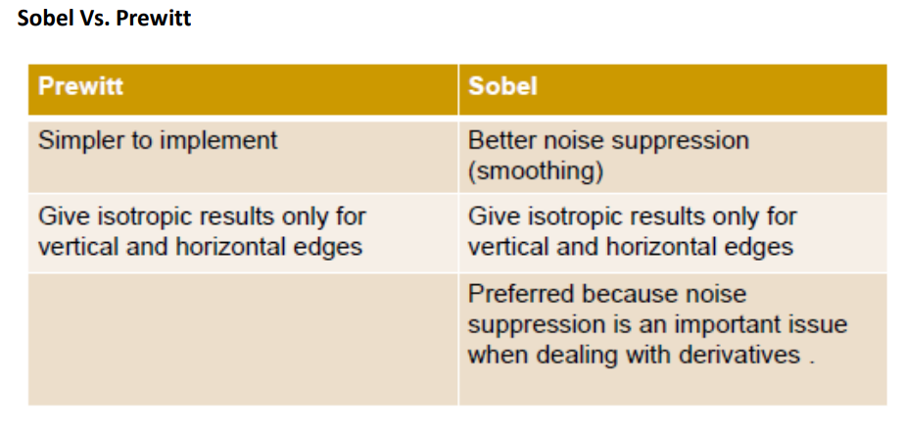

**3.3 Edge Linking**

Ideally, edge detection should yield sets of pixels lying only on edges. In practice, these pixels seldom characterize edges completely because of occlusions, non-uniform illumination, noise and breaks in the edges. Therefore, edge detection typically is followed by linking algorithms designed to assemble edge pixels into meaningful edges and/or region boundaries. Edge linking may be:

* **Local**: requiring knowledge of edge points in a small neighborhood.
* **Regional**: requiring knowledge of edge points on the boundary of a region.
* **Global**: the Hough transform, involving the entire edge image

**The Hough transform** is a technique which can be used to isolate features of a particular shape within an image. Hough transform is most commonly used for the detection of regular curves such as lines, circles, ellipses, etc. The main advantage of the Hough transform technique is that it is tolerant of gaps in feature boundary descriptions and is relatively unaffected by image noise. It maps a straight line y=mx+c in a Cartesian coordinate system into a single point in the (ρ,θ) plane or ρ=xcosθ+ysinθ For a point (x,y) in the Cartesian coordinate plane , there will be an infinite number of curves in the (ρ,θ) plane**.**

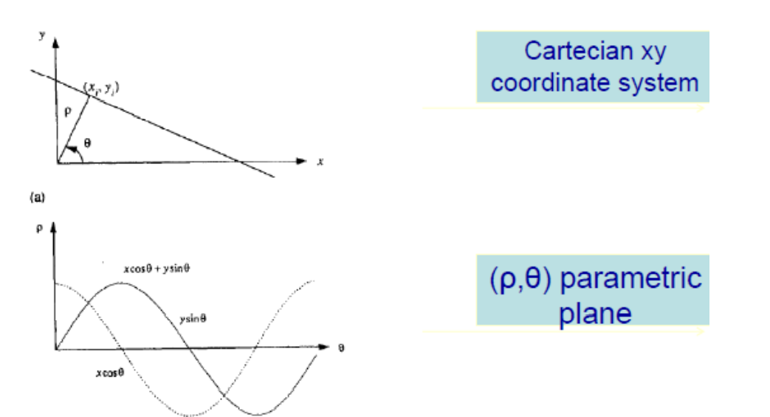

When two points (xi,yi) and (xj,yj) lie on the same straight line , the curves in the (ρ,θ) plane which correspond, respectively , to the two points (xi,yi) and (xj,yj) in the Cartesian plane will intersect at a point. This intersection point determines the parameter of the line that joins these two points Similar arguments apply for the three collinear points. This property between Cartesian plane and the parametric plane will be useful in finding the line that fits points in the xy plane**.**

1. **Thresholding**

Image partitioning into regions directly from their intensity values.

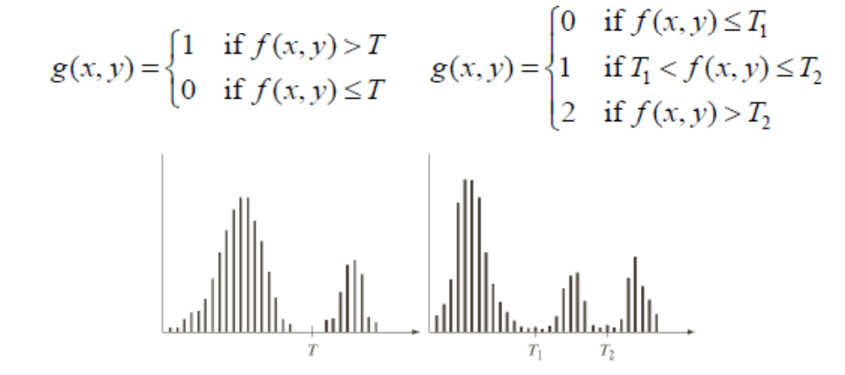

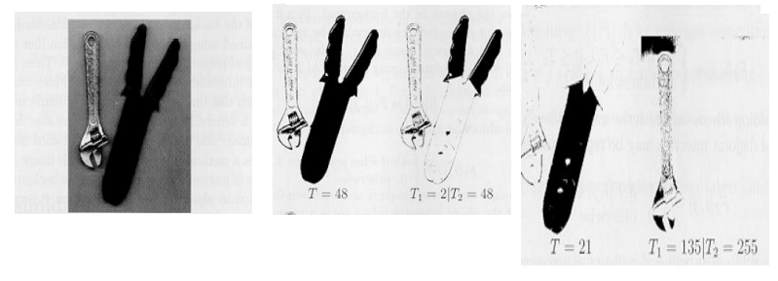

Basic Global Thresholding Algorithm

* Select initial threshold estimate T.
* Segment the image using T Region G1 (values > T) and region G2 (values < T).
* Compute the average intensities m1 and m2 of regions G1 and G2 respectively. Set T= (m1+m2)/2 Repeat until the change of T in successive iterations is less than ΔΤ