***Lecture 2***

***Fourth stage***

***Medical Physical Department***

***Medical Image Analysis***

**Ultrasound, Nuclear Imaging, Other Imaging Techniques.**

**By**

***Asst. Prof. Dr. Mehdi Ebady Manaa***

### **Ultrasound Images**

Sound waves will be reflected at the boundaries between materials of different acoustic impedance. An ultrasound wave sent into the human body will be reflected at organ boundaries. The locus مكان of reflection can be reconstructed if the speed of sound in the material through which the wave travels is known. For most soft tissues this speed is around 1500 m/sec. An ultrasound reflection signal is created using a transducer which acts as the sender and receiver of ultrasound waves (Fig. 2.1 shows typical ultrasound equipment). Frequencies for diagnostic ultrasound range between 1 and 20 MHz. High frequency waves attenuate faster than low frequency waves and do not penetrate the body as good as low frequency waves. High frequency waves resolve smaller structures, however, since the size of a reflecting object has to be larger than the wavelength.

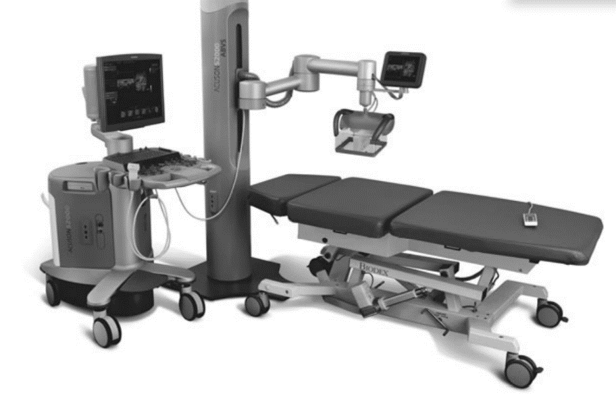

**Fig. 2.1 Ultrasound equipment**

Figure (2.2) shows the different types of sound waves

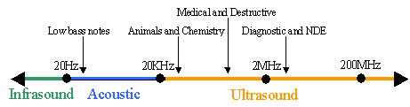

**Fig. 2.2 Sound Waves**

**2.1 Ultrasound Imaging**

An ultrasound A-scan sends a single wave with known direction into the body and records the amplitude of reflection

s as a function of travel time between sending and receiving the signal. It is a one-dimensional probe مسبار استكشاف into the body showing tissue boundaries and other boundaries between regions with different acoustic impedance مقاومة صوتية. Ultrasound (US) images (the so-called B-scans, see Fig. 2.3) are created from a planar fan beam of differently rotated A-scans. Amplitudes are mapped to gray values for creating the image. They may also be acquired as 3D images with this fan beam rotating around a second axis perpendicular to the first axis of rotation. Ultrasound imaging (also called sonography التصوير فوق الصوتي) happens in real time and is able to show the motion of the organs being imaged.

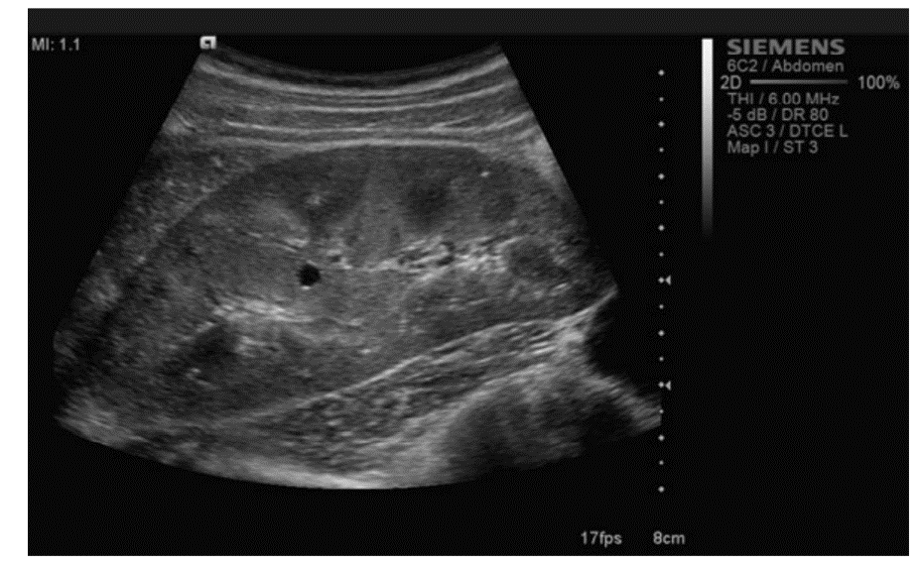

**Fig. 2.3 Ultrasound B-scan of the abdomen**

Ultrasound imaging of internal organs is only possible if they are not hidden by bone since bone causes the total reflection of the incident sound waves. The organs to be imaged include the liver, gallbladder, pancreas, kidneys, spleen, heart, and uterus. Heart imaging may also be carried out by putting the ultrasound device (a transducer sending and receiving sound waves) into the esophagus. Doppler imaging is a specific technique using the Doppler Effect for estimating the speed and direction of moving objects (such as blood) in the ultrasound image (see Fig. 2.3). It is used for diagnosing the effects of vessel blockages or changes of blood flow due to stenosis تضيق .

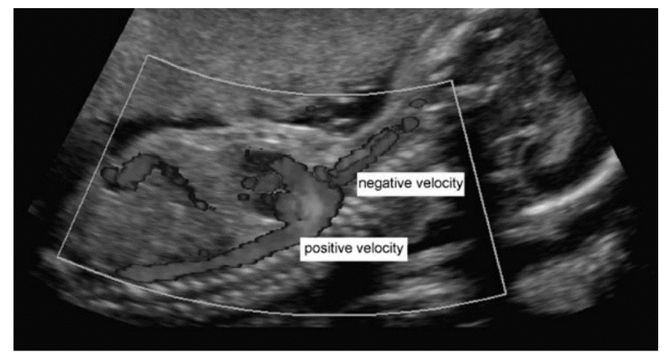

**Fig. 2.3 Doppler sonography uses the Doppler effect to depict blood velocity. In its original, velocity is color-coded differentiation between flow direction and velocity**

A number of effects cause **artefacts** in an ultrasound image (see Fig. 2.4).

* Sound waves are attenuated just as electromagnetic waves in x-ray imaging.
* Absorption turns wave energy into heat.
* The wave may be scattered or refracted.
* Interference and a diverging wave cause further deterioration تدهور. Absorption causes a decrease in amplitude with increasing depth. The decrease is exponential with an unknown absorption coefficient of the tissue. It is usually corrected by assuming constant absorption throughout the tissue. Interference, scatter, and refraction of and between waves lead to the typical speckle artefacts in ultrasound images. It is a nonlinear, tissue-dependent distortion of the signal. Tissues and tissue boundaries that reflect or attenuate a high amount of the incoming sound energy produce an acoustic shadow behind the tissue. Materials that attenuate little of the incident energy lead to signal enhancement in tissues behind this material. This is, for instance, the case when imaged organs are behind a fluidfilled organ such as a filled bladder. The smaller absorption in the fluid contradicts the hypothetically assumed constant absorption and causes a higher than necessary absorption correction.

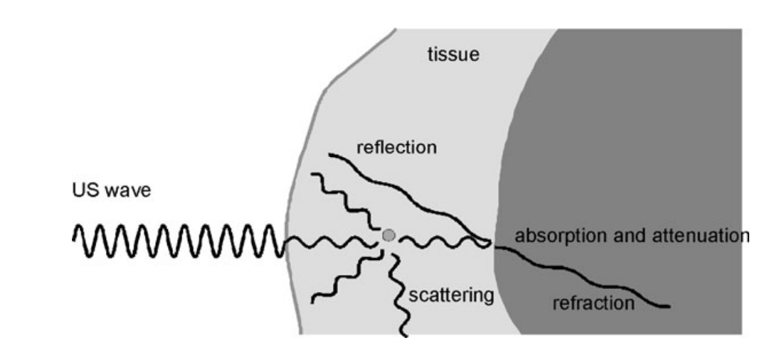

Fig. 2.4 Different effects influence the incident US wave of which only direct reflection is the wanted effect

Figure (2.5) shows the sender ultra sound waves to the detected object and the 1

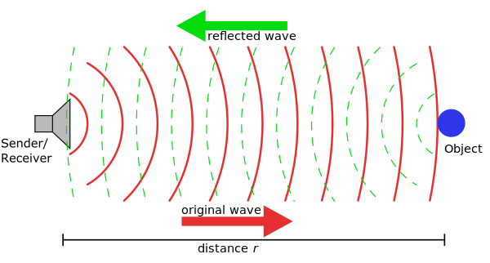

Fig. 2.5 Ultrasound Waves to detect Object

**2.2 Image Analysis on Ultrasound Images**

Ultrasound is noninvasive غير جراحيand inexpensive. Hence, it is widely used as a diagnostic tool. The artefacts mentioned in the previous section as well as the approximate nature of many of the underlying assumptions for imaging may adversely influence measurements in quantitative analysis.

* Localization in ultrasound imaging assumes that the speed of sound in the material is known. It is usually taken as a constant value of the average speed of sound in soft tissue and causes signal displacement depending on the deviation from this average.
* Refraction that has not been accounted for may lead to a further displacement error.
* Organ boundaries may cause mirror echoes or multiple echoes that appear as false boundaries in the image. Mirror echoes appear behind the true boundary. Multiple echoes appear between the transducer and boundary.
* False, hyperbola-shaped boundaries may be caused by low frequency lateral oscillation of the sound wave.
* Motion artefacts lead to wave-like distortions of boundaries.
* *Acoustic shadowing* may hide parts of tissues and fluid-induced signal enhancement may lead to a position-dependent signal increase.
* *Absorption* decreases the signal-to-noise-ratio with respect to the distance from the transducer. Artefact removal through postprocessing is only partially successful since their nonlinearity and nonstationarity defy common restoration techniques

1. **Nuclear Imaging**

Nuclear imaging measures the distribution of a radioactive tracer material and produces images of a function in the human body. The tracer material is injected intravenously عن طريق الوريدprior to the image acquisition and will distribute through blood circulation. Distribution is indicative to the perfusion نضح of organs in the body. Examples for applications are measurements of brain activity, perfusion studies of the heart, diagnosis of inflammations التهابات due to arthritis and rheumatism, or the detection of tumor metastases due to increased blood circulation. Images are created from measuring photons sent by the tracer material through the body. Spatial resolution in nuclear imaging is lower than for the procedures described above since tracer concentration is very low so as to not to interfere with the metabolism. The sensitivity of imaging techniques in nuclear medicine is high since detectors are able to measure a signal from a few photons. Major imaging techniques in nuclear medicine are as follows

* Scintigraphy, which measures a projection of the tracer distribution with a geometry similar to projection x-ray imaging.
* SPECT (Single Photon Emission Computed Tomographyتصوير طبي بأشعة كاما), which is a reconstruction from projections of tracer material producing a 3D material distribution.
* PET (Positron Emission Tomography التصوير المقطعي بالإصدار البوزيتروني), which is a tomographic technique as well, but uses a different tracer material that produces positrons. Radiation of positronelectron annihilation is measured and reconstructed.

1. **Scintigraphy**

For creating a scintigram (an image of an internal part of the body produced by scintigraphy), a molecule carrying the radioactive atom 99Tc (Technetium-99) is applied. Photons emitted by tracer radiation are measured by a gamma camera (also written as γ -camera and sometimes called Anger camera. The camera consists of a collimator that restricts measurements of photons to those who hit the detector approximately at a 90◦ angle, a scintillator crystalوميض that turns incident radiation into visible light, and photomultipliers المضاعفات الضوئيةfor amplifying the signal. The camera is usually mounted on a gantry that enables the camera to rotate (around various directions) around the patient. The collimator is a thick lead plate with drilled cylindrical holes whose axes are perpendicular to the scintillator crystal. Photons reaching the detector on a path perpendicular to the detector plane will reach the scintillator at a location that is given by the positioning of the detector hole through which it passes. Photons on a path with any other angle are reflected or attenuated by the lead collimator. If they reach the detector crystal through scattering, they have lost too much energy for being detected. Hence, the collimator causes the image to be an approximate parallel projection of photons from tracer material in the body onto the image (see Fig. 2.5)

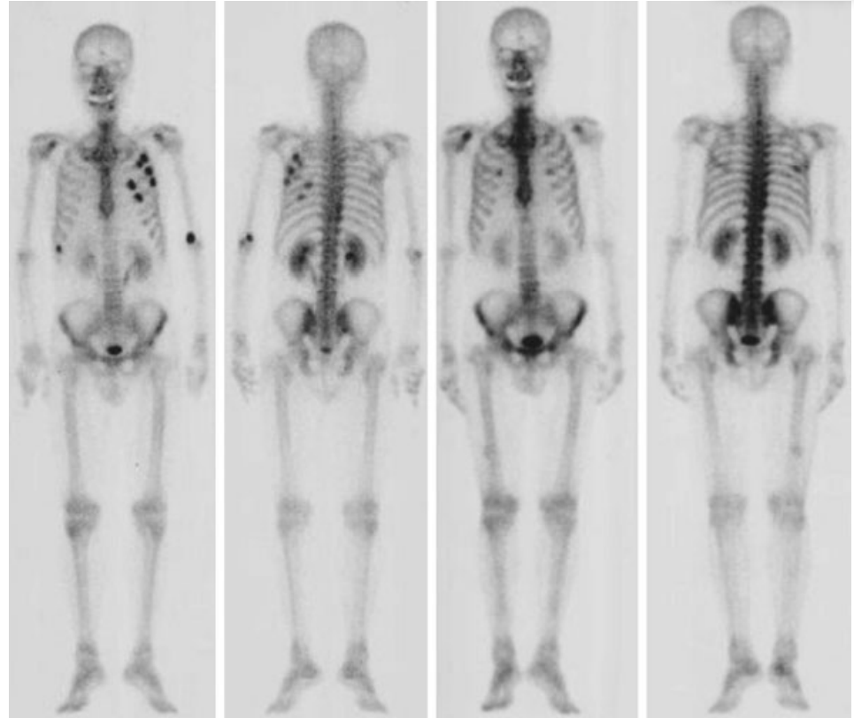

Fig. 2.5 Bone scintigraphy (in this case before and after-treatment bone scintigraphy

**3.2 Single Photon Emission Computed Tomography (SPECT)**

SPECT uses projection images from the gamma camera to create an image of the radioactive tracer distribution. Images without attenuation correction can be reconstructed by FBP yielding a spatial resolution of approximately 3 to 6 mm side length of a pixel. Image sizes vary between 64 × 64 and 128 × 128 voxels per slice with 25 to 35 slices to be reconstructed. Using iterative reconstruction, attenuation correction and smoothness constraints may be included, leading to a better image quality at the expense of longer reconstruction times if compared to (Filter Backpropagation) FBP Attenuation maps can be generated from the reconstruction of a transmission scan taken prior to imaging. The acquisition of SPECT images can be carried out by a single rotating gamma camera. However, modern systems use 3-head cameras for capturing three projections at a time. The acquisition time for a single projection is about 15 to 20 seconds, which amounts, for a 3-head system, to total acquisition times between 5 and 10 minutes. Scatter in SPECT decreases contrast and causes noise in the image. Due to the small number of photons measured, scatter may also cause artefacts since scattering in dense materials with a high uptake of radioactive material may be falsely attributed to nearby regions. Scattered photons due to Compton scattering can be identified due to the energy loss of the scattered photon. Scattered photons may be removed by the appropriate frequency filtering of the signal. The removal of scatter does reduce artefacts, but it cannot increase the signal-to-noise-ratio. Artefacts due to motion during image acquisition cause blurring of the data. Nongated cardiac عدم انتظام ضربات القلبSPECT is not able to show the heart motion because of the long acquisition time, but produces an average image over the complete heart cycle. Major application fields for SPECT imaging are the imaging of ventricular perfusionنضح البطين and ejection fraction of the heart, scans of lungs, kidneys, liver, and bone for tumor detection, and brain perfusion studies.

**3.3 Positron Emission Tomography (PET)**

PET uses positron emitters for producing the image. Radioactive isotopes of atoms such as oxygen or fluoride emitting positrons are administered to the human body. If distributed in the body, emanating positrons annihilate if they meet an electron and produce two photons that are emitted in the near-opposite direction. Photon energy is 511 keV. Events are measured by a detector ring and do not require collimators. An annihilation event is registered if two photons are detected at nearly the same time (within nanoseconds). PET is an expensive technique if compared to SPECT because positron emitting isotopes have a short half-life and need to be generated in a cyclotron in close neighborhood to the PET scanner. The scanning technique is demanding, requiring a fixed detector ring that is capable of analyzing events according to synchronicity of measurement. The image quality of PET is better than SPECT. The number of attenuated photons decreases without collimation, the higher energy of the photons reduces attenuation loss in the body, and the near-parallelism of the path of the two protons focuses the ray better than the cylindrical aperture of the collimator in a gamma camera. The spatial resolution of PET is in the range of 2 to 5 mm side length of a voxel. The signal-to-noise level is low due to the low number of counts. The true spatial resolution (i.e., the closest distance between two discernable objects) is often sacrificed to reduce noise by smoothing the data during or after reconstruction. PET, similarly to SPECT, does not produce anatomic information. Metabolic function as imaged by PET is best evaluated if registered with some anatomic scan (e.g., from CT or MRI). (see Fig. 2.6).

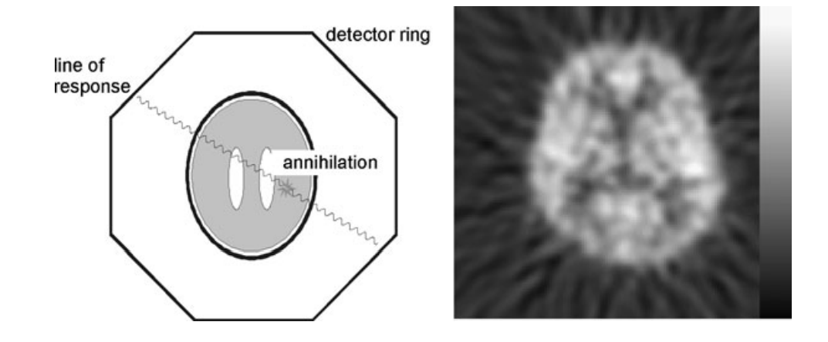

Fig. 2. 6 Schematic view of a PET scanner (left) and resulting image of measured activity in the brain