***Lecture 7***

***Fourth stage***

***Medical Physical Department***

***Medical Image Analysis***

**Edge Tracking, Hough Transform, Corners, Template**

**Matching Feature Detection-Part I**

***By***

***Asst. Prof. Dr. Mehdi Ebady Manaa***

1. **Feature Detection**

Data-based features in images such as *key point locations or potential parts of object boundaries can be extracted from local image characteristics*. Boundary parts are generated from the results of an edge enhancement step while key point locations are local extrema of some local object property. Features may also be computed from samples of an object’s boundary or interior. Potential object boundary parts are used for detecting or delineating objects in images. Key points may, in some simple cases, also be used to detect objects. In most cases, however, object characteristics are too complex to be captured by the attributes of a key point. They can be important attributes nonetheless. Key points define an object-dependent reference system in which they may be used to map objects of the same class onto each other.

Concepts, notions and definitions introduced in this chapter

› Edge tracking

› Canny edge detector

› Hough transform for lines

Image analysis aims at reducing information to a subset that is relevant to some analysis question. An example would be volumetry قياس الحجم where the user wants a single number (the volume of a certain organ or pathological structure بنية مرضية) from the image sequence. Other examples are the detection of metastases or the delineation of an organ boundary for radiotherapeutic treatment planning ومن الأمثلة الأخرى اكتشاف النقائل أو تحديد حدود العضو لتخطيط العلاج الإشعاعي

Information reduction often happens gradually with information being reduced until the desired result is extracted from the data. The first level of reduction computes local features that are assumed to pertain to objects of interest. Examples for local features are edges, blobs, or ridges in the image. Such features carry more information than a pixel as they represent a first differentiation between the object attributes and influences from image acquisition. تحمل هذه الميزات معلومات أكثر من البكسل لأنها تمثل أول تمايز بين سمات الكائن والتأثيرات من الحصول على الصورة.

There are a number of reasons to apply a feature detection step in medical image analysis. In cases where the object of interest is simple, its attributes may be captured directly by the feature detector. This then leads to object detection. More often it is a preprocessing step. Feature locations and attributes may serve as an object-specific reference if the same object is captured by different images that shall be compared. While the content of the images may be different (e.g., if one of the images is CT and the other MRI), the object features such as edges or corners should be extractable in both images. Features may also help to define a region of interest that shall be further inspected. A blob detector, for instance, could find potential regions of interest that may comprise the blob-like lymph nodes كاشف النقطة ، على سبيل المثال ، يمكن أن يجد مناطق الاهتمام المحتملة التي قد تشمل العقد الليمفاوية الشبيهة بالنقطة

Further processing will then be restricted to these regions. Features may also help to guide a segmentation process in cases where the data are noisy or of low contrast. Edge features, for instance, could be generated that support segmentation if noisy data would produce too many spurious responses from applying a simple gradient operator. Finally, features may also be used to characterize deviations from an assumed norm of an anatomic structure لوصف الانحرافات عن قاعدة مفترضة للتركيب التشريحي . As an example, features to enhance tubular structures may highlight the potential sites of aneurisms in the vascular system since they deviate from the normal على سبيل المثال ، قد تبرز ميزات تحسين الهياكل الأنبوبية المواقع المحتملة لتمدد الأوعية الدموية في نظام الأوعية الدموية لأنها تنحرف عن الوضع الطبيعي, tube-like shape of vessels. The description of a feature is richer than that of a pixel. It comprises at least the feature location in image space and the feature type (e.g., edge or corner) and some measure of strength of the feature response at that location. It may include other information such as scale (e.g., size of a blob) or orientation (e.g., the direction of an edge).

1. **Edge Tracking**

Edge Tracking Structures are meant to be detectable by a change of appearance between it and the background. Furthermore, the shape given by a structure’s outline may be an important characteristic to differentiate it from other objects or to specify object-specific locations. Hence, edges are relevant features for several types of analysis tasks. Edges can be those of intensity but may also separate different textures. The following section will deal with intensity edges. Most of the techniques can be applied to textures as well, provided that the texture measure can be mapped on a single scalar value. Texture edges are then edges of this scalar value. The detection of intensity edges uses the output of an edge enhancement step. Edge strength is given by the length of the intensity gradient. The edge location is given by the zero crossings of a Laplace operator (see Fig. 7.1). However, a large gradient does not automatically mean that there is an edge. **Finding salient edges in an image can be difficult**. Saliency can be based on many different attributes ranging from local smoothness and continuity constraints to high-level domain knowledge. Hence, edge detection is still an open problem in the general field of image analysis. For edge detection in medical images, various, rather simple assumptions are used to separate edges from noise.

* The gradient for edges is often stronger than that caused by noise.
* The edge direction varies slowly along the edge.
* The edge strength varies slowly along the edge. These assumptions are too simple to detect all edges defining an object boundary. They are, however, sufficient since edges resulting from a tracking step are usually not the final result. Rather, these edges initialize some top-down analysis step to find boundaries of an organ, pathological process, or other structure of interest.

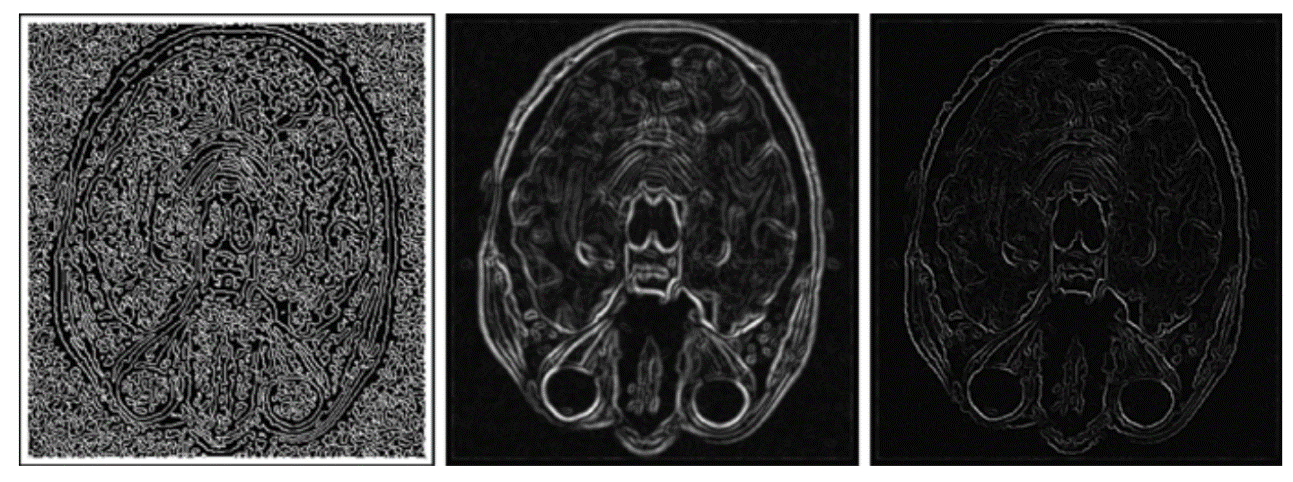

Fig. 7.1 Zero crossings computed from applying an LoG operator (a) may be combined with information about edge strength from a gradient operator (b) to find edge locations and rate their importance based on edge strength (c

The Canny edge operator (Canny 1986) takes into account all three assumptions. It consists of an edge-enhancement step and an edge tracking step. Edge enhancement is carried out by taking the maximum response from several one-dimensional edge filters because under an idealized edge model—the optimal response for an edge is created by a one-dimensional smoothing differential operator orthogonal to the yet unknown edge direction. The local maximum of the gradient length then specifies the edge location. In most applications, this step is replaced by a two-dimensional gradient operator (e.g., the derivatives of the Gaussian) combined with a non-maximum suppression step that reduces the edge response to a single pixel in the gradient direction. Non maximum suppression can be done by computing zero crossings of the second derivative. Edge tracking is done by hysteresis thresholding. Two threshold

s, t1 and t2 with t1 > t2, are defined and applied to the gradient length |g|.

If |g| > t1 for some pixel, this pixel always belongs to an edge.

Pixels with |g| > t2 are edge pixels if they are adjacent to other edge pixels. The algorithm proceeds as follows (see also Fig. 7.2).

* Select the next pixel with |g| > t1 that is not yet assigned to an edge and assign it to a new edge.
* Track the edge as long as the adjacent pixels are found with |g| > t2.

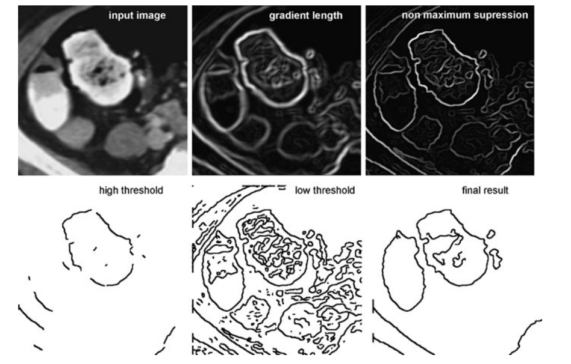

figure. 7.2 The different steps of the Canny Edge Operator (the result from non-maximum suppression has been dilated for better visibility)

This process is repeated until no further pixels with |g| > t1 are found. The method finds connected edge segments. At intersections, it will track only one of the continuing curves. The other curve will be found as well if at least one of its edge pixels has a gradient larger than t1. The value for t1 should be high enough to make sure that none of the starting pixels is a noise pixel. However, since the continuation of an edge is only found between neighboring pixels, the threshold t2 should be low so as not to hinder tracking (see the effect of different selections for t1 and t2 depicted in Fig. 7.3).

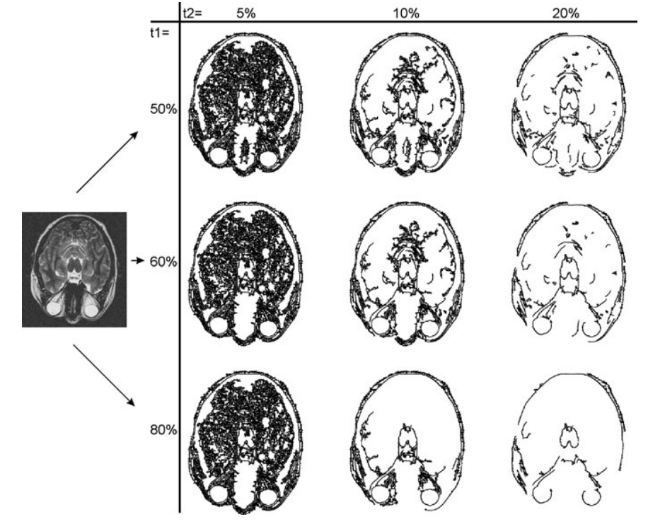

Fig. 7.3 Different choices for the two thresholds of the Canny Edge Detector lead to different results. Thresholds are given as percentage of the strongest gradient in the image

1. **Hough Transform**

The Hough transform computes edge features by comparing image evidence with a very specific edge model. Given an image containing edge information of an unknown number of edges of a known kind, the Hough transform finds instances of this kind.

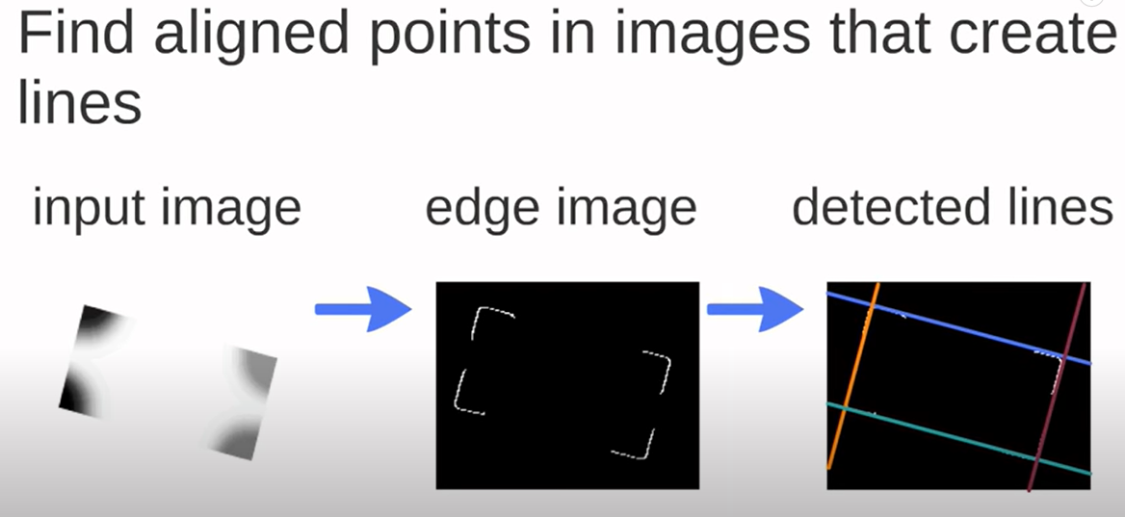

**Example of Hough Strategy**

The Hough transform is a voting scheme that was first presented to find straight lines in images and then was extended to find arbitrary kinds of boundaries. Each location of a potential boundary—e.g., each location where the gradient length exceeds some threshold—votes for reference points in parameter space that are associated to certain shapes. Parameter combinations that receive the most votes describe likely object instances. Being a voting system, the Hough transform keeps its ability to predict structure locations even if some votes are missing because of occlusion or a missing signal. The method is robust with respect to noise or artefactual edges that do not follow the edge model. Small variations from the predicted shape are tolerated. The Hough transform can be defined for any dimension, but is most often applied in 2D because the number of parameters (i.e., the dimensionality of parameter space in which voting takes place) increases fast with the increasing dimension of the images. The transform for finding straight lines was presented in Hough (1962). A line in 2D space x = (x1 x2) can be defined by the following variant of the line equation

d(α) = xi cos(α) + yi sin(α), (7.1)

where α is the angle and d(α) the distance to the origin of a line passing through a point (xi yi). The Hough transform for a given potential boundary point (xi yi) computes d(α). This point votes for all locations in parameter space (d(α),α) for which (7.1) is true (see Fig. 7.4). The parameter space is digitized into bins in which votes accumulate (called accumulator cells).

Please see this video for more information

<https://www.youtube.com/watch?v=4zHbI-fFIlI>

<https://www.youtube.com/watch?v=Ltqt24SQQoI>

The number of votes for a potential boundary point in an image depends on its probability of being part of a boundary. It could be, for instance, a function of the gradient length. The lines in the image are those for which corresponding accumulator cells are local maxima and have received a sufficiently high number of votes. The QoF (quality of fit) measure is a threshold on the number of votes (see Fig. 7.5 for an example). A number of strategies increase the computation speed of the Hough transform and can be applied to most of its variants.

* The order in which votes are cast does not matter, which makes the method inherently parallelizable.
* If gradient directions in the edge images are reliable, the number of votes may be reduced by letting every edge point only vote for those solutions of (7.1) for which α is almost perpendicular to the gradient direction.

• If edge points are selected randomly from the image, the intermediate results of the voting process may already be a good estimate for the final outcome. There are also some strategies for increasing the robustness of the Hough transform with respect to noise, artefacts, and shape variation.

* A multiscale strategy may be applied by computing an initial Hough transform only for large accumulator cells. The result is used as a prediction for ranges of parameters in Hough space that represent potential lines. The accumulation of votes at higher resolution is reduced to these ranges.
* Vote distribution in parameter space may be smoothed to take variation due to noise and artefacts into account. The voting strategy of the Hough transform is not restricted to the search of straight-line segments. Any boundary structure that can be represented by a small set of parameters can be found. Hence, the Hough transform is suitable to represent shape information for searching object instances instead of object features in the image.

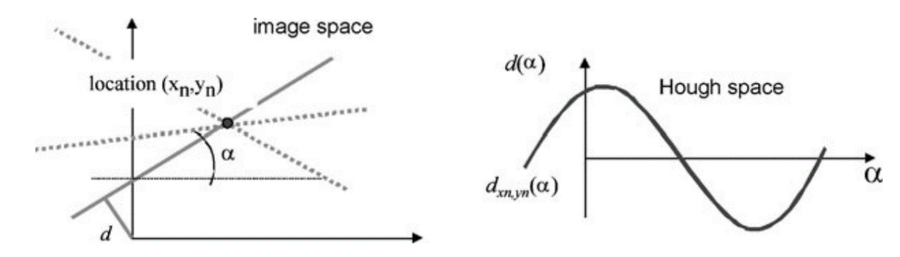

Fig. 7.4 Each edge point (xn,yn) in image space is represented by a curve in Hough space. The curve describes all parameter combinations α,d(α) for lines passing through (xn,yn)

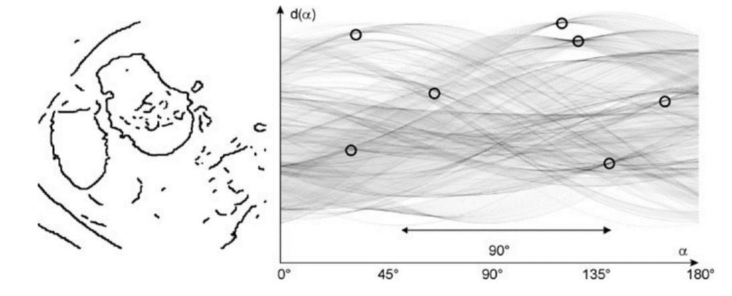

Fig. 7.5 Example of applying the Hough transform on an edge image. The predominance of edges at angles 45° and 135° with respect to the x-axis is visible as local maxima in Hough space