*** Lecture 10***

***Fourth stage***

***Medical Physical Department***

***Medical Image Analysis***

**Region-Based Segmentation, Segmentation Using the Watershed Transform**

**1 (preprocessing ) 2 (transformation ) 3 (Model Construction) 4 Model Evaluation (training / testing )**

**By**

***Asst. Prof. Dr. Mehdi Ebady Manaa***

### **Segmentation by Region Growing and WaterShed Transform**

As its name implies, region growing ***is a procedure that groups pixels or subregions into larger regions based on predefined criteria for growth***. The basic approach is to start with a set of “seed” points, and from these grow regions by appending to each seed those neighboring pixels that have predefined properties similar to the seed (such as ranges of intensity or color).

The selection of similarity criteria depends not only on the problem under consideration, but also on the type of image data available. For example, the analysis of *land-use satellite imagery depends heavily on the use of color*. This problem would be significantly more difficult, or even impossible, to solve without the inherent information available in color images. When the images are monochrome, region analysis must be carried out with a set of descriptors based on intensity levels and spatial properties**.**

***Region growing based techniques are better than the edge-based techniques in noisy images where edges are difficult to detect.*** Region growing is the formulation of a stopping rule. Region growth should stop when no more pixels satisfy the criteria for inclusion in that region. Criteria such as intensity values, texture, and color are local in nature and do not take into account the “history” of region growth. Additional criteria that can increase the power of a region-growing algorithm utilize the concept of size, likeness between a candidate pixel and the pixels grown so far (such as a comparison of the intensity of a candidate and the average intensity of the grown region), and the shape of the region being grown. The use of these types of descriptors is based on the assumption that a model of expected results is at least partially available***.***

*Region growing* is known as a simple and fast method to segment an image. Many papers on medical image segmentation have reported the use of this method in a variety of applications, for example, to detect cardiac disease and breast cancer and to delineate tumor volumes. One approach compares *the initial seed pixels with the unassigned pixels*. Another approach compares *the outermost pixels with their unassigned neighbor pixels at each iteration*. The first leads to consistent segmented areas but is very *sensitive to noise*. The second may result in inaccurate segmentations especially in cases where the pixel attributes change gradually, *but it is robust to noise*.

Region growing refers to the procedure that groups pixels or subregions into larger regions. Starting with a set of seed points, the regions are grown from these points by including to each seed point those neighboring pixels that have similar attributes like intensity, gray level texture, color, etc. It is an iterative process where each seed pixel grows iteratively until every pixel is processed and thereby forms different regions whose boundaries are defined by closed polygons. The important issues in the region growing are:

* *Selection of initial seeds that represent regions and the selection of suitable properties for including the points in various regions during the growing process.*
* Growing the pixels based on certain properties of the image may not ascertain good segmentation. Connectivity or adjacency information should also be used in the region-growing process.
* Similarity: The similarity denotes the minimum difference in the gray level observed between two spatially adjacent pixels or average gray level of a set of pixels, which will yield different regions. If this difference is less than the similarity threshold value, the pixels belong to the same region.

10 11 100 150 220

Seed1 = 11

Seed2 = 150

Euclidean distance : ( 10-11)2 = 1 = SQRT(1) = 1, then distance between seed 11 and point pixel 10 = 1

* Area of region: The minimum area threshold is associated with the smallest region size in pixels. In the segmented image, no region will be smaller than this threshold, defined by the user.

**Algorithm**

Let: f ( x,y) denote an input image; S (x,y) denote a seed array containing 1’s at the locations of seed points and 0’s elsewhere; and Q denote a predicate to be applied at each location ( x, y). Arrays f and S are assumed to be of the same size. A basic region-growing algorithm based on 8-connectivity may be stated as follows.

1. Find all connected components in S (x, y) and reduce each connected component to one pixel; label all such pixels found as 1. All other pixels in S are labeled 0.

2. Form an image fQ such that, at each point ( x ,y), f Q(x,y) = 1 if the input image satisfies a given predicate, Q, at those coordinates, and f Q(x,y) = 0 otherwise.

3. Let g be an image formed by appending to each seed point in S all the 1-valued points in fQ that are 8-connected to that seed point.

4. Label each connected component in g with a different region label (e.g.,integers or letters). This is the segmented image obtained by region growing. The following example illustrates the mechanics of this algorithm

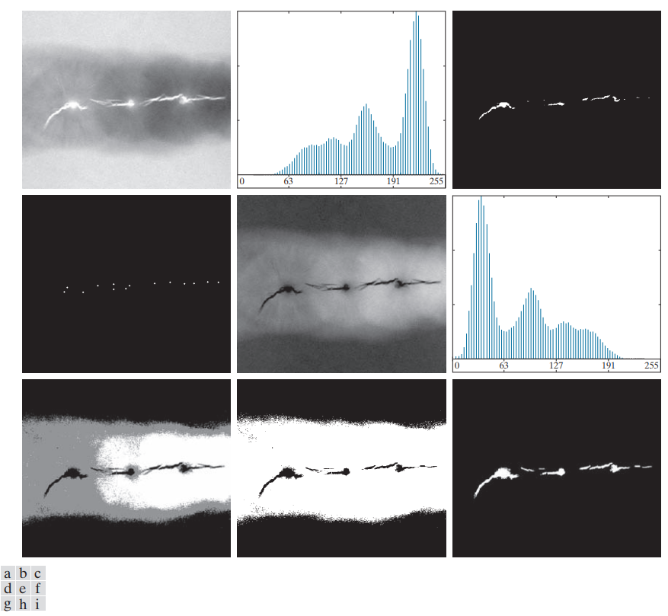

**Figure** (a) X-ray image of a defective weld. (b) Histogram. (c) Initial seed image. (d) Final seed image (the points were enlarged for clarity). (e) Absolute value of the difference between the seed value (255) and (a). (f) Histogram of (e). (g) Difference image thresholded using dual thresholds. (h) Difference image thresholded with the smallest of the dual thresholds. (i) Segmentation result obtained by region growing.

1. **Region Splitting**

* Region growing starts from a set of seeds points
* An alternative is to start with the whole image as a single region and subdivide the regions that do not satisfy a condition of homogeneity.

1. **Region Merging**

* Region merging is the opposite of region splitting.
* Strat with small regions (e.g. 2 x 2 or 4 x 4 regions) and merge the regions that have similar characteristics (such as gray level, variance).
* Typically, splitting and merging approaches are used iteratively.

***A simple way to measure the similarity is a comparison with the original pixel seed intensity***. The user can select a single arbitrary pixel and all the neighboring pixels are compared to this. The similarity can be defined as the difference of the intensity. This is a straight forward way to determine a region and leads to consistent segmented regions. However, this method is very sensitive to noise and results in an unsatisfactory segmentation when the original seed is a noise pixel.

* An alternative way to remove this effect is to compare all assigned pixel to the neighboring pixel that is already in the region of interest. Another approach is to initialize the region with not only a single pixel but with a small set of pixels to better describe the region statistics.
* ***Region Growing*** An image can be divided simply into two regions, namely background and foreground, using a region growing algorithm. A simple way to do so is to pick a seed and then expand it.

Let X ∈ I be a randomly selected pixel in a 2D image I. Let $R_{F}$ is a region of interest of the image I. namely foreground and $δ_{1}$ is tolerance of the difference in intensity. A simple way to expand $R_{F}$ Is to compare all neighborhood pixels with the initial seed and assign exah pixel to $R_{F}$ if it satistifes

$|x-N\left(P\right)|≤ δ_{1}$… (1)

Where N(P) ∈ I is a neighborhood pixel of $R_{F}$ and |.| is the absolute of the difference of intensity. Once a pixel is assigned to $R_{F}$. The new neighborhood pixel can be evaluated in the same way. Unfortunately, when a noise pixel is chosen accidently ( See figure below for (a) and (c), the results will lead to an undesribale results.

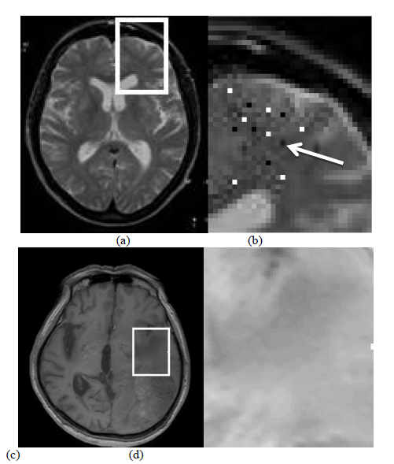

Fig . Zoom view: (a) and (c) are original images, (b) is a noise pixel

chosen in (a), (d) is a gradual area in (c)

Another approach is to compare the pixel at the outer most region with the closest neighborhood pixel (see figure below). This is similar to eq. (1) but the comparison is between N(*P*) and outermost pixel $R_{F}$, namely S(*x*):-

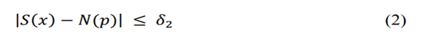

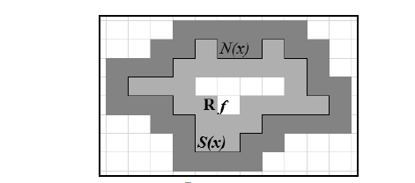

Fig. . Outermost pixels Rf in (brighter gray) and neighborhood pixels (darker gray)

The first approach leads to consistent segmented areas but is *very sensitive to noise* while the second approach may result in inaccurate segmentations especially in cases where the pixel attributes change gradually (see Figs 1(c) and (d)), *but is robust to noise.*

Multiple-seeds can be an alternative to solve the problem above. The initialization is not a single pixel but a small set of pixels to better describe the region using statistical tools such as mean or variance. Then the expansion also involves a statistic operation. This is an expensive operation because every neighborhood pixel is evaluated not as a single pixel but as an area. We combine the approaches above by modifying the multiple-seeds as a way to obtain the ground truth value of the area of interest (Fig 3). First, we use 5x5 multiple-seeds to get a better initialization.

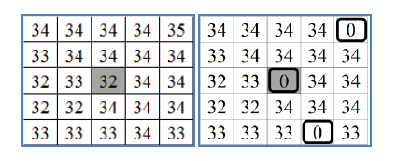

**Fig .Left: 32 is chosen. Right: 0, a noise pixel, is chosen**

To handle the case when the chosen pixel is not representative of the area, we compute the median of the initial multiple-seeds. For example, both initializations in Fig. 3 result in 34. In our experiment, applying blurring image using Gaussian results in a better segmentation. Image using Gaussian results in a better segmentation.

1. **Region Adjacency Graph**

The adjacency relation among the regions in a scene can be represented by a region adjacency graph (RAG). The regions in the scene are represented by a set of nodes N = { N1, N2,. . . , Nm,} in the RAG, where node Ni, represent the region R, in the scene and properties of the region R, is stored in the node Ni,. The edge ei,j, between Ni, and Nj represent the adjacency between the regions Ri, and Rj. Two regions Ri, and Rj are adjacent if there exist a pixel in region Ri, and a pixel in region Rj which are adjacent to each other. The adjacency can be either 4-connected or 8connected. The adjacency relation is reflexes and symmetric, but not necessarily transitive. In Figure 4, we show the adjacency graph of a scene with five distinct regions.

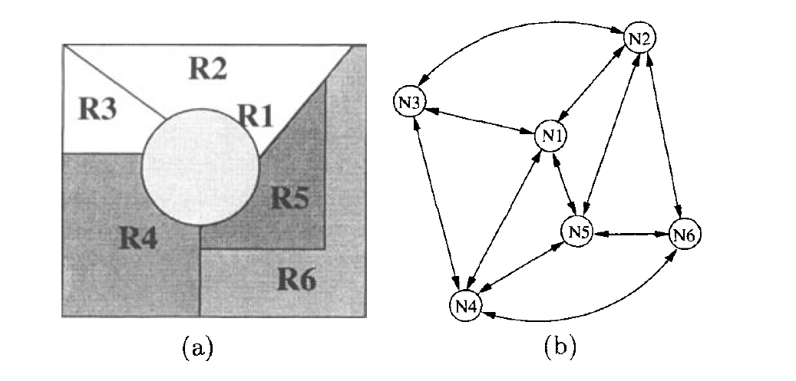

Fig (a) A scene with 6 distinct regions, (b) the adjacency graph of the scene

A binary matrix A is called an adjacency matrix when it represents a region adjacency graph (RAG). When the nodes Ni and Nj in RAG are adjacent, ai,j in A is 1. Since adjacency relation is reflexive, the diagonal elements of the matrix are all 1. The adjacency matrix (relation) of a multiregion scene in Figure 5(a) is shown below.

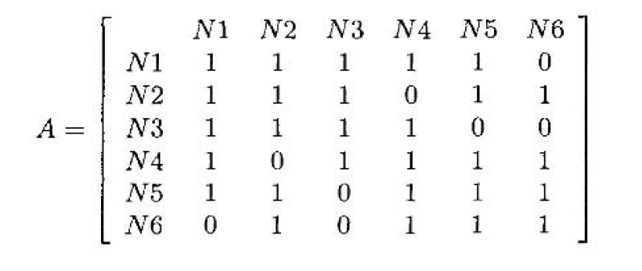

Region Merging and Splitting

A segmentation algorithm can produce too many small regions because of fragmentation of a single large region in the scene. In such a situation, the smaller regions need to be merged based on similarity and compactness of the smaller regions. A simple region merging algorithm is presented below.

Step 1: Segment the image into R1, Rz,. . . , R, using a set of thresholds.

Step 2: Create a region adjacency graph (RAG) from the segmented description of the image.

Step 3: For every Ri, i = 1 , 2 , . . . , m, identify all Rj, j # i from the RAG such that Ri is adjacent to Rj.

Step 4: Compute an appropriate similarity measure Si,j between Ri, and Rj, for all i and j .

Step 5: If Sij > T,then merge Ri, and Rj,.

Step 6: Repeat steps 3 to 5 until there is no region to be merged according to the similarity criteria.

There are situations, when too little regions are generated because of inaccurate preliminary segmentation. This is due to wrong merger of different regions into a single one. In such situation, the variances of the gray values in a segmented region may be above a threshold ( T ) and hence the region needs to be split in smaller regions such that each of the smaller regions has uniform small variances. Splitting and merging can be combined together for segmenting complex scenes where a rule-based may guide the applications of split and merge operations.

1. **Segmentation using WaterShed Transform**

Thus far, we have discussed segmentation based on three principal concepts: edge detection, thresholding, and region extraction. Each of these approaches was found to have advantages (for example, speed in the case of global thresholding) and disadvantages (for example, the need for post-processing, such as edge linking, in edge based segmentation). In this section, we discuss an approach based on the concept of so-called morphological watersheds. Segmentation by watersheds embodies many of the concepts of the other three approaches and, as such, often produces more stable segmentation results, including connected segmentation boundaries.

Watershed segmentation is another region-based method that has its origins in mathematical morphology. Since then, it has been widely applied to a variety of medical image [segmentation tasks](https://www.sciencedirect.com/topics/computer-science/segmentation-task). ***In watershed segmentation*** an image is regarded as a topographic landscape with ***ridges and valleys***. The elevation values of the landscape are typically defined by the gray values of the respective pixels or their [gradient magnitude](https://www.sciencedirect.com/topics/computer-science/gradient-magnitude). Based on such a 3D representation the [watershed transform](https://www.sciencedirect.com/topics/computer-science/watershed-transform) decomposes an image into [catchment basins](https://www.sciencedirect.com/topics/computer-science/catchment-basin). For each local minimum, a catchment basin comprises all points whose path of [steepest descent](https://www.sciencedirect.com/topics/computer-science/steepest-descent) terminates at this minimum (see Fig.). Watersheds separate basins from each other. The watershed transform decomposes an image completely and thus assigns each pixel either to a region or a watershed. With noisy medical image data, a large number of small regions arises. This is known as the “over-segmentation” problem (see Fig.).

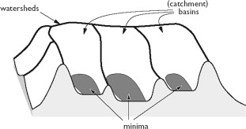 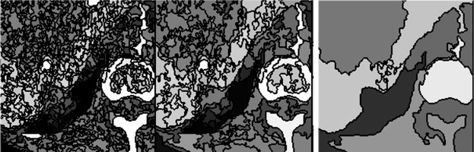

Figure. Principle of the watershed transform where the intensity Figure. Illustration of the over-segmentation

values define hills and basins problem of the watershed transform applied to an axial

slice of a CT image

The most widespread variant employs the [gradient image](https://www.sciencedirect.com/topics/computer-science/gradient-image) as the basis for the watershed transform. Gradient magnitude, however, is strongly sensitive to image noise. Therefore, appropriate filtering is essential. There are many variants how the watershed transform may be used as a basis for a general [segmentation approach](https://www.sciencedirect.com/topics/computer-science/segmentation-approach). The “over-segmentation” problem may be solved by some criteria for merging regions. The user must be provided with some facilities to influence the merging process.

*Merging Basins* The decomposition of an image into regions is the basis for merging them. In the metaphorical sense of a landscape, catchment basins are merged at their watershed locations by flooding them. While some regions merge early (with low flooding level), other regions are merged later. In order to support interactive merging, they introduced a *merge tree*. This tree consists of the original catchment basins as leafs and of intermediate nodes that represent *merging events*. A merging event is characterized by the nodes that are merged and by the flood level that is necessary for merging. As a first step, a certain amount of flooding may be applied (“pre-flooding” which may already be sufficient for segmenting the target structure.

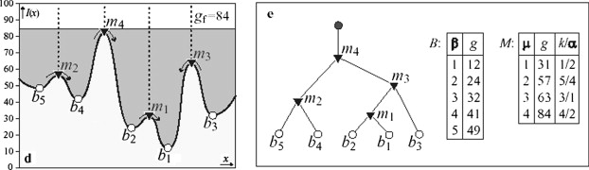

*Marker-based Watershed* often however, no examined flooding levelis sufficient to segment target structures. Therefore, the user may specify image locations that belong to the target structure (include points), or that do not belong the target structure (exclude points). If the user specifies an include point and an exclude point, an additional watershed is constructed at the maximum level between them. The merge tree is traversed such that each region contains either include points or exclude points but not both. This interaction style is called *marker-based watershed segmentation*. There are many variants of the watershed transform. For example, merging may consider also gradient information or other criteria for homogeneity. A frequently used variant is to merge regions where the difference of the mean gray value is below a threshold. This process can be carried out iteratively and results also in a hierarchical merging tree.

