Unit 2
3rd stage.

Blood
Testing blood
Use a syringe to take some blood from a vein in the patient’s arm. Put the blood into a test tube to prevent it from clotting. Then, use a pipette to place a drop of the blood onto a microscope slide. What do you examine it under? You examine it under a microscope. And what do you see?

Language spot

We use Zero and First Conditional the Zero Conditional to talk about what always happens in a particular situation It is often used to talk about scientific facts.
If you heat water to 100°C, it boils.
When you get pregnant, you put on weight.
The Present Simple tense is used in both parts of the sentence.
What happens to the blood when you take aspirin?
We use the First Conditional to talk about possible future actions or situations.
If you remind me later, I'll come and help you.
You won't get there on time if you don't hurry.
You won't get there on time unless you hurry.
We don't use will/won't after if/when/unless.
We use the Present Simple.
.if you go through swing door, you will see the office on the left.
Complete these sentences using the zero or the first conditional
- If you explain the problem to Sister, she will tell you what to do.
- When you have an anaesthetic, it stops you from feeling pain.
- If I have time this evening, I will help with your homework.
- If a person’s brain does not get oxygen, they will die.
- If you take a sleeping pill before you go to bed, you will sleep well tonight.

- Blood without oxygen comes into the right side of the heart. It enters the right atrium. The tricuspid valve opens, and the blood goes into the right ventricle. The pulmonary valve opens, and the blood flows through the pulmonary artery.
- The heart is a muscle as big as your fist in the center of your chest. It is an efficient pump that can get blood to the furthest cell in your body within sixty seconds.
- Blood carrying oxygen comes into the left side of the heart. The left atrium fills, the mitral valve opens, and the blood enters into the left ventricle. The aortic valve opens, and the blood leaves through the aorta. When you listen to a heart, you hear “lub dub, lub dub.” This is the sound of the valves working¹

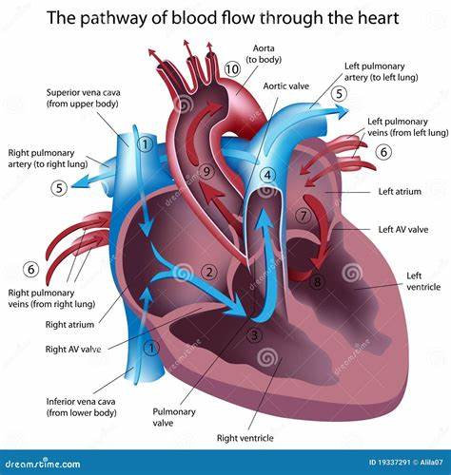

BLOOD PATTERN ANALYSIS
Even a tiny drop of blood at the scene of a violent crime can give important information to the police. Blood is there either because it has dripped out of a small wound, sprayed out from an artery, oozed out through a large wound, or flown off a weapon. Using blood pattern analysis, police can learn a lot about what happened from the shape of the blood drops.
In 1984 a man, Graham Backhouse, was found injured near his home with deep cuts across his face said the neighbor attacked him, and so he shot the and chest. A neighbor lay dead nearby Backhouse neighbor to defend himself. But the shape of the blood drops showed that Backhouse was standing still when he was wounded, and there was also no blood from Backhouse on his gun or near the victim. Police were sure Backhouse shot his victim and then wounded himself. He was found guilty of murder. Sometimes a murderer cleans the crime scene very carefully, and if detectives cannot see any blood they spray a chemical called Luminol across the scene. This makes it possible to see the blood in the dark, Luminol can show up very small drops of blood. From blood at the scene of a crime, police can learn about the person the blood came from. They can tell the person's blood type and, because male and female blood cells are different, they can also work out if the blood comes from a man or woman. Also, 80% of us are 'secretors', which means our blood type is contained in other bodily fluids. This can also help identify suspects.

State these sentences are true or false.
1 Blood from a cut artery drips out. True
2 Blood pattern analysis looks at the shape of drops of blood. True
3 Luminol tells you the blood type. False
4 Male blood is different from female blood. True

