**Chapter Two**

**Radioactive Decay**

**What is radioactivity?**

Nuclear decay or radioactivity, is the process by which a nucleus of an unstable atom loses energy by emitting ionizing radiation (particles or electromagnetic waves).

When the strong force can hold a nucleus together forever, the nucleus is stable.

If not, the nucleus becomes unstable and can break apart or decay by emitting particles and energy to become more stable. There are three main types of nuclear radiation: alpha (α) particles, beta (β) particles, and gamma (γ) rays.

**What makes nuclei unstable?**

The ratio of neutrons to protons determines whether a nucleus is stable or unstable.

nuclei with too many or too few neutrons compared to the numbers are unstable or radioactive. Large nuclei are more unstable; all with more than 83 protons are radioactive.

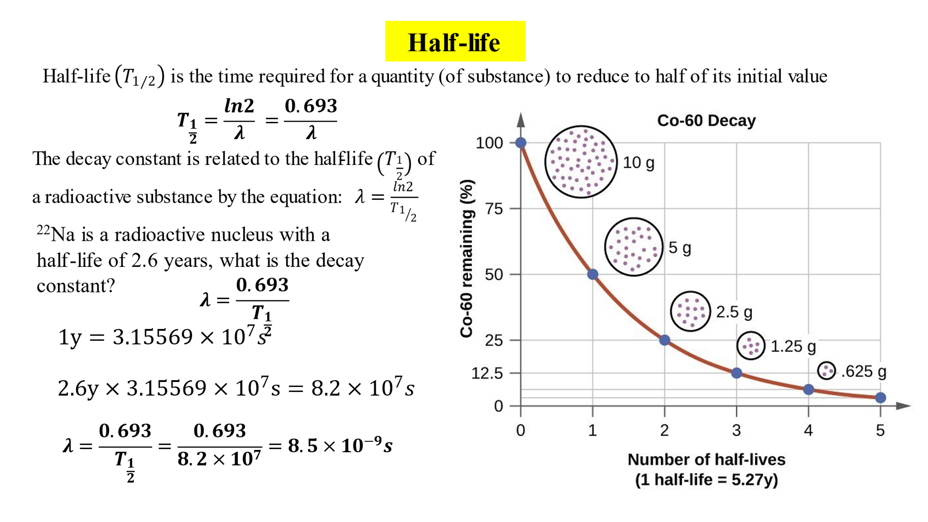

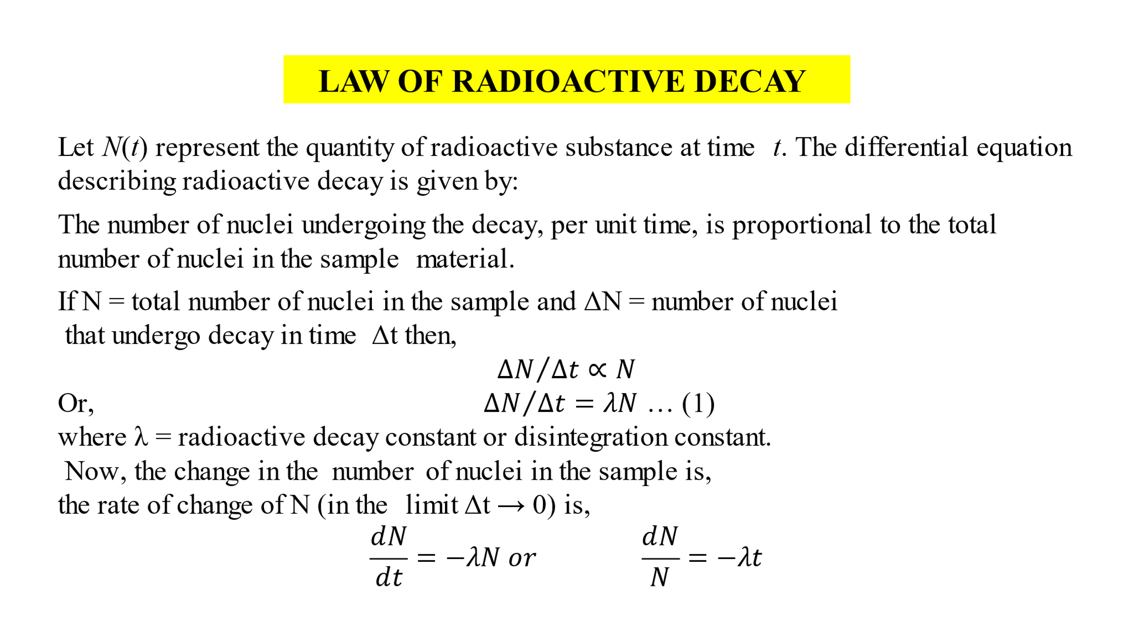

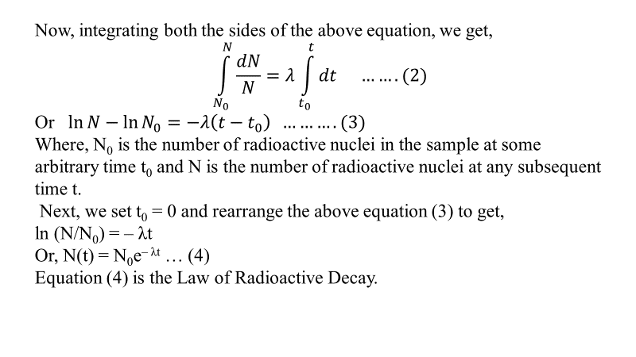

**Radioactive materials:** are substances that emit radiation due to the unstable atomic nuclei they possess. These materials undergo radioactive decay, which involves the emission of particles or electromagnetic waves from the nucleus. The emitted radiation can take various forms, such as alpha particles, beta particles, gamma rays, or neutrons.

Radioactive materials can occur naturally in the environment, such as uranium and thorium, or they can be created artificially in laboratories for various purposes, including medical diagnostics and treatments, industrial applications, and scientific research. While some radioactive materials have beneficial uses, others pose risks to human health and the environment if not handled properly.

