Shear force, Bending Moment and Axial Force Diagrams.

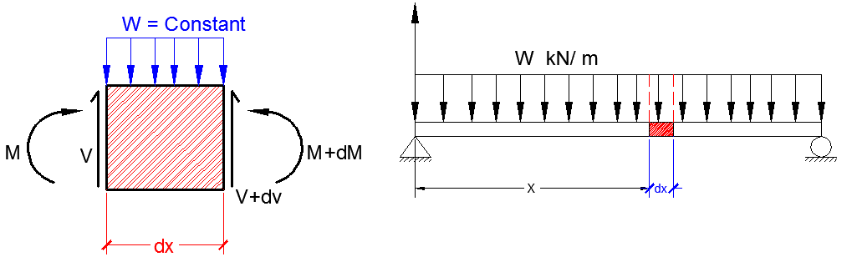

For the strip of width (dx) infinitesimal element

$$\sum{f_{y}=0}$$

V + dv = v + w *dx

W= $\frac{d_{v}}{d_{x}}$------------- 1

Slope of shearing force diagram of any section equal to the intensiting the load at that section.

By integration:-

=

V2- V1 =

--------------2

Changing in shearing force between x1&x2 section equals the total applied load between x1 &x2.

M + dM = M + Vdx + $\frac{W\left(x\right) {dx}^{2}}{2}$

$$\frac{W\left(x\right) {dx}^{2}}{2}, neglect because is small magnitude$$

dM = v . dx

*Vx* = $\frac{dM }{dX}$---------------- 3

Slope of bending moment diagram at any section equals the shear force at that section.

By integration:-

=

M2- M1 =

-------------- 4

Change in bending moment diagram between section x1 & x2 equal to the area under (v – diagram) between x1 & x2 plus any additional concentrated moment applied between x1 & x2.

Differentiate Equation:-

With respect to x

$$\frac{dv}{dx}=\frac{d^{2}M}{{dx}^{2}}, Then sub into equ. 1$$

W = $\frac{d^{2}M}{{dx}^{2}}$------------ 5

**Sign Convention:-**

1. Internal force:-
2. Axial: tensile +ve

Comp. –ve

1. Shear: on left segment

Down word +

Up word -

1. Bending Moment:
2. External force:-
3. Up word force +ve
4. Clockwise moment +ve
5. Axial force to the left +ve
6. Curves:-

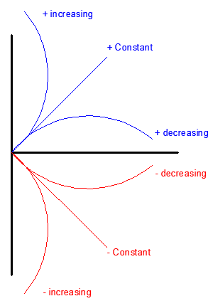

EX1:- Draw the axial force; shear force and bending moment diagrams.

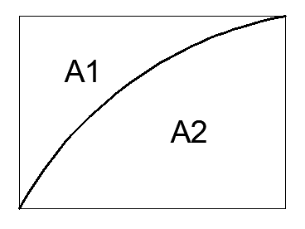

A1= 1/ (n+1), الكيرف مقعر A2= n / (n+1), الكيرف محدب

EX2: Draw the axial force; shear force and bending moment diagrams for the frame shown below.



Sol: - SEGMENT (AB)



Segment (DC)



Segment BCE



EX3:- Draw the axial force; shear force and bending moment diagrams for the frame as shown below.

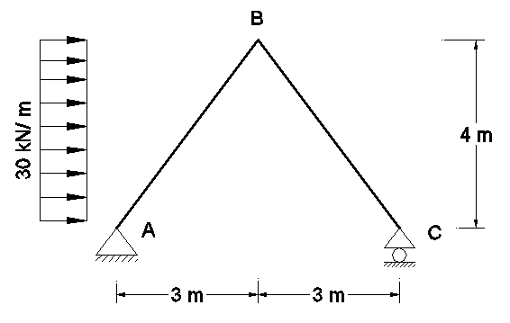

Sol:

$\sum{M_{A}=0}$

Cy*6 – (120*2) =0, Cy= 40 kN

$\sum{F_{y}=0}$, 40 + Ay = 0, Ay= -40 kN = 40 kN

$\sum{F_{X}=0}$, 120 – Ax = 0, Ax = 120 kN

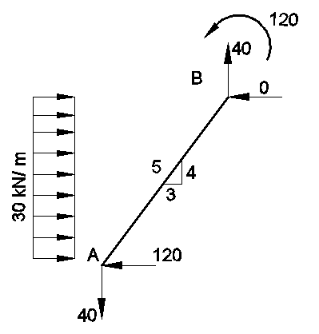

For segment. AB

$\sum{F_{y}=0}$, -40 + By = 0, By = 40 kN

$\sum{F_{X}=0}$, 120 – 120 – Bx = 0, Bx = 0

$\sum{M_{B}=0}$, MB + 120*2 + 40*3 -120*4 =0

MB= 120 kN.m



Segment AB.



Segment BC



EX4: Draw the axial force; shear force and bending moment diagrams for the frame shown below.

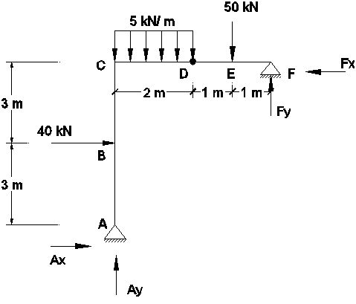

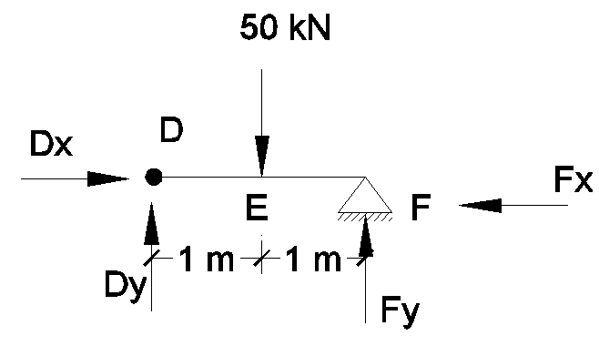Sol:

For segment (DEF)

$\sum{M_{D}=0}$,

Fy * 2 – (50*1) =0

Fy= 25 kN

For whole structure

$\sum{M_{A}=0}$ => Fx*6 + (25*4) – (50*3) – (10 *1) – (40*3) =0

Fx = 30 kN

$\sum{F_{y}=0}$,

Ay +25 -50- (5*2) = 0, => Ay= 35 kN

$\sum{F_{x}=0}$, => -Ax – 30 + 40 = 0, => Ax= 10 kN

Segment ABC



Segment CDEF



EX5: Draw the axial force; shear force and bending moment diagrams for the frame shown below.



Sol:-

For Member AB:



For Member CD:



For Member BC:



H.W: Draw the axial force; shear force and bending moment diagrams for the frame shown below.

