Theory of structure

Stability and determinacy of structures

Beams

* Total equation of equilibrium of beam

$\sum{F_{X}=0}$

$\sum{F_{Y}=0}$

$\sum{M=0}$

* Equation of condition

Internal hinge:-

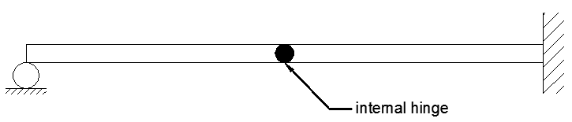 $$\sum{M=0}$$

C=1

C = m - 1

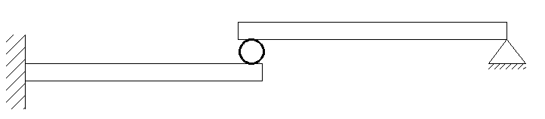Roller:-

$\sum{M=0}$

$\sum{F_{X}=0}$

C=2

Let r= No. of reaction

1. If r < c+3, unstable
2. r = c+3, determine if stable
3. r> c+3, indeterminate if stable

Let (m) degree of indeterminate

m= r- (c+3)

* the structure is said to be unstable if one of the following facts couter

1. r < c+3
2. The reaction element constitutes a parallel force system.

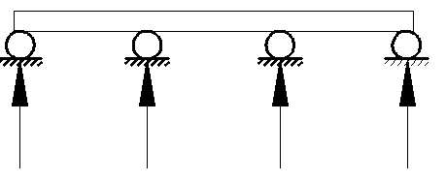

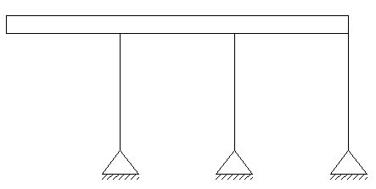

1. The reaction element constitutes a concurrent force system.

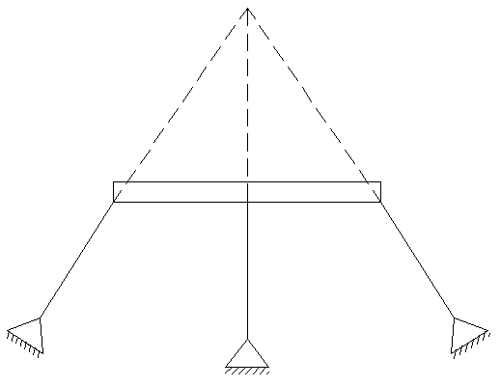

1. Internal geometric instability:-

Example

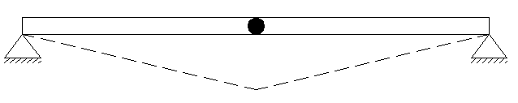r = 4

c =1

r = c+3

4=4

The beam is unstable because the Internal geometric instability

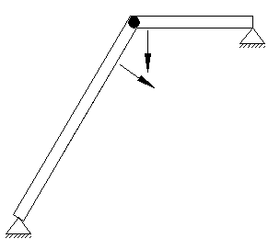Example

r = 4

c = m-1, c =1

r = c+3

4=4

The beam is determiate if stable

Example

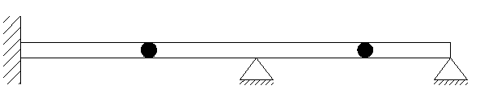r= 7

c= 2

r>c+3

7>5

The beam is indeterminate 2nd degree if stable

Example

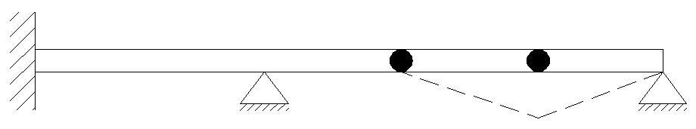r= 7

c= 2

r>c+3

7>5

The beam is unstable

Examples:-

|  |  |  |  |  |  |
| --- | --- | --- | --- | --- | --- |
| Beam | r | c | c+3 | state | Stability & determinate. |
|  | 3 | 0 | 3 | r=c+3 | Stable & deter. |
|  | 4 | 0 | 3 | r>c+3 | Stable & indeter. First degree |
|  | 6 | 1 | 4 | r>c+3 | Stable &indeter. Second degree |
|  | 6 | 2 | 5 | r>c+3 | unstable |
|  | 3 | 0 | 3 | r =c+3 | unstable |

Home Works

H.W1: Find the stability and determinacy of beam.

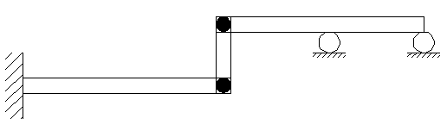

H.W2: Find the stability and determinacy of beam.

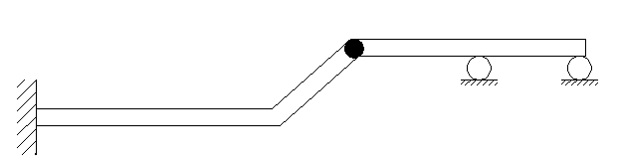

Stability and Determinacy of Trusses

b + r = unknown

j = equations

1. b + r < 2j, the truss is unstable
2. b + r = 2j, the truss is determinate if stable
3. b + r > 2j, the truss is indeterminate if stable

Let (m) equal to the degree of indeterminate

m= (b + r) – 2j

b = No. of bars

r = No. of reactions

j = No. of joints

Examples: - Find the stability and determinacy of trusses below.

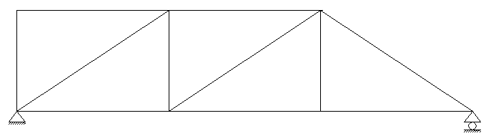Ex1

r = 3, b = 11, j = 7

b+r =14

2j= 14

b+r = 2j

The truss is stable &determinate

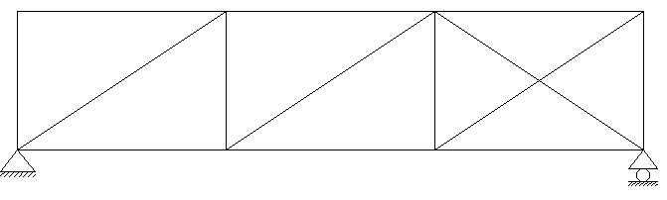Ex2

r = 3, b =14, j = 8

b+r = 17

2j = 16

b+r > 2j, the truss is stable& indeterminate 1st degree

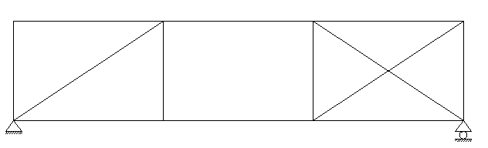Ex3

r = 3

b = 13

2j = 16

b+r = 2j, the truss is unstable because of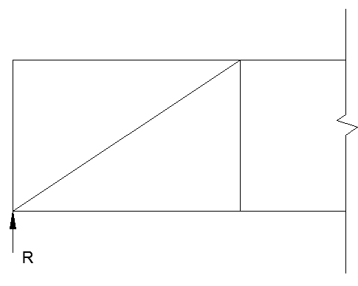 $\sum{F_{y}}≠0$, in this section

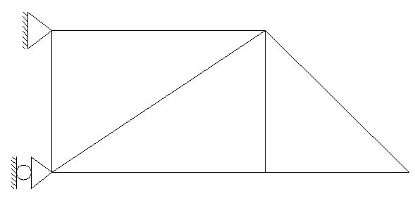Ex4

r = 3, b = 7, j = 5

b + r = 10

2 j = 10

b + r = 2j

The truss is stable & determinate

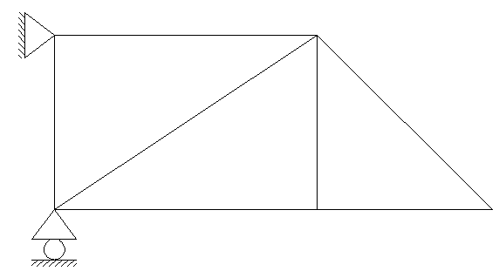Ex5

r = 3, b = 7, j = 5

b + r = 10

2 j = 10

b + r = 2j

The truss is unstable

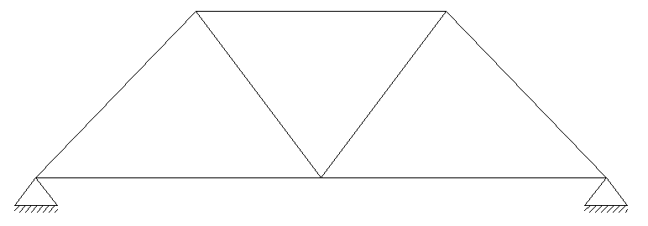Ex6

r = 4, b = 7, j = 5

b + r = 11

2 j = 10

b + r > 2j

The truss is stable & indeterminate 1st degree

Home works

H.W1

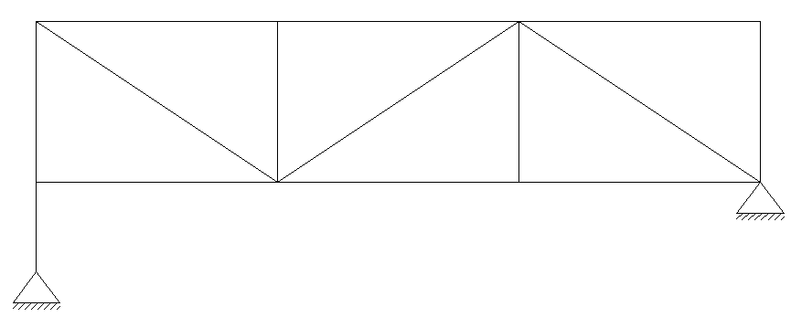

H.W2

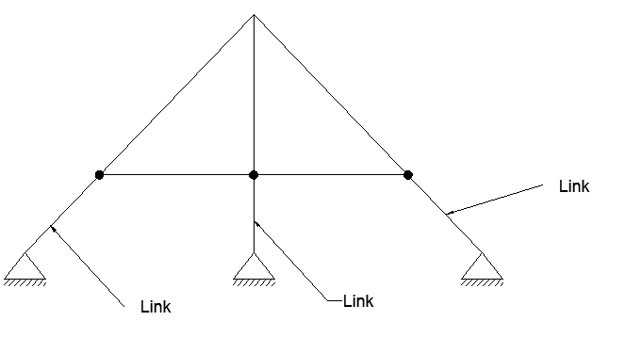

Stability and Determinacy of Frames

1. Open frames

r < C+3, unstable

r = C+3, determinate if stable

r > C+3, indeterminate if stable

Ex1:- Find the stability and determinacy of frame below

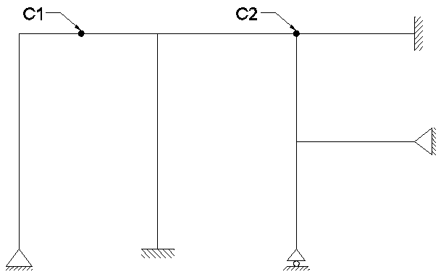C1 = m-1, C1 = 2-1 = 1

C2 = m-1, C2 = 3-1 = 2

C = C1+C2, C = 3

r = 11

C+3 = 6

r > C+3, the frame is stable& indeterminate 5th degree.

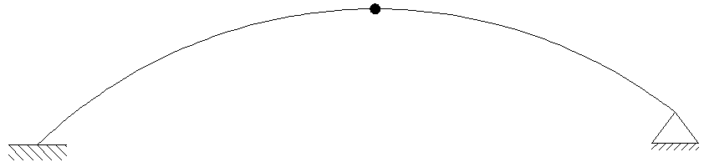Ex2:-

r = 5

C = 2-1 = 1

r > C+3, the frame is stable & indeterminate 1st degree.

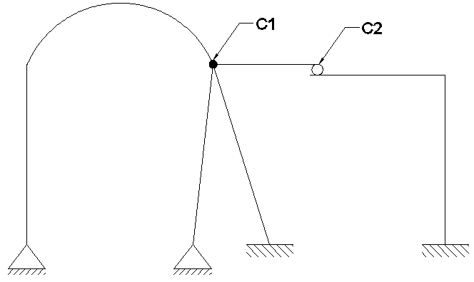Ex3:-

C1 = m-1, C1 = 4-1 = 3

C2 = 2

C = C1+C2, C = 5

r = 10

C+3 = 8

r > C+3, the frame is stable & indeterminate 2nd degree.

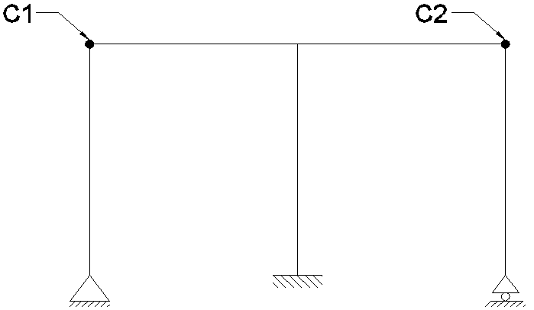

Ex4:-

r = 6

C = 2

r > C+3

The frame is unstable because of internal geometric instability

1. Closed Frames:-

3b+r < 3j+c, unstable

3b+r = 3j+c, determinate if stable

3b+r >3j+c, indeterminate if stable

Where,

3b+r = unknown

3j+c = equations

b = No. of members

r = No. of reactions

j = No. of joints

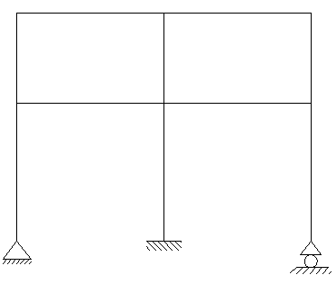

Ex1:-

b = 10

r = 6

j = 9

3b+r = 36

3j+c = 27

3b+r > 3j+c, stable & indeterminate 9th degree

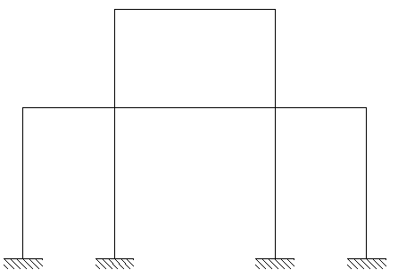

Ex2:-

b = 10

r = 12

j = 10

3b+r = 42

3j+c = 30

3b+r > 3j+c, stable & indeterminate 12th degree

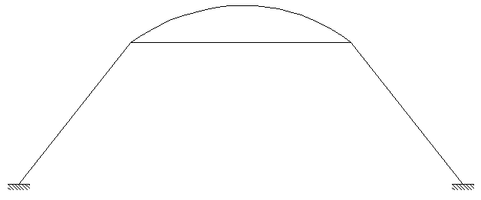 Ex3:-

b = 4

r = 6

j = 4

c = 0

3b+r = 18

3j+c = 12

3b+r > 3j+c, stable & indeterminate 6th degree

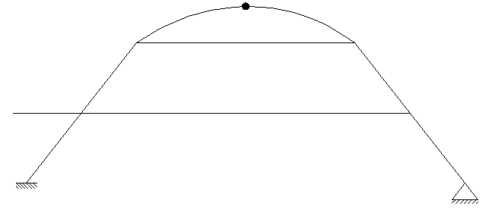 Ex4:-

b = 9

r = 5

j = 7

c = m-1 => c = 1

3b+r = 32

3j+c = 22

3b+r > 3j+c, stable & indeterminate 10th degree

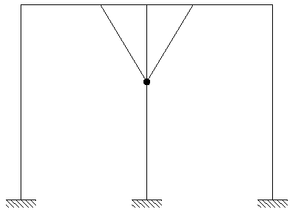 Ex5:-

b = 10

r = 9

j = 9

c = m-1 => c = 4-1=> c = 3

3b+r = 39

3j+c = 30

3b+r > 3j+c, stable & indeterminate 9th degree

ملاحظة:- اذا جاء ال internal hinge في بداية او نهاية الضلع فيحسب منه (c &j) اما اذا جاء في داخل الضلع فيحسب منة c فقط

Home work:

H.W1: Find the stability and determinacy of frame below

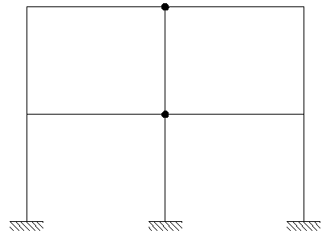

H.W2: Find the stability and determinacy of frame below

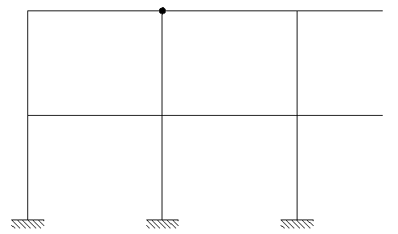

Stability and Determinacy of Composite Structure

|  |  |
| --- | --- |
| Unknowns | Equations |
| 1. Each truss member give one unknown | 1. each member carry moment give   ( 3 equations) |
| 1. reactions | 1. each joint connect truss members only give (2 equations) |
| 1. each joint connect member carry moment give unknown in these equation (2*(m-1)) |  |

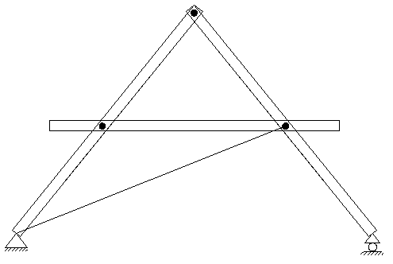Ex1:- Find the stability and determinacy of composite structure as shown below.

Solution:

Equations

(3*3) +0 = 9

Unknowns

1+3+ (3*(2(2-1))) = 10

Unknowns > Equations, Stable & indeterminate 1st degree

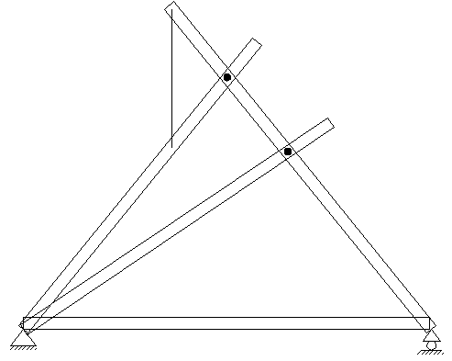Ex2:- Find the stability and determinacy of composite structure as shown below.

Solution:

Equations

(4*3) +0 = 12

Unknowns

1+3+ (3*(2(2-1))) + (2(3-1)) = 14

Unknowns > Equations, Stable & indeterminate 2nd degree

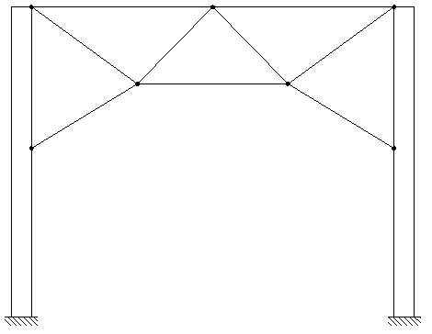Ex3:- Find the stability and determinacy of composite structure as shown below.

Solution:

Equations

(2*3) + (3*2) = 12

Unknowns

9+6+ 0 = 15

Unknowns > Equations, Stable & indeterminate 2nd degree

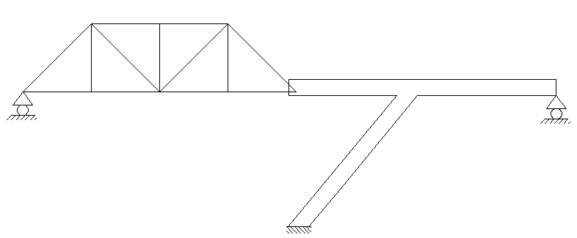Ex4:- Find the stability and determinacy of composite structure as shown below.

Solution:

Equations

(1*3) + (7*2) = 17

Unknowns

13+5+ 0 = 18

Unknowns > Equations, Stable & indeterminate 1st degree

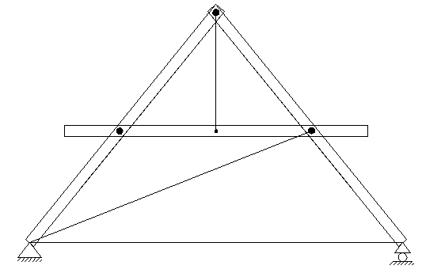H.w: Find the stability and determinacy of composite structure as shown below.