**EXP.NO: 3**

**Name of experiment: Metal-Oxide-Semiconductor Field-Effect Transistor (MOSFET)**

**Purpose of experiment:** To Study motor speed control of an N- channel MOSFET in common N Source Configuration.

**Apparatus:**

Bread bored, variable resistance, motor, DC power, MOSFET, resistance 10 KΩ

**Theory:**

The operation of a MOSFET relies on the control of the channel conductivity between the source and drain terminals by the voltage applied to the gate terminal. Here's a basic explanation of how it works:

**Structure:** A MOSFET has three terminals: the source (where current enters), the drain (where current exits), and the gate (which controls the current flow between source and drain).

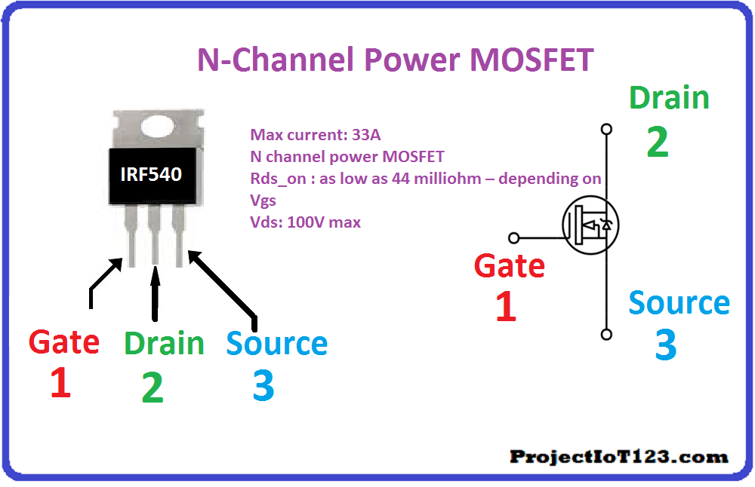

**Formation of Channel:** When a voltage is applied to the gate terminal, it creates an electric field in the oxide layer, which attracts or repels charge carriers (electrons or holes) in the semiconductor below. This process forms a conducting channel between the source and drain.

**Modes of Operation:**

1. **Enhancement Mode:** By default, there is no conducting channel between the source and drain. Applying a positive voltage to the gate (for an N-channel MOSFET) attracts electrons, creating a conducting channel (enhancement mode).
2. **Depletion Mode:** Some MOSFETs have a conducting channel even with no gate voltage applied. Applying a negative voltage to the gate depletes this channel, reducing conductivity (depletion mode).

MOSFETs can switch quickly between on and off states because the gate acts like a capacitor, storing charge to rapidly turn the channel on or off.

**Motor Speed Control with MOSFET**

The main intention of this is to design a circuit for controlling a DC motor speed with a MOSFET. A MOSFET is a type of transistor, used to amplify or switch voltages within circuits. The type of MOSFET used in this circuit is enhancement mode MOSFET which works only in the enhancement mode This means this transistor will be turned off whenever there is no voltage provided to the gate terminal & it will be turned ON whenever a voltage is provided. So makes the transistor ideal to use like a switch for controlling a DC motor.

In summary, MOSFETs offer numerous advantages for motor speed control, including high efficiency, fast switching speed, low gate drive power requirements, and reduced EMI. These advantages make them the preferred choice in a wide range of applications, from electric vehicles and industrial automation to home appliances and renewable energy systems. The versatility and reliability of MOSFETs make them a cornerstone of modern motor control technology.

**Procedure**

1. Connect the circuit as shown om below figure using bread board and control

the speed of motor using MOSFET.

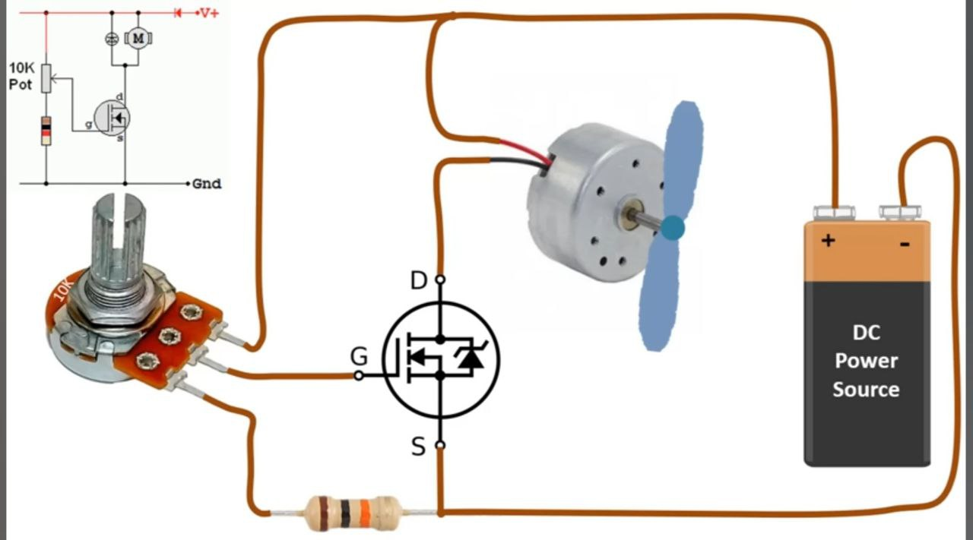

**Results**

Control the speed of motor by varying value of variable resistance.

**Discussion**

1. Describe the structure and operation of a MOSFET transistor.
2. Compare and contrast enhancement-mode and depletion-mode MOSFETs.
3. Explain how a MOSFET can be used as a switch to control the speed of a motor.
4. Discuss the advantages of MOSFETs over other types of transistors, such as BJTs.