Lecture9 Microbial Safety Cabinet (MSC)

Objectives:-

What is Microbial Safety Cabinet ?

Classification of Microbial Safety Cabinets

Principal and uses.

Types of safety cabinets.

Maintenance of Microbial safety cabinet.

What is Microbial Safety Cabinet?

Biosafety cabinet or Microbiological safety cabinet, also called a biological safety cabinet is an enclosed, ventilated laboratory workspace, for safely working with contaminated materials or potentially contaminated pathogens, which require a defined biosafety level. Several different types of BSC exist, differentiated by the degree of biocontainment required.

The primary purpose of biosafety cabinets is to protect the laboratory personnel and the environment from the pathogenic microorganism as aerosols might be formed during the processing of such microorganisms. These cabinets are provided with HEPA-filters that decontaminate the air moving out of the cabinet. This filter removes particles of 0.3 microns (which essentially includes all bacteria, spores, and viruses) with an efficiency of 99.97%. However, it does not remove vapors or gases.

Biosafety cabinets might be confused with the laminar hood as both of these pieces of equipment work as enclosed workspaces. But, laminar hood only provides protection to the sample and not to the personnel and the environment, whereas biosafety cabinets protect all three.

Besides, most BSCs also function to sterilize biological materials that are kept inside the cabinets. The primary purpose of a Biosafety cabinet is to serve as a means to protect the laboratory worker and the surrounding environment from pathogens.

Classification of Microbial Safety Cabinet:

Biosafety cabinets are classified into three classes by the U.S. Centers for Disease Control and Prevention (CDC). These classes and the types of BSCs classified according to:

a-The level of personnel and environmental protection

b-The level of product protection provided

1.Biosafety Cabinet Class I

Class I is the most basic biosafety cabinet that provides protection to the environment and the laboratory personnel.

It doesn’t, however, provide protection to the product as the unsterilized room air is drawn over the work surface.

Class I biosafety cabinets are typically used to either enclose specific equipment like centrifuges or for procedures like aerating cultures that might potentially generate aerosols.

Biosafety cabinets of this class are either ducted (connected to the building exhaust system) or not ducted (recirculating filtered exhaust back into the laboratory).The air inside the cabinet then takes in the aerosol particles that may have been generated and moves it away from the operator towards the HEPA filter.

The air moving out of the cabinet is thus, sterilized via the HEPA filters before its discharge to the environment. In this way, the cabinets protect the operator and the environment from the aerosol but not the sample.

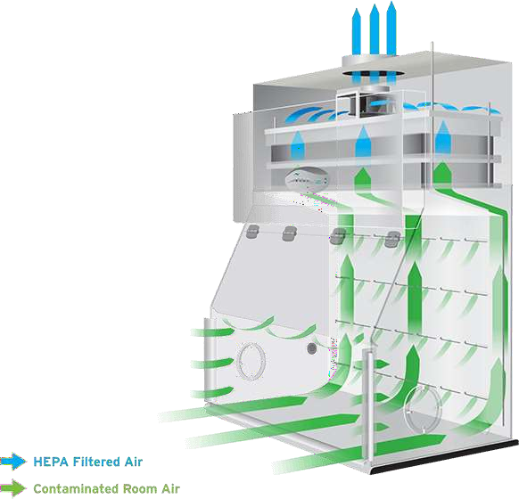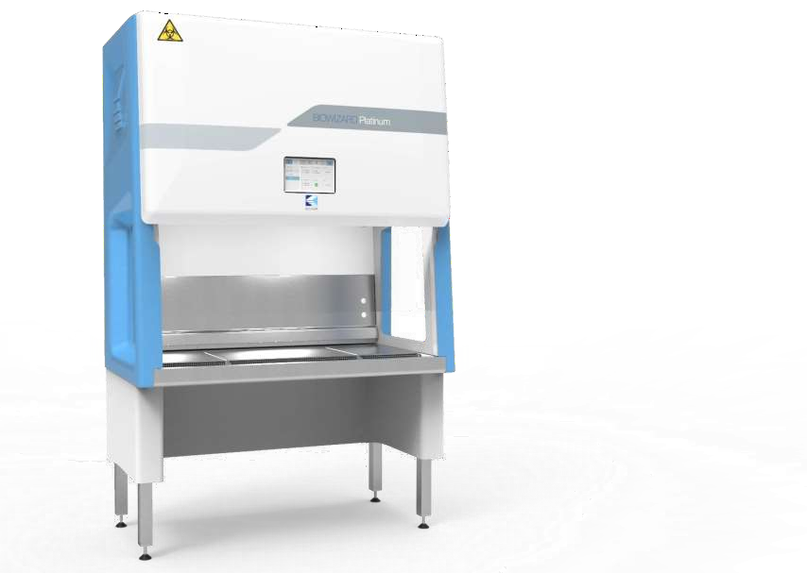

2.Biosafety Cabinet Class II protection of kinds both provide cabinets IIBSC- Class the and samples the (of environment) since makeup air is also HEPA-filtered.The principle of operation of Class II cabinets involves a fan mounted in the top of the cabinet that draws a curtain of sterile air over the work station where the biological products are being handled. The air then moves underneath the work station and back up to the top of the cabinet before passing through the HEPA filters.

Class II BSCs are further divided into five types depending on the exhaust system and the mechanism of work (recirculation of the exhaust air); Type A1, Type A2, Type B1, Type B2, and Type C1. About 90% of all biosafety cabinets installed are Type A2 cabinets.

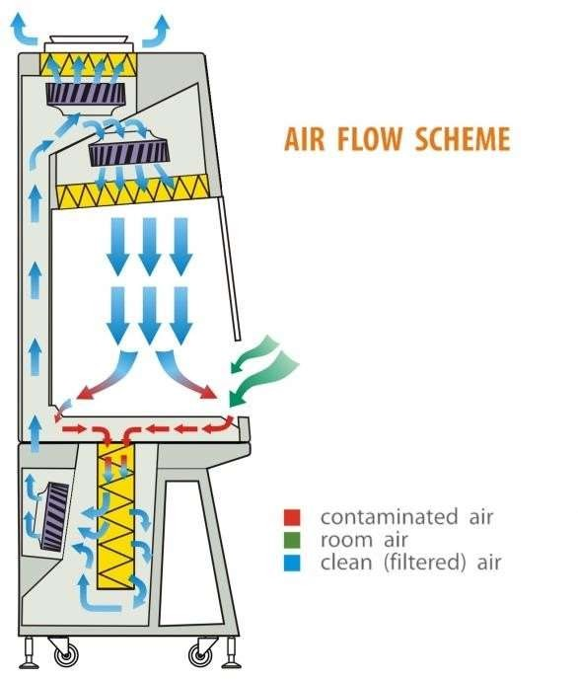

3.Biosafety Cabinet Class III

Class III cabinets are leak-tight, totally enclosed but ventilated cabinets, where all air that either enters or leaves through the facility pass through a HEPA filter. The cabinets are provided with rubber gloves that are attached to the system to be used during operations in the cabinet. This is why these cabinets are also termed ‘glove boxes’.

The cabinet even has a transfer chamber that facilitates the sterilization of materials before they leave the glove box.

Even though the gloves restrict the hand movement of the operator inside the cabinet, it prevents direct contact between the operator and the samples in combination with HEPA filters or double HEPA filters with treated air exhaust. These cabinets can be used for all four Biosafety levels (1, 2, 3, and 4). But these are the most important for the manipulation of biological materials in the Biosafety level 4.These cabinets are mostly custom-built for

Specific laboratories with lab equipment built inside the chamber. These Structural and features design provide maximum protection to the operator, and the sample against the high-risk group 4 pathogenic organisms.

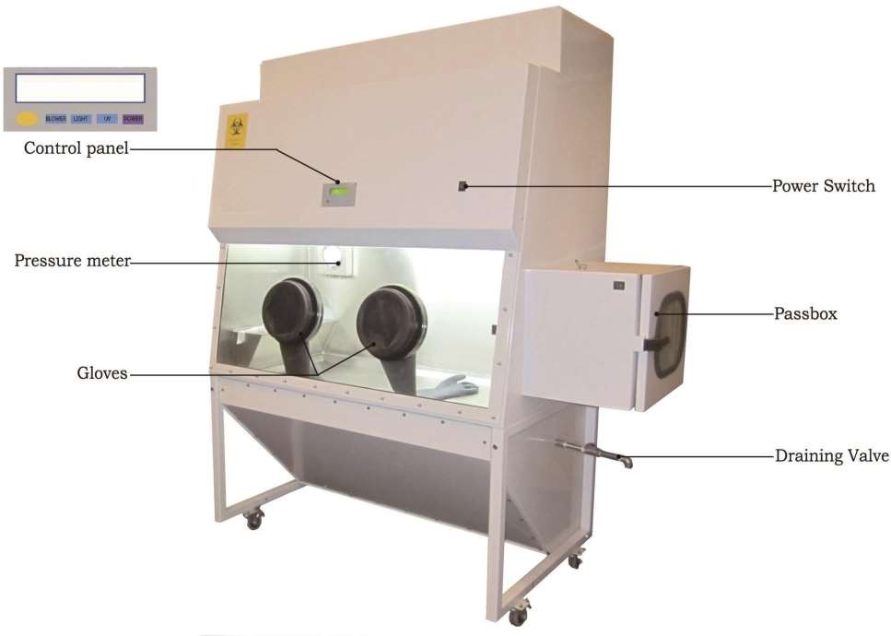

**Maintenance of safety cabinets**

Cabinets need to be maintained on a regular schedule. During this certification check, the airflow and the filter capacities are verified.

The filters have a limited lifespan - determined by the air quality within the • laboratory space and the amount of particles and aerosols generated inside the BSC' work zone. As these filters load, the internal fan is required to do more work to push/pull the same volume of air through them. Newer cabinets measure the air flow constantly and self-compensate fan performance to ensure constant volumes of air moving through the filters and the cabinet.