Medical Laboratory Instruments



prof.Dr.Hadi Yasir Abbood &Alaa Ahmed Ubaid

Tissue Microtomy

# Introduction

After embedding the tissue and preparing the block, the next step is microtomy. The word “microtomy” is originated from the Greek language. Mikros means small and temnein means to cut. So the word “microtomy” means to cut the tissue in thin sections. For successful microscopic examination, it is necessary to have thin sections of the tissue by microtomy.

# Microtomes

It is the main instrument by which we cut the embedded tissue in the paraffin block as thin section.

There are different types of microtomes in the traditional histology laboratory:

1. Rotary microtome
2. Rocking microtome
3. Cryo microtome
4. Ultra microtome

## Rotary microtome:

This is the most commonly used microtome in routine laboratory. The cutting blade is kept in horizontal position, and the block containing tissue moves up and down with the help of rotary handle attached with the microtome. In each 360° rotation of the wheel handle, the block moves down followed by up, and the tissue is cut as thin ribbon.

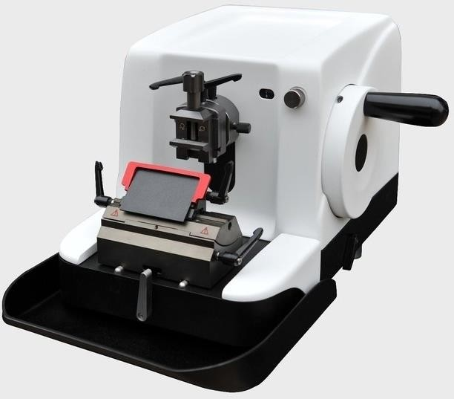

## Rocking microtome:

This is one of the oldest designs of the microtome. The microtome can cut thin section with ribbons and is ideal for serial section. The sections are slightly curved in this microtome.

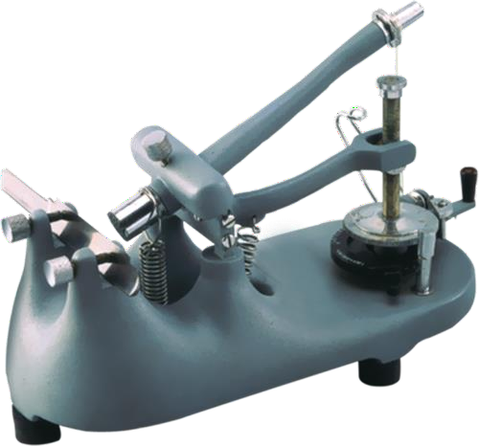

## Cryo microtome:

This type of microtome is used for the cutting tissue for frozen sample.

The sample is made hard in liquid nitrogen and then cut by the microtome in the chamber that contains liquid nitrogen.

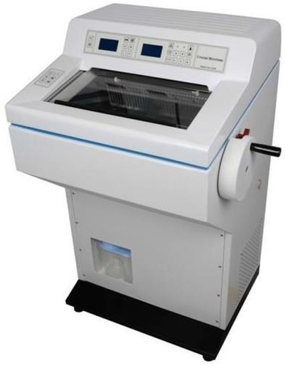

## Ultra microtome:

Ultra microtome is used to cut ultrathin sections for transmission electron microscopy. Sections are cut between 40 and 100 nanomicron thickness with the help of glass knife or diamond knife.

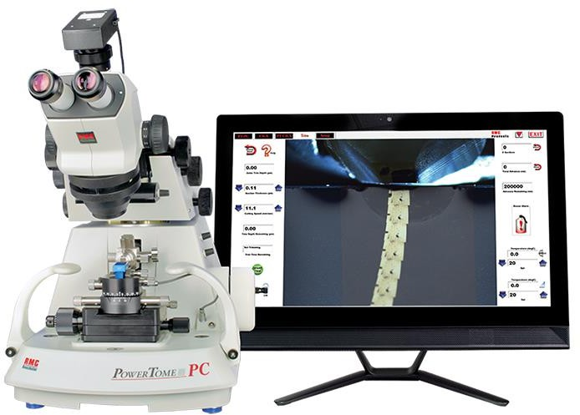

### Factors Involved in Cutting:

1. *Temperature*: Lowering the temperature facilitates section cutting.
2. *Angle of rake*: Higher rake angle helps in smooth flow of ribbons. Lower rake angle is used for hard tissue.
3. *Consistency of tissue*: Soft tissue is cut at a slow rate than the hard tissue.

### Sectioning the Paraffin Block:

The following instruments are essential for section cutting:

1. Microtome with blade
2. Water bath
3. Paraffin block with embedded tissue to cut
4. Ice tray
5. A blunt forceps or camel brush
6. Slide rack with slide.