**Spectrophotometer**

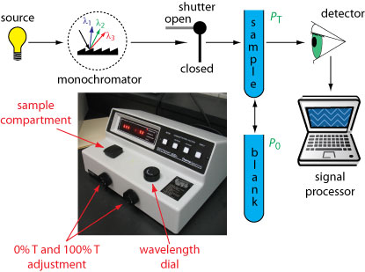

Spectrophotometer : its instrument for measure light intensity which measures light intensity in terms of color (Wavelength).

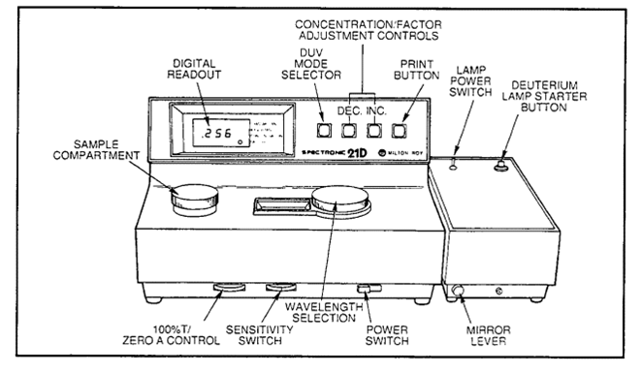

**There two used for this spectrophotometer**

1-Used for measure light absorption .

2- Used for measure light rebound .

In medical laboratories used the first type any light absorption . There are two types from this instrument .

1-Single beam : measure the absolute intensity of light .

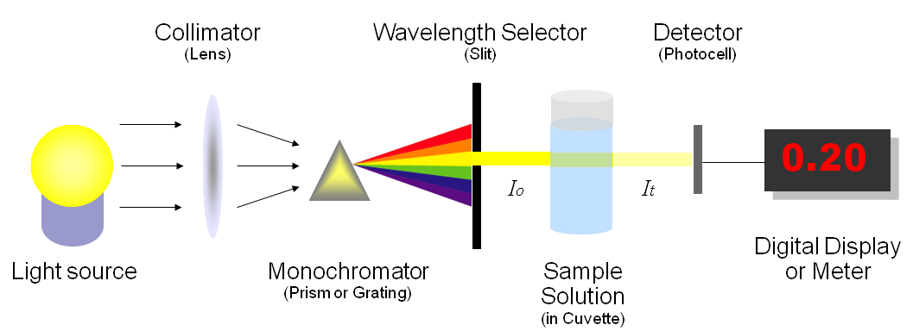

Single beam Spectrophotometer

2- Double beam : measure the percentage of light intensity by two beam different track .

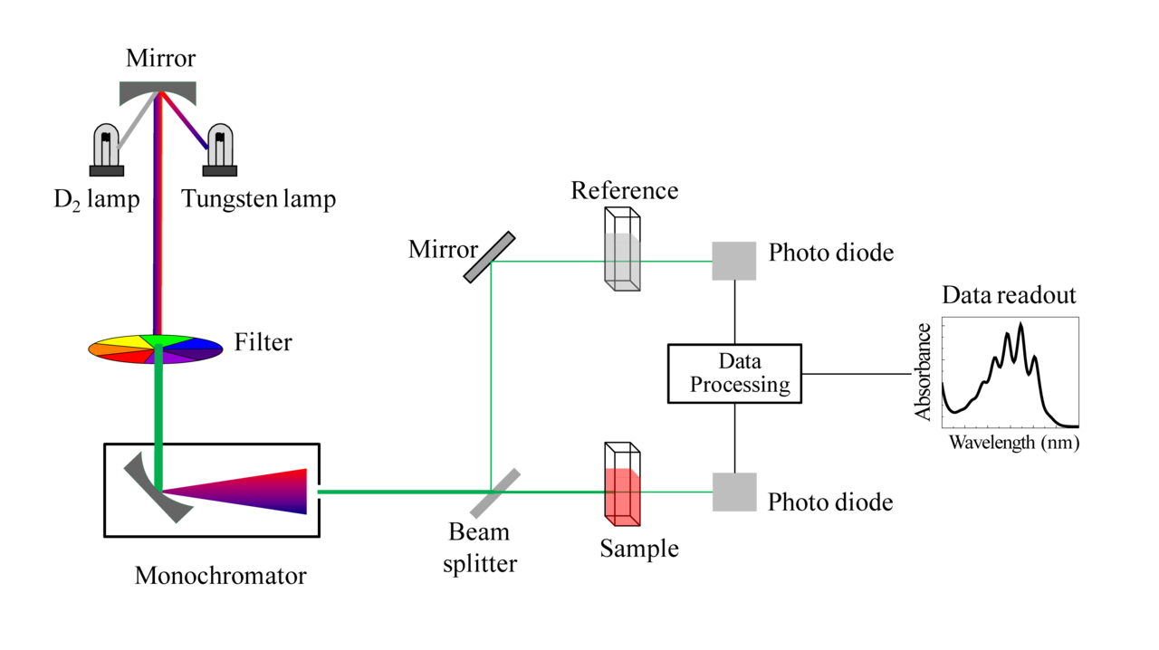

Double beam Spectrophotometer

The first type easier and more stability but second type more use because has a longer range of wavelengths .

**Consists spectrophotometer of four main parts** .

1-Light source : this part is the main source for radiation in this instrument used ( Hollow cathode lamps) (HCL) this type of light source consists of cathode and anode with inert gas (Ergun or neon ) in sealed tube .

2- Collimator (lens)

3- Monochromatic : it an important part in spectrophotometer function this part in work instrument separate wavelengths required for different wavelengths by (HCL). Where it to selection required wavelength to examine the sample .

4- Wavelength selector (slit)

5- Cuvette

6- photometer (photocell): after selecting wavelength required by monochromatic where it the light passes through the sample and be on the opposite side a set of detectors for the amount of remaining amount of energy then displays the result on the screen .

**Method used spectrophotometer**

1-Run instrument and leaves for 15 minutes for heated .

2- Use the key to the wavelength for adjust instrument on the wavelength required used .

3- Close the cover where placed the sample and used key (zero control) to adjust the gauge .

4- Adjust the gauge on (Transmittance 0%) this process is done without putting a sample in instrument where the path is closed the photometer does not record anything .

5- putting tube containing the reference solution in the space close the c0over and used key control of light where the absorption index of the spectrum becomes zero.

6- Get out reference sample , put the sample to be examined and close the cover then read absorption .

**Some important notes**

*Take a blood sample from the patient put in centrifuge for separation blood components and get a plasma .

* Mixing the limiting factor with serum interaction produces cause the movement of molecules or change in color. The color vary depending on the type of tests .

**Maintenance**

1-Change the light source .

2- Cleaning lenses and mirrors and optical lanes .

3- Must keep the lens from dust and touch because this change the outcome .

4- Lenses and mirrors sensitive very must be treated with caution .