Medical Laboratory Instruments



prof.Dr.Hadi Yasir Abbood &Alaa Ahmed Ubaid



The PH meter is designed to measure the effective concentration of hydrogen ions in a solution.

The PH meter is more commonly in the clinical laboratory to measure the PH of blood and check the PH of certain reagent such as buffer that are prepared for use in lab.

**PH** is defined as the negative log of the hydrogen ion activity PH = -log [H+]

The sum of PH and POH = 14 POH=-log[OH-]

**EXAMPLE**: water at 25°C has 0.0000001 mole of hydrogen per liter. This expressed as 10-7, the log of hydrogen ion concentration is -7. The PH of water at 25°C is 7.

* A strong alkaline solution such as NaOH would have a higher concentration of hydroxyl ions and lower concentration of hydrogen ions . An acid have a higher concentration of hydrogen ions .
* 0←← ACID←←← 7 →→→ALKALINE→→14



1. Electrode holder.
2. Electrode.
3. Beaker.
4. Switch on the instrument , allow to warm up for a few minutes .
5. Set up the temperature on the actual temperature reading.
6. Rinse the electrode with distilled water and read the reference buffer.
7. Adjust the reading of the reference buffer on the scale.
8. Read your unknown by dipping the electrode into the sample flask.

[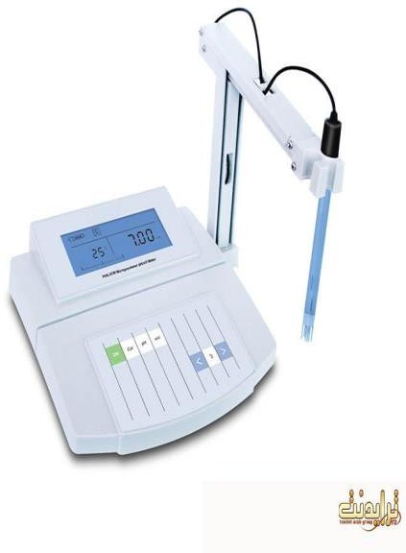](http://www.google.iq/url?sa=i&rct=j&q&esrc=s&source=images&cd&cad=rja&docid=naChK1f7IUNLMM&tbnid=YxYUheNv6_l-BM:&ved=0CAUQjRw&url=http://www.school-labs.com/t4501-2.html&ei=oeTWUoKkHYLTtAauooGYDw&bvm=bv.59378465,d.bGE&psig=AFQjCNE9nMHWObXY0kf9YUMqgLv8JdURug&ust=1389901285036731)[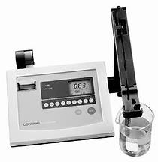](http://www.google.iq/url?sa=i&rct=j&q&esrc=s&source=images&cd&cad=rja&docid=92oML95kDWQpRM&tbnid=epS7O2aOZKTChM:&ved=0CAUQjRw&url=http://ar.medwow.com/med/ph-meter/corning/445-digital-ph-meter/44082.model-spec&ei=K-XWUrDkBoOJtQaQ5YBg&bvm=bv.59378465,d.bGE&psig=AFQjCNE9nMHWObXY0kf9YUMqgLv8JdURug&ust=1389901285036731)