Medical Laboratory Instruments



Pro Prof. Dr. Hadi Yasir & M.Sc. Alaa Ahmed Ubaid



A **water bath** is laboratory equipment made from a container filled with distilled water. It is used to incubate samples in water at a constant temperature over a long period of time. All water baths have a digital or an [analogue](https://en.wikipedia.org/wiki/Analog_device) interface to allow users to set a temperature. It is also used to enable certain chemical reactions to occur at high temperature. Water bath is a preferred heat source for heating flammable chemicals instead of an open flame to prevent [ignition](https://en.wikipedia.org/wiki/Combustion). Different types of water baths are used depending on application. For all water baths, it can be used up to 99.9 °C. When temperature is above 100 °C, alternative methods such as oil bath, [silicone](https://en.wikipedia.org/wiki/Silicone) bath can used.

* Water level should be regularly monitored, and filled with distilled water only. This is required to prevent salts from [depositing](https://en.wikipedia.org/wiki/Deposition_(chemistry)) on the heater.
* [Disinfectants](https://en.wikipedia.org/wiki/Disinfectant) can be added to prevent growth of organisms.
* Raise the temperature to 90 °C or higher to once a week for half an hour for the purpose of [decontamination](https://en.wikipedia.org/wiki/Decontamination).
* If application involves liquids that give off [fumes](https://en.wikipedia.org/wiki/Vapor), it is recommended to operate water bath in fume hood or in a well ventilated area.
* The cover is closed to prevent evaporation and to help reaching high temperatures.

Circulating the water baths (also called *stirrers )* are ideal for applications when temperature uniformity such as [enzymatic](https://en.wikipedia.org/wiki/Enzymology) and [serologic](https://en.wikipedia.org/wiki/Serology) experiments. Water is thoroughly circulated throughout the bath resulting in a more uniform temperature.



This type of water bath relies primarily on [convection](https://en.wikipedia.org/wiki/Convection) instead of water being uniformly heated. Therefore, it is less accurate in terms of temperature control.



This type of water bath has extra control for shaking, which moves liquids around. This shaking feature can be turned on or off. In [microbiological](https://en.wikipedia.org/wiki/Microbiology) practices, constant shaking allows liquid-grown [cell cultures](https://en.wikipedia.org/wiki/Microbiological_culture) grown to constantly mix with the air.

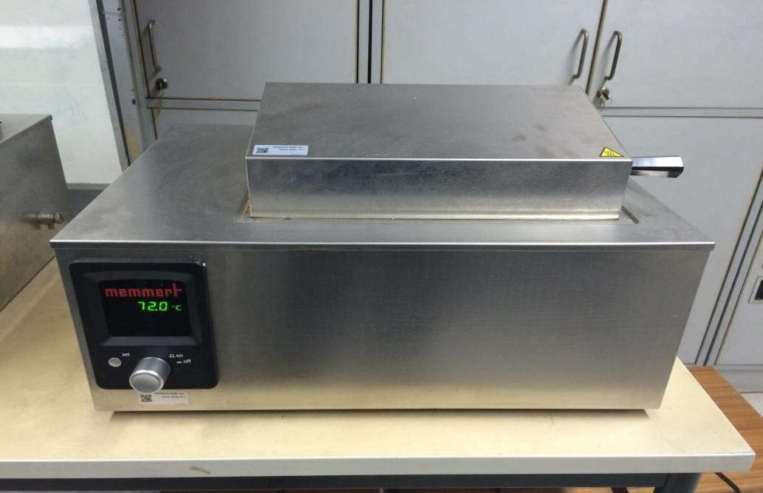



A **vortex mixer**, or vortexer, is a simple device used commonly in laboratories to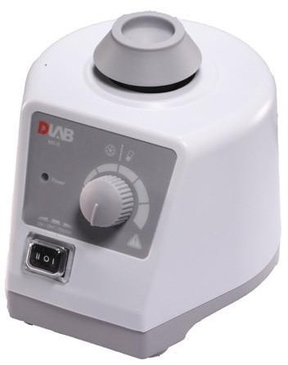 mix small vials of liquid. It consists of an [electric motor](https://en.wikipedia.org/wiki/Electric_motor) with the drive shaft oriented vertically and attached to a cupped rubber piece mounted slightly off-center. As the motor runs the rubber piece oscillates rapidly in a circular motion. When a test tube or other appropriate container is pressed into the rubber cup (or touched to its edge) the motion is transmitted to the liquid inside and a [vortex](https://en.wikipedia.org/wiki/Vortex) is created. Most vortex mixers are designed have variable speed settings ranging from 100 to 3,200 rpm, and can be set to run continuously, or to run only when downward pressure is applied to the rubber piece.

