Lecture 10

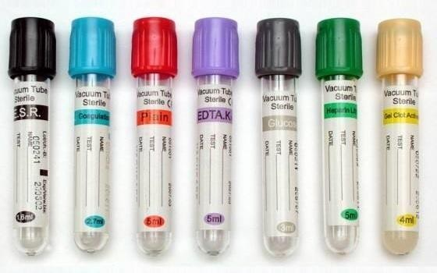

**Specimens collection:**

Proper collection, identification, processing, storage, and transport of common sample types associated with requests for diagnostic testing are critical to the provision of quality test results. Many errors can occur during these steps. Minimizing these errors through careful adherence to the concepts discussed here.

**Types of biological specimens that are analyzed in clinical laboratories include**:

❖ Whole Blood

❖ Serum

❖ Plasma

❖ Urine

❖ Feces

❖ Saliva

❖ Spinal, Synovial, amniotic, pleural, pericardial, and ascitic fluids

❖ Various types of solid tissue.

**Types of tubes used to collect the blood sample**:

1. **Sodium Heparin -Top Tube (Green):** This tube contains sodium heparin -- used for tests requiring plasma or whole blood (such as cytogenetic when using blood DNA)
2. **Potassium Oxalate/Sodium Fluoride -Top Tube (Grey):** This tube contains potassium oxalate as an anticoagulant and sodium fluoride as a preservative -- used to preserve glucose in whole blood and for some special chemistry tests
3. **EDTA -Top Tube (PURPLE**): This tube contains EDTA as an anticoagulant -- used for most haematological tests.
4. **Sodium Citrate -Top Tube (Light Blue):** This tube contains sodium citrate as an anticoagulant -- used for drawing blood for coagulation studies.
5. **Plain -Top Tube(Red):** This tube is a **plain** VACUTAINER containing no anticoagulant -- used for most chemistry, including drug levels and serological tests that require serum.
6. **Serum Gel Tube(Yellow):** This tube contains a clot activator and serum gel separator

– used for all tests requiring serum except those few that need red cells as well (such as abnormal blood group antibody screen, cold agglutinins).

1. **ESR-Vacuum Tubes (Black):** contain tri-sodium citrate to avoid coagulation, used to collect, transport, and analyze the erythrocyte sedimentation rate (ESR) of whole blood.

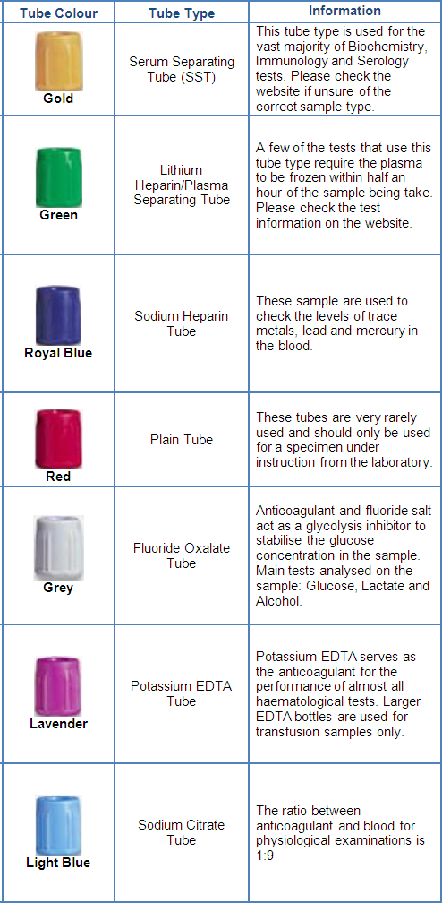

Summary of blood collection tubes:

