Lecture 5



It is a device used to sterilize equipment’s by subjecting them to high pressure saturated steam at 121 °C for around 15–20 minutes, this means that all bacteria, viruses , fungi and spores are inactivated.



The sterilizing action depend on the heat of pressurized steam which is about 2.2 bar at 121°C , ( when heat water in a closed container like autoclave we can raise the temperature of water above boiling temperature).



* Strong metal jackets ( strong enough to withstand high pressure required).
* Autoclave door.
* Pressure gauge (indicate pressure).
* Thermostat.
* Safety valve.
* Plastic rubber.
* Timer.
* Water level indicator.
* Thermometer (give temperature).

Electrical heater (heat supply) located at the bottom of autoclave which is covered with water.



\*\*Autoclaves are widely used inmicrobiology,medicine, Typical loads include laboratory glassware, surgical instruments and medical waste.



1. Fill the bottom of autoclave with distilled water.
2. Place the object within the basket.
3. close the lid and tighten the screws.
4. adjust the temperature, pressure and time.
5. Upon completion of the sterilization time, discards steam by opening the valve then opens the lid.

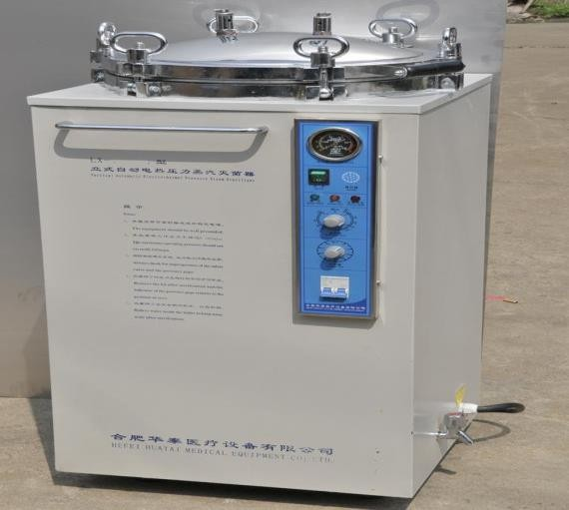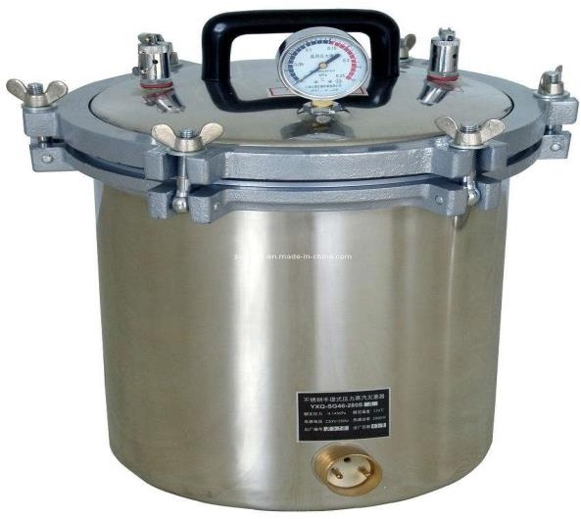

Shape (1) : Autoclave devic