Lecture 7

# Balance

Balance are one of most important instrument being used in labs for measuring ( chemicals , media , laboratory animals ) .

# How to weigh:

1. Put a clean container on the balance pan.
2. Press the zero switch (zeroes appear on the screen)

*(Most electronic balances have a tare function. The tare function resets the digital display to zero when pressed.)

1. Add the material on the plate and read the numbers and the unit , it preferred to use appropriate spatula.

# NOTES:

*Don't measure too heavy things by the balance.

*Take care during weighing , not to breath onto the weight or into the balance chamber.

*Keep your balance clean and covered when it is not in use.

*Balance should be placed on a solid surface that is free of air currents , vibrations, and not in direct sun light.

# Keeping a Balance Clean

Balances are expensive and chemicals spilled on the balance may corrode the delicate mechanism, causing readings to be incorrect or preventing the balance from working at all. Therefore, several rules for keeping a balance (and the balance area) clean are described below.

*Never weigh a sample directly on the balance pan.

* Using a brush to clean all solids from the balance pan.
* Wear gloves while cleaning if a material may be hazardous. Also clean the area around the balance.

[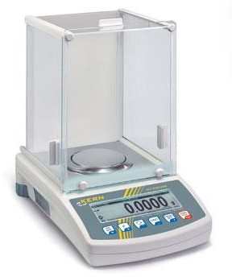](http://www.google.iq/url?sa=i&rct=j&q&esrc=s&source=images&cd&cad=rja&docid=meZcsRLeb_65dM&tbnid=-A7_7zzzboZUlM:&ved=0CAUQjRw&url=http://www.tovatech.com/blog/4111/lab-scale/college-analytical-chemistry-survival-guide&ei=1WC0Uq3TLYbO0QXAk4DwDQ&bvm=bv.58187178,d.d2k&psig=AFQjCNEtufLoa1kXQCwTnocQDgodj6O7xw&ust=1387639362593361)[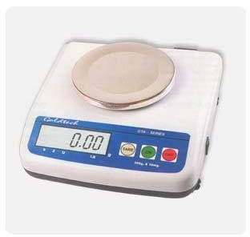](http://www.google.iq/url?sa=i&rct=j&q&esrc=s&source=images&cd&cad=rja&docid=_1ojk8mqw63XzM&tbnid=mISpq7ic3blVCM:&ved=0CAUQjRw&url=http://www.alibaba.com/product-free/109137318/Analytical_balance/showimage.html&ei=pmG0Ut3AHu6y0AWYn4CQAg&bvm=bv.58187178,d.d2k&psig=AFQjCNEtufLoa1kXQCwTnocQDgodj6O7xw&ust=1387639362593361)

Shape (1) :Balance device

[Amazon.com: High Precision Analytical Balance Electronic ...](https://www.amazon.com/Precision-Analytical-Electronic-Instrument-180x140mm/dp/B0773F6MQ6)

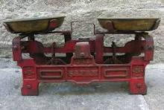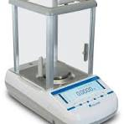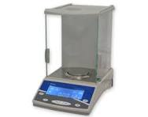

[Balance | Precision Weighing & Calibration Techniques...](https://www.britannica.com/technology/balance-measuring-instrument)

[[https://encrypted-tbn0.gstatic.com/faviconV2?url=https://www.britannica.com&client=IMAGE_SEARCH&size=24&type=FAVICON&fallback_opts=TYPE,SIZE,URL](https://www.britannica.com/technology/balance-measuring-instrument)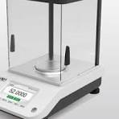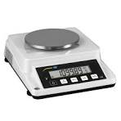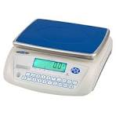](https://www.britannica.com/technology/balance-measuring-instrument)

[Britannica](https://www.britannica.com/technology/balance-measuring-instrument)

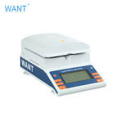

[Chinese digital balance scale manufacturer,analytical ...](https://www.wantbalance.com/)

[[https://encrypted-tbn2.gstatic.com/faviconV2?url=https://www.wantbalance.com&client=IMAGE_SEARCH&size=24&type=FAVICON&fallback_opts=TYPE,SIZE,URL](https://www.wantbalance.com/)](https://www.wantbalance.com/)

[www.wantbalance.com](https://www.wantbalance.com/)

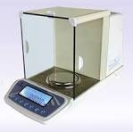

[Amazon.com: High Precision Analytical Balance Electronic ...](https://www.amazon.com/Precision-Analytical-Electronic-Instrument-180x140mm/dp/B0773F6MQ6)



[Balance | Precision Weighing & Calibration Techniques ...](https://www.britannica.com/technology/balance-measuring-instrument)

[[https://encrypted-tbn0.gstatic.com/faviconV2?url=https://www.britannica.com&client=IMAGE_SEARCH&size=24&type=FAVICON&fallback_opts=TYPE,SIZE,URL](https://www.britannica.com/technology/balance-measuring-instrument)](https://www.britannica.com/technology/balance-measuring-instrument)

[Britannica](https://www.britannica.com/technology/balance-measuring-instrument)

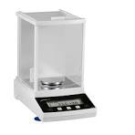

[Series Dx Analytical Balances - Accuris Instruments](https://accuris-usa.com/Products/series-dx-analytical-balances/)

[Accuris Instruments](https://accuris-usa.com/Products/series-dx-analytical-balances/)

