Lecture 4

# Centrifuge

* A centrifuge is a device for separating particles from a solution according to their **size**, **shape**, **density**, **viscosity of the medium** and **rotor speed** by subjecting high gravitational force.
* In a solution, particles whose density is higher than that of the solvent sink (sediment), and particles that are lighter than it float to the top. If there is no difference in density the particles stay steady.
* **A centrifuge is used to separate particles or macromolecules such as** Cells , Sub-cellular components ( mitochondria, ribosome, membranes) , Proteins , Nucleic acids (DNA, RNA) and salts.

# Principle:

The centrifuge works using the sedimentation principle, where more dense substance to separate out and become at the bottom of the tube, when we uses a centrifuge on blood the blood cells collect at the bottom while the blood plasma moves to the top. Centrifugal force depends essentially on variables (mass,shape, speed and radius)

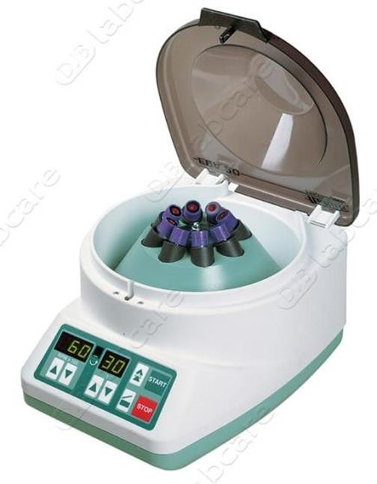

**Figure: centrifuge**

**Types of Centrifugal Separations**

1. **Differential centrifugation:** Separation is based on the size of the particles. This type of separation is commonly used in obtaining partiallypure preparation of subcellular organelles and macromolecules.

During

centrifugation of a cell homogenate, larger particles sediment faster than smaller ones. After spin, pellet contains larger to smaller particles (usually mixture) , Supernatant = liquid + most slowly sedimenting component.

1. **Density gradient centrifugation:** is the preferred method to purify subcellular organelles and macromolecules. Density gradients can be generated by placing layer after layer of gradient media .

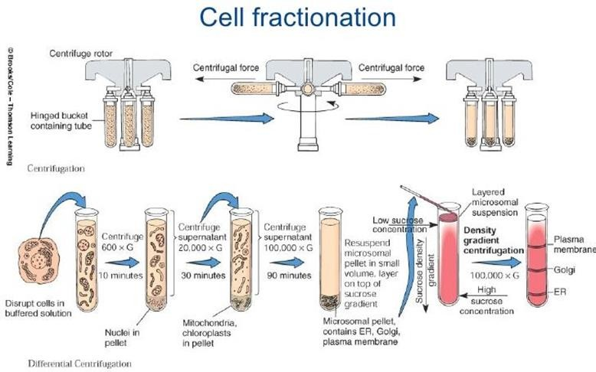

# Types of centrifuge :

1. **Microcentrifuge** : are used to process small volumes of biological molecules, cells, or nuclei. Microcentrifuge tubes generally hold 0.5 - 2.0 mL of liquid, and are spun at maximum angular speeds of 12,000–13,000 rpm.
2. **High-speed or superspeed centrifuge** : can handle larger sample volumes, from a few tens of millilitres to several litres. Additionally, larger centrifuges can also reach higher angular velocities (around 30,000 rpm).
3. **Ultracentrifuge** : Use high centrifugal force for studying properties of biological particles. Ultracentrifuges can isolate much smaller particles, including ribosomes, proteins, and viruses. Ultracentrifuges can also be used in the study of membrane fractionation. This occurs because ultracentrifuges can reach maximum angular velocities in excess of 70,000 rpm.
4. **Cold centrifuge** : cooling is important added feature to any laboratory centrifuge, temperature ranges as wide as( -20C – -40C ) , making them perfect for DNA, RNA, PCR or antibody analysis. Cold centrifuge can obtain rotational speeds of over 30,000 rpm, and a relative centrifugal force (RCF) of over 65,000 x g.