**Lec Three : Body Membrane**

**Function of body membranes**

* Line or cover body surfaces
* Protect body surfaces
* Lubricate body surfaces

**Classification of Body Membranes**

1. Epithelial membranes
2. Cutaneous membrane

* Mucous membrane
* Serous membrane

1. Connective tissue membranes

* **Cutaneous Membrane** 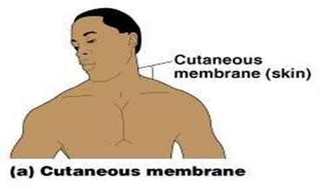
* **Cutaneous membrane = skin , A dry membrane**
* **Outermost protective boundary**
* **Superficial epidermis : Keratinized stratified squamous epithelium**
* **Underlying dermis : Mostly dense connective tissue**
* Dermis: consist of two layers
* Papillary layer
* Reticular layer
* **Hypodermis**
* Deep to dermis is the hypodermis
* Not part of the skin
* Anchors skin to underlying organs
* Composed mostly of adipose tissue

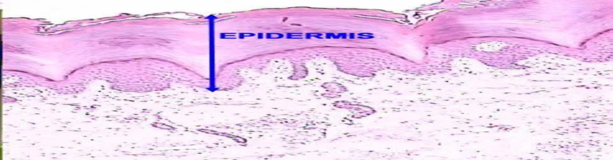

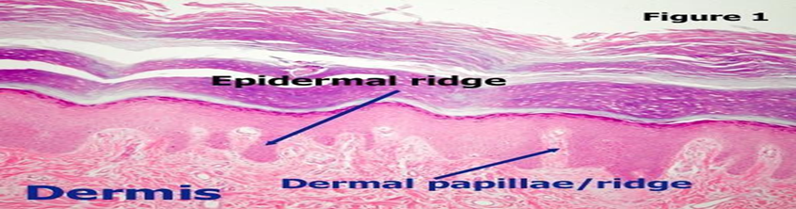

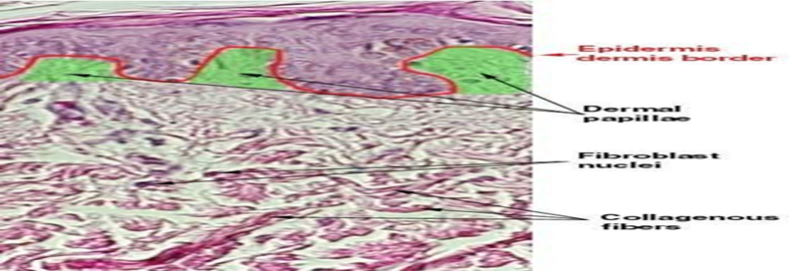

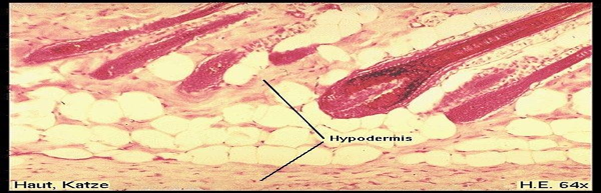

* **Skin functions:**

**• Protects deeper tissues from:**

**• Mechanical damage**

**• Chemical damage**

**• Bacterial damage**

**• Thermal damage**

**• Ultraviolet radiation**

**• Desiccation**

**• Aids in heat regulation**

**• Aids in excretion of urea and uric acid**

**• Synthesizes vitamin D**

**Melanin**

**Skin Color Determinants**

**1.Melanin**

Yellow, brown or black pigments

Pigment (melanin) produced by melanocytes

Amount of melanin produced depends upon genetic and exposure to sunlight .

**2. Carotene**

Orange-yellow pigment from some vegetables

**3. Hemoglobin**

Red coloring from blood cells in dermis capillaries

Oxygen content determines the extent of red coloring

* **Appendages of the Skin**

**** Sebaceous glands: Produce oil

❖ Sweat glands

❖ Associated Hair Structures

**•** Hair follicle , Arrector pilli , Smooth muscle

• Dermal and epidermal sheath surround hair root

* **Mucous Membranes**
* Surface epithelium
* Type depends on site
* Underlying loose connective
* Lines all body cavities that open to the exterior body surfa
* Often adapted for absorption or secretion
* 
* **Serous Membranes**
* Surface simple squamous epithelium
* Underlying areolar connective tissue
* Lines open body cavities that are closed to the exterior of the body
* 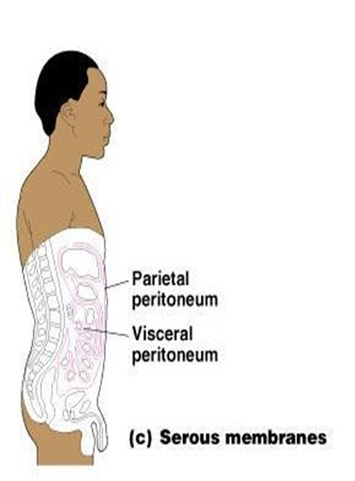Serous layers separated by serous fluid

Specific serous membranes : EXAMPLES

Peritoneum: Abdominal cavity

Pleura : Around the lungs

Pericardium : Around the heart

* + **Connective Tissue Membrane**

Synovial membrane: Connective tissue only Lines fibrous capsules surrounding joints

