Lec two : Body tissues and Membrane

Histology : Is the science that study the structure of cells and tissues

The cell: Is the smallest structural and functional unit in the body

Tissues: are groups of cells that are similar in structure and function

**There are four basic tissue types:**

1. The Epithelial tissue: covering
2. The Connective tissue: support
3. The Nervous tissue: control
4. The Muscular tissue : movement

: this Found in different areas : **1.The Epithelial tissue**

1. Body coverings
2. Body linings
3. Glandular tissue

ITS Functions :Protection , Absorption , Filtration and Secretion

**Classification of Epithelium:** **SIMPLE AND STRATIFIED**

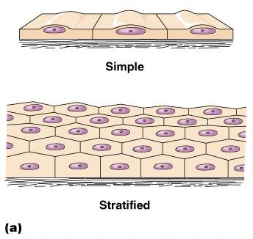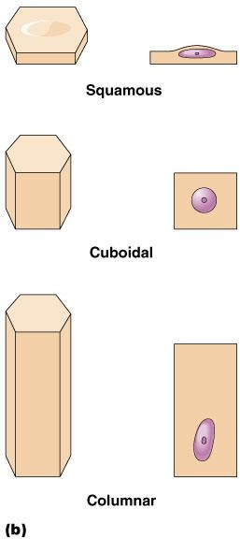

* + Simple : single layer of cells;

Types of Simple Epithelium

* 1. Simple squamous epithelial tissue.
  2. Simple cuboidal epithelial tissue.
  3. Simple columnar epithelial tissue.
  4. peudostratified columnar epithelial tissue
  + Stratified : layers of cells; common in areas where protection is needed like the skin

2.Stratified epithelial tissue: Types of Stratified Epithelium

1. Stratified squamous epithelial tissue.
2. Stratified cuboidal epithelial tissue.
3. Stratified columnar epithelial tissue.
4. Transitional epithelial
5. Simple squamous epithelial tissue: Single layer of flat cells Usually forms membranes , Lines body cavities Lines lungs and capillaries

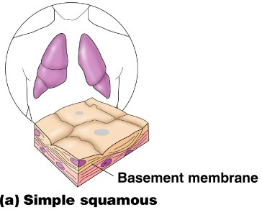

**B.Simple cuboidal epithelial tissue.**  Single layer of cube-like cells Common in glands and their ducts

Forms walls of kidney tubules also Covers the ovaries.

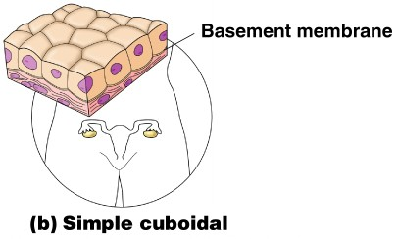

1. Simple columnar epithelial tissue

Single layer of tall cells Often includes goblet cells, which produce mucus Lines digestive tract

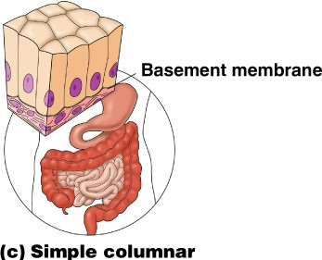

**Peudostratified columnar epithelial tissue**  : Single layer, but some cells are shorter than others , Often looks like a double cell

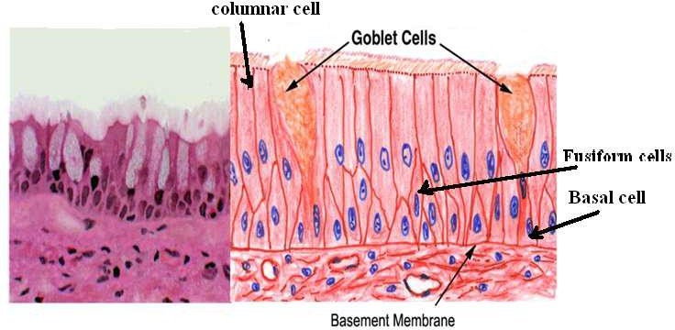 layer , Sometimes ciliated, such as in the respiratory tract

**Stratified epithelial tissue :-** Composed of more than one layer based on basement membrane , classified to :-

A. Stratified squamous epithelial tissue.

There are two types of stratified squamous epithelial tissue:

* -Non keratinized squamous epithelial tissue which is covering moist cavities such as mouth , esophagus , pharynx …..etc.
* 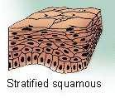Keratinized squamous epithelial tissue found on exposed surface of the body such as the skin .

**Stratified cuboidal epithelial tissue B.**

The surface layer cuboidal in shape , found in the large excretory ducts in the salivary glands and pancreas .

**C. Stratified columnar epithelial tissue**

Is found in the fornix of conjunctiva while the ciliated Stratified columnar epithelial tissue is found in the larynx .

**D.Transitional epithelial tissue**

Is found exclusively in the passages of the urinary system .

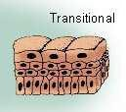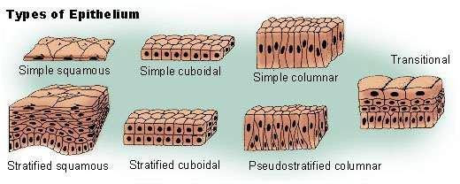

# Glandular tissue : cells or parenchyma of the glands developed from epithelial tissue , according to the methods of secreted products of gland the glandular epithelial tissues classified to :

A-Exocrine glands(excrete their product into ducts )like skin

B- Endocrine glands(secret their products direct into circulatory system) C-Mixed glands (like pancreas)

A- Exocrine gland :have a secretory portion which contains the cells specialized for secretion and ducts which transport the secretion out of the gland .According to the way the secretory products leave the cell

1. 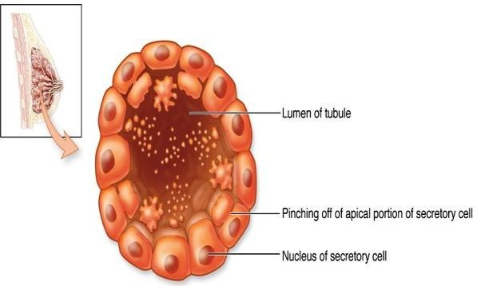Apocrine ; the secretory products is typically a large lipid droplet and is discharged together with some of the apical cytoplasm Example; Mammary glands
2. Merocrine / Eccrine: secrete product usually containing proteins by means of exocytosis at the apical end of the secretory cells Example; (e.g. salivary glands)

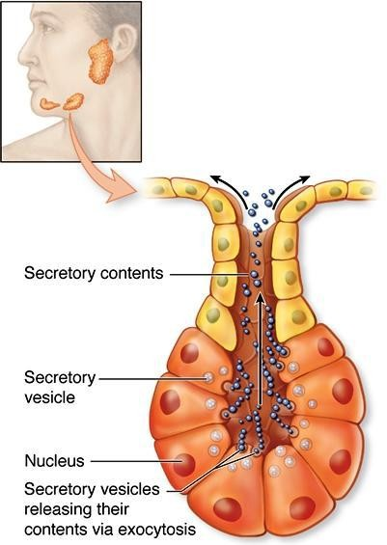

1. 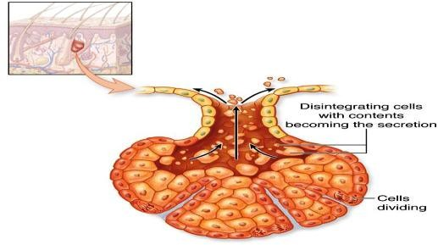Holocrine : the cell filling with secretory product and then the whole cell being disrupted and shed .EG: Sebaceous glands of skin.

**B. ENDOCRINE GLANDS**

* Endocrine glands have not any ducts - *ductless*
* Their specific products – hormones are released directly into the bloodstream . The major endocrine glands include:

Pituitary,Hypothalamus thyroid,Parathyroid,Adrenal,Pancreas,Ovary (females), Testis (males)

Connective tissue

Connective tissue is the most abundant and the most widely distributed of the tissues. Connective tissues perform a variety of functions including support and protection. All connective tissue consists of three main components: fibers, ground substance and cells.

Connective Tissue Fibers:

* 1. Collagen Fibers
  2. Elastic Fibers
  3. Reticular Fibers



**Connective Tissue Types**

1. Loose CT: Adipose CT

2. Dense CT: Regular and irregular

3. Spescialized : bone , cartilage, areolar , Reticular:

**1- Loose connective tissue:** has a relatively large proportion of ground substance or cells, The fibers are very few. E.g Adipose, or fat tissue,.



**2- Dense connective tissue:** It has thicker, denser fibers and fewer cells. E.g( tendons and ligaments) There are 2 types of dense connective tissue: regular, and irregular



**1.Dense Regular Connective Tissue** :The collagen fibers are bundled in parallel fashion.

**2. Dense Irregular Connective Tissue :**This tissue has fibers that are not arranged in parallel bundles ., such as the capsules of the kidneys and adrenal glands.

**3.Specialized Connective Tissue:** This type CT found in Skeletal tissues (cartilage and bone) and vascular or fluid tissues (blood and lymph).

* BONE , osseous CT : Composed of
* Bone cells in lacunae (cavitie
* Hard matrix of calcium salts
* Large numbers of collagen fibers
* Used to protect and support body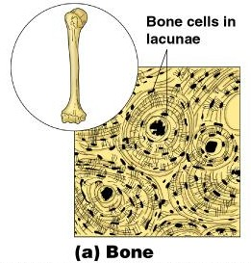
* Cartilage Connective Tissue: Types includes include hyaline , elastic and fibrocartilage

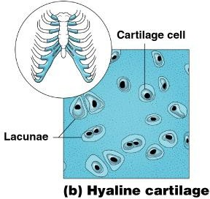

A.Hyaline cartilage ; Most common cartilage Composed of Abundant collagen fibers Rubbery matrix, Example fetal skeleton

B.Elastic cartilage : Provides elasticity , Example: the external ear

C.Fibrocartilage: Highly compressible Example: forms cushion-like discs between vertebrae

* Areolar CT: Most widely distributed connective tissue Soft, pliable tissue , Contains all fiber types,Can soak up excess fluids

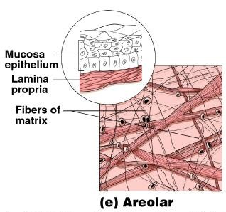

* Reticular Connective Tissue: lymphoid organs Lymph nodes , Spleen and Bone marrow.

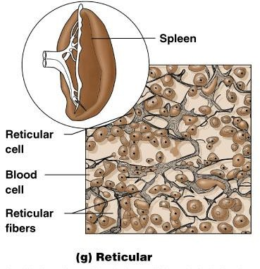

**MuscleTissue :** Function is to produce movement

Three types Skeletal muscle , Cardiac muscle and Smooth muscle

**Nervous Tissue :** Neurons and nerve support cells , Function is to send impulses to other areas of the body, irritability and conductivity

