**كلية العلوم**

**قــســــــــــم الانظمة الطبية الذكية**

**Lecture: (4)**

**Arrays Part IV**

**Subject: Computer Programming II**

**Level: First**

**Lecturer:** **Dr. Maytham N. Meqdad**

**Main Diagonal**

The **main diagonal** of a matrix consists of those elements that lie on the diagonal that runs from top left to bottom right.

If the matrix is **A**, then its main diagonal are the elements who's row number and column number are equal, **ajj**.

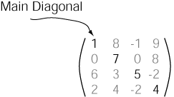

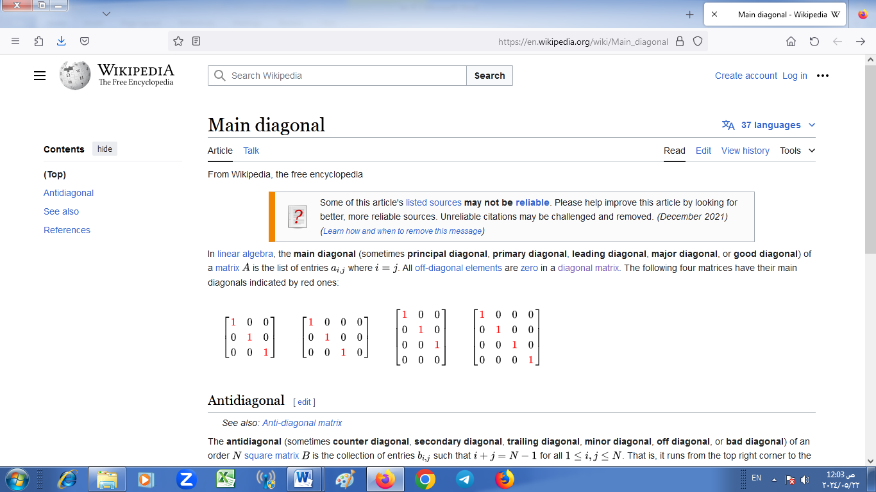

**Main Diagonal**

* Given a 2D square matrix, print the Principal and Secondary diagonals.

**Examples :**

**Input:**   
  
1 2 3 4  
4 3 2 1  
7 8 9 6  
6 5 4 3  
**Output:**  
Principal Diagonal: 1, 3, 9, 3  
Secondary Diagonal: 4, 2, 8, 6

**Input:**  
  
1 1 1  
1 1 1  
1 1 1  
**Output:**  
Principal Diagonal: 1, 1, 1  
Secondary Diagonal: 1, 1, 1

/ Java Program to print the Diagonals of a Matrix

class GFG {

    static int MAX = 100;

    // Function to print the Principal Diagonal

    static void printPrincipalDiagonal(int mat[][], int n)

    {

        System.out.print("Principal Diagonal: ");

        for (int i = 0; i < n; i++) {

            for (int j = 0; j < n; j++) {

                // Condition for principal diagonal

                if (i == j) {

                    System.out.print(mat[i][j] + ", ");

                }

            }

        }

        System.out.println("");

    }

    // Function to print the Secondary Diagonal

    static void printSecondaryDiagonal(int mat[][], int n)

    {

        System.out.print("Secondary Diagonal: ");

        for (int i = 0; i < n; i++) {

            for (int j = 0; j < n; j++) {

                // Condition for secondary diagonal

                if ((i + j) == (n - 1)) {

                    System.out.print(mat[i][j] + ", ");

                }

            }

        }

        System.out.println("");

    }

    // Driver code

    public static void main(String args[])

    {

        int n = 4;

        int a[][] = { { 1, 2, 3, 4 },

                      { 5, 6, 7, 8 },

                      { 1, 2, 3, 4 },

                      { 5, 6, 7, 8 } };

        printPrincipalDiagonal(a, n);

        printSecondaryDiagonal(a, n);

    }

}

// This code is contributed by Rajput-Ji

**Output**

Principal Diagonal: 1, 6, 3, 8,

Secondary Diagonal: 4, 7, 2, 5,

**Above and below the main diagonal java**

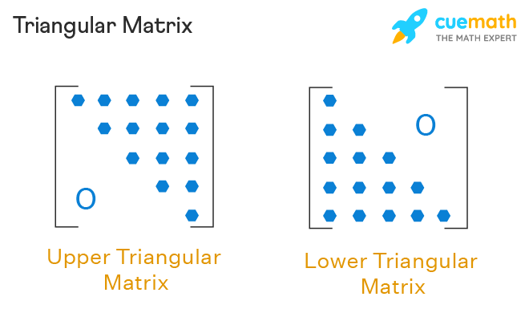

-To print the elements above the main diagonal of a matrix

class GFG {

static int MAX = 100;

// Function to print the elements above the main diagonal

static void printElementsAboveMainDiagonal(int mat[][], int n) {

System.out.println("Elements above the main diagonal:");

for (int i = 0; i < n; i++) {

for (int j = i + 1; j < n; j++) {

System.out.print(mat[i][j] + " ");

}

System.out.println();

}

}

// Driver code

public static void main(String args[]) {

int n = 4;

int a[][] = { { 1, 2, 3, 4 },

{ 5, 6, 7, 8 },

{ 1, 2, 3, 4 },

{ 5, 6, 7, 8 } };

printElementsAboveMainDiagonal(a, n);

}

}

Out put

Elements above the main diagonal:

2 3 4

1. 8

4

* To print the elements below the main diagonal of a matrix in Java

class GFG {

static int MAX = 100;

// Function to print the elements below the main diagonal

static void printElementsBelowMainDiagonal(int mat[][], int n) {

System.out.println("Elements below the main diagonal:");

for (int i = 1; i < n; i++) {

for (int j = 0; j < i; j++) {

System.out.print(mat[i][j] + " ");

}

System.out.println();

}

}

// Driver code

public static void main(String args[]) {

int n = 4;

int a[][] = { { 1, 2, 3, 4 },

{ 5, 6, 7, 8 },

{ 1, 2, 3, 4 },

{ 5, 6, 7, 8 } };

printElementsBelowMainDiagonal(a, n);

}

}

Output

Elements below the main diagonal:

5

1 2

5 6 7

**Anti-diagonal**

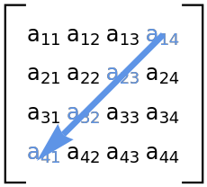

-To print the elements along the anti-diagonal of a matrix in Java, you can modify the code as follows:

class GFG {

static int MAX = 100;

// Function to print the elements along the anti-diagonal

static void printAntiDiagonal(int mat[][], int n) {

System.out.println("Elements along the anti-diagonal:");

for (int i = 0; i < n; i++) {

for (int j = 0; j < n; j++) {

// Condition to check if the element is on the anti-diagonal

if ((i + j) == (n - 1)) {

System.out.print(mat[i][j] + " ");

}

}

}

System.out.println();

}

// Driver code

public static void main(String args[]) {

int n = 4;

int a[][] = { { 1, 2, 3, 4 },

{ 5, 6, 7, 8 },

{ 1, 2, 3, 4 },

{ 5, 6, 7, 8 } };

printAntiDiagonal(a, n);

}

}

Output

Elements along the anti-diagonal:

4 7 2 5