**Carbohydrates**

**Introduction**

**Carbohydrates are the most abundant organic molecules in nature. They have a wide range of functions, including**

* **providing a significant fraction of the dietary calories for most organisms**
* **acting as a storage form of energy in the body**
* **serving as cell membrane components that mediate some forms of intercellular communication.**
* **Carbohydrates also serve as a structural component of many organisms.**

**The empiric formula for many of the simpler carbohydrates is (CH2O)n, hence the name “hydrate of carbon.”**

**CLASSIFICATION AND STRUCTURE OF CARBOHYDRATES**

1. **Monosaccharides: (simple sugars) can be classified according to the number of carbon atoms they contain.. Carbohydrates with an aldehyde as their most oxidized functional group are called aldoses, whereas those with a keto as their most oxidized functional group are called ketoses, For example, glyceraldehyde is an aldose, whereas dihydroxy acetone is a ketose.**

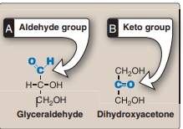

**Isomers and epimers** :

**Compounds that have the same chemical formula but have different structures are called isomers. For example, fructose, glucose, mannose, and galactose are all isomers of each other, having the same chemical formula, C6H12O6.**

**Epimers**

**Carbohydrate isomers that differ in configuration around only one specific carbon atom (with the exception of the carbonyl carbon are defined as epimers of each other. For example, glucose and galactose are C4- epimers their structures differ only in the position of the –OH group at carbon 4. Glucose and mannose are C-2 epimers.**

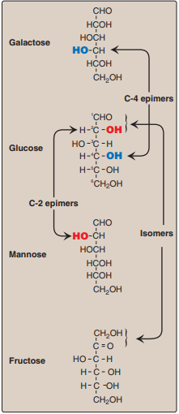

**Enantiomers:**

**A special type of isomerism is found in the pairs of structures that are mirror images of each other. These mirror images are called enantiomers, and the two members of the pair are designated as a D- and an L-sugar. The vast majority of the sugars in humans are D-sugars. In the D isomeric form, the –OH group on the asymmetric carbon (a carbon linked to four different atoms or groups) farthest from the carbonyl carbon is on the right, whereas in the L-isomer it is on the left. Enzymes known as racemases are able to interconvert D- and L-isomers.**

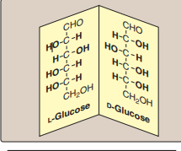

**Cyclization of monosaccharides:**

**Less than 1% of each of the monosaccharides with five or more carbons exists in the open-chain. Rather, they are predominantly found in a ring (cyclic) form, in which the aldehyde (or keto) group has reacted with an alcohol group on the same sugar.**

**Anomeric carbon:**

**Cyclization creates an anomeric carbon), generating the α and β configurations of the sugar, for example, α-D-glucopyranose and β-D-glucopryanose. These two sugars are both glucose but are anomers of each other.**

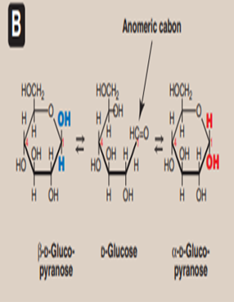

**2.Disaccharides: Monosaccharides can be joined to form disaccharides. Important disaccharides include lactose (galactose + glucose), sucrose (glucose + fructose), and maltose (glucose + glucose).**

1. **Polysaccharides :Important polysaccharides include branched glycogen (from animal sources) and starch (plant sources) and unbranched cellulose (plant sources); each is a polymer of glucose.**

**Glycosidic bonds:**

**The bonds that link sugars are called glycosidic bonds. These are formed by enzymes known as glycosyltransferases that use nucleotide sugars such as UDP-glucose as substrates.**

**Naming glycosidic bonds:**

**Glycosidic bonds between sugars are named according to the numbers of the connected carbons, and with regard to the position of the anomeric hydroxyl group of the sugar involved in the bond. If this anomeric hydroxyl is in the α configuration, the linkage is an α-bond. If it is in the β configuration, the linkage is a β-bond. Lactose, for example, is synthesized by forming a glycosidic bond between carbon 1 of β-galactose and carbon 4 of glucose. The linkage is, therefore, a β(1→4) glycosidic .**

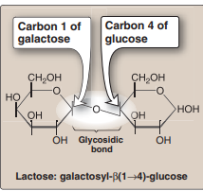

**DIGESTION OF DIETARY CARBOHYDRATES**

**The principal sites of dietary carbohydrate digestion are the mouth and intestinal lumen. This digestion is rapid and is catalyzed by enzymes known as glycoside hydrolases (glycosidases) that hydrolyze glycosidic bonds. The final products of carbohydrate digestion are the monosaccharides, glucose, galactose and fructose, which are absorbed by cells of the small intestine.**

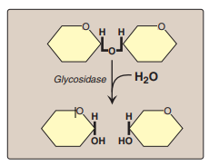

**Digestion of carbohydrates begins in the mouth :**

1. **The major dietary polysaccharides are of plant (starch, composed of amylose and amylopectin) and animal (glycogen) origin. During mastication, salivary α-amylase acts briefly on dietary starch and glycogen, hydrolyzing random α(1→4) bonds. [Note: There are both α(1→4)- and β(1→4)-endoglucosidases in nature, but humans do not produce the latter. Therefore, we are unable to digest cellulose, a carbohydrate of plant origin containing β(1→4) glycosidic bonds between glucose residues.] Because branched amylopectin and glycogen also contain α(1→6) bonds, which α-amylase cannot hydrolyze, the digest resulting from its action contains a mixture of short, branched and unbranched oligosaccharides kown as dextrins .Carbohydrate digestion halts temporarily in the stomach, because the high acidity inactivates salivary α-amylase**

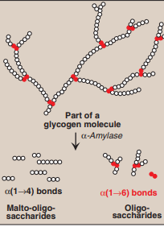

1. **Further digestion of carbohydrates by pancreatic enzymes occurs in the small intestine When the acidic stomach contents reach the small intestine, they are neutralized by bicarbonate secreted by the pancreas, and pancreatic α-amylase continues the process of starch digestion.**
2. **Final carbohydrate digestion by enzymes synthesized by the intestinal mucosal cells The final digestive processes occur primarily at the mucosal lining of the upper jejunum, and include the action of several disaccharides.**. For example, sucrase cleaves sucrose producing glucose and fructose, and lactase (β-galactosidase) cleaves lactose producing galactose and glucose.

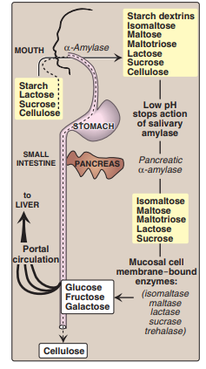

**D. Absorption of monosaccharides by intestinal mucosal cells The duodenum and upper jejunum absorb the bulk of the dietary sugars. However, different sugars have different mechanisms of absorption. For example, galactose and glucose are transported into the mucosal cells by an active, energy-requiring process that requires a concurrent uptake of sodium ions; the transport protein is the sodium-dependent glucose cotransporter 1 (SGLT-1).**